Air Microbiology
Definition
Study of microbes that are found in air is called air microbiology.
Air is not a medium for a microorganism but it is a carrier of particulate matter, dust,droplets which remain cover microorganisms. The origin of the micro organisms takes place through various ways. Soil is one of the source to transfer microorganisms to the air. Whenever the wind blows it disturbs the micro organisms and liberate them into the air and these micro organisms remains suspended in the air for long time. Another way of transferring micro organisms to the air is by manmade actions like ploughing and digging. Organisms can also be released in the form of water droplets or aerosols which are produced by wind or tidal actions. Micro organisms from plant and animal surfaces are also transferred by air currents. But the main source of micro organisms is human beings. These are discharged through human activities like coughing, sneezing, laughing and even talking. In air, the microorganisms tend to settle down quickly with their carriers leaving air free from them. The air after heavy rain is fairly free of microorganisms. In general, air above warmer regions of earth carries greater number of microorganisms. The air of a uncrowded and mountainous area and ocean is pure and good for health as it is relatively free from microorganisms.
Microbes normally found in atmosphere within 300-10000 feet above from the land. Fungal spores which are found in air consist of Alternaria, Cladosporium, Penecillium and Aspergillus found above 4000 feet from the land, found in both polar and non polar air masses. Organisms found below 500 feet is mainly in overpopulated area, these include spores of Bacillus and Clostridium, aslo spores of yeast and fragments of mycelium, mould, streptomycetaceae, pollen, protozoan cysts, algae, Micrococcus and corynebacterium. Air found in school and hospital or living places of the person suffered from infectious disease usually found microbes like tubercle bacilli, streptococci and pneumococci. Some airborne microorganisms are bacteria, protozoa, fungi especially fungal spores, algae, viruses.Some airborne diseases are
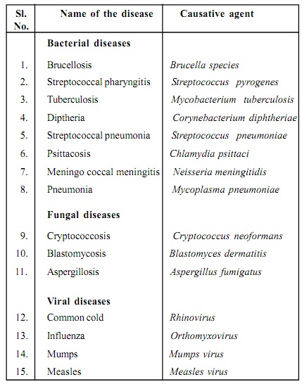

Methods to Study Air Microbiology
- Settling Plate Technique
In this method, the lid of a Petri dish containing agar medium is exposed to air in room for several minutes and plate is then incubated. A certain number of colonies will develop. Each colony represents a particle carrying microorganisms which is fallen on agar.
- Advantages Of Settling Plate Technique
Settling plate method is an extremely useful method for air contamination by microorganisms.
It is easy to conduct and very cost effective.
- Disadvantages Of Settling Plate Technique
Only viable microorganisms would be detected by this method and hence it may give a false impression that the air is clean if most of airborne microorganisms are dead.
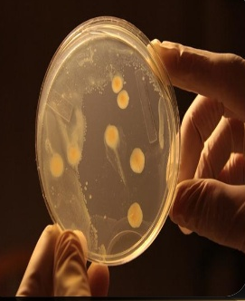

- Sieve Plate Technique
A measured volume of air is drawn through a device consisting of a large number of evenly spaced holes In a metal cover under which is placed a petridish containing agar media. Particle containing microorganisms settle down. The plates are now incubated and microbial colonies are observed on agar surface
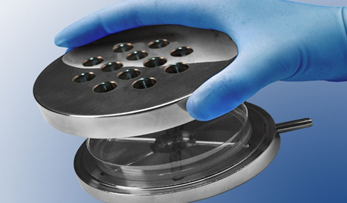

- Slit Sample or Slit Plate Technique
Slit sample operates on the same principle as the sieve plate technique. A known volume of air is directed on media containing plates to a slit of 0.25 nm. Plate is mechanically rotated so that microorganisms are evenly deposited over it. These samplers are used for examining the amount of microbial contamination in indoor environment of hospitals schools and industries
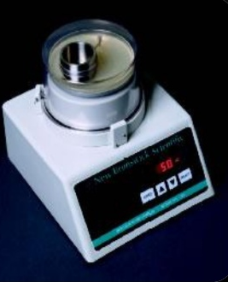

Techniques for controlling airborne contaminations
- Physical Techniques
- Dust Control
As dust particles contain microorganism so control of dust is necessary for the control of air borne microbial contamination. Use of vacuum pick up followed by use of suitable disinfectants and detergent solution has been recommended to control the dust in indoor environment
- U.V Radiations
Germicidal lamps are use for this purpose. These emit radiations in 250-260 nm range (The most effective bactericidal region).
- Use of Laminar Air Flow System
This technique represents unidirectional air flow system in which air passes through HEPA filters (High efficiency particulate air filters). It is used in industries where high degree of cleanliness is required.
- Chemical Technique
Certain chemicals are also used to control airborne contaminations such as formaldehyde, hypochlorus acid, resorcinol, beta-propiolactones and propylene glycol .
These chemicals are sprayed or fumigated in room to kill the microorganisms present in the room.

