ACCURACY AND PRECISION
ACCURACY
Accuracy descibes the nearness of a measurement to the standard or true value, i.e., a highly accurate measuring device will provide measurements very close to the standard, true or known values.Example: in target shooting a high score indicates the nearness to the bull's eye and is a measure of the shooter's accuracy. Refer to pictures below:
PECISION
Precision is the degree to which several measurements provide answers very close to each other. It is an indicator of the scatter in the data.The lesser the scatter, higher the precision. The pictures given below clearly describe Accracy and Precision.
EXAMPLES
If we measure the length of a foot-ruler and get values of
12.01 in, 12.00 in, 11.99 in, 12.00 in.
These numbers are precise enough for us to believe that if we measure it again we would get 12.00+0.01 in. These meaurements are precise but necessarily accurate. The foot-ruler may actually be metric ruler of 30.0 cm long. Our measurement is precise but not accurate.
APPROXIMATIONS
Even though physicists usually try for a high degree of precision, there are times when only a close approximation is neeed. Physicists some times make rough estimates for making tentative decisions. The accuracy of estimates depends on reference materials available, time devoted, and experience with similar problems.

ORDERS OF MAGNITUDE
Some times physicists make orders of magnitude calculations. In these calculations, the numbers may differ by a factor of ten. Example: 106m 10,980 m differ by two orders of magnitude.
It’s important to note that measurement systems can suffer from both accuracy and precision problems! A dart board can help us visualize the difference between the two concepts:
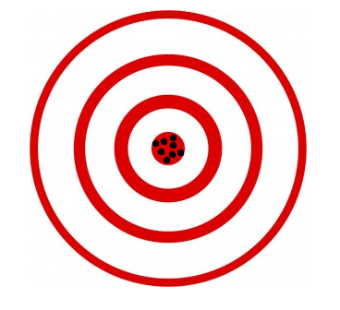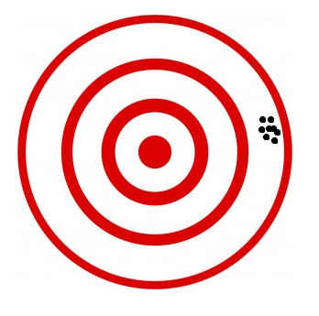
Accurate and Precise Precise...but not Accurate

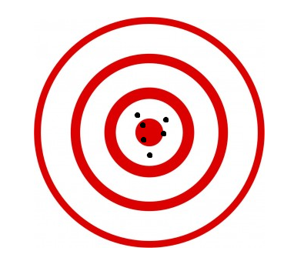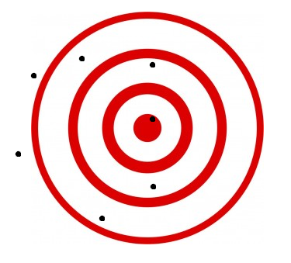
Accurate, but not Precise Neither Accurate nor Precise

