DIAMETER-MEASURING INSTRUMENTS
1.1 Calipers
Thecaliperconsists of a fixed arm mounted perpendicularly to a graduated beam and a movable arm, parallel to the former and sliding along the fixed beam
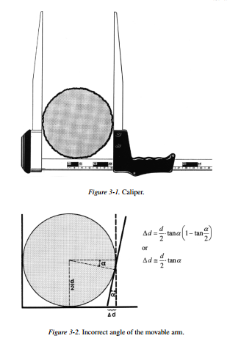
(Figure 3-1).
The caliper is used to measure stem diameters on felled trees and the over bark breast height diameter of standing trees. In order to minimize instrument errors, a rigid construction of the caliper is imperative. The early wooden calipers were subject to wear and tear, steel calipers are rigid and reliable but heavy and uncomfortable during cold weather. Aluminum calipers have increased in popularity, but they should be regularly checked for their accuracy and, if necessary, calibrated at least once annually. In general, calipers have to meet the following quality specifications:
1. The graduated beam must be perfectly straight, of sufficient length for measuring large-dimension and sturdy trees. To eliminate recording errors the graduations should be clearly visible.
2. The movable and fixed arm should run exactly parallel, two arms of the caliper should be located on a plain. If the movable arm is not at a right angle to the fixed beam
(Figure 3-2), the resultant systematic positive error is dependent upon the angle of deviation (α) and the diameter of the tree.
3. The point of measurement is consistently incorrectly positioned. The resultant operator bias is two-sided. In research plots, the error may be negligible by permanently marking the breast height position.
4. The graduated beam is not held at an angle of 90 degree to the stem. For an angle of deviation of α degrees, the observed diameter is approximately equal tod(1−tan(α)/2)and the percentage error is equal to 50(tan(α).

Figure 3-1.Caliper. and Figure 3-2.Incorrect angle of the movable arm.
The corresponding error in the estimated basal area is approximately twice as high.
5. The operator sometimes tends to exert too much pressure during measuring, in which case a systematic, negative operator-bias is introduced.
6. On slopes, a positive bias is likely to occur by not consistently measuring from the uphill position.
7. On terrain with a heavy and tough ground vegetation of grasses and other plants, the point of measurement is usually located above its true position, in which case a negative bias is introduced. A similar situation may arise during winter, if the ground is covered by snow. In Continuous Forest Inventories, the measuring point is usually permanently marked, partly to establish whether or not a particular tree was measured at the previous occasion. It has the additional advantage of reducing random or systematic errors associated with inaccurately positioning the tape or caliper. When using calipers for remeasuring permanent sample plots, they should be checked regularly for the occurrence of instrument-related errors. In forest inventories, they are to be calibrated annually. Calipers used to measure research plots require a 1 mm graduation. Those with a 1, 2 or 4 cm graduation are adequate and more practicable for management, regional, and national forest inventories. The diameters are marked on the graduated beam, and show the midpoint of the diameter class. When using self-rounding calipers, these midpoints are always printed at the lowest point of the diameter class.
1.2 Biltmore stick
The Biltmore stickis occasionally used to obtain quick and rough estimates of the mean diameter of standing trees, but its use is restricted to North America. It consists of a graduated rule, which is held against the stem at breast height. It is usually calibrated for a distance of 25 in. between the operator and the tree. The observer aligns the zero mark of the stick with the left edge of the stem and at this point reads off the diameter. The calibration formula for a distance of 60 cm is
distance from zero point=d 60 60+d The tree fork consists of two fixed arms, mounted on a handle at a certain angle between the arms. The diameter is read out on the graduated arm, at the contact point with the stem. In order to avoid an excessive length of the instrument, forks are constructed with different fixed angles between the arms, for example, an angle of 60 ◦ for young and medium-aged trees, with a diameter below 30 cm. An angle of 90 ◦ should be used for mature stands, with a mean diameter above 30 cm. For an angle of 60 ◦ the stem diameter is 1.154 times the recorded distance between the contact point and the zero mark, for an angle of 90, the tree diameter equals twice this distance. 36 Instruments 1.3 Diameter tapes Before the beginning of the 19th century, European foresters used diameter tapes to measure the diameter of felled roundwood. They were gradually replaced by the more convenient caliper. The tape is graduated on both sides, with the linear scale on one side giving the true circumference of the tree, whereas on the other side it is scaled to give the corresponding diameter. The earlier steel tapes were gradually replaced by those manufactured from weave material, reinforced with wire. The diameter tape produces slightly biased estimates, if the stem cross section is not exactly circular. The following sources of errors have been noted: • Systematic errors occur when the measuring position is consistently located above or below 1.30 m.
• The tape is slanted around the tree and sags on one side, in which case a positively biased estimate is obtained. The error increases with the size of the tree and may be substantial for large-sized trees, when it is inconvenient for the operator to verify the position of the tape on the backside of the tree.
• Excessive pressure induces a negative operator bias. In general the resultant bias remains within acceptable limits.
• The occurrence of loose bark, for example, in Eucalyptus plantations generates a positive error unless these bark sections are removed prior to measurement. The diameter tape is usually considered to produce an almost error-free estimate of the tree diameter. Because of the smaller random error involved in successive tape measurements on the same tree, the diameter increment is also obtained free of bias and more accurately, compared with caliper measurements. Some studies have been carried out to compare the two instruments. Kennel (1959) reported on the accuracy of diameter tape and caliper in estimating the tree basal area. The caliper produced estimates with a mean difference of 2.14% below that obtained with the diameter tape, which indicated a positive instrument-bias for the diameter tape.
1.4 Permanent diameter tapes
Hall (1944) introduced the vernier tree-growth band to measure short-term growth responses at breast height. It consisted of an aluminum band, which was held in place by a coil spring. The band was graduated in inches and 1/10inches and fitted with a vernier to permit more accurate readings. Aluminum has the advantage of being light and easy to work with, but has a relatively high factor

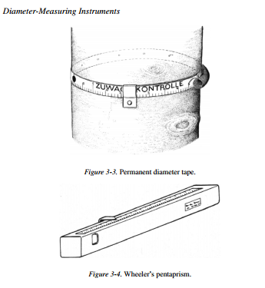
Figure 3-3.Permanent diameter tape.
Figure 3-4.Wheeler’s pentaprism.
of expansion when exposed to the sun in outdoor conditions. The permanent band is widely used in growth studies in Germany. When graduating in centimeters and millimeters, the use of a vernier is not necessary (see Figure 3-3). Other devices to measure short-term radial growth responses are discussed in section 6.
1.5 Wheeler’s pentaprism
Wheeler’s pentaprism (Figure 3-4) consists of a fixed and a movable pentaprism, which is mounted on or moves along a graduated beam. After sighting the point of measurement on the upper stem, the movable prism is adjusted in such a way that the right side of the stem coincides with its left, which is directly viewed. Up to a measuring height of 15 m, the measurement error lies between 0.5 and 1.2 cm (Avery et al. 1983). Van Laar (1984) investigated the accuracy of upper stem measurements obtained with Wheeler’s pentaprism and the Finnish optical caliper. The latter produced the best results.
1.6 Finnish parabolic caliper
The Finnish parabolic caliper is used to measure the stem diameter at those positions on the stem, which cannot be reached from the ground. In Finland, Germany, and Switzerland, for example, they are used to measure the stem diameter at 6 or 7 m above the base of the tree. The latter serves as an additional predictor variable to estimate tree volumes from volume functions with three predictor variables. The instrument consists of a parabolically curved arm with a 1 cm graduation, which is mounted on a hand-held 5–7 m aluminum pole. In order to improve visibility, the diameter class limits enclose 1 cm wide strips of different colors. During measuring the straight section of the caliper is in contact with the stem. In order to eliminate a positive operator-bias, the operator stands exactly vertically underneath the caliper arm. In comparison with the standard type of calipers, diameters are measured less accurately, but it is feasible to classify the stem diameter in classes of 1 cm. (Figure 3-5).
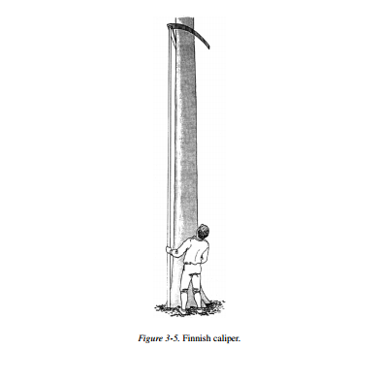
Figure 3-5.Finnish caliper.

Relascopes and Prisms
1.7 Barr and stroud optical dendrometer
The Barr and Stroud optical dendrometer, which is no longer manufactured, has been used extensively in conjunction with Grosen baugh’s 3P sampling and has a confirmed accuracy of 2.5 mm for upper stem diameters below 25 cm. The instrument is a split-image magnifying rangefinder and is used primarily to measure upper diameters. However, it can also be used to measure tree heights and distances. The readings obtained with the dendrometer are transformed, either by using tables or with the aid of a computer program. The dendrometer is still used in 3P sampling.
RELASCOPES AND PRISMS
The principle of Bitterlich’s method, based on angle count sampling, is discussed in Chapter 10. All instruments in this group have in common that the angle subtended between the sampling point and the stem at breast height is evaluated.
2.1 Angle gauges
The earlyangle gaugesconsisted of a 50 cm or 1 m long hand-held stick, with a metal blade 1 cm wide for the 50 cm stick and 2 cm for the 1 m stick being mounted on one side. The trees surrounding the sampling point were sighted at breast height in a 360 ◦ sweep. The tree is counted if it subtends an angle which exceeds the critical angle of the instrument.
2.2 Kramer’s dendrometer
The multipurpose instrument incorporates the basic principle of the measuring blade, which is 1 cm wide (Figure 3-5) and generates such an angle that each tree counted corresponds with 1 m 2 basal area per hectare, i.e., it represents a basal area factor (BAF) of 1. When using a width of either 2 or 4 cm (“op” or “mn” in Figure 3-6), the corresponding BAF are 2 and 4, respectively. The dendrometer is held vertically at a distance of 50 cm to determine the basal area per hectare. The right edge is equipped with a scale for measuring heights, which is similar to theVorkampff–Laue hypsometer. The observer seeks a position where the top and base of the scale (kandhin Figure 3-5) exactly covers the tree and measures the height of the point on the stem which
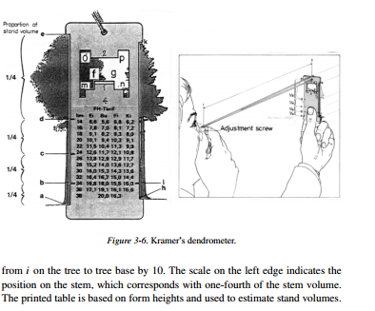
Super imposes the marking on the instrument. Tree height can be calculated by multiplying the distance 40
Figure 3-6.Kramer’s dendrometer.
on the tree to tree base by 10. The scale on the left edge indicates the position on the stem, which corresponds with one-fourth of the stem volume. The printed table is based on form heights and used to estimate stand volumes.
2.3 Bitterlich’s mirror relascope
The mirror relascope (Figure 3-7) is a small hand-held instrument, which can be used for a variety of purposes:
• Estimation of the basal area per hectare
• Optical distance measurements, adjusted for slope
• Measurement of tree height either for distances of 15, 20, 25, and 30 m or for arbitrary distances
• Measurement of upper-stem diameter, from fixed distances
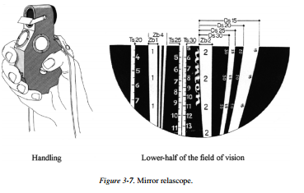
• Combined height and diameter measurements
• Estimation of relative form heights, to determine absolute form heights, factors, and the volume of the standing tree
• Measurement of slopes
• Estimation of Hirata’s stand mean height, based on vertical point sampling The instrument is based on the principle of a drum pendulum, which is released when measurements are made. The relascope is equipped with a peephole to be used for viewing the object of measurement and lateral windows to admit Relascopes and Prism light. The instrument is usually held with the
Figure 3-7.Mirror relascope.
right hand, and the left hand may be used to give the instrument extra support and the middle fingers to press the button. Alternatively, the mirror relascope can be mounted on a tripod or monopod, in order to reduce erratic movements of the instrument during viewing, although this restricts the freedom of movement of the operator. The drum pendulum is equipped with a number of measuring bands, which are mounted on roller bearings to ensure that the pendulum is in a vertical position during the measurements. The pendulum wheel is provided with a brake to dampen the movements of the pendulum. A built-in lens projects the magnified measuring bands onto a mirror. The image is visible in the lower half of the field of vision, with a horizontal line separating the lower from the upper half of the field of vision, which is used to view the object. The width of the measuring bands is adjusted for slope. The adjustment factor is equal to the cosine of the angle of slope. This property is used when measuring upper-stem diameters and when evaluating stems at breast height on sloping terrain. The lower halffield of vision, which reveals a number of white and black bands, is shown in Figure 3-7.
The “count” bands 1 and 2, which correspond with Zb1 and Zb2 in Figure 3-6, are used to estimate the basal area per hectare for the BAFs 1 and 2 in the metric system. Adding the two white and black bands on the right of Zb1 gives band 4 (Zb4 in Figure 3-6) to estimate the BAF of 4. The distance bands Ds15, Ds20, Ds25, and DS30 are required for optical distance measurements with the aid of a 2 m vertical staff and correspond with horizontal distances of 15, 20, 25, and 30 m from the object. The tangent scale Ts is used for height measurements, for combined diameter and height measurements and to determine Hirata’s stand height. They are located to the left of Zb1, (20 m scale), and between Zb2 and Zb4 (25 m and 30 m scale).
• Estimating the basal area per hectare at breast height In a 360 ◦sweep, the number of trees is counted with an apparent diameter, which exceeds one of the selected “count” bands. The number of trees counted gives the estimated basal area in square meter per hectare if band 1 is used, multiplied by 2 and by 4 when using band 2 and 4, respectively.
• Distance measurements with the aid of a horizontal staff Band Zb4 is to be used for measuring horizontal distances. A staff of a fixed length, for example, 80 cm is held against the tree, in a horizontal position. The operator locates the point where band Zb4 exactly covers the 80 cm staff. The distance is found as the product 0.80 ∗ 25=20 m.
• Distance measurements with the aid of vertical staff The distance bands Ds 15 to Ds 30 are used in combination with a vertical 2 m staff to determine one of the fixed distances of 15, 20, 25 or 30 m (See Figure 3-7). Before determining the exact distance, the latter is estimated ocularly, ignoring slope. Releasing the pendulum, the relascope is pointed at the halfway point of the horizontal staff and arrested in this position, in order to adjust for slope. The relascope is subsequently rotated counterclockwise at an angle of 90 ◦. The operator moves forward and backward in order to ensure that the lower terminal point of the vertical staff coincides with the lower edge of band 2 and the upper terminal point of the vertical staff coincides with the appropriate distance band.
•Measuring tree height
The tangent scales are used in combination with the distance bands. The tangent scales are provided for each of the horizontal distances 20, 25, and 30 m. The 30 m scale can be used for the measuring distance 15 m by multiplying the recorded tree heights by 0.5. The height scale for 20 m is found at the far left of the instrument (Ts20), whereas Ts25 and Ts30 are located between ZB4 and ZB2.
• Estimating an upper-stem diameter Band Zb1 and the adjoining Zb4 are used to measure an upper diameter. Band Zb1 and Zb4 correspond with a ratio object width: horizontal distance of 1:50 and 1:200, respectively. The relascope unit is defined as the band width Zb4, so that count-band Zb1 contains 4 and ZB4 contains 8 relascope units. For a horizontal distance of 10 m, one relascope unit corresponds with a width of 5 cm of the object. When measuring upper diameters from a fixed m horizontal distance, the diameter is measured in relascope units and then
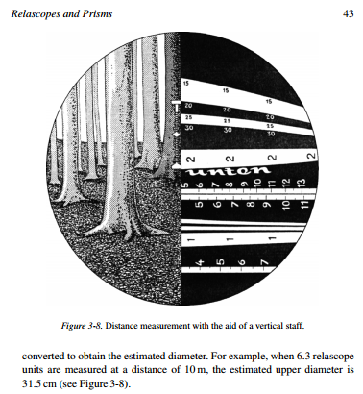
Figure 3-8.Distance measurement with the aid of a vertical staff.
converted to obtain the estimated diameter. For example, when 6.3 relascope units are measured at a distance of 10 m, the estimated upper diameter is 31.5 cm (see Figure 3-8).
2.4 Wide-scale mirror relascope At a later stage, Bitterlich constructed the wide-scale mirror relascope for measuring upper diameters of large trees and to apply the relascope technique to estimate the basal area per hectare for large BAF (see Figure 3-9).
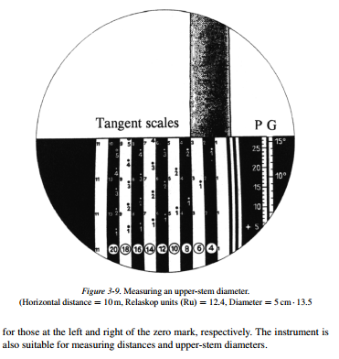
The instrument is equipped with slope scales for degrees (G) and percentage (P), respectively, with four narrow black–white bands to measure upper diameters and to estimate the basal area per hectare for low basal-area factors, with a white band 1 (Zb1), which corresponds with BAF=1 and distance factor 50 as well as with five black and five white bands, which correspond with BAF=1. The zero mark is located at the right edge of the Zb1 band. Those units, which are completely covered by the tree to the left and right, are counted and converted into basal area per hectare by using the appropriate conversion factors

2.5 Bitterlich’s telerelascope
The tele relascope represents a vastly improved version of Bitterlich’s mirror relascope, primarily to estimate upper-stem diameters and their corresponding heights above the base of the tree, from arbitrary sighting distances. The following steps are required:
• The instrument is mounted on a tripod, either with a movie head adapter or with a micrometer head with a fixed avallactical point, i.e., with a fixed sighting-angle vertex.
• The left edge of the tree and that of a white band, which corresponds with one tachymetric unit are aligned. The number of tachymetric units is determined in 1/10 units. This gives the upper-stem diameter in tachymetric units. A second reading is made on a horizontal base rod, positioned aside the tree on which as many full tachymetric units as possible are read out. The reading on the base rod, divided by the number of full units, gives the base reading, which is multiplied by the number of tachymetric units obtained for the upper stem diameter.
• The reading obtained on the base rod gives the horizontal distance in meters.
• The left graduation on the instrument is used to obtain percentage readings for the position of the upper diameter and that of the base rod. The algebraic difference is multiplied by the base reading and gives the height above ground level of the upper diameter. Sterba (1976) summarized errors involved in the estimation of stem volume with the aid of the telerelascope. Instrument errors were associated with movements of the vertex of the sighting angle, which affected the estimation of the operator to tree distance. The distance errors varied between 0.5% and 1% and necessitated upper-stem diameter adjustments between 1% and 2%, whereas height estimates should be adjusted upward by 20–40 cm. The volume estimates were furthermore associated with errors due to the formulae being used. An upward adjustment of 3–5% was required to remove this source of bias.
2.6 Prisms
The prism is a thin wedge made of glass or plastic, which deflects the incoming rays through an angle that is constant for a given prism. Deflection causes displacement of the tree when viewed through the prism, the amount of displacement being dependent on the diopter strength of the prism, which in turn is a function of the angle between the two surfaces of the prism. A strength of one diopter is the equivalent of a displacement of 1 unit per 100 units distance. The displacement of the image produces a critical angle, similar to that established by the relascope. When the left edge of the stem, viewed through the prism, is aligned with the right edge of the stem, viewed over the prism, the corresponding stem diameter is 1/100 of the distance to the tree, for a prism with a diopter strength of one. During a 360◦sweep with the sampling point as center, the line between the two surfaces of the prism is held vertically above the sampling point and should remain in this position. Trees which are displaced less than the apparent diameter are counted, those which are displaced fall outside the imaginary plot and are not counted (see Figure 3-10).
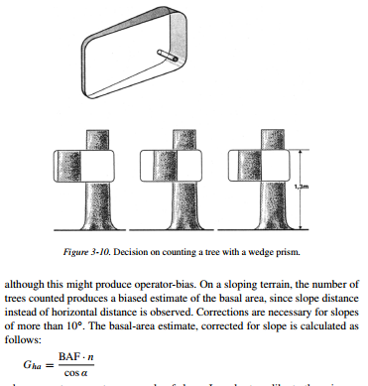
The borderline trees, i.e., those trees for which the amount of displacement is equal to the apparent diameter, should be checked by measuring the stem diameter and distance from sampling point. Because of the amount of time involved in checking, it is customary to assign a count of one-half to each borderline tree, Figure 3-10.Decision on counting a tree with a wedge prism. although this might produce operator-bias. On a sloping terrain, the number of trees counted produces a biased estimate of the basal area, since slope distance instead of horizontal distance is observed. Corrections are necessary for slopes of more than 10 ◦ The basal-area estimate, corrected for slope is calculated as follows: 