Respiratory Substrates

5.2.2.
24 January, 2018

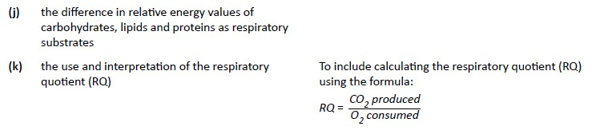
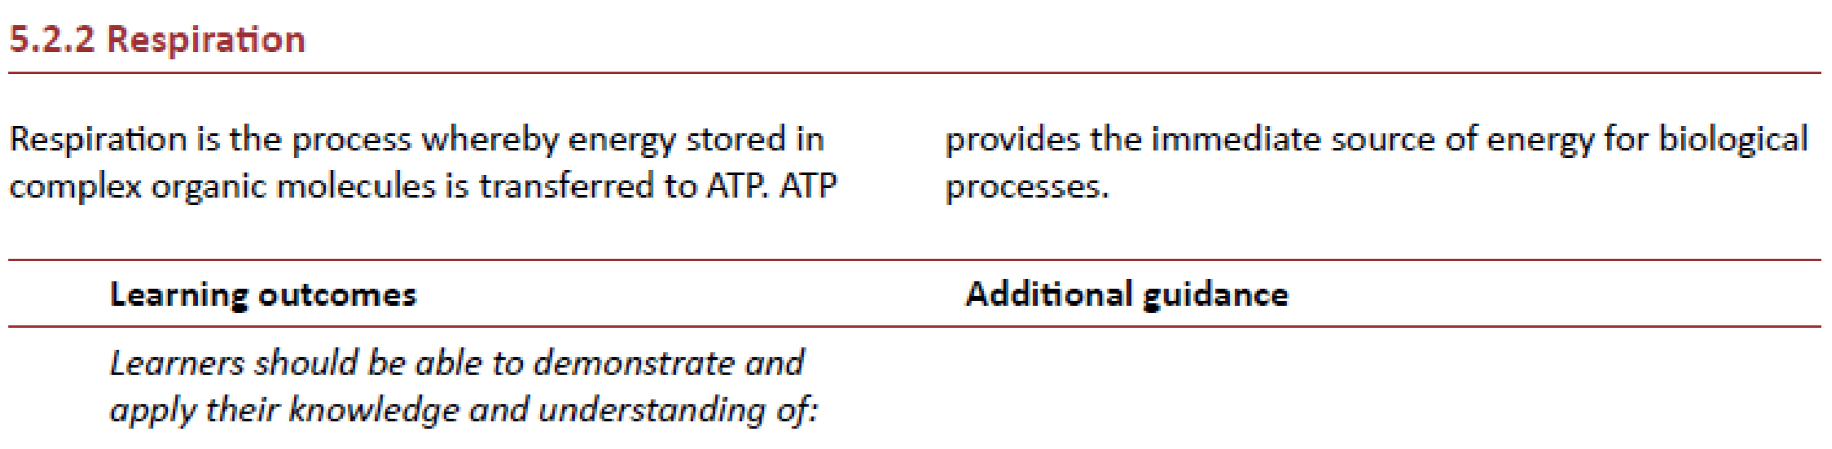

Respiratory Substrate = something that will be broken down to release energy for the synthesis of ATP
For example:
- Triglycerides are hydrolysed to fatty acids and glycerol – glycerol can be converted into pyruvate, while the fatty acids can be converted into acetyl groups which are then picked up by CoA to make acetyl CoA.
- Proteins first have to be hydrolysed to amino acids and then the amino acids have to be deaminated before being converted into pyruvate.
Lipids store and release about twice as much energy as carbohydrates, while proteins are roughly equivalent to carbohydrates.

Respiratory Quotient (RQ)
Calculated by dividing the volume of carbon dioxide released by the volume of oxygen taken in during respiration of that particular substrate.
_{RQ =} CO2 produced
O₂ consumed
It takes six oxygen molecules to completely respire one molecule of glucose, resulting in the production of six molecules of carbon dioxide. This results in an RQ of 1.0
- Lipids contain a greater proportion of carbon-hydrogen bonds than carbohydrates which is why they produce more ATP in respiration.
- This means that they require relatively more oxygen to break them down and release relatively less carbon dioxide.
- This results in RQs of less than one for lipids.
- The structure of amino acids leads to RQs somewhere between carbohydrates and lipids.

