What is Model?
A model is a symbolic representation that shows how elements of a structure or system relate for analysis and discussion purposes. Communication models help to explain the process of communication.
Or we can say graphical or visual representation of a process is called model.
A model is a systematic representation of an object or event in idealized and abstract form. Models are somewhat arbitrary by their nature.
Aristotle’s Mode of Communication
Aristotle’s Concept of Communication The first known scholar, who wrote about communication, though not directly, is Aristotle (384-322 BC). In his famous books, ‘Rhetoric’, Aristotle called the study of communication as ‘rhetoric’ and elaborated three elements within the process. According to him, communication process composed of a speaker, a message and a listener. Person at the end of the communication process holds the key to whether or not communication takes place.
In Aristotle’s point of view,
• Communication is purposive;
• It is based on the intention of affecting others;
• Its effects can be evaluated and measured in terms of effect, and also in terms of the truth;
• Rhetoric considers not only what is or was, but also what might be.

To his communicators need to develop five skills:
• Invention-ability to generate ideas;
• Disposition-ability to organize ideas;
• Style-use of appropriate language;
• Memory-ability to recall facts & ideas;
• Delivery-use of voice and gestures.
From his observations, later scholars developed a model of communication using the elements he mentioned.
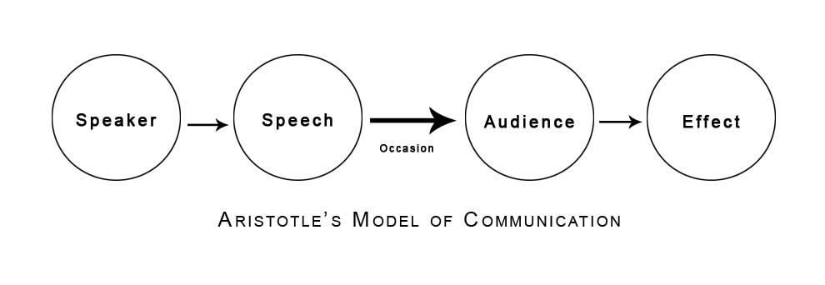
The model consists of four visible elements: Speaker or receiver, speech or message, audience or receiver(s) and effect of communication. And, context or occasion of the communication covers all the elements indicating that it has influence on other four elements.
Lasswell Model of Communication
Harold Dwight Lasswell (1902-1978) is the proponent of famous question formula, which is otherwise called Lasswell formula of communication. We can’t call his definition of communication which is presented in an array of question as a communication model in its strict sense. This American political scientist stated that the most convenient and comprehensive way to describe an act of communication was to answer the following questions: Who (says) What (to) Whom (in) What Channel (with) What Effect?
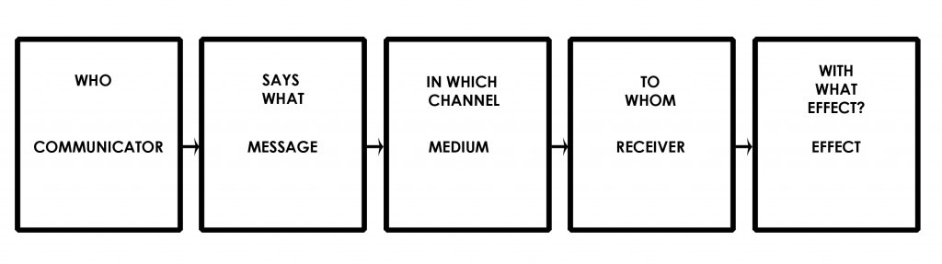
This model is self speaking of the process of communication which consists of five elements namely communicator (who), message (says what), medium (in which channel), receiver (to whom) effect (with what effect).
Lasswell conceived communication as a linear process which starts from communicator and ends at receiver with some effect. The major missing elements of this basic model are feedback and context of communication. However, this model is said to be highly helpful for organizing communication research as audience analysis, content analysis, control analysis, reception analysis and effect studies which are respectively represented by communicator, message, medium, receiver and effect
Harold Lasswell (1948), in proposing a convenient way to describe communication, came out with the model which was expressed in terms of the basic elements of the communication process. According to Lasswell, communication occurs when:
• a source sends a message
• through a medium
• to a receiver
• producing some effect
The point in Lasswell's comment is that there must be an "effect" if communication takes place. If we have communicated, we've "motivated" or produced an effect. It is also interesting to note that Lasswell's version of the communication process mentions four parts — who, what, channel, whom. Three of the four parallel parts mentioned by Aristotle — speaker (who), subject (what), person addressed (whom). Only channel has been added.

