Cell:
All living things are made up of cells. Most cells are so small that you can only see them with a microscope. Cells have different components and each performs its own function within the cell.
What’s in a cell?
Cells are the basic building blocks of all animals and plants. Inside cells are various structures that are specialized to carry out a particular function. Both animal and plant cells have these components:
- Cell membrane – this surrounds the cell and allows nutrients to enter and waste to leave it.
- Nucleus – this controls what happens in the cell. It contains DNA, the genetic information that cells need to grow and reproduce.
- Cytoplasm – this is a jelly-like substance in which chemical reactions happen.
- Mitochondria – these are the powerhouse of the cell. They are structures where respiration takes place.
How are plant and animal cells different?
Plant cells have all the parts in the list above, plus a few extra structures:
- Cell wall - this is an outer structure that surrounds the cell and gives it support.
- Vacuole - this is a space within the cytoplasm of plant cells that contains sap.
- Chloroplasts - these contain chlorophyll and are the site of photosynthesis.
How big are cells?
Cells can vary greatly in size. You need a microscope to see most human cells.
Red blood cells are some of the smallest cells in the human body. These have a diameter of 0.008 mm, meaning a line of 125 red blood cells is only 1 mm long.
The ovum (or egg cell) is one of the largest cells in the human body. It has a diameter of roughly 0.1 mm, so you can see them without a microscope. A line of 10 egg cells is 1 mm long.
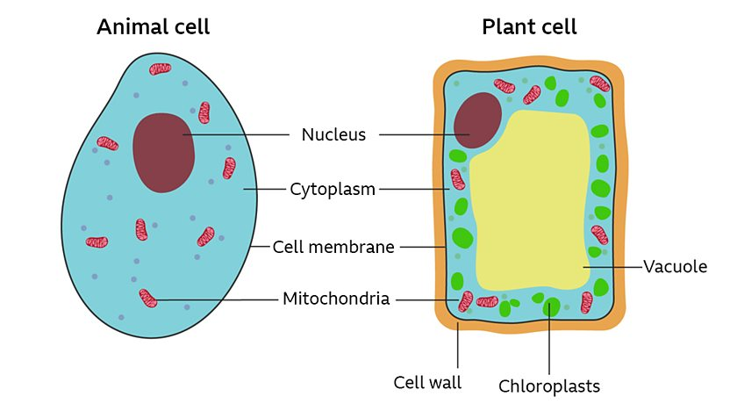

Chromosome:
Chromosomes are thread-like structures in which DNA is tightly packaged within the nucleus. DNA is coiled around proteins called histones, which provide the structural support. Chromosomes help ensure that DNA is replicated and distributed appropriately during cell division. Each chromosome has a centromere, which divides the chromosome into two sections – the p (short) arm and the q (long) arm. The centromere is located at the cell’s constriction point, which may or may not be the center of the chromosome.
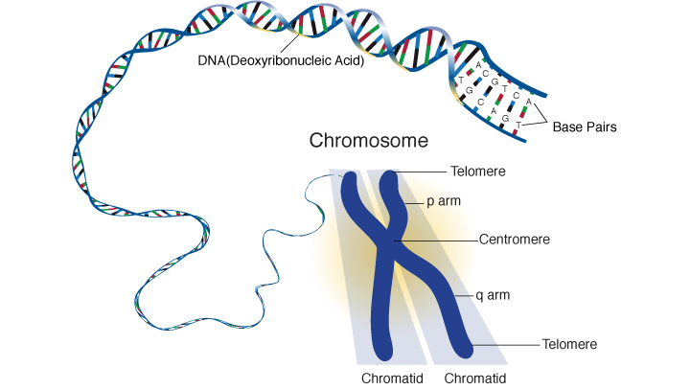
At the end of each chromosome is a repetitive nucleotide sequence cap called a telomere. In vertebrates, the telomere is a TTAGGG sequence repeated to approximately 15,000 base pairs. These DNA regions serve a critical role of preserving the genomic sequence by protecting the genome from degradation, and inhibiting chromosomal fusion and recombination. These regions are also involved in chromosome organization within the nucleus.
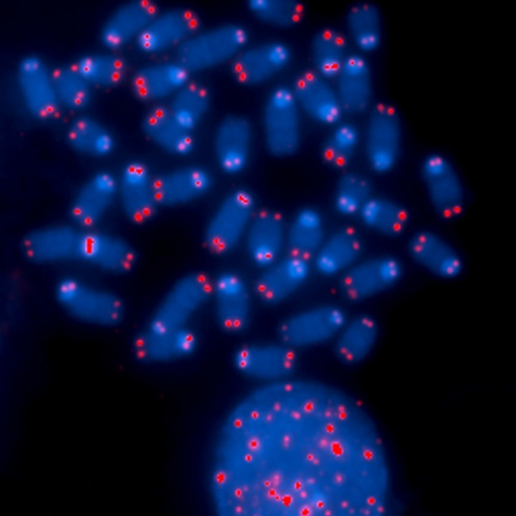
This image shows the ends of chromosomes with the telomeres visualized in red.
In humans, 46 chromosomes are arranged in 23 pairs, including 22 pairs of chromosomes called autosomes. Autosomes are labeled 1-22 for reference. Each chromosome pair consists of one chromosome inherited from the mother and one from the father.
In addition to the 22 numbered autosomes, humans also have one pair of sex chromosomes called an allosome. Instead of labeling these chromosome pairs with numbers, allosomes are labeled with letters such as XX and XY. Females have two copies of the X chromosome (one inherited from the mother and one from the father). Males have one copy of the X chromosome (inherited from the mother) and one copy of the Y chromosome (inherited from the father).
Arranged on the chromosomes are genes. Genes are made of DNA and contain the instructions for building proteins and are integral in making and maintaining the human body.
Gene:
Chromosomes contain the recipe for making a living thing. They are found in almost every cell’s nucleus and are made from strands of DNA (deoxyribonucleic acid). Segments of DNA called "genes" are the ingredients. Each gene adds a specific protein to the recipe. Proteins build, regulate and maintain your body. For instance, they build bones, enable muscles to move, control digestion, and keep your heart beating.
Most of our cells contain 46 chromosomes (here is an early look at our chromosomes, taken in the 1950s by Dr. Joe Hin Tjio of the National Institute of Diabetes and Digestive and Kidney Diseases). Sperm and egg cells contain only 23 chromosomes. When the sperm and egg cells unite, the resulting fetus inherits half of its DNA recipe from its mother and half from its father.
Two of these 46 chromosomes determine the sex of a person. A girl inherits two X-chromosomes, one from her mother and one from her father. A boy inherits one X-chromosome from his mother and a small Y-chromosome from his father.
46 Chromosomes. Collection of DeWitt Stetten, Jr., Museum of Medical Research

The Austrian monk Gregor Mendel (1822-1884) was the first person to describe how traits are inherited from generation to generation. He studied how pea plants inherited traits such as color and smoothness, and discovered that traits are inherited from parents in certain patterns. Not until the 20th century did other scientists take his ideas further. Mendel is considered to be the father of genetics, although his work was relatively unappreciated until the early 20th century.
Gregor Mendel and Pea Plants. Courtesy of Medical Arts and Photography Branch
A gene can exist in many different forms, calledalleles. For example, let’s say that there is one gene which determines the color of your hair. That one gene may have many forms, or alleles: black hair, brown hair, auburn hair, red hair, blond hair, etc. You inherit one allele for each gene from your mother and one from your father.
Each of the two alleles you inherit for a gene each may be strong ("dominant") or weak ("recessive"). When an allele is dominant, it means that the physical characteristic ("trait") it codes for usually is expressed, or shown, in the living organism. You need only one dominant allele to express a dominant trait. You need two recessivealleles to show a recessive form of a trait. See the heredity diagram for tongue rolling to see how dominant and recessive alleles work.

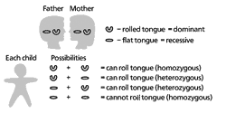
Tongue Rolling Heredity Diagram
For example, mild forms of red/green color blindness are very common, resulting only in the inability to tell apart shades of red and green. The gene for this trait is located on the X-chromosome. A mother who carries this recessive trait has normal red/green vision. Any of her sons who inherit the X-chromosome that carries this trait -- the allele for color blindedness -- will be mildly red/green color blind. In this chart used to test for color-blindedness, people with normal color vision can see the number seven. People with red/green color blindness cannot see the number seven.

