Biscuits and Cookies

Ingredients for making biscuits
Major ingredients | Role | Minor ingredients | Role
White sugar | Used for caramelization and enhance sweetness | Eggs | Creates stability and structure
Butter | Act as lubricants | Vanilla | To enhance taste
Flour | To absorb excess water and quality flour is required | Color | To gain quality by good appearance
Water | Used for mixing dough and bring uniformity in dough | Emulsifier | To modify texture and viscosity
Salt | Act as preservative, develop texture and enhance flavor | Milk and milk products | Tenderness could be improved, develop taste and flavour
Fats and oils | Act as lubricants, provide texture | Baking soda | To make the dough rise

Ingredients for making cookies
Major ingredients | Role | Minor ingredients | Role
White sugar | Used for caramelization | Chocolate chips | To add flavour and texture
Brown sugar | To enhance sweetness | Eggs | Creates stability and structure
Butter | Act as lubricants | Vanilla | To enhance taste
Flour | To absorb excess water and quality flour is required | Color | To gain quality by attractive appearance
Water | Used for mixing dough and bring uniformity in dough | Emulsifier | To modify texture and viscosity
Fats and oils | Act as lubricants, provide texture | Baking soda | To make the dough rise

Difference between biscuits and cookies
Biscuits | Cookies
Biscuits are sweet and salty | Cookies are also known as small cakes as they are always sweet in taste
Biscuits have hard texture than cookies | Cookies have soft textured due to the availability of high content of sugar and fat
Biscuits are flat, crisp and small | Cookies are sweet, flat and soft

Manufacturing procedure of biscuits and cookies
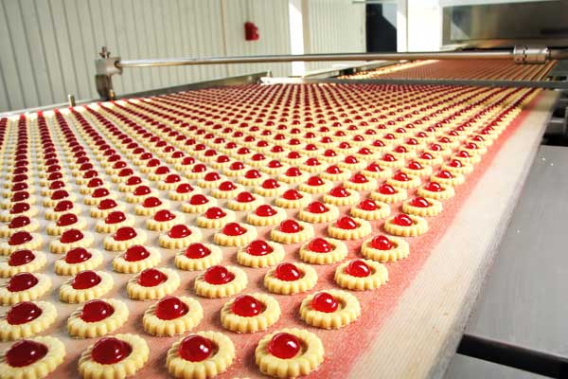
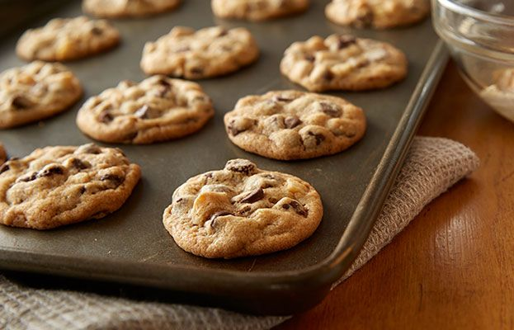

Flow diagram of manufacturing biscuits and cookies

Material receiving
Premixing

Mixing

Dough preparation

Sheeting

Moulding

Biscuits forming
Baking

Cooling

Quality control

Packaging

Major stages in biscuits manufacturing
Forming
Sheeting
Moulders
Cutter
Size reduction
Maintain shape and size of biscuits’ dough

Mixing
Mixers
Mixing time (5 minutes)
Water
Dough consistency
Biscuits grinders

Premixing
Ingredients addition
Sugar solution
Milk solution
Preparation of flour
Fat
Additives

Packaging
Aluminum foils
Plastic trays
Air traffic control ATC boxes
Polyethylene wrappers
Corrugated board boxes

Cooling
Cooling time
Cooling conveyer
Baking
Proofing and puffing zone (15 minutes)
Baking and coloring zone
Baking ovens
Time and temperature

Quality control in biscuits’ industries
- The quality of biscuits could be evaluated by sensory methods
- The analysis of problems in manufacturing process is established
- The validity of equipments is necessary
- (GMP) Good manufacturing process is significant for the production of biscuits
- Maintenance of High-Quality Packaging is essential to ensure a longer shelf life.
- Elimination of contaminants are important especially in the case of raw material
- All the control measures are adopted to ensure quality in biscuits industries

