Citizenship Education and Community Engagement
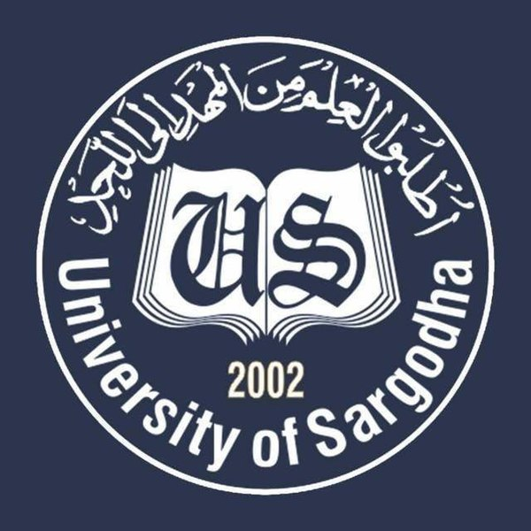

Program: BS Botany COVID-19 Awareness Session: 2019-2023
Submitted To:
Ma’am Mehlah Jabeen
Submitted By: Submission Date: 10-05-2020
Javed Abbas Roll No: BBTF19BM020
Hira Roll No: BBTF19BM006
Rawish Munir Roll No: BBTF19BM022
Sana Saleem Roll No: BBTF19BM026
Fatima Asad Roll No: BBTF19BM053
Riffat Rani Roll No: BBTF19BM004
Department of Biological Sciences,
UOS Bhakkar Campus
Contents
1.Title of the Project: 3
2. Introduction: 3
2.1 Background of the problem: 3
2.2 Present situation: 3
3. Justification of the Project: 3
3.1. Importance of the Project Activity: 3
3.2. Practical implications (Who will get benefits of the activity?) 3
5. Plan of Action: 4
5.1 How will you do this project activity? 4
5.2 Needed resources & the source of generation (financial, human resources etc.) 4
5.5 Proposed duration of the project: 9
6 How will you evaluate your project for possible outcomes? 9
7 References: 9

1.Title of the Project:
Give Awareness regarding COVID-19 to the people of targeted areas and Rashaan distribution. What are the impacts of COVID-19 on human health? What are the possible precautionary measures which should be taken?

2. Introduction:

2.1 Background of the problem:
COVID-19 is transmissible disease caused by a family of viruses called ‘corona virus’. Most people infected with COVID-19 will face mild to moderate respiratory illness and recover without requiring special treatment. Older people and those with underlying medical problems like cardiovascular disease, and cancer are more likely to develop serious illness. The best way to prevent and slow down transmission is be well informed about infectious disease, the disease it causes and how it spreads. Protect yourself and other from infection by washing your hands and using sanitizers and not touching your face. This disease primarily spreads through droplets of saliva from the nose when an infected person coughs and sneezes. So, it is important that you also practice respiratory etiquette.[1]

Present situation:
The asperity of corona virus in Pakistan is increasing day by day. More than 6000 people have been infected throughout the country. In Bhakkar, there are more than 61 confirmed corona cases. Government of Pakistan has suggested some precautionary measures to the nation. There are no specific vaccines or treatments for corona patients. It is the need of time to come forward to give awareness regarding COVID-19 to the people of our areas. That’s why we have decided to give awareness to the people of our areas. We have decided to give masks and sanitizers to the people of our areas.[2]

3. Justification of the Project:
We will do this project because present situation is very dangerous and critical due to spread of Corona Virus. People will need masks and sanitizers to protect themselves from this pandemic People also need food in this critical situation. Poor people have no resource to get food masks and sanitizers. So, we will do this project to give awareness through charts because prevention is better than cure. [3]

3.1. Importance of the Project Activity:
The main purpose of this project is to save or protect our country. Keeping in view the present situation of our country as well as our district Bhakkar, it is very important to give awareness to the people. Being the citizen of Pakistan and district Bhakkar it is our duty to come forward to fight against corona virus. To beat covid-19 our contribution is necessary.[2]

3.2. Practical implications (Who will get benefits of the activity?)
There are two main stakeholders who will get benefits from this project.
- People of respective areas:
First of all, awareness regarding corona virus will be provided to the residents of targeted areas. In this project our main focus is to tell about the advantages of social distancing and use of protective measures. By acting upon these precautionary measures residents of targeted areas will get benefits from this project.
- Group members of this project:
- Students who are directly involved in this project will be able to manage any hazardous situation
- By doing this project, students will get good grades from their teacher.
- Interaction with society will be increased.[2]
4. Objectives of the Project:
- Give awareness to the people of targeted areas
- Impacts of COVID-19 on human health
- Maintain Social distancing
- Wash your hands frequently
- Avoid touching eyes, nose and mouth
- If you have fever, cough and difficulty breathing, seek medical care early.
- Mask distribution
- Sanitization [1]

5. Plan of Action:

5.1 How will you do this project activity?
- First of all, we will select a team member who will help us to do this project
- Collect contribution from our circle
- Purchase personal protective equipment (PPE) gloves, masks, googles etc.
- we will purchase Dettol, bleach and plastic bottles
- Prepare chart on which precautionary measures would be written.
- Hang charts on public places
- Make documentary and submit it to the Ma’am Mehlah Jabeen. [2]

5.2 Needed resources & the source of generation (financial, human resources etc.)
- Javed Abbas
- Mask (Mujahid Abbas provided masks)
- I donated Dettol, Soap and bleach for sanitization
- Engineer Zahid Abbas provided gloves, plastic bottles, googles
- Mobile and laptop used for editing
2.Hira:
- Ration (my father, Ghulam Abbas will provide ration)
- Masks (I will donate masks and Mohammad Naeem will also donate masks)
- Charts (I will make charts and Mohammad Naeem will help me in making charts) [4]
3.Rawish Munir
- Ration (My father M. Munir khan will help me financially in case of ration distribution).
- Masks (my brother Shahraiz will provide masks).
- Charts (my sisters will help me in making charts).[3]
4.Sana Saleem
- Ration (my father Saleem Khan will help me financially to distribute ration among needy and poor people).
- Masks (My brother Hamza Saleem will provide masks to the people).
- Charts (my sister sherbano will help me in making charts regarding corona virus).[5]
5.Fatima Asad
- Masks (I will distribute masks among the people of my area).
- Charts (my brother will help me in making and hanging charts on public places).[6]
6.Riffat Rani
- My brother Zeeshan Ali will provide the required material Which is used in the project to maintain social distance.[7]
5.3 Each person’s role in the project:
- Javed Abbas
- Mask distribution, give awareness to the people of one mentioned village (Navan Khoo Chak No. 06/TDA)
- Making charts on which safety measures will be written
- Hanging charts on public places i.e. shops, mosques etc.
- Video editing
  - Engineer Zahid Abbas (Brother)
- Mask distribution, give awareness to the people of one mentioned village (Gudara Khoo Chak No. 06/TDA)
- Hanging charts on public places i.e. shops, mosques etc.
- Making charts on which safety measures will be written.[2]
2-Hira
- I will purchase masks and distribute among the people
- Making charts and give awareness on which preventive measures will be written
- I will contribute in Rashaan distribution.
2.1- Ghulam Abbas(father)
- My father will give contribution for ration distribution.
2.2-Muhammad Naeem
- Muhammad Naeem will help me in distribution of masks, hanging charts and in giving awareness about corona virus.[4]
3-Rawish Munir
- Making charts on which preventive measures will be written.
- Hand-made sanitizer will be distributed among the people of targeted areas.
- I will give awareness about regarding corona virus.
3.1-Shahraiz(brother)
- Shahraiz will hang charts on public places (mosque, road and shops)
3.2- Ushna (sister)
- My sister will help me in making charts about corona virus.
3.3- M. Munir khan (father)
- My father will help me financially to distribute ration and masks among the people.
- My father will also help me in giving awareness to the people.[3]

4-Sana Saleem
- Making charts on which safety measures will be written.
- I will distribute masks and hand-made sanitizer among the people.
- I will give awareness regarding COVID-19.
4.1-Sherbano (sister)
- My sister will help me in making charts on which precautionary measures will be written.
4.2-Hamza Saleem(brother)
- My brother will help me in hanging charts and distributing masks and sanitizers.
4.3- Saleem Khan(father)
- My father will help me financially to distribute ration among needy and poor people.[5]
5- Fatima Asad
- I will make charts on which preventive measures regarding corona virus will be written.
- I will distribute masks among the people of targeted area.
- I will give awareness to people about the corona virus.
5.1-Balkees Fatima (mother)
- My mother will help me in making charts and giving awareness to the people.
5.2- Muhammad Ali(brother)
- M. Ali will me in the distribution of masks
- He will hang charts on public places.[6]
6- Riffat Rani
- I will maintain social distance by drawing circle on public places.
- I will give awareness to the people through the charts on which preventive measures will be written.
6.1- Zeeshan Ali (brother)
- My brother will help me throughout the project in making charts and in drawing circles on public places for social distancing.
- Zeeshan Ali will hang charts about corona virus on public places (mosque, shops etc.).[7]

5.5 Proposed duration of the project:
- Mask distribution and sanitization in one village would be completed within 20-25 days.

6 How will you evaluate your project for possible outcomes?
We are hoping that there will be the positive outcomes of our project. Our main goal is to overcome the present situation of corona virus. We will give awareness through charts. We will maintain social distancing in the targeted areas by drawing circle on public places, by following this people will protect themselves from corona virus. We will hang charts on public places, when people of the targeted areas will read precautionary measures (washing hands, using sanitizer, proper usage of masks etc), people will try to act upon these measures to save them from this pandemic.
We will distribute ration (food) among needy people we are hoping that it will be helpful for them. We will provide sanitizers to the people by using the sanitizer people will protect them from the corona virus. We will also provide masks to the people, by using masks properly there will be the less chances of spread of the virus. If a person is affected from the corona virus, this pandemic would not spread to other people if the person (who is suffering from the virus), follow the rules of social distancing.[6]

7 References:
[1] Engineer Zahid Abbas (info collected from WHO site).
[2] www.cov.gov.pk (Javed Abbas (BBTF19BM020), BS Botany II semester, Department of Biological Sciences UOS sub-campus Bhakkar.

[3] Rawish Munir (BBTF19BM022), BS Botany II semester, Department of Biological Sciences UOS sub-campus Bhakkar.

[4] Hira (BBTF19BM006), BS Botany II semester, Department of Biological Sciences UOS sub-campus Bhakkar.

[5] Sana Saleem (BBTF19BM026), BS Botany II semester, Department of Biological Sciences UOS sub-campus Bhakkar.

[6] Fatima Asad (BBTF19BM053), BS Botany II semester, Department of Biological Sciences UOS sub-campus Bhakkar.

[7] Riffat Rani (BBTF19BM004), BS Botany II semester, Department of Biological Sciences UOS sub-campus Bhakkar.
“Strong people stand up for themselves, but stronger people stand up for others”.
“When you wish good for others, good things come back to you. This is the law of nature”.

“The End”

