Outline
- Abstract
- Keywords
- Definitions
- Ecological Aspects of Parasitism
- Medical Implications
- Evolution of Parasitism
- References
- Suggested Readings
Show full outline

Figures (3)
- 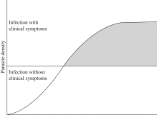
- 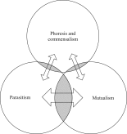
- 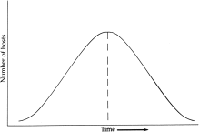

Human Parasitology (Fifth Edition)
2019, Pages 1-14
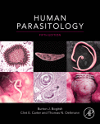

Chapter 1 - Symbiosis and Parasitism
Burton J. Bogitsh Clint E. Carter Thomas N. Oeltmann

https://doi.org/10.1016/B978-0-12-813712-3.00001-1Get rights and content

Abstract
Chapter 1 opens with a section in which the four categories of heterospecific relationships (commensalism, phoresis, parasitism, and mutualism) discussed in subsequent portions of the text are defined. Within this context, a comparison between various types of hosts is explained. Included also is a discussion of the roles of reservoir hosts as integral parts of the life cycle of some parasites. The narrative moves into an overview of the broader aspects of parasitism such as ecology, medical implications, and evolution. Topics such as the correlation of diseases caused by parasites relative to the density of a parasitic burden and the effect of influences such as AIDS and cancer treatments on parasitism are discussed. Other areas considered in this chapter include environmental influences that impede the control and/or elimination of harmful parasites as well as those factors that contribute to the prevalence of parasitic diseases. The chapter closes with a discussion of the possible ways that different groups of organisms may have adapted to a parasitic lifestyle.

Keywords
Commensalism, endoparasites
mutualism, parasitism,
phoresis, symbiosis

