Experiment No-6
Experimental Verification of Maximum Power Transfer Theorem for a Network.

OBJECTIVES:
To prove maximum power transfer theorem practically.
APPARATUS:
- Resistors
- DC Power Supply
- Digital Multimeter (DMM)
- Connecting wires

Introduction:
Maximum Power Transfer Theorem
Theory:
The power transferred from a source supply source to load is at its maximum when the resistance of the load is equal to the internal resistance of the source. In other words “A resistive will be consuming maximum power from the supply when the load resistance is equal to the equivalent (Thevenin) resistance.”

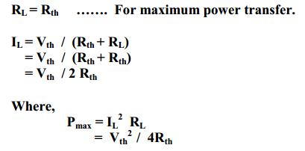
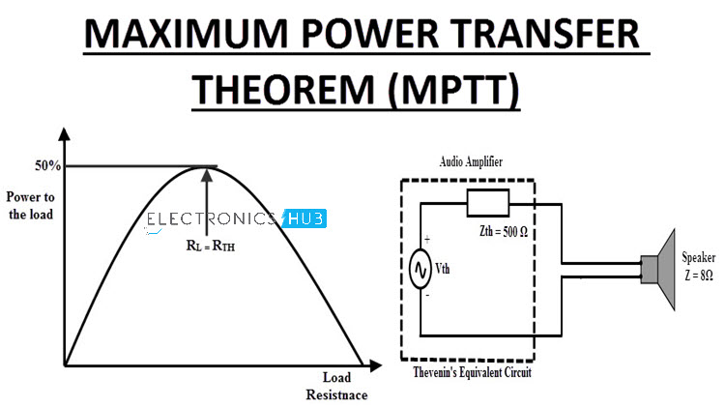
A graph of RL against P is shown in figure below, the maximum value of power occurs at RL= Rth.
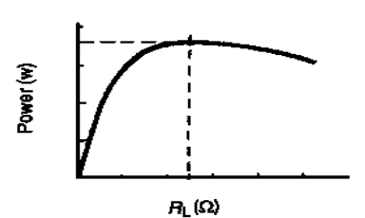
Procedure:
› Connect the circuit shown in the figure below.
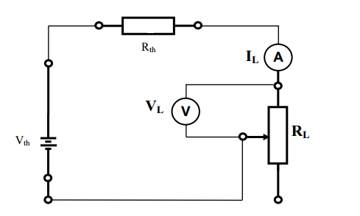
› From the circuit it can be noted that Rth is fixed resistance of value 2.2kΩ but RL is variable of value 5kΩ.
› Set the value of Vth = 10 V.
› Change the value of RL in steps as shown in table.
› Measure the voltage VL and current IL and record it in table.
› Plot the graph of power vs. load resistance (RL).
› Using graph estimate P max (practical).
› Use P max = Vth²/ 4Rth to have the value of P max (theoratical).
Observation Table:
For Vth = 10 V, Rth = 2.2kΩ
RL | IL | VL | Power = IL x VL
0.3kΩ
0.6kΩ
0.9kΩ
1.5kΩ
2.2kΩ
2.5kΩ
3.0kΩ
3.3kΩ
3.6kΩ
4.0kΩ

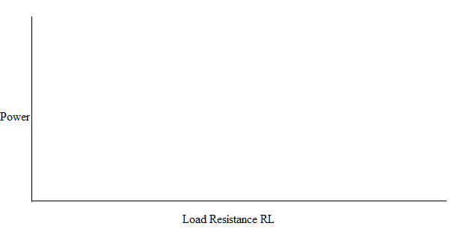

P max (theoretical)
P max (practical)
Difference

Conclusion:

Comments:

