2. School
Content
2.1. | Definition of School
2.2. | Role of School
2.3. | Effects of School on Community
2.4. | Role of School in process of Socialization
2.5. | Environment of School  - What is School Environment  - Who effects School Environment  - Importance of School Environment
2.6. | Elements in creating a Positive learning Environment  - Physical Environment  - Emotional Climate
2.7. | Definition of School Discipline
2.8. | Goals of School Discipline
2.9. | Types of School Discipline  - Preventive  - Supportive  - Corrective
2.10. | General rules and regulations
2.11. | Education in School
2.12. | Types of Education  - Formal Education  - Informal Education  - Non-formal Education

Definition of School:
- A school is a place where children are educated you usually refer to this place.
- Institutions where instruction is given especially to persons under college age. The children are at school.
- A school is an organization that provides instruction such as how to use school in a sentence synonym Discussion of school.
- A school is an educational institution designed to provide learning spaces and learning environment for the teaching of students (or Pupils) under the direction of teachers. Most countries have systems of formal education.
Role of School:
- Help students identify their interests and abilities.
- Support students in setting personal learning goals.
- Facilitate student involvement and learning in decision making regarding their own learning (use of power & responsibility in the class room and school).
- Create a writer of care and community where students learn to support one another and take responsibility for the well being of each other and the total community.
- Facilitate students learning together in a diverse group where they learn how to value contributions of other & manage productive group work.
- Teacher students who are functioning at many differing leads of ability together.
- Assess student skills and learning styles to facilitate learning an promote personal excellence.
- Wisdom is the principal things therefore get wisdom and with all they getting get understanding Proverb.
Effects of School on community:
Schools have a deep impact on the community parents school choice decision are influenced by the group or organizations to which they belong argues that parents’ decisions not only influence students academic performance but also effect students future.
- Upgraded school facilities.
- Improved school leadership and staffing.
- Higher quality learning programs for student.
- New resources and programs to improve teaching and curriculum.
- Resources for after school programs and family supports.
- Increased social and political capital of participants.
Role of school in process of socialization:
School is an important part of society it is known as social organization because it is the school which provides an exposure to educed and it prepares the students to occupy social roles according to their capacities after receiving the school. School is considered as a second home for students because it is school where in students passes most of the time of his day and this is utilized in form of learning every student learns about social life, social norms and social believes etc. so in the process of socialization school plays a very significant role.
Environment of School:
Student: Term student is used for the learner.
Environment of school: Environment is the most powerful source of leverage for bringing about change in a school or any organization for that matter.
What is school environment?
School environment is abt norms developed over time, based on:
- Shared attitudes
- Values / Norms
- Beliefs
- Expectations
- Relationship
- Traditions of a School
The norms of a school are what impact the way things Operate.
School climate is the communication of its norms, beliefs, and values through various behaviors and interactions and their effect on others, with the primary focus being on students school climate is driven by and reflected in the daily interactions of staff, administration, students, support staff and the outside community.

Who affects school Environment?
- School Environment is driven by and reflected
- Administration
- Daily interactions of staff
- Students
- Support staff and the outside community.
School environment can be described as a
- Mainstream (assessment driven)
- Transformative (Student or driven)
Why is school environment important?
“Positive learning can only take place in a positive culture. Ahealthy school culture will affect more student and teacher success than any other reform or school improvement effort currently being employed.
Elements in Creating a Positive learning Environment:
- Physical Setting
- Emotional Climate.
- Physical Environment:
  - Desk arrangements
  - Student placement
  - Classroom decoration
  - Music in the classroom
- Structuring the emotional climate:
  - “It is teacher responsibility to value each and every one of the students in their class, so that each student feels special and important”
  - The bond between a teacher &student is much more important for students with management and behavioral issues
Basic Emotional Needs
- Psychological safety
- Positive self image
- Feeling of belonging
- Purpose behavior
- Sense of personal competence.
Definition of school discipline:
School discipline is a system of rules, punishments and behavioral strategies appropriate to the regulation of children and the maintenance of order in school its aim is to create a safe and conducive learning environment in the classroom.
School discipline has two main goal:
- Ensure the safety of staff and students
- Create an environment conducive to learning

Types of discipline:
There are 3 types of discipline:
- Preventive
- Supportive
- Corrective
Preventive:
Can be define as the measures many educators take to misbehavior by keeping students engaged we believe that the best way to prevent classroom misbehavior is to provide a stimulating curriculum that involves students so successfully that they spend time thinking of misbehavior.
Supportive:
Discipline is the type of classroom management that focuses on eliminating misbehavior on type of discipline is supportive discipline which is about stopping misbehavior in its earliest stage by engaging students self control to get them beckon task.
Corrective:
It could imply that such actions is aimed to correct any behavior on violations may be a first level violation that does not immediately cause disruption but a violation that need to be corrected to prevent repetition mitigate escalation.
General rules and regulations:
Student should treat school staff with respect at all time and be courteous to fellow students.
Students will refrain from damaging any form of school property. The school reserves the right to be compensated by the student for any such dingoes.
Student will refrain from littering and keep the school premises clear.
Any of misbehavior or violation of school discipline will be dealt by the disciplinary committee and corrective action will be taken. In extreme cases parents will be called in to discuss the child behavior and may lead to suspension or expulsion from the school.
The medium of instruction is English and students are expected to communicate in English all time.
It is compulsory to bring the school issued ID card to school every day.
For safety and security parents should refer from scanning money with their child without specific written notice from the school.
The student should:
Be proactive in promoting and working towards making school positive, supportive, safe and wellbeing place for all students and teacher.
Be respectful and courteous to fellow students parents, grandiose and non teaching staff.
Follow schools rules and contribute to a positive school dimate by behaving appropriately even when both specifically asked to do so.
Co-curriculum Activities:
- Morning assembly:
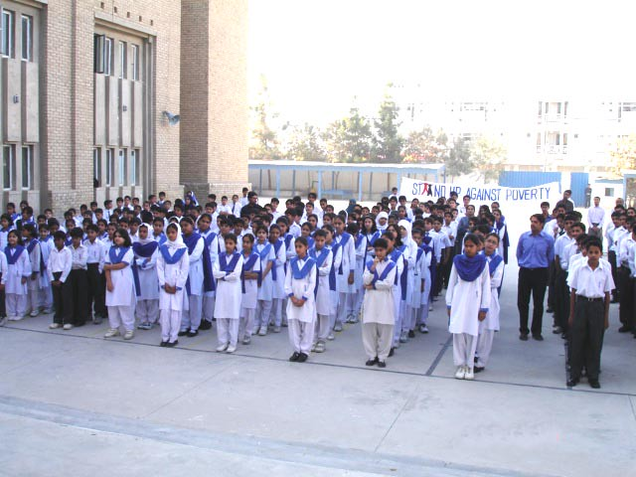

- Speech competition:
- Arts:
- Fun:
- Sports gala:
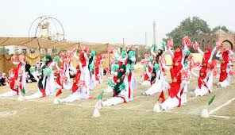
- Trips:
- Village survey:
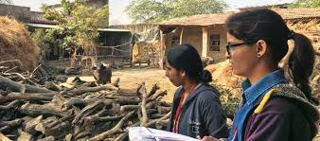
- Tuck shop:
-

Definition:
Education is the process of the individual mind gathering to its full possible development. Dr. Zakir Hussain. Education is the process of teaching to develop the knowledge skill, or character of the student.
Type of education
- Formal education
- Non formal education
- Informal education
Formal Education
Formal education is basically an:
- Institutional activity,
- Uniform and subject oriented,
- Full time,
- Sequential,
- Hierarchically structured,
- Leading to certificates degrees and diplomas.
Formal Education is intentional organized and structured form at learning imparted in educational institutions like schoo., college or university in order to modify the behavior of an individual.
Meaning:
Formal education is the education that occurs within an organized and structured content. It is usually located in institutions dedicated to education or training. Structured via learning objectives or learning strategies.
Characteristics of Formal Education:
- Full time education
- Technical and professional training.
- A variety of specialized program.
- Running from primary school through the university.

In formal education
The truly life long process whereby every individual acquires attitude values, skills and knowledge from daily experience and the educative inferences and researches in his or her environment from family and neighbors, form work and play, from the market place, the library and the mass media, Learning that goes on in daily life and can be received through daily experiences, such as from family, peer group, the media and other influences in a person’s environment.
Meaning:
Informal education covers a vast array of learning that all people take part in, hair lives every day. It covers activities line individual and personal research on a subject or interests for themselves by using books, libraries, informal trainers, he internet or other resources.
Non Formal Education:
“learning resulting from daily activities related to work, family or leisure. It is not organized or structured in terms of objectives, time or learning support.
Example:
- Swimming sessions.
- Certification courses.
- Distance Learning.
- Any organized education activity.
- Outside the established formal system whether operation separately.
- As an important feature of some broader activity that is intended to sere identifiable learning clienteles and learning objectives.

