Experiment No-1
To study the resistor color code and its verification by using ohm-meter.

OBJECTIVE:
- Determine the value of resistors from their EIA (Electronic Industries Association) color code.
- Measurement of resistance using ohm-meter.
APPARATUS:
- Resistors
- Ohm-meter
THEORY:
Resistor
A resistor is defined as an opposition to the flow of current. The basic unit of resistor is ohm. Resistors are devices that limit current flow and provide a voltage drop in electrical circuits. Because carbon resistors are physically small, they are color-coded to identify their resistance value in ohms. The use of color bands on the body of a resistor is the most common system for indicating the value of a resistor. Color-coding is standardized by the Electronic Industries Association (EIA).
Resistor values are often indicated with color codes. Practically all leaded resistors with a power rating up to one watt are marked with color bands. The coding is defined in the international standard IEC 60062. This standard describes the marking codes for resistors and capacitors. It includes also numerical codes, as for example often used for SMD resistors. The color code is given by several bands. Together they specify the resistance value, the tolerance and sometimes the reliability or failure rate. The number of bands varies from three till six. As a minimum, two bands indicate the resistance value and one band serves as multiplier. The resistance values are standardized, these values are called preferred value.
Resistor Color Code Chart
The chart below shows how to determine the resistance and tolerance for resistors. The table can also be used to specify the color of the bands when the values are known. Normally there are 4 classification of resistors according to their color bands. 3 band resistor, 4 band resistor, 5 band resistor and 6 band resistor.

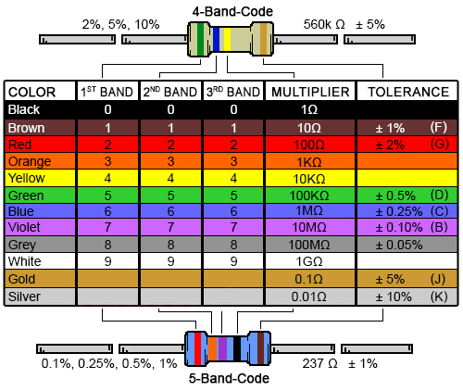
4 Band Resistor
The four band color code is the most common variation. These resistors have two bands for the resistance value, one multiplier and one tolerance band. In the example as shown in fig 1.1 bands are green, blue, red and gold. By using the color code chart, one finds that green stands for 5 and blue for 6. The value is thus 56·100 =5600 Ω. The golden band means that the resistor has a tolerance of 5%. The resistance value lies therefore between 5320 and 5880 Ω.
If the tolerance band would be left blank, the result is a 3 band resistor. This means that the resistance value remains the same, but the tolerance is 20%.

5 Band Resistor
Resistors with high precision have an extra band to indicate a third significant digit. Therefore, the first three bands indicate the significant digits, the fourth band is the multiply factor and the fifth band represents the tolerance. 5 band resistor is shown in fig 1.2 below.

Fig1.1 4-Band Resistor

Fig1.2 5-Band Resistor
Zero ohm resistor
A resistor with a single black band is called a zero-ohm resistor. Principally it is a wire link with only function of connecting traces on a PCB. Using the resistor package has the advantage of being able to use the same automated machines to place components on a circuit board.
Definitions of color bands
The color of the multiplier band represents multiples of 10, or the placement of the decimal point. For example: ORANGE (3) represents 10 to the third power or 1,000. The tolerance indicates, in a percentage, how much a resistor can vary above or below its value. A gold band stands for +/- 5%, a silver band stands for +/- 10%, and if no fourth band exists, it is assumed to be +/- 20%. For example: A 100-ohm 5% resistor can vary from 95 to 105 ohms and still be considered within the manufactured tolerance. The temperature coefficient band specifies the maximum change in resistance with change in temperature, measured in parts per million per degree Centigrade (ppm/°C).
Measurement of Resistance using Ohm-Meter
Be sure to never measure the resistance of any electrically ‘live’ object or circuit. In other words, do not attempt to measure the resistance of a battery or any other source of substantial voltage using a multi-meter set to the resistance (ohms) function, failing to heed this warning will likely result in meter damage and even personal injury. Connect the meter’s test probes across the resistor as such, and note its indication on the resistance scale:

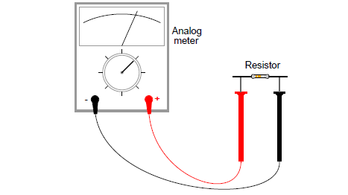
If the needle points very close to zero, you need to select a lower resistance range on the Meter. If you are using a digital multi-meter, you should see a numerical figure close to 10 shown on the display, with a small ”k” symbol on the right-hand side denoting the metric prefix for ”kilo” (thousand). Some digital meters are manually-ranged, and require appropriate range selection just as the analog meter. If yours is like this, experiment with different range switch positions and see which one gives you the best indication.

PROCEDURE & OBSERVATIONS:
- You are given with the resistor of various values and tolerances. Examine each one and determine its resistance and tolerance according to its color code.
- Measure these values using ohm-meter and record them.

Observation Table
Resistor | 1st Color Band | 2nd Color Band | 3rd Color Band | 4th Color Band | % Tolerance | Coded Value (ohm) | Measured value (ohm)

Conclusion

Comments:

