History and Components of Photosynthesis
Photosynthesis:
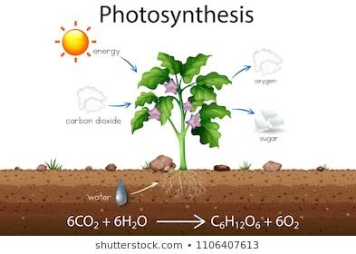
Photosynthesis, the process by which green plants and certain other organisms transform light energy into chemical energy. During photosynthesis in green plants, light energy is captured and used to convert water, carbon dioxide, and minerals into oxygen and energy-rich organic compounds
Figure 1 photosynthesis
Equation of photosynthesis:
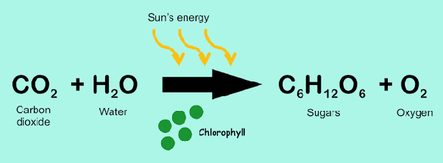
Figure 2

History of photosynthesis:

The first photosynthetic organisms probably evolved early in the evolutionary history of life and most likely used reducing agents such as hydrogen or hydrogen sulfide, rather than water, as sources of electrons. Cyanobacteria appeared later; the excess oxygen they produced contributed directly to the oxygenation of the Earth which rendered the evolution of complex life possible. Today, the average rate of energy capture by photosynthesis globally is approximately 130 terawatts, which is about eight times the current power consumption of human civilization. Photosynthetic organisms also convert around 100–115 billion tons (91-104 petagrams)
Photosynthesis is a process used by plants and other organisms to convert light energy into chemical energy that can later be released to fuel the organisms' activities. This chemical energy is stored in carbohydrate molecules, such as sugars, which are synthesized from carbon dioxide and water – hence the name photosynthesis, from the Greek phōs , "light", and synthesis), "putting together". In most cases, oxygen is also released as a waste product. Most plants, most algae, and cyanobacteria perform photosynthesis; such organisms are called photoautotrophs. Photosynthesis is largely responsible for producing and maintaining the oxygen content of the Earth's atmosphere, and supplies most of the energy necessary for life on Earth.
Although photosynthesis is performed differently by different species, the process always begins when energy from light is absorbed by proteins called reaction centres that contain green chlorophyll pigments. In plants, these proteins are held inside organelles called chloroplasts, which are most abundant in leaf cells, while in bacteria they are embedded in the plasma membrane. In these light-dependent reactions, some energy is used to strip electrons from suitable substances, such as water, producing oxygen gas. The hydrogen freed by the splitting of water is used in the creation of two further compounds that serve as short-term stores of energy, enabling its transfer to drive other reactions: these compounds are reduced nicotinamide adenine dinucleotide phosphate (NADPH) and adenosine triphosphate (ATP), the "energy currency" of cells.
In plants, algae and cyanobacteria, long-term energy storage in the form of sugars is produced by a subsequent sequence of light-independent reactions called the Calvin cycle; some bacteria use different mechanisms, such as the reverse Krebs cycle, to achieve the same end. In the Calvin cycle, atmospheric carbon dioxide is incorporated into already existing organic carbon compounds, such as ribulose

Discovery:
Although some of the steps in photosynthesis are still not completely understood, the overall photosynthetic equation has been known since the 19th century.
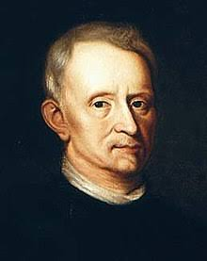
,Figure 4
Figure 3
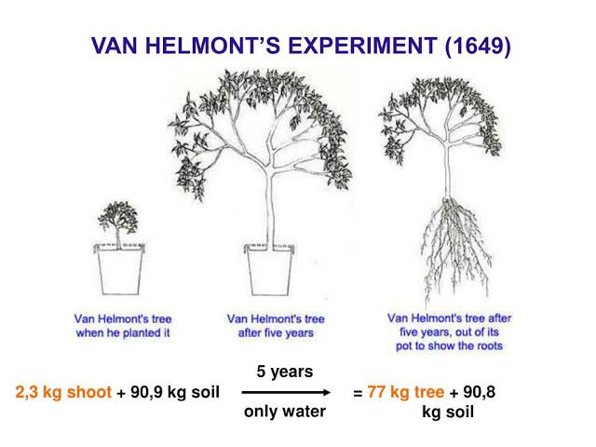
JAN Baptist Van Helmont Experiment: Portrait of Jan Baptist van Helmont by Mary Beale, c.16Jan van Helmont began the research of the process in the mid-17th century when he carefully measured the mass of the soil used by a plant and the mass of the plant as it grew. After noticing that the soil mass changed very little, he hypothesized that the mass of the growing plant must come from the water, the only substance he added to the potted plant. hypothesis was partially accurate – much of the gained mass also comes from carbon dioxide as well as water. However, this was a signaling point to the idea that the bulk of a plant's biomass comes from the inputs of photosynthesis, not the soil
f
Joseph Priestley experiment:
Joseph Priestley, a chemist and minister, discovered that, when he isolated a volume of air under an inverted jar, and burned a candle in it (which gave off CO2), the candle would burn out very quickly, much before it ran out of wax. He further discovered that a mouse could similarly "injure"thenshowed that the air that had been "injured" by the candle and the mouse could be restored by a plant.
Figure 5
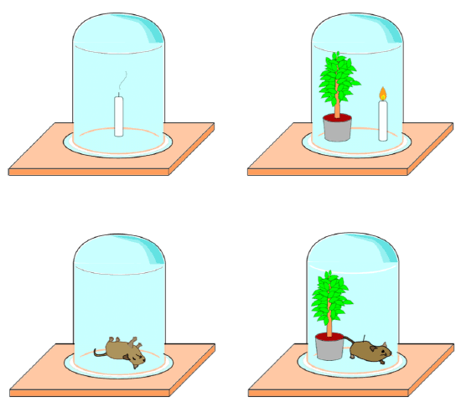
Figure 6
Ingenhousz Experiment:
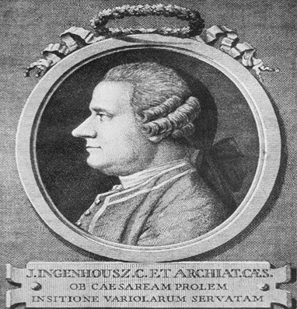
Figure 7 Ingenhousz
In 1778, Jan Ingenhousz, repeated Priestley's experiments. He discovered that it was the influence of sunlight on the plant that could cause it to revive a mouse in a matter of hours.

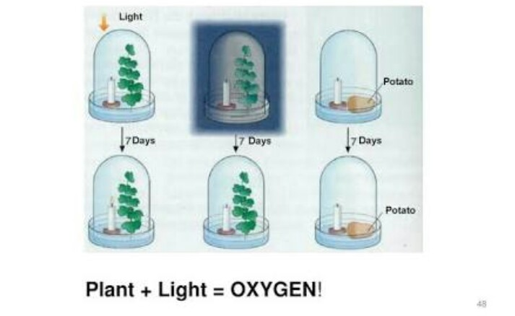
Figure 8 Ingenhousz experiment

NICOLAS THEODORE DE SAUSSURE: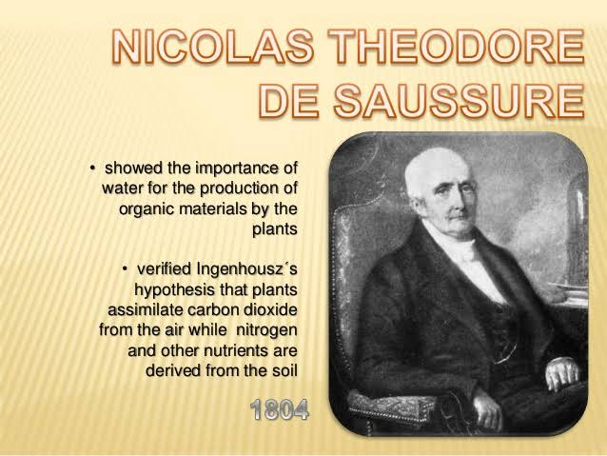RE:
In 1796, Jean Senebier, a Swiss pastor, botanist, and naturalist, demonstrated that green plants consume carbon dioxide and release oxygen under the influence of light. Soon afterward, Nicolas-Théodore de Saussure showed that the increase in mass of the plant as it grows could not be due only to uptake of CO2 but also to the incorporation of water. Thus, the basic reaction by which photosynthesis is used to produce food (such as glucose).
CORNELIS VAN NIEL EXPERIMENT:
Cornelis Van Niel made key discoveries explaining the chemistry of photosynthesis. By studying purple sulfur bacteria and green bacteria he was the first to demonstrate that photosynthesis is a light-dependent redox reaction, in which hydrogen reduces (donates its – electron to) carbon dioxide
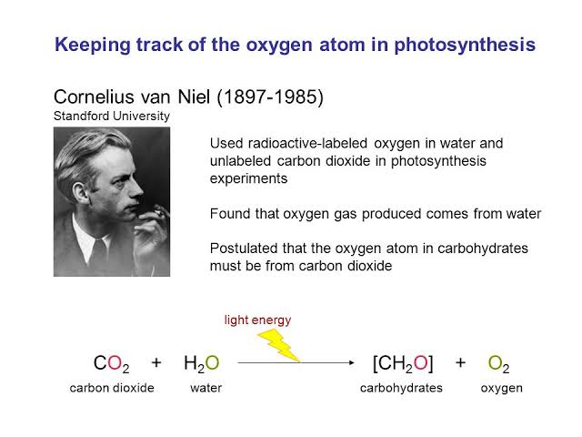
Figure 9
Robert Emerson Experiment:
Robert Emerson discovered two light reactions by testing plant productivity using different wavelengths of light. With the red alone, the light reactions were suppressed. When blue and red were combined, the output was much more substantial. Thus, there were two photosystems, one absorbing up to 600 nm wavelengths, the other up to 700 nm. The former is known as PSII, the latter is PSI. PSI contains only chlorophyll "a", PSII contains primarily chlorophyll "a" with most of the available chlorophyll "b", among other pigment. These include phycobilins, which are the red and blue pigments of red and blue algae respectively, and fucoxanthol for brown algae and diatoms. The process is most productive when the absorption of quanta is equal in both the PSII and PSI, assuring that input energy from the antenna complex is divided between the PSI and PSII system, which in turn powers the photochemistry.[13]
Figure 10

Robert Hills Experiment:
Robert Hill thought that a complex of reactions consisting of an intermediate to cytochrome b6 (now a plastoquinone), another is from cytochrome f to a step in the carbohydrate-generating mechanisms. These are linked by plastoquinone, which does require energy to reduce cytochrome f for it is a sufficient reductant. Further experiments to prove that the oxygen developed during the photosynthesis of green plants came from water, were performed by Hill in 1937 and 1939. He showed that isolated chloroplasts give off oxygen in the presence of unnatural reducing agents like iron oxalate, ferricyanide or benzoquinone after exposure to light. The Hill reaction [71] is as follows:

2 H2O + 2 A + (light, chloroplasts) → 2 AH2 + O2
where A is the electron acceptor. Therefore, in light, the electron acceptor is reduced and oxygen is evolved.
Samuel Ruben and Martin Kamen experiment:
Samuel Ruben and Martin Kamen used radioactive isotopes to determine that the oxygen liberated in photosynthesis came from the water.
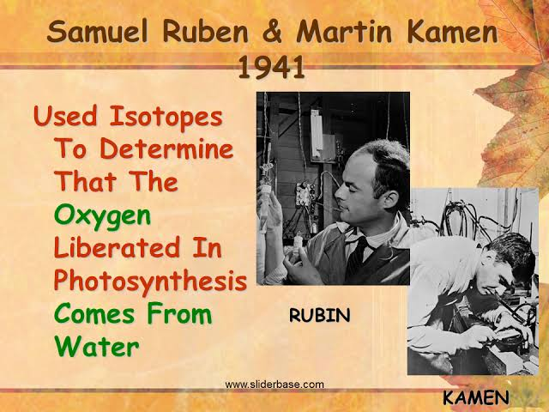
Figure 11
Melvin Calvin Experiment:
Melvin Calvin works in his photosynthesis laboratory.
Melvin Calvin and Andrew Benson, along with James Bassam, elucidated the path of carbon assimilation (the photosynthetic carbon reduction cycle) in plants. The carbon reduction cycle is known as the Calvin cycle, which ignores the contribution of Bassham and Benson. Many scientists refer to the cycle as the Calvin-Benson Cycle, Benson-Calvin, and some even call it the Calvin-Benson-Bassham (or CBB) Cycle.
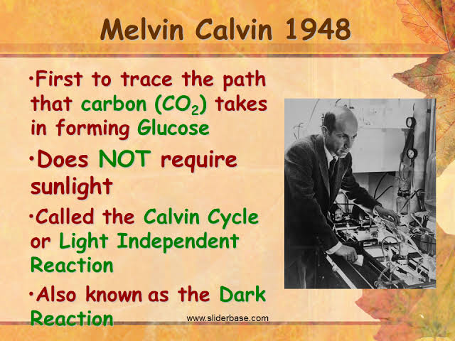
Figure 12

Rudolph Marcus:
Nobel Prize-winning scientist Rudolph A. Marcus was able to discover the function and significance of the electron transport chain.

Figure 13

Otto Henrich Warburg and Dean Burk Experiment:

Otto Heinrich Warburg and Dean Burk discovered the I-quantum photosynthesis reaction that splits the CO2, activated by the respiration.[72]
Otto kandler Experiment:
In 1950, first experimental evidence for the existence of photophosphorylation in vivo was presented by Otto Kandler using intact Chlorella cells and interpreting his findings as light-dependent ATP formation.[73] In 1954, Daniel I. Arnon et al. discovered photophosphorylation in vitro in isolated chloroplasts with the help of P32.[74][75]
LOUIS N.M DUYSENS AND JAN AMSEZ EXPERIMENT:
Louis N.M. Duysens and Jan Amesz discovered that chlorophyll a will absorb one light, oxidize cytochrome f, chlorophyll a (and other pigments) will absorb another light, but will reduce this same oxidized cytochrome, stating the two-l a and photophosphorylation necessitated redefinition of the term.[76]

C3: C4 photosynthesis research
After WWII at late 1940 at the University of California, Berkeley, the details of photosynthetic carbon metabolism were sorted out by the chemists Melvin Calvin, Andrew Benson, James Bassham and a score of students and researchers utilizing the carbon-14 isotope and paper chromatography techniques. The pathway of CO2 fixation by the algae Chlorella in a fraction of a second in light resulted in a 3 carbon molecule called phosphoglyceric acid (PGA). For that original and ground-breaking work, a Nobel Prize in Chemistry was awarded to Melvin Calvin in 1961. In parallel, plant physiologists studied leaf gas exchanges using the new method of infrared gas analysis and a leaf chamber where the net photosynthetic rates ranged from 10 to 13 μmol CO2·m−2·s−1, with the conclusion that all terrestrial plants having the photosynthetic capacities that were light saturated at less than 50% of sunlight.
Later in 1958–1963 at Cornell University, field grown maize was reported to have much greater leaf photosynthetic rates of 40 μmol CO2·m−2·s−1 and was not saturated at near full sunlight.[80][81] This higher rate in maize was almost double those observed in other species such as wheat and soybean, indicating that large differences in photosynthesis exist among higher plants. At the University of Arizona, detailed gas exchange research on more than 15 species of monocot and dicot uncovered for the first time that differences in leaf anatomy are crucial factors in differentiating photosynthetic capacities among species. In tropical grasses, including maize, sorghum, sugarcane, Bermuda grass and in the dicot amaranthus, leaf photosynthetic rates were around 38−40 μmol CO2·m−2·s−1, and the leaves have two types of green cells, i. e. outer layer of mesophyll cells surrounding a tightly packed cholorophyllous vascular bundle sheath cells. This type of anatomy was termed Kranz anatomy in the 19th century by the botanist Gottlieb Haberlandt while studying leaf anatomy of sugarcane.[84] Plant species with the greatest photosynthetic rates and Kranz anatomy showed no apparent photorespiration, very low CO2 compensation point, high optimum temperature, high stomatal resistances and lower mesophyll resistances for gas diffusion and rates never saturated at full sun light.

COMPONENTS OF PHOTOSYNTHESIS
Components involved in photosynthesis are:
- Chlorophyll present in the chloroplasts
- Light
- Carbon dioxide
- Water

Chloroplast
Chloroplast is the structure within the cells of plants and green algae that is the site of photosynthesis. The free living close relatives of chloroplasts are photosynthetic cyanobacteria. Endosymbiotic theory posits that chloroplasts and mitochondria are descended from such organisms.
Structure of chloroplast
All green parts of a plant, including green stems and unripened fruits, have chloroplasts. But the leaves are the major sites of photosynthesis.
About half a million of chloroplasts are present per square millimeter of leaf surface. The color of the leaves is from chlorophyll, the green pigment located within the chloroplast. The synthesis of food molecules in the chloroplasts is energized by the light energy absorbed by the chlorophylls.
Chloroplasts are mainly found in the in a tissue in the interior of the leaf called mesophyll. Microscopic pores called stroma are present in the chloroplasts by which carbon dioxide enters the leaf and oxygen exits. Water absorbed by the roots is delivered to the leaves through veins.
Ultrastructure
Mature chloroplast of higher plants have a complex structure each chloroplast is enclosed by two concentric unit membranes. These membranes are smooth, continuous and differentially permeable. There are two distinct systems within the membrane:
- Granular matrix or stroma , composed of ribosomes and cellular proteins
- A lamellar system, which is differentiated into
- Grana lamellae or thylakoids
- Intergrana lamellae or fret
- The matrix: (stroma)
The outer and inner membranes of the chloroplast enclose a substance known as matrix or stroma. The lamellar system remain embedded in the matrix. In addition, granules, lipid droplets, starch grains, vesicles, ribosomes and proteins are also found in the matrix.
- The grana: (lamellar system)
The lamellar system contains photosynthetic pigments. In higher forms, the pigments are restricted to certain areas of the lamella. These areas are stacked on each other to form grana. The size of grana may range from 0.3 to 1.7 microns and the number of grana per chloroplast may vary from 40 to 60.
There are superimposed closed compartments which form a single granum called thylakoids. The number of thylakoids per granum may vary from a few to 50 or more. Each thylakoids remains separated from the matrix by its unit membranes. The grana are interconnected by a network of tubules called inter grana or stroma lamellae.

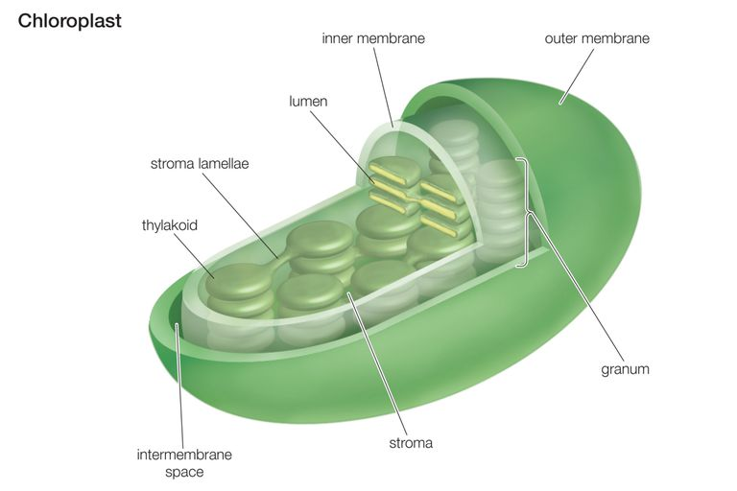
Figure 1 structure of chloroplast

Chloroplast as the Photosynthetic Machinery
The thylakoid membranes houses chlorophylls and different protein complexes, including photosystem I, photosystem II, and ATP synthase, which are specialized for light dependent photosynthesis. When sunlight strikes the thylakoids, the light energy strikes the chlorophyll pigments, and give up electrons. The electrons then enters the electron transport chain that ultimately drives the phosphorylation of ADP to energy rich storage compound ATP. It also results in the production of reducing agent NADPH.
ATP and NADPH are used in the light independent reaction (dark reaction) which are carried out in the chloroplast of stroma, where the enzyme ribulose 1,5- bisphosphate carboxylase/oxygenase is present. Rubisco catalyzes the first step of carbon fixation in the Calvin cycle, the primary pathway of carbon transport in plants.
Among C4 plants, the initial carbon fixation step and the Calvin cycle are separated- carbon fixation occurs via PEP carboxylation in chloroplasts located in the mesophyll, while malate, the four carbon product of that process, is transported to chloroplasts in bundle sheath cells , where the Calvin cycle is carried out.
Chloroplast Genome and Membrane Transport
Typically, the chloroplast genome is circular and is roughly 120-200 kilobases in length. However, the modern chloroplast genome is much reduced in size. Over the course of evolution, increasing numbers of chloroplasts genes have been transferred to the genome in the cell nucleus. As a result, proteins encoded by nuclear DNA have become essential to chloroplast function. Hence, the outer membrane of the chloroplast, which is freely permeable to small molecules , also contains transmembrane channels for the import of larger molecules, including nuclear encoded proteins. The inner membrane is more restrictive and the transport is limited to certain proteins.
The Quantasome Concept
According to Park and Pon (1963) some isolated particles in the membranes of the thylakoid represent the smallest morphological photosynthetic unit called quantasome.
They are about 185A° long, 155A° wide and 100A° thick and are usually randomly scattered.
Saucer and Calvin (1962) have shown that 3 to 6 quantasomes may aggregate to form a large particle.
Park and Beggins (1964) reported that each quantasome is composed of four subunits. The quantasome contains chlorophyll.
Branton an Park (1967)observed following three types of membranes:
- Membranes with quantasome particles
- Membranes with smaller particles
- Membranes with rough texture and with few or no particles
According to this view, both the quantasomes and the smaller particles lie within the membrane of thylakoid.
Howell and Moundrianakis (1967) gave the concept of quantasomes as photosynthetic units. They suggested that the chloroplast is one of the most elaborated biochemical machine producing energy transformation at a molecular level.
Chlorophyll
Chlorophyll is a green pigment found in the mesosomes of bacteria as well as in the chloroplasts of algae and plants. Its name is derived from the Greek words “khloros” (pale green) and “phyllon” (leaf). Chlorophyll is essential in photosynthesis, allowing plants to absorb energy from light.
In the electromagnetic spectrum, chlorophyll absorbs light most strongly in the blue portion. Conversely, it reflects the green and near green portions of the spectrum producing the green color of chlorophyll containing tissues.
Two types of chlorophyll exists in the photosystems of green plants; chlorophyll a and b.
Chemical structure
The basic structure is a ring made of four pyrroles, a tetrapyrrole, which is also named porphyrin.
Mg++ is present in the center of ring as the central atom. Mg++ is covalently bound with two N-atoms and coordinately bound to the other two atoms of the tetrapyrrole ring.
A cyclopentanone (C₅H₈O) is attached to ring c.
At ring d a propionic acid (CH₃CH₂CO₂H) group forms an ester with the alcohol phytol (C₂₀H₄₀O).
Phytol consists of a long branched hydrocarbon chain with one C-C double bond. It is derivd from an isoprenoid, formed from four isoprene units.
This long hydrophobic hydrocarbon tail renders the chlorophyll highly soluble in lipids and therefore promotes its presence in the membrane phase. Chlorophyll always occurs bound to proteins.
In ring b, chlorophyll contains a formyl residue instead of the methyl residue in chl-a. this small difference has a large influence on light absorption.

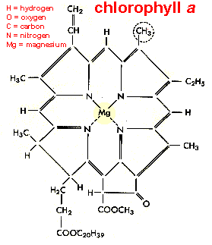
Figure 2 chemical structure of chlorophyll a

Light
Nature of light
A number of theories have been proposed regarding the nature of light. Some of them are:
- Corpuscular theory:
It was proposed by Sir Issac Newton (1666). According to this theory:
The light is made up of several streams of minute particles or corpuscles of different colors.
The corpuscles always travel in a straight line.
This theory was discarded because it cannot explain the laws of reflection and refraction.
- Wave theory:
It was proposed by Christian Huygens (1678). According to his theory, light particles always move in the form of waves and not in a straight line. This theory was also discarded because it could not explain well about reflection and refraction.
- Electromagnetic wave theory:
It was proposed by James Clark Maxwell (1860). According to this theory, the waves of all types of radiations including light are electromagnetic in nature. These electromagnetic radiations are never continuous and are emitted by matter as discontinuous units called photons which bear energy called quantum.
- Quantum theory:
It was proposed by Max Plank (1900). According to this theory, the radiant energy including light is made up of discrete energy particles called quanta. This concept was called quantum theory.
He stated that the size of a quantum of energy is directly proportional to the frequency of radiation and the intensity of light depends upon the number of photons. The energy of quantum can be calculated by the following Planck’s equation:
E_{photon} = hv where E= energy
h = Plank’s constant = 1.5x 10 ⁻³⁷ Kcal sec/quantum
v = frequency of radiation
⸪ v = c/ƛ where c= velocity of light
ƛ = wavelength of light in cm
The light quanta are called photons. They have been considered as physical units of light while the quantum as unit of energy of photons.
The blue light photons have more energy than the red light photons because the energy of photons depends upon the frequency of wavelength of radiation and the blue light had more wavelength than red light. It should be noted that although blue light photon possess more energy than red light photon but the red light is more effective in promoting photosynthesis than blue light. The difference is because chlorophyll molecules undergo differential changes in their energy states in blue and red light.
Mechanism of Absorption of Light
Excited or activated state:
When a visible light photon with wavelength between 380nm and 780 nm strikes a chlorophyll molecule it releases an electron from chlorophyll to an outer molecular orbital. This stte of molecular orbital is called excited or activated state.
Singlet state (S₀):
The normal state of an atom or a molecule in which the electrons are present in even number and paired condition.
These paired electrons always spin in opposite direction. They possess the lowest energy in the molecular orbital and the molecule shows all spins paired and no magnetic moment.
The excited electron molecules show at least four states:
- First singlet state (S1)
- Second singlet state (S2)
- First triplet state (T1)
- Second triplet state (T2)
When a red light photon strikes a chlorophyll molecule, it becomes photoexcited and an electron is released from its ground state orbital to n outer molecular orbital. It is called first excited singlet state (S1). It is unstable state having a half life period of only 10 ⁻⁹ seconds and the molecule contains high energy provided by the visible red light photon. Thus, in this state, two molecular orbitals, each having one electron, are produced.
When a chlorophyll molecule is strike by blue light photons, its one electron from ground level orbital is released to an outer molecular orbital. The chlorophyll molecules become photoexcited and the electron is raised more high than S1 condition. It is because blue light photons possess more energy than red light photons. This is the second singlet state (S2). This state is also unstable having a half life of less than 10⁻⁹ seconds.
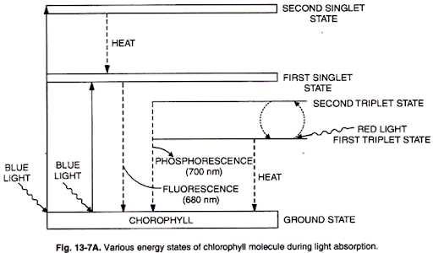
Figure 3 mechanism of absorption of light

The return of the chlorophyll molecule from the first singlet state to the ground state can proceed in different ways:
The S1 and S2 both states being unstable are converted into ground state through process like heat, phosphorescence, fluorescence or chemical energy.
The most important path for conversion of the energy released when the first singlet state returns to the ground state is its utilization for chemical work. The chlorophyll molecules transfers the excited electron from the first singlet state to an electron acceptor and a positively charged chlorophyll radical remains. This is possible since the excited electron is less strongly bounded to the chromophore molecule than in the ground state. As an alternative, the electron deficit in the chlorophyll radical may be replenished by another electron donor e.g. water.
Fluorescence
The first singlet state is converted to the ground state by the release of radiation energy in the red region. It is called fluorescence. It should be noted that the total energy is not lost as fluorescence but a small amount of energy is still present which is utilized in driving photosynthetic reactions. The S2 state is first converted into S1 state by the release of some energy in the form of heat.
Phosphorescence
The S1 state when releases only small amount of energy, it is converted into the triplet states (T1 and T2). Both are interconvertible. T1 is converted to T2 by the absorption of red light by the pigment in T1 state.. T1 state is converted to ground state by the release of very small amount of energy. This delaying effect of light emission is called phosphorescence.
The remaining major amount of energy of T1 is utilized in photochemical reaction. T1 is a metastable state having a half life period of about 10⁻² seconds.
The singlet and triplet state of excitation differ in the spinning of electrons in their orbitals.

Components of Electromagnetic Spectrum
The electromagnetic spectrum consists of radiations of different wavelengths including cosmic rays, gamma rays, X-rays, the visible spectrum, infrared rays and radio waves.
The waves of each of these types have a characteristic range of wavelengths. The visible spectrum represents only a small region in the electromagnetic spectrum and consists of different colored bands. It ranges from 3800-7600 A°. Of the total visible spectrum, only a small part is used in photosynthesis.
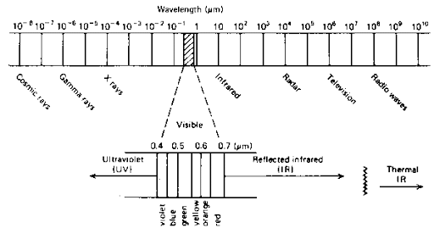
Figure 4 details of electromagnetic spectrum

Absorption Spectrum
An absorption spectrum displays the amount of light energy taken up or absorbed by a molecule or substance as a function of the wavelength of the light.
If chlorophyll is extracted and light of different wavelengths is passed through it, the absorption at each wavelength can be measured by a spectrophotometer.
spectrophotometer: the instrument used to measure the relative ability of different photosynthetic pigments to absorb the different wavelengths of light.
Different pigments absorbs different wavelengths of light. An absorption spectrum of chlorophyll a shows that light is mainly absorbed in the blue and red regions. Other lights like green, yellow and orange are absorbed only slightly . it is because the chlorophyll being green color does not absorb green light but reflects it. The exact positions of peaks depends upon the solvent used in the extraction of pigments. In ether solution, the chlorophyll a shows maximum absorption at 662 mµ in red region and 430 mµ in blue region.
In living plants, the maximum absorption peak of chlorophyll a is obtained at 683 mµ.
The chlorophyll b in ether solution shows maximum absorption peak at 644 mµ in red region and 455 mµ in blue region. The absorption peaks of chlorophylls in blue-violet region are called soret bands.
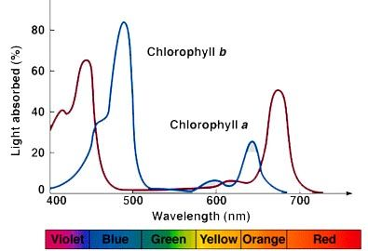
Figure 5 absorption spectra of chlorophyll a and b

Action Spectrum
An action spectrum is the graph of rate of the biological effectiveness of light plotted against the wavelength of light.
In case of photosynthesis, it is utilized in carbon dioxide fixation, oxygen production and NADP+ reduction etc. therefore it is called the action spectrum of photosynthesis. The study of action spectra shows that during photosynthesis the light is maximum absorbed in red and blue regions of visible spectrum. Green, yellow and orange regions show only slight absorption of visible light.
The studies on relative effectiveness of photosynthesis at different wavelengths showed that the action spectrum of photosynthesis differs from absorption spectrum. There is quite a lot of photosynthetic activity even in parts of the spectrum where chlorophyll a absorbs little light. This suggests that the light energy absorbed by other pigments like carotenes, xanthophylls and other forms of chlorophyll is transferred to chlorophyll a.

