Project Report (Group No 7 BS Botany II Semester)

Course Name:
Citizenship Education and Community Engagement
Report Title:
- Distribution of first aid box
- Awareness about accidents and usage of first aid box
- Distribution of food bags
Submission date:
07 - 06 - 2020
Group Members:
- Wajeeha Maryam(BBTF19BM035)GroupLeader
- Rida kalsoom (BBTF19BM030)
- Ishmal Munawar (BBTF19BM039)
- Hina Nisar (BBTF19BM044)
- Kumail Abbas (BBTF19BM031)
Submitted to:
Mam Mehlah Jabeen
Session:
2019-2023

University of Sargodha sub campus Bhakkar

Qno1: Title
Distribution of first aid box, awareness about prevention from accidents and usage of first aid kit and distribution of food bags to poor and needy people.

Qno2: Introduction
First aid kit is used for the treatment of ailments and injuries. A first aid kit consists of equipments that are utilized to provide medical treatment. First aid is the first and quick assistance provide to any patient suffering from small or critical wounds. However it is not necessary to utilize any instrument and facts for first aid. (Wajeeha Maryam BBTF19BM035)

Accidents are those conditions which occur suddenly and unconsciously related with any hazards and ailments. Accidents are the general events of the human skills which cause sudden injuries. Accidents can happens everywhere like in homes, in roads, in offices and any educational institutions. (Wajeeha Maryam BBTF19BM035)

Foods bags are those bags which contain necessary food material like rice, wheat, sugar, salt and vegetables etc and distributed among needy and poor people to satisfied their hungers and fulfill their basic needs in epidemic and emergency situations. Food bags provide support to those people who are financially weak and cannot survive without any support. (Wajeeha Maryam BBTF19BM035)

- Background of the problems:
Nowadays, our societies are suffering badly from pitiless accidents. Thousands of innocent people face painful death especially our young generation lay down their lives due to their minor mistakes. Similarily, there is another critical problem which is rising day by day is poverty. Poor people face starvation and sometimes they kill their children because they cannot provide them with basic needs and if they are lacking, the overall successful program is significantly diminished. (Wajeeha Maryam BBTF19BM035)

An emergency food distribution is an on-going process during which several activities are simultaneously not necessarily. Another problem is that mostly people are unfamiliar to the use of first aid box and they neglect their minor injuries and these injuries become critical infection which is harmful for life and they suffer to death. (Wajeeha Maryam BBTF19BM035)

The study of awareness about accidents clarifies the relation between accidents history and chances of riskness or hard travel and traffic protection behaviour by taking into mind and seriousness of the accidents examined. A sample of 525 users in Camron answered a question compromising items on demand of risk. In Protective behaviour and personal accidents history, participants would report involvement in more than three accidents or involvement in any serious accidents during road travel. (Wajeeha Maryam BBTF19BM035)

Road travel are less risky and reported less protectively as compared to involved in fewer and less intense accidents. These results have practical implication and prevention of road accidents. The association between accidents history decrease risk of road accidents and save behaviour investigation about their work by using cell report questioning data. The personal involved in more than three accidents or in serious accidents. (Wajeeha Maryam BBTF19BM035)

Road traveler are less risky and also reported more unsafe behaviour involved in fewer, or less serious accidents. Compaigns targeting people with less intense, less intensive accidents history should aim to raise awareness of hazards and potential intensity of consciousness as well as emphasizing how easily it ease to take the favoured preventive actions, compaign targeting involve in more accidents in survivour of intense accidents should address feelings of invulner ability and helpness. (Wajeeha Maryam BBTF19BM035)

The background of the first aid is that children spend most of their time in schools and are near to injuries and small ailments. Hence, they need first aid care. School teachers can provide any care through first aid box in the absence of any health profession. This study assesses first aid facilities and help of teachers on first aid training. Cross sectional study was reported from July- December (2017). (Wajeeha Maryam BBTF19BM035)

Participant were spending full time with school teachers of both public and private sectors so, they need first aid assist. We do not expect accidents because accident may happen at any time like simple cuts and bleedings while preparing food at home. Fractures and strains occur during sports at school or holidays activities. (Wajeeha Maryam BBTF19BM035)

- Present situation:
Our society had to face hard and dangerous epidemicity. Nowadays, all business institutions are locked down due to this epidemicity. People have nothing to eat. All life activities are blocked now. Everybody is scared from these situations. No one wants to talk rusk in these days. This is changing our lives. These changes are very scary. In this hard situation, we have to perform our role in society and in our country. (Wajeeha Maryam BBTF19BM035)

The main point of this study was to provincially analyze road accidents in Pakistan. In present days, we see many types and reasons of accidents. However, many accidents occurred due to negligence which might be avoided a wide range literature. This research comprises on working of secondary data. Different variables included total accidents which are fatal and non fatal. (Wajeeha Maryam BBTF19BM035)

Person who killed on get injuries and total number of vehicles present in accidents from 2000-2010 had face many road accidents. Our society had to face hard and well valnerable and they had to face them perfectly. Being regularly aware of how they are operating at work and are able to know hazards and safety related risks. In short safety awareness are much deeper than any work and creating awareness ongoing is a huge part of building a huge part of successful safety culture. (Wajeeha Maryam BBTF19BM035)

People feel that this situation is not scary but they should understand the hard aspects of the bad time. Accidents are not planned. At any time anyone from us can experience any hurdle. Thousands of accidents are happening because people do not follow the rules of traffic and they can compete with one another to move speedily. People face many problems due to the lack of traffic signals so first aid box is necessary according to present situation. Due to locked down, people have nothing to eat? So food bags are essential element in present situation for needy and poor people. (Wajeeha Maryam BBTF19BM035)
Qno3: Justification
- Importance of the project:
First aid box is necessary to go through small injuries and ailments that happened at home. First aid box reduce the risk of infectious diseases and severity of injuries. Why it is important to prevent accidents? The financial and emotional cause of an accident is high. Injuries can cause distress to the individual involved in the accidents because they do not be able to perform normally. (Ishmal Munawar BBTF19BM039)

Accidents can happen to everyone at anytime. Many accidents can happen at workplace. People have to face many hazards such as loaded machinary and works at heights. This risky situation and unsaved method of working conditions are actual causes of injuries and death. So, we have a proper control about what will happened in future. By doing this, we can minimize the dangers. (Ishmal Munawar BBTF19BM039)

The best way to do this is overall developing and implementing and accident prevention plan. Injuries can cause tension to the people involved in the accidents because they are not able to functionally perform. Accidents are usually happened unknowingly, and sometimes it cause injuries. Permanent damage caused by accidents can completely make a person disabled for all his life. So, it is more convenient to take extra precautions in avoiding possible accidents that have the capability to fix the damage that design. (Ishmal Munawar BBTF19BM039)

Accident prevention plan:
Safety and accidental preventions plans are tead up toward protecting you and your worker from hazards. This contains complete preparation and necessary actions taken to decrease, if not completely prevent accidents. When an accident prevention plan is completely followed, the chances of accidents are significantly low. Accident prevention plan consist of following elements.

- Risk assessment:
This process consists of complete observation of working place and proper introduction of potential risks and dangers.

- Reducing risks or hazards:
This step contains actions to reduce risk or completely eliminate the potential hazards in working place. This could lessen fixing or replacing all errored machinery and other ornaments keeping the workplace free for spoiled material or debris.

- Proper participation:
Accident prevention plan can be affected only when the management and employers together to make confirmed that prevention plan is followed properly. This management worker should encourage the people to follow the precautionary steps. Everyone should follow these precautions for prevention. (Ishmal Munawar BBTF19BM039)

Benefits of accident prevention plan:
When a strong prevention plan is followed and enforced in a working place, it will surely give profits to the workers.

- Increase morals of employer:
When a worker feels safe in the working place, they want to ensure a more positive attitude at his work or duty. It provides a safe environment to your workers. They would make a positive attitude towards his duty. They will do their work more efficiently.

- More productive workers:
Happy and mentally calm workers are more likely to create better work. Having a safe and danger free working environment help to keep the working functions smoothly and ordered.

- Reduce costs:
If this prevention plan is followed smoothly, many hazards like injuries, cuts are less likely happened in working place. It does not mean that you have spent a lot of money on expenditures of their plan. It reduces the chances of less lamayes.

By providing food bag to the people, we defended our society and make it strong. We protected our youth which play a vital role for the construction of a strong nation. By providing food bags to the poor we demolished poverty and starvation. By this project we forced poor people to live a life in the absence of basic amenities. (Ishmal Munawar BBTF19BM039)

- Practical implications (Who will get benefits of the activity):
Communication methods are settled as important tool to promote road accidents. Communication campaigns are more effective when they are apologizing appeals which are neutral to their communicative strategy. These are based on explicit. The theoretical study explained practical implementations. This study developed a detail categorization of continuous appeals which is used in road safety communication campaigns. (Ishmal Munawar BBTF19BM039)

But they have different concepts and to highlight the advance limitiations and social issues associated with each other. They are able to know hazards and critical in managing, safety related risk. Safety awareness are much deeper and creating a huge part of safety culture. (Ishmal Munawar BBTF19BM039)

When we distributed food bags to poor people, they enabled to stand on their feets and they had fulfilled their needs. We saw a strong bond between society and people were astonished to help each other. They raised a spirit of helping others. They enabled many people to not be stayed hungry. (Ishmal Munawar BBTF19BM039)

When we gave awareness to people about road accidents, they were surely known about road accident. People were surely understood about road accident hazards. When we distributed first aid box to people, they were get benefit from it. They were easily face minor injuries and accicdental cases. When citizen were tried to save each other, they were get benefit not only in world but also in the end. (Ishmal Munawar BBTF19BM039)

Qno4: Objectives
The dominant goals of first aid project were protecting people, stopping wounds and ailment to become worsen, reducing afflication; promote assist and securing the drowsy people. The major goals of our projects were to secure humanity. (Rida Kalsoom BBTF19BM030)

Objectives of First aid box:
- Protect life:
Protecting humanity was the major objective of our project. It involved that a wound was not hazardeous and serious. This included calling rescues as fast as you can and played their role in CPR during ultimate conditions. The person who is experted in first aid should also checked for essential life signs to observe if a wound was life threatening. Signs to study for survival of actions, interests, pulse rate and recognized extremely inadequate wounds. (Rida Kalsoom BBTF19BM030)

- Stopping ailments:
Stopping ailments was also a major target of project. To evaded wound to become worse, a first aider should not change the position of victim if they are hemorrhage or have a wound. Moreover, cleaning injuries with antiseptic reduce afflication and eliminate any exterior danger. Dangers are something that makes wound unpleasant for the victims. (Rida Kalsoom BBTF19BM030)

- Reduce afflication:
Reduce afflication was another purpose of our project. First aid must decrease pain and all rates by relaxing victims as possible. This may comprised by providing them painkillers, ice packs for crashes and smashes as well as raising wounds. Covered the injured area in a dressing and uplifted the affected area to raise blood circulation and also do not move the injured area. (Rida Kalsoom BBTF19BM030)

- Promote recovery:
Promote recovery was the aim of our project. This included injuries, dressing, and applying force on bleeding. Pressure is required to raise the movement of blood, so victims keep their hand on the region of bleeding. If the victim is inadequate to promote recovery, first aid should help it. This is the application of surving individual by healing their injuries. We advised to people replace dressing daily to reduce afflications. (Rida Kalsoom BBTF19BM030)

- Securing the unconscious:
Securing the unconscious was an important goal of our project. Drowsy persons were mostly endangered and they required more safety. Recognized and removed risks away from the victim. This is concluded to ewade more injury to the unconscious persons. You kept the individual into safe environment. (Rida Kalsoom BBTF19BM030)

Objectives of Prevention from accidents:
- We motivated persons to accept and supported life saving operations.
- We encouraged people to protect life by giving awareness about accidents.
- We inspired to give accident information and also enhanced experience.
- Our aims were to change the behaviours and attitudes especially in drivers to protect people from road accidents.
- We motivated people to assist anyone regarding wounds or cuts.
- We informed people about risk of using mobile during driving.
- We informed about risks to people in accidental cases.
- We encouraged people perturbed with formulating and changing behaviour, beliefs and judgement.
- We also provided strick restriction about speed limits to people.
- Strategies and risks were to be recognized, rectified and managed.
- All wounds and cuts related with suffer (measures, informations, resources, etc) were removed.
- We also gave secure environment to people by acknowledging them about risks in driving vehicles.
- We also originated the positive thinking and expectations to people about driving. (Rida Kalsoom BBTF19BM030)

Objectives of food bags:
- Our aim was to demolished hunger and poverty from society.
- Our objective was to fulfill the needs of unemployed persons.
- Our purpose of distributing food bags was to raise the equality and finished the differences in status of rich and poor.
- Our aim was to provide essential requirements to jobless or workless people to support life. (Rida Kalsoom BBTF19BM030)

Qno5: Plan of Action
- How will we do this project activity?

- We have done this project activity in group.
- We made handmade first aid boxes. First of all we took a shoe box and covered with white chart completely then, we used red tape to cover the edges of shoe box. We also made partitions in the box to kept things separately. Then, we also made the sign (+) of first aid kit on the box with the help of red tape.

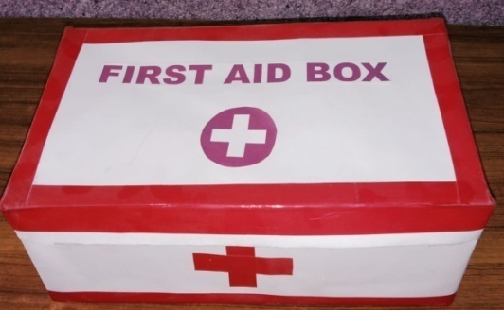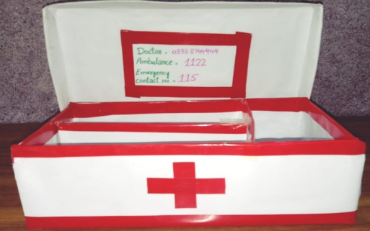
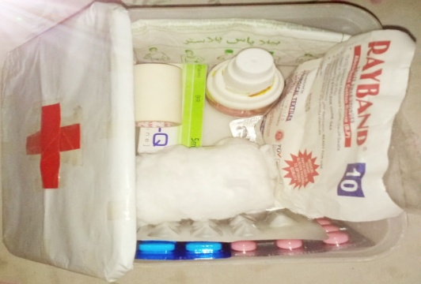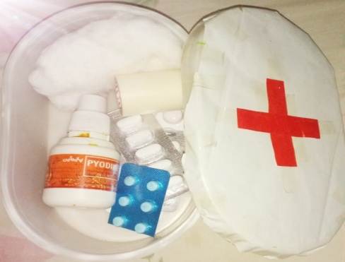
- We made charts of awareness about usage of first aid box and displayed them in neighbourhood and surroundings.

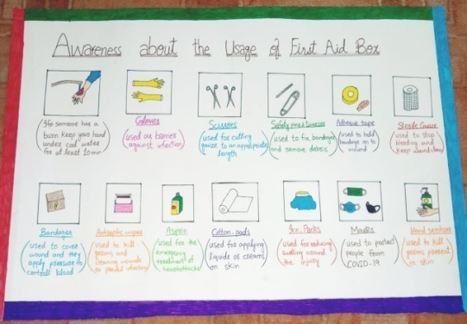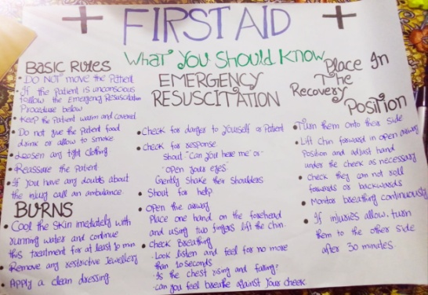

- We informed safety measures to people in accidental situations. We persuaded people to follow traffic rules. In this regard, we made handmade charts to give awareness about prevention from accidents and also displayed them in streets and neighbourhood.

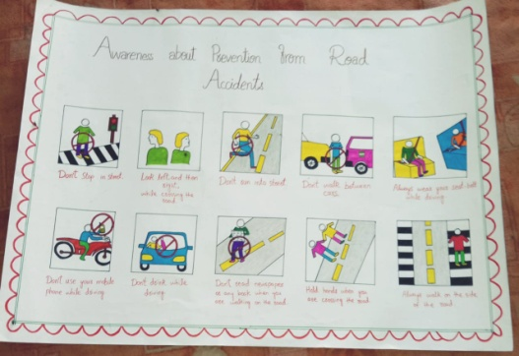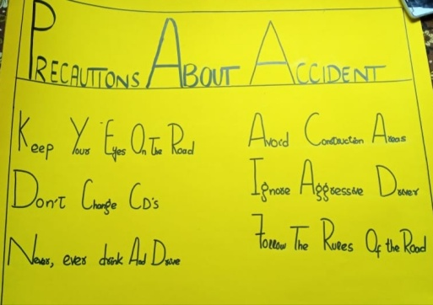

- We distributed food bags to poor and needy people to fulfill their basic needs.
- We gave awareness to people through social media by displaying status on whats app and also gave awareness about usage of first aid box and prevention from accidents especially to uneducated people. For this purpose, we went to their homes. (Rida Kalsoom BBTF19BM030)

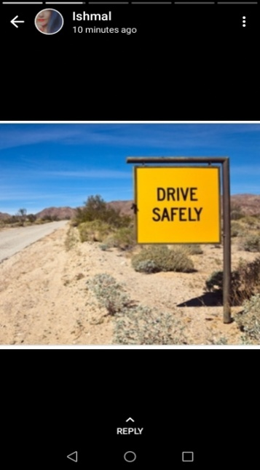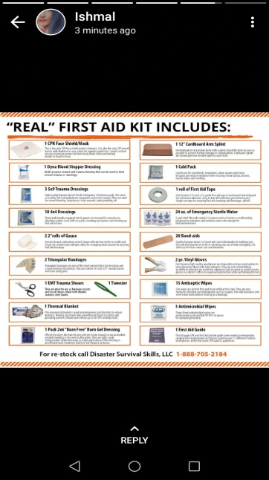
- Needed resources and source of generation (financial human resources):

In this project, our responsibility was to raise awareness among people. How the people can survive in critical circumstances. For example, how they can manage their things in disaster. How they can survive in different type of atrocities. No doubt, calamity is a part of nature and anytimes a person or a city may damage due to these severe disasters. (Hina Nisar BBTF19BM044)

In the same way, a man has enough knowledge to handle the critical situations. We can say that accidents are also a type of atrocity. But they can survive by adopting a few precautions. For examples, if they will know how to use first aid box in critical circumstances, they can easily compete the tough time. (Hina Nisar BBTF19BM044)

In this project, our needed resources included shoe boxes, white charts, red tapes, seizers, gloves, masks, antiseptic medicines, cotton pades, safety pins, tweezers, guaze, painkillers, sticky tapes, medicines for vomiting, acidity, fewer, antiseptic creams, bandages and handmade sanitizers. We also used flour, rice, sugar, salt, pulses, etc in the food bags. (Hina Nisar BBTF19BM044)

- Each person will play a vital role in this project:

Every person does not know how to use first aid box. It was our responsibility to tell them how they could use first aid box. Different members of our group performed different duties.

- Wajeeha Maryam (BBTF19BM035):

- She made handmade first aid box by her own.
- She also made handmade charts about awareness of accidents and first aid box.
- She distributed food bags among the needy and poor people.
- She also arranged meetings on Zoom App to discuss the project.
Supporter:
- Her father Muhammad Mukhtar helped her financially. He played a key role in fulfilling her project. He provided her helping material.
- He gave her money and also provided her food bags.
- Her brother Bilal Mustafa helped her in displaying charts on streets and also distributed food bags among poor people.

- Rida kalsoom (BBTF19BM030):

- She made handmade first aid box by her own.
- She also made handmade charts about awareness of accidents and first aid box.
- She distributed food bags among the needy and poor people.
- She went door to door and informed people how they can preserve their life.
Supporter:
- Her father Muhammad Mukhtar helped her financially.
- He gave her money and also provided her food bags.
- Her uncle Muhammad Iftikhar helped her in displaying charts on streets and also distributed food bags among poor people.

- Ishmal Munawar (BBTF19BM039):

- She also made handmade first aid box. She was also our treasurer.
- She collected money from all group members for the food bags.
- She also gave awareness to people about accidents and first aid box.
- She went for the financial support of the poor people
Supporter:
- Her father Munawar Hussain supported her financially. Her father gave her money to support our project.
- Her brother Ali Abbas also helped her in displaying charts and distributing food bags.

- Hina Nisar (BBTF19BM044):

- She also made first aid boxes and distributed foodbags among the needy person in her area.
- She went door to door and informed people how to cover up the burning situations.
- She went for the financial support of the poor people.
Supporter:
- Her father Nisar Ahamad and her brother Ammir Nisar supported her a lot.
- Her brother visited with her and told people about prevention from accidents.

- Kumail Abbas (BBTF19BM031):

- He distributed first aid box and also displayed charts in streets.
- He also distributed food bags in his surroundings among poor people.
Supporter:
- His brother Khawar Abbas and his friend Ali supported him in visiting the surrounding area for the distribution of food bags.
- His brother also went door to door for the sake of giving awareness to the people. (Hina Nisar BBTF19BM044)

- Proposed duration of the project:

We completed this project in two weeks. During this period, we arranged few meetings to discuss the project on Zoom App. The meeting Id is 9178264497. (Kumail Abbas BBTF19BM031)

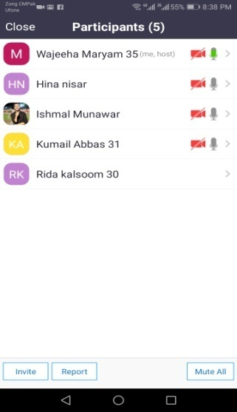

Qno6: How we will evaluate your project from possible outcomes:
We evaluated this project by considering it the basic necessity of our society. Because nowadays, our society faces many epidemic and starvation problems and accidents are also increasing day by day so, we thinked that this project of awareness and distribution of first aid box proved to be beneficial for people. (Kumail Abbas BBTF19BM031)

After doing this project, we observed people very deeply and they gave us very positive response. When we visited the area in which we gave proper awareness and told about the usage of first aid box, we observed that people carefully followed our instructions. For example, in our backward area we saw many local people wear halmets during driving their vehicles. So, we decided that people got benefit from our project and this project proved to be beneficial for the development of the society. (Kumail Abbas BBTF19BM031)

Our friends and relatives started paying attention to our instructions. Now people are well awared about how to use first aid box and they trained to face any emergency situation. We also included masks and sanitizers to our first aid kit according to the present situation of COVID-19. So, people got benefit from our project because, we saw many people wearing masks and use sanetizers properly. They were well-awared from the risk happened around them. (Kumail Abbas BBTF19BM031)

By distributing food bags to the needy and jobless people, we succeeded to save their lives and prevented them to kill due to starvation so our efforts proved fruitful for the community. We also checked that people gained knowledge from our handmade charts which we displayed on streets. Our relatives saw these precautions and adopted in their lives. (Kumail Abbas BBTF19BM031)

Before our project, a child had driven a heavy vehicle with unlimited speed. But when we gave awareness about accidents and told hazards and risks, their parents had stopped him from driving any vehicles. In this regard, we also got some benefits from this project activity. For example, when we distributed food bags, we succeeded to develop friendship relations among people. (Kumail Abbas BBTF19BM031)

We met many people of our surrounding area and they blessed us with great wishes. We can say that we worked for the welfare of society and engaged our community. So, we also got benefit according to Islamic point of view because God likes those people who think about other benefits. We enjoyed this duration of project activity with full zeal.

All group members felt inner satisfaction by doing such a marvellous project activity. We also worked day and night to fulfill the actual aim of this project. Everyone got full benefit from this activity and we also tried to provide a calm and peaceful society to the inhabitants. Every person played his dominant role. We imagined that this project is necessary to preserve life and life is most important than any other thing. So, we not only got benefit from this project activity but people also acquired benefits from it. (Kumail Abbas BBTF19BM031)

We believed that our project played a specific role for the prosperity and construction of the society. We got conclusion from our project that we promoted the sense of sympathy, self construction, and learned how to defend themselves on their own. So, we succeeded to become a good citizen and developed a sense of moral values among people. We felt proud to serve our community and we were able to fulfill our aims of community engagement. (Kumail Abbas BBTF19BM031)

References:
- Wajeeha Maryam (BBTF19BM035) Group Leader BS Botany II Semester, Department of Biological sciences, University of Sargodha sub campus Bhakkar.
- Rida Kalsoom (BBTF19BM030) BS Botany II Semester, Department of Biological sciences, University of Sargodha sub campus Bhakkar.
- Ishmal Munawar (BBTF19BM039) BS Botany II Semester, Department of Biological sciences, University of Sargodha sub campus Bhakkar.
- Hina Nisar (BBTF19BM044) BS Botany II Semester, Department of Biological sciences, University of Sargodha sub campus Bhakkar.
- Kumail Abbas (BBTF19BM031) BS Botany II Semester, Department of Biological sciences, University of Sargodha sub campus Bhakkar.

The End

