Clauses: Definition, Types & Examples

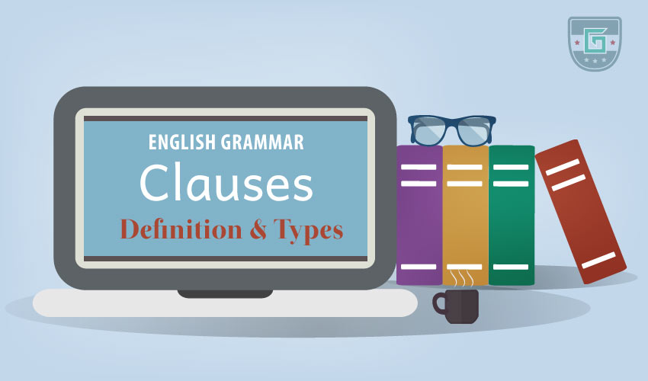
A clause is comprised of a group of words which includes a subject and a finite verb. A clause contains only one subject and one verb. The subject of a clause can be mentioned or hidden, but the verb must be apparent and distinguishable.
A clause “a group of words containing a subject and predicate and functioning as a member of a complex or compound sentence.” – Merriam-Webster
Example:
- I graduated last year. (One clause sentence)
- When I came here, I saw him. (Two clause sentence)
- When I came here, I saw him, and he greeted me. (Three clause sentence)

Types of Clause
Clauses are mainly of two types:
- Independent Clause
- Dependent Clause

Independent Clause
An independent clause functions on its own to make a meaningful sentence and looks much like a regular sentence.
In a sentence two independent clauses can be connected by the coordinators: and, but, so, or, nor, for*, yet*.
Example:
- He is a wise man.
- I like him.
- Can you do it?
- Do it please. (Subject you is hidden)
- I read the whole story.
- I want to buy a phone, but I don’t have enough money. (Two independent clauses)
- He went to London and visited the Lords. (Subject of the second clause is ‘he,' so “he visited the Lords” is an independent clause.)
- Alex smiles whenever he sees her. (One independent clause)

Dependent Clause
A dependent clause cannot function on its own because it leaves an idea or thought unfinished. It is also called subordinate clause. Dependent clauses help the independent clauses complete the sentence. A dependent clause alone cannot form a complete sentence.
The subordinators do the work of connecting the dependent clause to another clause to complete the sentence. In each of the dependent clause, the first word is a subordinator. Subordinators include relative pronouns, subordinating conjunctions, and noun clause markers.
Example:
- When I was dating Daina, I had an accident.
- I know the man who stole the watch.
- He bought a car which was too expensive.
- I know that he cannot do it.
- He does not know where he was born.
- If you don’t eat, I won’t go.
- He is a very talented player though he is out of form

