Chapter No# 4
Administrative function in education
4.1Educational Administration Meaning and Nature
Administration is machinery through which any organization or institution can be managed. It is a mean set up for a smooth and efficient working of educational structure. Educational administration is the direction, control and management of all matters pertaining to school affairs. Direction is the leadership within the community and the school system. Control and management are the means for realization of purposes defined in educational planning. Education is in the control of the state as certain controls are at the state level in the form of constitutional provisions, enactments and also as executive activities. Management designates a broad function, which the responsibilities related to the school, pupils, teachers and other affairs related to the school.
Russel T. Gregg defines,
“Educational administration is the process of utilizing appropriate materials in such a way as to promote effectively the development of human qualities. It is concerned not only with the development of children and youth but also with the growth of adults and particularly with the growth of school personnel.
Good’s Dictionary of Education defines educational administration as,
“All those techniques and procedures employed in operating the educational organization in accordance with established policies.”
4.2 The scope of educational administration:
The scope of educational administrationis very vast. It includes every thesis regarding the efficient functioning of the educational institutions, securing the greatest benefits to the greatest number through an adoption of practical measures. It interprets and clarifies the functions and the activities educational program in fruitful relationship and also harmonizes their mutual action. It ensures sound educational planning, good direction and efficient and systematic execution.
A good administration is one, which exhibits human activity at its best. The ingredients of good administration are:
1. Associated performance-Human beings work in close collaboration and there is sharing of responsibilities.
2. Organized purpose-well-defined purposes are achieved through sharing of responsibilities.
3. Creativity-through dynamic approach. The group proceeds towards it goal.
4. Achievement – the feeling of achievement makes an administrator to take more efforts to achieve perfection. Administration also involves different kinds of activities to achieve its purpose and to perform the functions related to it.
4.3 Importance of Educational Administration:
The purpose of educational administration is to enable an organization or an institution to carry out its functions with maximum efficiency. It also enables the right pupils to receive the right education and from the right teachers at a cost which should be within the means of state, and which will enable the pupils to profit from their learning. The basic purpose is to bring students and teachers together under such conditions which will successfully promote the end of the education. The major purposes are:
i) To frame well-defined policies and programs so that teaching, learning situation results in the growth and development of human beings.
ii) To make use of appropriate materials to bring about the effective development of human qualities.
iii) To execute the programs and activities of the organization so that its objectives may be achieved.
iv) To assure the growth of children and adults and all the people involved in the management.
4.3. The concept of PODSCORB :
Fayol’s idea was further developed by Gulick and Urwick. The formula of the functions of administration was referred to as POSDCORB, involving.
Planning:
The establishment of the formal structure of authority, through which work subdivisions are arranged, defined and coordinated for defined objectives.
Organizing:
The establishment of the formal structure of authority, through which work subdivisions are arranged, defined and coordinated for defined objectives.
Staffing:
The personnel function of brining in and training the staff and maintaining favorable conditions for work.
Directing:
It is a continuous task of making decisions and also deciding on specific and general orders and instructions and serving as the teacher of enterprise.
Coordinating:
It is the important aspect of inter-relating the various parts of the work.
Reporting:
Keeping the those records of who are answerable to executive and also to inform him about what is going on, and keeping himself and his subordinate informed through records research and inspection.
Budgeting:
It is the financial planning, accounting and control.
4.2.1.Planning:
Planning is an intellectual activity, which is performed on the basis of facts and principles. It plans its activities in such a way that the objectives for which it has come into existence can be achieved. To organize the means of arrangements, by which interrelationship along with order for people, materials, procedure, knowledge and the work can be done.
Command or to direction involves the execution of plans and decisions and makes the staff do their work.
Coordination requires harmonizing in a unified manner all the elements involved in the programme. It seeks the cooperation of all who are involved in the administration.
By control we can see that everything is carried out in accordance with the rules, which have been laid down in the instructions, in other words, it is evaluations.
4.2.2.Process of Planning:
It involves the identification and classification of objectives and scope of operation. It also investigates to reveal the condition which is affecting the achievement of objectives.
Organizing:
Organization means taking those steps by which, the people who are involved in administration remain in cooperative manner with each other and are prepared to contribute their best to the joint activity of their talents and their energies are optimally utilized.
Decision Making:
It is the art of executive decision to be taken on pertinent questions which are not pre-mature and which can be effective and can be put into action.
Stimulating:
A successful administrator makes all efforts to provide stimulation to the member of the organization in order to get their cooperation spontaneously to achieve the goals. He avoids the exercise of authority. He does not give specific direction but helps them to attain the highest level of creativity.
Coordinating: It s the brining up of appropriate relationships between people and the thing which are necessary for the organization to achieve the objectives and involves the allotment of duties and responsibilities also help the organization of all activities of the individuals.
Communicating:
It is process by which direct-information, ideas, explanations and questions are transmitted from person to person or from group to group. There are three channels of communication process:
1. Upward Communication is from teachers to the principals to district officials and to directorate etc.
2. Horizontal Communication, which runs along the same level of workers and enables the colleagues to be conversant with activities of the organization. There is no situation of subordination or superiority.
3. Downward Communication, where the flow of communication ideas, suggestions and commands, are from senior officers towards juniors.
Evaluating:
In this process whatever activities are performed, are put to test in order to find out the extent by which they provided success in the accomplishment of set goals. It is done to find out the weak spots and to make improvement in future by overcoming the deficiencies. Evaluation is done through cooperative studies, surveys, testing programs, opinion polls.
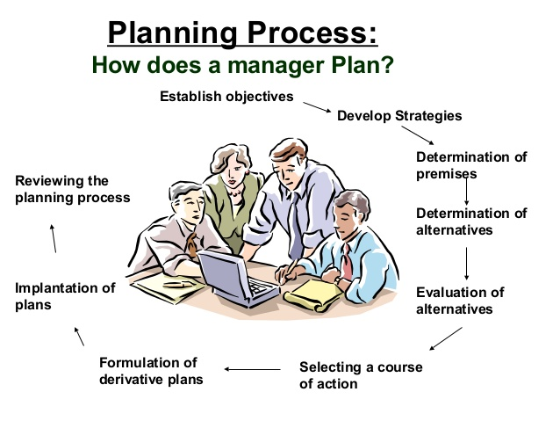

4.2.3 Kinds of Organizational Plans:
Organizations establish many different kinds of plans. At a general level, these include strategic, tactical, and operational plans.
Strategic Plans ;
Strategic plans are the plans developed to achieve strategic goals. More precisely, a strategic plan is a general plan outlining decisions of resource allocation, priorities, and action steps necessary to reach strategic goals. These plans are set by the board of directors and top management, generally have an extended time horizon, and address questions of scope, resource deployment, competitive advantage, and synergy.
Tactical Plans
A tactical plan, aimed at achieving tactical goals, is developed to implement
specific parts of a strategic plan. Tactical plans typically involve upper and middle management and, compared with strategic plans, have a somewhat shorter time horizon and a more specific and concrete focus. Thus tactical plans are concerned more with actually getting things done than with deciding what to do. Tacticalplanning is covered in detail in a later section.
Operational Plans:
An operational plan focuses on carrying out tactical plans to achieve operational goals. Developed by middle and lowerlevel managers, operational plans have a Short term focus and are relatively narrow in scope. Each one deals with a fairly small set ofactivities. We also cover operational planning in more detail later. Time Frames for Planning As we noted previously, strategic plans tend to have a longterm focus, tactical plans an Intermediateterm focus, and operational plans a shortterm focus. The sections that follow address these time frames in more detail. Of course, we should also remember that time frames vary widely from industry to industry.
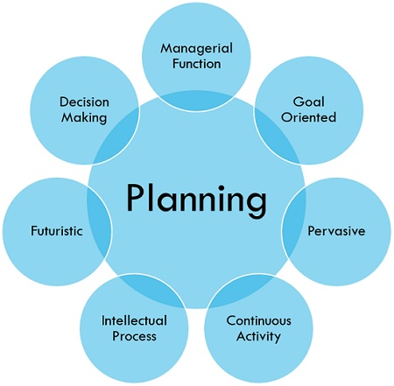
Characteristics of Planning:

- Managerial function: Planning is a first and foremost managerial function provides the base for other functions of the management, i.e. organizing, staffing, directing and controlling, as they are performed within the periphery of the plans made.
- Goal oriented: It focuses on defining the goals of the organization, identifying alternative courses of action and deciding the appropriate action plan, which is to be undertaken for reaching the goals.
- Pervasive: It is pervasive in the sense that it is present in all the segments and is required at all the levels of the organization. Although the scope of planning varies at different levels and departments.
- Continuous Process: Plans are made for a specific term, say for a month, quarter, year and so on. Once that period is over, new plans are drawn, considering the organizations present and future requirements and conditions. Therefore, it is an ongoing process, as the plans are framed, executed and followed by another plan.
- Intellectual Process: It is a mental exercise at it involves the application of mind, to think, forecast, imagine intelligently and innovate etc.
- Futuristic: In the process of planning we take a sneak peek of the future. It encompasses looking into the future, to analyse and predict it so that the organization can face future challenges effectively.
- Decision making: Decisions are made regarding the choice of alternative courses of action that can be undertaken to reach the goal. The alternative chosen should be best among all, with the least number of the negative and highest number of positive outcomes.
Importance of Planning:
- It helps managers to improve future performance, by establishing objectives and selecting a course of action, for the benefit of the organization.
- It minimizes risk and uncertainty, by looking ahead into the future.
- It facilitates the coordination of activities. Thus, reduces overlapping among activities and eliminates unproductive work.
- It states in advance, what should be done in future, so it provides direction for action.
- It uncovers and identifies future opportunities and threats.
- It sets out standards for controlling. It compares actual performance with the standard performance and efforts are made to correct the same.
- Planning is present in all types of organizations, households, sectors, economies, etc. We need to plan because the future is highly uncertain and no one can predict the future with 100% accuracy, as the conditions can change anytime. Hence, planning is the basic requirement of any organization for the survival, growth and success.
Steps involved in Planning
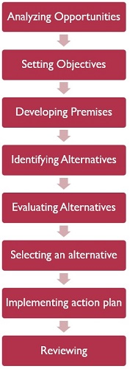

5.Organizing:
The Definition of Organizing
“It is a process that refers to identifying and grouping of activities to be performed, defining and delegating authority, specifying responsibility and establishing relationships to enable people to work together effectively in accomplishing objectives.”
Organization:
A social unit of people, systematically structured and managed to meet a need or to pursue collective goals on a continuing basis.
Why we do need an organizational structure?
All organizations have a management structure that determines the relationships between functions and positions and subdivides and delegates role responsibilities and authority to carry out defines tasks.
5.1.Organizational structure:
It is a framework within which an organization arranges its line of authorizes and communications and allocates rights and duties.
Organizational Structure:
An organizational structure is a system that outlines how certain activities are directed in order to achieve the goals of an organization. These activities can include rules, roles, and responsibilities.
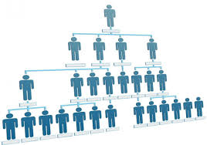
The organizational structure also determines how information flows between levels within the company. For example, in a centralized structure, decisions flow from the top down, while in a decentralized structure, decision-making power is distributed among various levels of the organization.

5.1.Types of organizational structure:
- Tall organizational structure
- Flat organization structure
- Virtual organizational structure
- Boundary less organization structure

1.Tall organizational structure:
- Large, complex organizations often require a taller hierarchy.
- In its simplest form, a tall structure results in one lone chain of command similar to the military.
- As an or
- ganization grows,the number of management levels increases and the structure grow taller. In a tall structure, managers form many ranks and each has a small area of control.
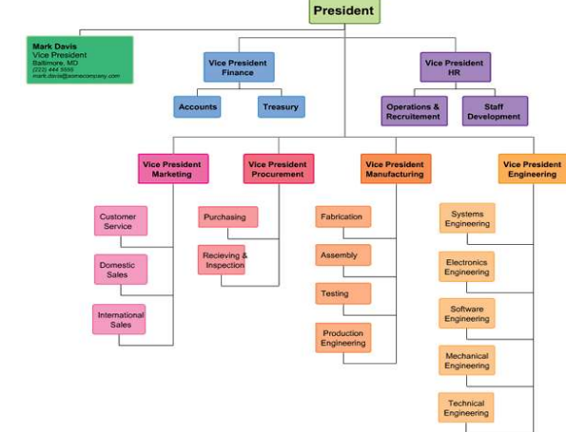

2.Flat organizational structure:
- Flat structure have fewer management levels, with the level controlling a broad area or groups
- Flat organizational focus on empowering employees rather than adhering to the chain of command.
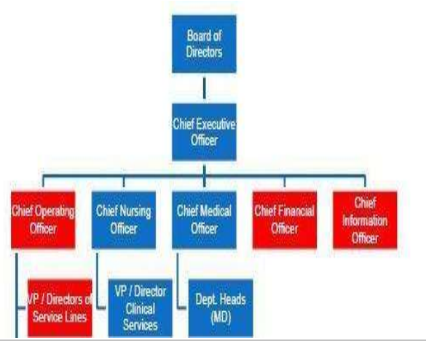
- By encouraging autonomy and self-direction, flat structure attempt to tap into employees’ creative talents and to solve problem by collaboration.

3.Virtual organizational structure:
Virtual organization can be thought of as a way to which an organization uses information and communication technologies to replace or augment some aspect of the organization.
People who are virtually organized primarily interact by electronic means.
For example:
Many customer help desks link customers and customers together via telephone or the internet and problems may be solved without ever bringing people together.

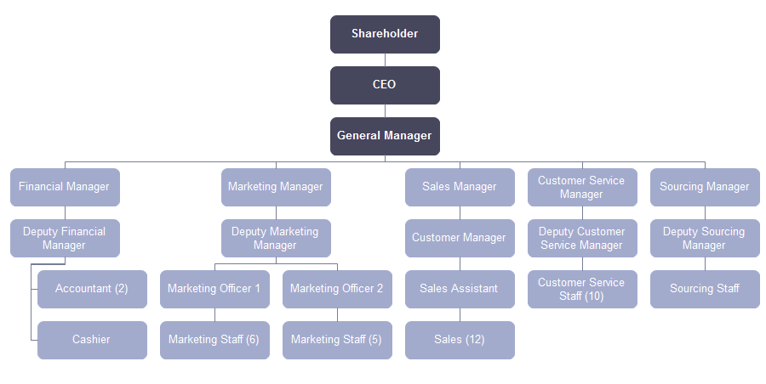

4.Boundary less organizational structure:
- A boundary less organizational structure is a contemporary approach in organizational design.
- It is an organization that is not defined by, or limited to the horizontal, vertical or external boundaries imposed by a predefined structure.
- It behaves more like an organism encouraging batter integration among employees and closer partnership with stakeholders.
- It’s highly flexible and responsive and draws on talent wherever it’s found.
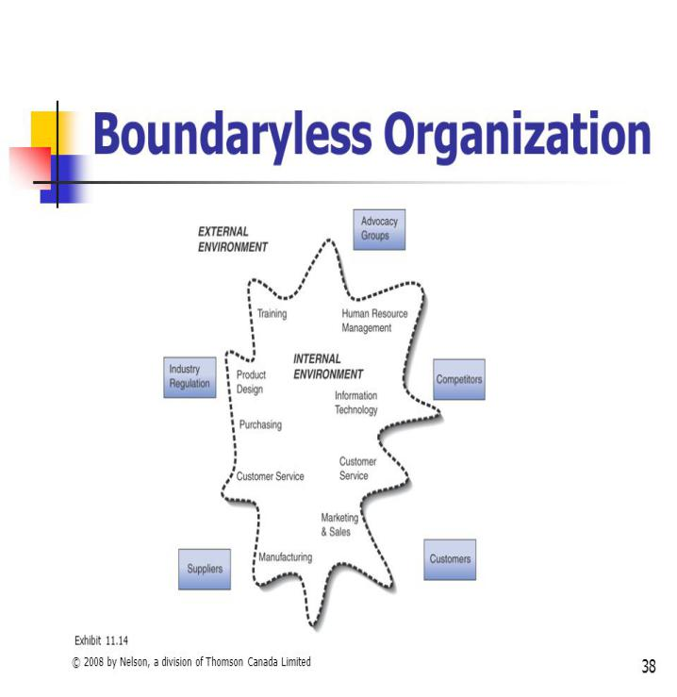
Types of Organizational Structures
Functional Structure:
Four types of common organizational structures are implemented in the real world. The first and most common is a functional structure. This is also referred to as a bureaucratic organizational structure and breaks up a company based on the specialization of its workforce. Most small-to-medium-sized businesses implement a functional structure. Dividing the firm into departments consisting of marketing, sales, and operations is the act of using a bureaucratic organizational structure.
Divisional or Multi-divisional Structure:
The second type is common among large companies with many business units. Called the divisional or multidivisional structure, a company that uses this method structures its leadership team based on the products, projects, or subsidiaries they operate. A good example of this structure is Johnson & Johnson. With thousands of products and lines of business, the company structures itself so each business unit operates as its own company with its own president.
Flatarchy Structure:
Flatarchy, a newer structure, is the third type and is used among many startups. As the name alludes, it flattens the hierarchy and chain of command and gives its employees a lot of autonomy. Companies that use this type of structure have a high speed of implementation.
Matrix Structure:
The fourth and final organizational structure is a matrix structure. It is also the most confusing and the least used. This structure matrixes employees across different superiors, divisions, or departments. An employee working for a matrixed company, for example, may have duties in both sales and customer service.
5.2.Components of Organization:
1. Task
2. People
3. Structure
4. Technology
1. Task: This component can be defined as a mission or purpose of the existence of organization.
Every organization is having a purpose ofexistence that is accomplished byproducing certain goods and services asan output, which is termed as task.
2. People: The workforce or human part oforganization that performs differentoperations in the organization.
3. Structure: Structure is the basicarrangement of people in theorganization.
4. Technology: The intellectual andmechanical processes used by anorganization to transform inputs into products or services.
5.3 Classical and modern views of organization:
The theory of organization can be classified into three broad categories:
- Classical organization theory
- Neoclassical organization theory
- Modern organization theory
1.classical organization theory:
It is the oldest theory of organization. It is originated from the writing of classical management thinking such as Taylor and Fayol. The classical writers views organization as a machine and individual working in it as different component of this machine. They believe that efficiency of organization can be increased by making each individual more efficient.
Characteristics or contribution of classical organization theory:
- It is based an organization as machine and individual working in it as different components of this machine.
- It believe that efficiency of organization can be increased by making each individual more efficient.
- It deal with formal organization structure.
- It focuses on objectives and tasks and not on the human beings performing the tasks
- It aims at maximizing control.
- It emphasis on the direction on the detection of errors occurred and correction.
Theclassical organization theory has been develop round of the following principle or pillars:
- Division of labor and departmentization.
- Scalar chain: I.e. hierarchy of authority.
- Unity of command
- Unity of direction
- Line and staff relationship
- Span of control
- Parity of authority and responsibility
- Structural relationship among varies tasks, activities and people
(i) Division of Labour:
Division of labour implies that work must be divided to obtain specialization with a view to improve the performance of workers. The classical theory rests on the assumption that more a particular job is broken into its simplest component parts, the more specialized a worker can become in carrying out his part of the job.
The specialization in workers will make the organization efficient. Various activities of a job are specified and subdivided into different components so that these may be assigned to different persons. The workers will go on repeating their work under division of labour. The performance of same work will help workers to improve their efficiency and the organization as a whole is benefited by this exercise.
(ii) Scalar and Functional Process:
The scalar process refers to the growth of chain of command, delegation of authority, unity of command and obligation to report. It is called scalar process because it provides a scale or grading of duties according to the degree of authority and responsibility. It generates superior- subordinate relationship in the organization. The functional process deals with the division of organization into specialized parts or departments and regrouping of the parts into compatible units.
(iii) Structure:
It is the framework of formal relationships among various tasks, activities and people in the organization. The basic structural element in the classical theory is position. Each position is assigned a specific task and authority is delegated for its accomplishment. The efficiency with which these tasks will be accomplished will determine the effectiveness of the organization. The classical writers emphasized line and staff organizations.
(iv) Span of Control:
The span of control means the number of subordinates a manager can control. Classical thinkers specified numbers at different levels which can be effectively supervised by a superior. A manager cannot exercise proper control if the number of subordinates increases beyond a certain figure, on the other hand if the number is less then his capacity and knowledge cannot be fully utilized.
Criticism of classical theory:
- It ignores human aspect and views human beings as components of the organization machine.
- It believe that people at work can be motivated solely through monetary incentives.
- It is an authoritarian theory.
- It is based on certain principles which are based mainly on experience and not tested by scientific researches.
- It takes static view instead of dynamic view of the organization.
- It regards organization as a closed system instead of open system. Thus it ignores the influence of external factor of organization and its members.
- Neoclassical organization theory:
The neoclassical theory originated from the finding of famous hawthorne experiments conduct under the leadership of mayo. It develop with the human relations movement.
The neoclassical school focuses attention on human beings and their behavior in organizations. It believes that human behavior in organizations is greatly influenced by formal well as informal relations.
Characteristics or contribution of neoclassical organization theory:
- The organization is a social system composed of several interacting sub system
- The social environment on job affect people and is also affected by the people.
- Integration between organization and individual goals is a must.
- Money is only one of the motivators but not the sole.
- Human beings are not always rational. They behave rationally as far as rewards form the job are concerned.
- To way communication is necessary are for sound functioning of the organization.
- Team work is essential for cooperation and higher productivity. But it can be achieved only through behavioral approach.
Criticism of Neoclassical organization theory:
- It is not a new theory of organizations. It is merely a modification of classical theory.
- The structures of organization suggested by this theory are not suitable in all situation.
- The theory over- emphasized on human aspect. Consequently, other aspects remained ignored or neglected.
- Certain assumption of this theory are not true. Consequently, there are conflicts of interest of various groups in the organization.
- Modern organization theory:
The modern organization theory originated in sixties and flourished in seventies of the 20th century.the modern of organization views organization as a system.
Characteristics or contribution of modern organization theory:
- It consider organization as a system composed of many subsystems such as managerial, technical, social sub system.
- It regards individual as complex being who can be motivated in multitude of ways.
- It is descriptive approach of studying organization.
- It is multidisciplinary theory as draws concepts and principle form several disciple such as sociology, psychology, economics and so on
- It is a dynamic in interaction with the structure. It is contently subject to change as environment changes. organization adopts it self suitably to the changing environment and it survives.
- It is both macro and micro in its approach.
Criticism of modern organization theory:
- It is not a unified theory of organization but a mixture of several theories.
- It is based on passed impartial studies and their is nothing new in it.
- It does not identify the precise relationship among the organization and its external system.
- It is not useful for smaller organizations.
6.Leadership:
Leaders:
People who can influence the behaviors of others without having to rely on force; those accepted by others as leaders.
Leadership:
Martin M. Chemers definition:
“Leadership is a process of social inﬂuence in which one person is able to enlist the aid and support of others in the accomplishment of a common task.”
Leadership
Leadership broadly as a social process in which an individual or a group inﬂunces behavior toward a shared goal; leadership is distributed widely in organizations both formally and informally and has rational, social, and emotional bases.
The Meaning of Leadership:
The meaning ofLeadership is both a process and a property.
As a process—focusing on what leaders actually do—leadership is the use of non coercive influence to shape the group or organization’s goals, motivate behavior toward the achievement of those goals, and help define group or organizational culture.
As a property, leadership is the set of characteristics attributed to individuals who are perceived to be leaders. Thus leaders are (1) people who can influence the behaviors of others without having to rely on force or (2) people whom others accept as leaders.
Early approaches to the study of leadership adopted what might be called a “universal” or “generic” perspective. Specifically, they assumed that there was one set of answers to the leadership puzzle. One generic approach focused on leadership traits, and the other looked at leadership behavior.
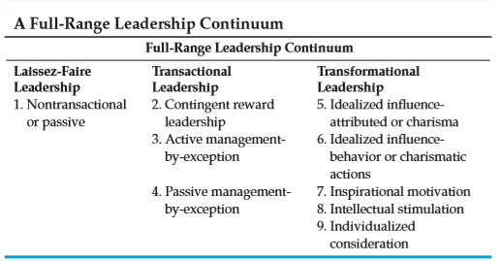
6.2.Three Types of Leadership:

1.Laissez-Faire Leadership:
Bass (1998) characterizes this type of leadership as the absence of transactions with followers. For instance, laissez-faire leaders avoid expressing their views or taking action on important issues, fail to make or at least delay decisions, ignore responsibilities, provide no feedback, and allow authority to remain dormant. It essentially is the avoidance or absence of leadership, and consequently is the most passive and least effective.
2.Transactional Leadership:
Transactional leaders motivate followers by exchanging rewards for services rendered.
for example, a principal provides new instructional materials or increased planning time to teachers so they can institute a new curricular program. When subordinates are doing their work in organizations such as schools, Transactional leaders recognize what followers want from work and try to provide them with what they want. They exchange rewards and promises of reward for effort and respond to followers’ immediate self-interests. Transactional leaders pursue a cost-beneﬁt, economic exchange to meet followers’ current material and psychological needs in return for contracted services rendered by the subordinate (Bass, 1985a).
Transactional leadership is posited to have three components (Antonakis, Avolio, and Sivasubramaniam, 2003).
- Contingent reward leadership refers to leader behaviors that focus on clarifying role and task requirements and provide followers with rewards contingent on the follower’s performance. In other words, this subtype of leadership behavior gives followers things they want in exchange for things leaders want (Kuhnert and Lewis, 1987).
2.Active management-by-exception: means that leaders maintain high levels of vigilance to ensure that standards are met. That is, leaders actively monitor performance and take corrective action as problems become apparent.
3.Passive management-by-exception: means that leaders fail to intervene until problems become serious. These leaders wait to take action until after mistakes or other performance problems have happened and are called to their attention.
4Bass and Riggio (2006) maintain that in most situations, transactional leadership can be very effective. Contingent reward behaviors in particular provide a solid foundation for effective leadership. However, enhanced effort, effectiveness, and job satisfaction result when transactional leadership is augmented with transformational leadership.
3.Transformational Leadership:
Transformational leadership is an expansion of transactional leadership that goes beyond simple exchanges and agreements. Transformational leaders are proactive, raise the awareness levels of followers about inspirational collective interests, and help followers achieve unusually high performance outcomes.
1.Idealized inﬂuence:
Builds trust and respect in followers and provides the basis for accepting radical and fundamental changes in the ways individuals and organizations do their work. These leaders display conviction about important issues; exhibit high standards of ethical and moral conduct, sharing risks with followers in setting and attaining goals; consider the needs of others over their own; and use power to move individuals or groups toward accomplishing their mission, vision, and cause, but never for personal gain. As a result,
2.Attributed idealized inﬂuence:
is the extent to which followers perceive leaders as being charismatic, conﬁ dent, powerful, and focused on higher-order ideals and ethics. In contrast, idealized inﬂuence as behavior is charismatic actions of leaders that focus on values, beliefs, and a sense of mission (Antonakis, Avolio, and Sivasubramaniam, 2003).
3.Inspirational motivation:
changes the expectations of group members to believe that the organization’s problems can be solved (Atwater and Bass, 1994). It also plays a central role in developing an appealing vision that guides the development of organizational goals and operating procedures (Avolio, 1994). Inspirational motivation comes primarily from leader behaviors that provide meaning and challenge for followers.
Transformational leaders energize people by projecting an attractive and optimistic future, emphasizing ambitious goals, creating idealized visions for the organization, and clearly communicating to followers that the vision is attainable.
4.Intellectual stimulation:
Addresses the problem of creativity (Atwater and Bass, 1994). Transformational leaders stimulate followers to be innovative and creative by questioning old assumptions, traditions, and beliefs; reframing problems; and approaching old situations in new ways. Transformational leaders challenge followers to think creatively, design new procedures and programs, and solve difﬁ cult problems; foster unlearning and eliminate the ﬁxation on old ways of doing things; and refrain from publicly criticizing individual members for mistakes (Bass and Avolio, 1994).
6.3.Leadership traits:
The first organized approach to studying leadership analyzed the personal, psychological, and physical traits of strong leaders. The trait approach assumed that some basic trait or set of traits existed that differentiated leaders from non leaders. If those traits could be defined, potential leaders could be identified. Researchers thought that leadership traits might Copyright include intelligence, assertiveness, above-average height, good vocabulary, attractiveness, self-confidence, and similar attributes.
6.4.Leadership behaviors:
Spurred on by their lack of success in identifying useful leadership traits, researchers soon began to investigate other variables, especially the behaviors or actions of leaders. The new hypothesis was that effective leaders somehow behaved differently than less effective leaders. Thus the goal was to develop a fuller understanding of leadership behaviors.
Job-centered leader behavior: The behavior of leaders who pay close attention to the job and work procedures involved with that job
Employee-centered leader behavior: The behavior of leaders who develop cohesive work groups and ensure employee satisfaction
Initiating-structure behavior: The behavior of leaders who define the leader–subordinate role so that everyone knows what is expected, establish formal lines of communication, and determine how tasks will be performed
Consideration behavior: The behavior of leaders who show concern for subordinates and attempt to establish a warm, friendly, and supportive climate
6.4. Behaviors and Leadership:
Early conceptualizations of leadership typically relied on two distinct categories of leader behavior-one concerned with people, interpersonal relations, and group maintenance, and the other with production, task completion, and goal achievement (Cartwright and Zander, 1953). Similar findings were reflected in other early studies of leadership. We now turn to a description of an early program of research and a more recent perspective on leader behavior.
6.5.Leadership and supervision:
Leaders are an essential part of any company, helping to expand its horizons through new ideas while leading team members down a productive path. Meanwhile, supervisors help to ensure an organization's processes run smoothly. Supervisors and leaders are alike in many ways, but they are not necessarily the same. Some of the key differences are their focus, tasks and outside perception in an organization.
The first major difference between supervisors and leaders:
is their set of primary goals. According to Tom Searcy of Inc. Magazine, supervisors focus on organizational accuracy, compliance and the implementation of day-to-day tasks. Leaders, on the other hand, put a heavier focus on resources, direction and goals for a team or organization.
The second major difference between the two:
Supervisors must oversee the work being done to ensure that it meets organizational standards and is completed on time. They often have to complete technical and administrative tasks, many of which require job-specific expertise gained through education or special training. While general leaders may have varying responsibilities, those designated as team leadersoften act as intermediaries between supervisors and employees. During a project, they may be responsible for delegating tasks to certain members, developing a time line and generally take responsibility for the team's progress.
A third difference between:
supervisors and leaders is the way they are viewed by other workers and the organization as a whole. A leader can sometimes be placed in this role by the organization and thus carry the title of leader, such as the case of a team leader, it is often a role that workers in various positions can fill. In other words, Everyone can be a leader if they demonstrate leadership skills. Supervisors, on the other hand, are almost always appointed to their job by the organization. Thus, a supervisor is normally seen as someone whose orders must be followed, while a leader is someone who takes the initiative and is naturally followed by other workers.
supervisors and leaders also share certain responsibilities and characteristics.
Both are responsible for resolving workplace conflict, and those with official titles are likely to be asked to evaluate employees. Lastly, both supervisors and leaders are responsible for helping the organization to stay on track and move forward to greater success.
Despite their job titles, supervisors can also fill the role of a leader when the situation demands it. A supervisor with good leadership skills is likely to be more respected by workers and have an easier time taking initiative. Leaders in various positions may also complete supervisory tasks, such as a team leader supervising an important project. In the end, both supervisors and leaders are crucial components of an organization.
6.Leadership Effectiveness:
The final set of concepts in a contingency model is the criteria used to judge leadership effectiveness. To both practicing administrators and scholars, effectiveness is a complicated, multifaceted, and subtle topic.
Three types of effectiveness outcomes
- Personal :Other perceptions of reputation and self-assessments.
- Individual member satisfaction.
- Organizational goal attainment.
Perceived evaluations of performance are important: subjective judgments of the leader by himself or herself, subordinates, peers, and superiors within the school and by members of the public outside the school yield measures of effectiveness. In schools, the opinions.
for example:, respect, admiration, and commitment held by students, teachers, administrators, and patrons are highly significant.
A second indicator of leadership effectiveness is the satisfaction of organizational participants. Finally, the relative levels of school goal achievement also define the effectiveness of educational leaders
Leadership effectiveness:
Then can be define as having a more objective dimension—accomplishment of organizational goals—and two subjective dimensions—perceptual evaluations of signiﬁcant reference groups and overall job satisfaction of subordinates
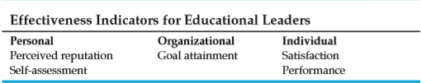

Fiedler’s Contingency Model of Leadership:
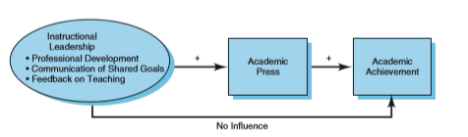
Fiedler (1967) constructed the first major theory to propose specific contingency relationships in the study of leadership. Lacking a behavior component, the least preferred co-worker model uses leader style as a trait, three indicators of situational control, and effectiveness.

Leadership style:
is determined by the motivational system of the leader, that is, the underlying needs structure that motivates behavior in various interpersonal situations. The least preferred co-worker (LPC) scale is used to measure this trait. Using the LPC, a respondent selects the person with whom he or she works least well (least preferred co-worker) and then describes that individual on the scale. A person scoring high on the LPC describes the least preferred co-worker positively as being pleasant, loyal, warm, kind, efﬁcient, and so forth. In contrast, the individual scoring low on the LPC describes the least preferred co-worker negatively as being unpleasant, backbiting, cold, unkind, inefﬁcient, and so forth. The LPC score indicates the extent to which the individual sets a higher priority or value on task accomplishment (task-motivated) or on maintaining good interpersonal relations (relationship-motivated) (Fiedler and Garcia, 1987).
Situational control:
is the degree of power and inﬂ uence that leaders have to implement plans, decisions, and action strategies (Fiedler and Garcia, 1987). Situational control is determined by three factors. First, position power is the power that the organization confers on the leader for the purpose of getting the job done.
Examples include the extent to which a leader can reward and punish members and whether the group can depose the leader.
Second, task structure is the extent to which the task has clearly speciﬁed goals, methods, and standards of performance. The more structured the task, the more control the leader has in directing the group.
Third, leader-member relations is the extent to which the leader is accepted and respected by group members.
Two factors are important with respect to leader-member relations:
The quality of interpersonal relations between the leader and subordinates, and the level of informal authority granted to the leader. The quality of leader-member relations is the most important factor in determining the leader’s inﬂuence over group members, followed by task structure and position power.
Effectiveness:
in the least preferred co-worker theory is straightforward namely, the extent to which the group accomplishes its primary task.
In many of Fiedler’s studies, objective measures of group effectiveness are used net proﬁ t, cost per unit, percentage of wins, number of problems solved. If a reliable objective measure of group performance is not available, then performance ratings by the supervisor of the leader or group are used. But in all cases, leader effectiveness is determined by the degree to which the task is judged to be achieved.
Data collected before 1962, Fiedler developed three propositions for his contingency theory:
- In high-control situations, task-oriented leaders are more effective than relationship-oriented leaders.
- In moderate-control situations, relationship-oriented leaders are more effective than task-oriented leaders.
- In low-control situations, task-oriented leaders are more effective than relationship-oriented leaders.
Substitutes for Leadership Model:
Contingency and other models of leadership assume that some kind of formal hierarchical leadership is needed in organizations such as schools. Steven Kerr and John M. Jermier (1978) questioned this assumption and found that leadership made a difference in less than 50 percent of the cases they studied. They believed that a number of substitute factors lessened the effective exercise of leadership.
As Peter Gronn (2003) notes, Kerr and Jermier claimed that in many situations, an individual’s leadership acts are canceled, replaced with surrogates, or become pointless. To explain their ﬁndings and ideas, Kerr and Jermier created the substitutes for leadership model . Substitutes are things that make person-oriented and task-oriented behavior unnecessary and redundant. In other words, substitutes are situational aspects that replace or reduce a leader’s ability to inﬂ uence the attitudes, perceptions, or behaviors of followers.

Three factors have the potential to act as leader substitutes (Kerr and Jermier, 1978; Keller, 2006):
1.Characteristics of subordinates :their abilities, training, experience and knowledge, professional orientation, and indifference toward rewards.
2.Characteristics of the task: structured routine work, intrinsically satisfying tasks, and feedback provided by the task.
3.Characteristics of the organization: formalization of roles and procedures, ﬂexibility of rules and policies, work group cohesiveness and autonomy, and spatial distance between the administrator.

