Classification Of Carbohydrates

Types of Carbohydrates
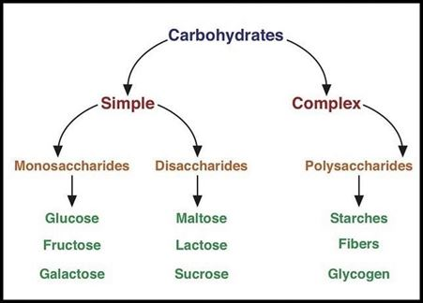
The different types of carbohydrates can be classified on the basis of their behavior on hydrolysis. They are mainly classified into three groups:
- Monosaccharides
- Disaccharides
- Polysaccharides
Monosaccharides
Monosaccharide carbohydrates are those carbohydrates that cannot be hydrolyzed further to give simpler units of polyhydroxy aldehyde or ketone. If a monosaccharide contains an aldehyde group then it is called aldose and on the other hand, if it contains a keto group then it is called a ketose.
Function of Monosaccharide
Monosaccharides have many functions within cells. First and foremost, monosaccharide are used to produce and store energy. Most organisms create energy by breaking down the monosaccharide glucose, and harvesting the energy released from the bonds. Other monosaccharide are used to form long fibers, which can be used as a form of cellular structure. Plants create cellulose to serve this function, while some bacteria can produce a similar cell wall from slightly different polysaccharides. Even animal cells surround themselves with a complex matrix of polysaccharides, all made from smaller monosaccharide.
Monosaccharide Structure
All monosaccharide have the same general formula of (CH₂O)_{n}, which designates a central carbon molecule bonded to two hydrogen’s and one oxygen. The oxygen will also bond to a hydrogen, creating a hydroxyl group. Because carbon can form 4 bonds, several of these carbon molecules can bond together. One of the carbons in the chain will form a double bond with an oxygen, which is called a carbonyl group. If this carbonyl occurs at the end of the chain, the monosaccharide is in the aldose family. If the carboxyl group is in the middle of the chain, the monosaccharide is in the ketose family.

Examples of Monosaccharide
Glucose
Glucose is an important monosaccharide in that it provides both energy and structure to many organism. Glucose molecules can be broken down in glycolysis, providing energy and precursors for cellular respiration. If a cell does not need any more energy at the moment, glucose can be stored by combining it with other monosaccharide. Plants store these long chains as starch, which can be disassembled and used as energy later. Animals store chains of glucose in the polysaccharide glyocogen, which can store a lot of energy.
Glucose can also be connected in long strings of monosaccharide to form polysaccharides that resemble fibers. Plants typically produce this as cellulose. Cellulose is one of the most abundant molecules on the planet, and if we could weigh all of it at once it would weigh millions of tons. Each plant uses cellulose to surround each cell, creating rigid cell walls that help the plants stand tall and remain turgid. Without the ability of monosaccharide to combine into these long chains, plants would be flat and squishy.
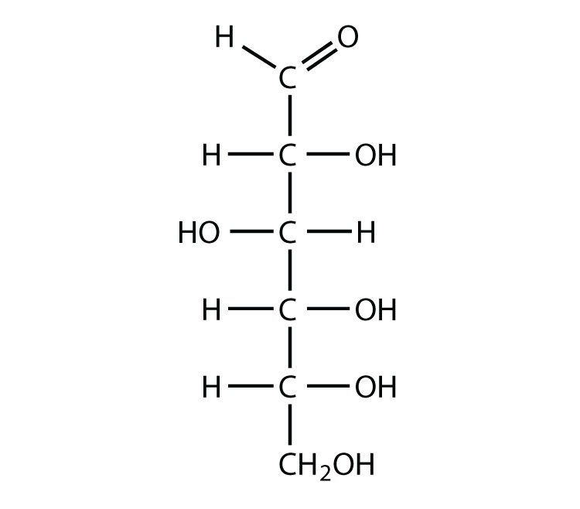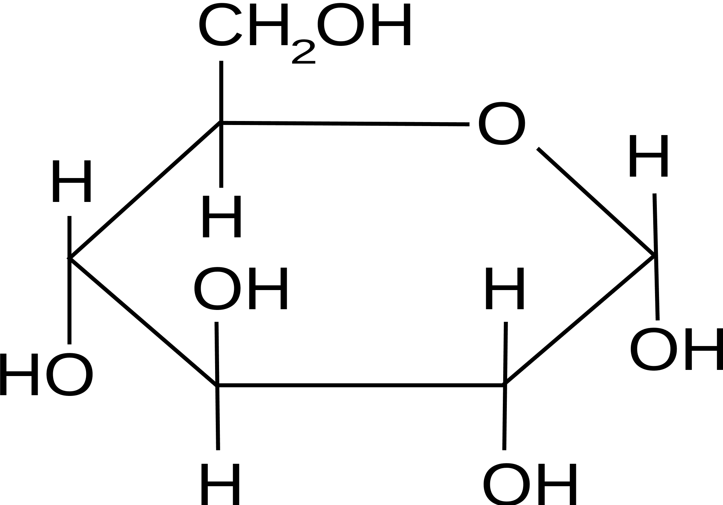
Fructose
Although almost identical to glucose, fructose is a slightly different molecule. The formula ((CH₂O)₆) is the same, but the structure is much different.
Notice that instead of the carbonyl group being at the end of the molecule, as in glucose, it is the second carbon down. This makes fructose a ketose, instead of an aldose. Like glucose, fructose still has 6 carbons, each with a hydroxyl group attached. However, because the double bonded oxygen in fructose exists in a different place, a slightly different shaped ring is formed. In nature, this makes a big difference in how the sugar is processed. Most reactions in cells are catalyzed by specific enzymes. Different shaped monosaccharide each need a specific enzyme to be broken down.
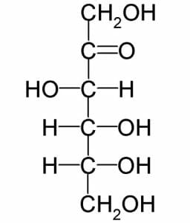
Fructose, because it is a monosaccharide, can be combined with other monosaccharide to form oligosaccharides. A very common disaccharide made by plants is sucrose. Sucrose is one fructose molecule connected to a glucose molecule through a glycosidic bond.
Galactose
Galactose is a monosaccharide produced in many organisms, especially mammals. Mammals use galactose in milk, to give energy to their offspring. Galactose is combined with glucose to form the disaccharide lactose. The bonds in lactose hold a lot of energy, and special enzymes are created by newborn mammals to break these bonds apart. Once being weaned of their mother’s milk, the enzymes that break lactose down into glucose and galactose monosaccharide are lost.
Humans, being the only mammal species that consumes milk in adulthood, has developed some interesting enzyme functions. In populations that drink a lot of milk, most adults are able to digest lactose most of their lives. In populations that do not drink milk after being weaned, lactose-intolerance afflicts nearly the whole population. Although the monosaccharides could be broken down individually, the molecule lactose can no longer be digested. The symptoms of lactose-intolerance (abdominal cramps and diarrhea) are caused by toxins produced by bacteria in the gut digesting the excess lactose. The toxins and excess nutrients they create raised the total amount of solutes in the intestines, making them retain more water to keep a stable pH.

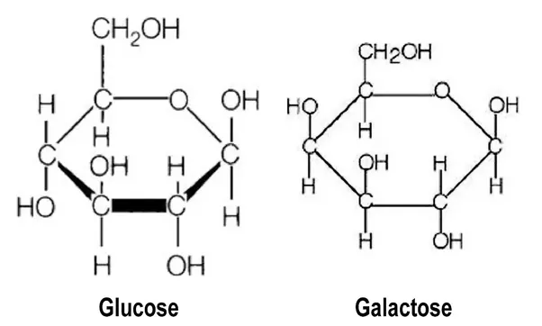

https://biologydictionary.net/monosaccharide/

Disaccharide

Disaccharide Definition
A disaccharide, also called a double sugar, is a molecule formed by two monosaccharides, or simple sugars. Three common disaccharides are sucrose, maltose, and lactose. They have 12 carbon atoms, and their chemical formula is C₁₂H₂₂O₁₁. Other, less common disaccharides include lactulose, trehalose, and cellobiose. Disaccharides are formed through dehydration reactions in which a total of one water molecule is removed from the two monosaccharide.

Functions of Disaccharides
Disaccharides are carbohydrates found in many foods and are often added as sweeteners. Sucrose, for example, is table sugar, and it is the most common disaccharide that humans eat. It is also found in other foods like beetroot. When disaccharides like sucrose are digested, they are broken down into their simple sugars and used for energy. Lactose is found in breast milk and provides nutrition for infants. Maltose is a sweetener that is often found in chocolates and other candies.
Plants store energy in the form of disaccharides like sucrose and it is also used for transporting nutrients in the phloem. Since it is an energy storage source, many plants such as sugar cane are high in sucrose. Trehalose is used for transport in some algae and fungi. Plants also store energy in polysaccharides, which are many monosaccharide put together. Starch is the most common polysaccharide used for storage in plants, and it is broken down into maltose. Plants also use disaccharides to transport monosaccharide like glucose, fructose, and galactose between cells. Packaging monosaccharide into disaccharides makes the molecules less likely to break down during transport.

Formation and Breakdown of Disaccharides
When disaccharides are formed from monosaccharide, an -OH (hydroxyl) group is removed from one molecule and an H (hydrogen) is removed from the other. Glycosidic bonds are formed to join the molecules; these are covalent bonds between a carbohydrate molecule and another group (which does not necessarily need to be another carbohydrate). The H and -OH that were removed from the two monosaccharide join together to form a water molecule, H₂O. For this reason, the process of forming a disaccharide from two monosaccharide is called a dehydration reaction or condensation reaction.
When disaccharides are broken down into their monosaccharide components via enzymes, a water molecule is added. This process is called hydrolysis. It should not be confused with the process of dissolution, which happens when sugar is dissolved in water, for example. The sugar molecules themselves do not change structure when they are dissolved. The solid sugar simply turns into liquid and becomes a solute, or a dissolved component of a solution.

Examples of Disaccharides

Sucrose
Sucrose, commonly known as table sugar in its refined form, is a disaccharide found in many plants. It is made up of the monosaccharide glucose and fructose. In the form of sugar, sucrose is a very important component of the human diet as a sweetener. Sugar was first extracted and purified from sugar cane in India as early as the 8th Century BCE. In fact, the word candy gets its name in part from the word khanda, which was a name for sugar crystals in Sanskrit. Today, around 175 metric tons of sugar are produced each year.
People with congenital sucrase-isomaltase deficiency (CSID) are sucrose intolerant and cannot digest it well because they are missing the enzyme sucrose-isomaltase. Some people with CSID have trouble digesting starches as well. A person who is sucrose intolerant must limit sucrose as much as possible, and they may have to take
medications.
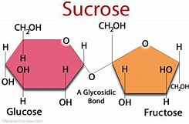

Maltose
Maltose, also known as malt sugar, is formed from two glucose molecules. Malt is formed when grains soften and grow in water, and it is a component of beer, starchy foods like cereal, pasta, and potatoes, and many sweetened processed foods. In plants, maltose is formed when starch is broken down for food. It is used by germinating seeds in order to grow.

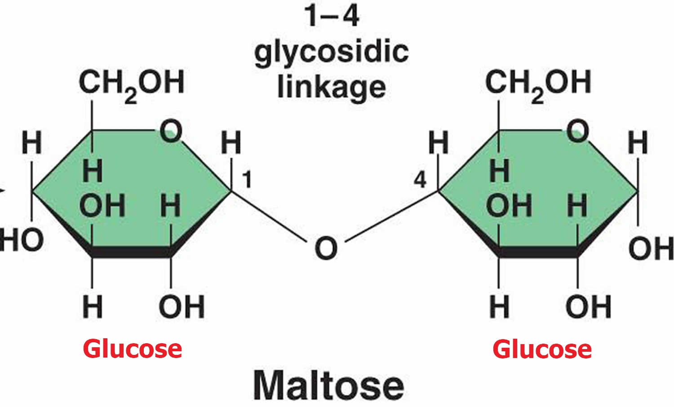

Lactose
Lactose, or milk sugar, is made up of galactose and glucose. The milk of mammals is high in lactose and provides nutrients for infants. Most mammals can only digest lactose as infants, and lose this ability as they mature. In fact, humans that are able to digest dairy products in adulthood actually have a mutation that allows them to do so. This is why so many people are lactose intolerant; humans, like other mammals, did not have the ability to digest lactose past childhood until this mutation became prevalent in certain populations around 10,000 years ago. Today, the number of people who are lactose intolerant varies widely between populations, ranging from <10% in Northern Europe to 95% in parts of Africa and Asia. The traditional diets of different cultures reflect this in the amount of dairy consumed.
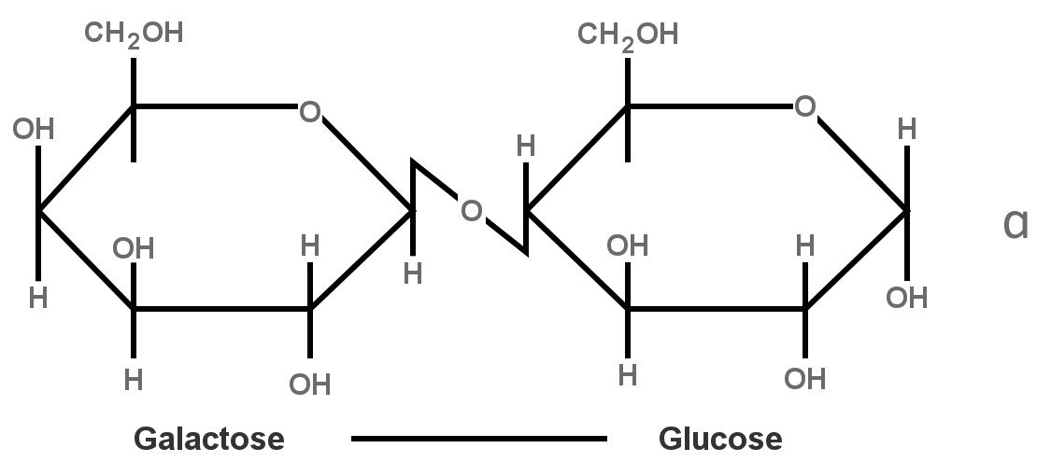

Polysaccharide

Polysaccharide Definition
A polysaccharide is a large molecule made of many smaller monosaccharide. Monosaccharides are simple sugars, like glucose. Special enzymes bind these small monomers together creating large sugar polymers, or polysaccharides. A polysaccharide is also called a glycan. A polysaccharide can be a homopolysaccharide, in which all the monosaccharide are the same, or a heteropolysaccharide in which the monosaccharide vary. Depending on which monosaccharide are connected, and which carbons in the monosaccharide connects, polysaccharides take on a variety of forms. A molecule with a straight chain of monosaccharide is called a linear polysaccharide, while a chain that has arms and turns is known as a branched polysaccharide.

Functions of a Polysaccharide
Depending on their structure, polysaccharides can have a wide variety of functions in nature. Some polysaccharides are used for storing energy, some for sending cellular messages, and others for providing support to cells and tissues.

Storage of Energy
Many polysaccharides are used to store energy in organisms. While the enzymes that produce energy only work on the monosaccharide stored in a polysaccharide, polysaccharides typically fold together and can contain many monosaccharides in a dense area. Further, as the side chains of the monosaccharide form as many hydrogen bonds as possible with themselves, water cannot intrude the molecules, making them hydrophobic. This property allows the molecules to stay together and not dissolve into the cytosol. This lowers the sugar concentration in a cell, and more sugar can then be taken in. Not only do polysaccharides store the energy, but they allow for changes in the concentration gradient, which can influence cellular uptake of nutrients and water.

Cellular Communication
Many polysaccharides become glycoconjugates when they become covalently bonded to proteins or lipids. Glycolipids and glycoproteins can be used to send signals between and within cells. Proteins headed for a specific organelle may be “tagged” by certain polysaccharides that help the cell move it to a specific organelle. The polysaccharides can be identified by special proteins, which then help bind the protein, vesicle, or other substance to a microtubule. The system of microtubules and associated proteins within cells can take any substance to its destined location once tagged by specific polysaccharides. Further, multi-cellular organisms have immune systems driven by the recognition of glycoproteins on the surface of cells. The cells of a single organisms will produce specific polysaccharides to adorn its cells with. When the immune system recognizes other polysaccharides and different glycoproteins, it is set into action, and destroys the invading cells.

Cellular Support
By far one of the largest roles of polysaccharides is that of support. All plants on Earth are supported, in part, by the polysaccharide cellulose. Other organisms, like insects and fungi, use chitin to support the extracellular matrix around their cells. A polysaccharide can be mixed with any number of other components to create tissues that are more rigid, less rigid, or even materials with special properties. Between chitin and cellulose, both polysaccharides made of glucose monosaccharide, hundreds of billions of tons are created by living organisms every year. Everything from the wood in trees, to the shells of sea creatures is produced by some form of polysaccharide. Simply by rearranging the structure, polysaccharides can go from storage molecules to much stronger fibrous molecules. The ring structure of most monosaccharide aids this process, as seen below.

Structure of a Polysaccharide
All polysaccharides are formed by the same basic process: monosaccharide is connected via glycosidic bonds. When in a polysaccharide, individual monosaccharide is known as residues. Seen below are just some of the many monosaccharides created in nature. Depending on the polysaccharide, any combination of them can be combined in series.
The structure of the molecules being combined determines the structures and properties of the resulting polysaccharide. The complex interaction between their hydroxyl groups (OH), other side groups, the configurations of the molecules, and the enzymes involved all affect the resulting polysaccharide produced. A polysaccharide used for energy storage will give easy access to the monosaccharide, while maintaining a compact structure. A polysaccharide used for support is usually assembled as a long chain of monosaccharide, which acts as a fiber. Many fibers together produce hydrogen bonds between fibers that strengthen the overall structure of the material, as seen in the image below.

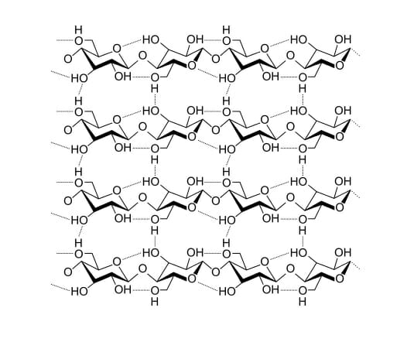
The glycosidic bonds between monosaccharide consist of an oxygen molecule bridging two carbon rings. The bond is formed when a Hydroxyl group is lost from the carbon of one molecule, while the hydrogen is lost by the hydroxyl group of another monosaccharide. The carbon on the first molecule will substitute the oxygen from the second molecule as its own, and glycosidic bond is formed. Because two molecules of hydrogen and one oxygen are expelled, the reaction produced a water molecule as well. This type of reaction is called a dehydration reaction as water is removed from the reactants.

Examples of a Polysaccharide

Cellulose and Chitin
Cellulose and chitin are both structural polysaccharides that consist of many thousand glucose monomers combined in long fibers. The only difference between the two polysaccharides are the side-chains attached to the carbon rings of the monosaccharide. In chitin, the glucose monosaccharide has been modified with a group containing more carbon, nitrogen, and oxygen. The side chain creates a dipole, which increases hydrogen bonding. While cellulose can produce hard structures like wood, chitin can produce even harder structures, like shell, limestone and even marble when compressed.
Both polysaccharides form as long, linear chains. These chains form long fibers, which are deposited outside the cell membrane. Certain proteins and other factors help the fibers weave into a complex shape, which is held in place by hydrogen bonds between side chains. Thus, simple molecules of glucose that were once used for energy storage can be converted into molecules with structural rigidity. The only difference between the structural polysaccharides and storage polysaccharides are the monosaccharide used. By changing the configuration of glucose molecules, instead of a structural polysaccharide, the molecule will branch and store many more bonds in a smaller space. The only difference between cellulose and starch is the configuration of the glucose used.

Glycogen and Starch
Probably the most important storage polysaccharides on the planet, glycogen and starch are produced by animals and plants, respectively. These polysaccharides are formed from a central starting point, and spiral outward, due to their complex branching patterns. With the help of various proteins that attach to individual polysaccharides, the large branched molecules form granules, or clusters. This can be seen in the image below of glycogen molecules and the associated proteins, seen in the middle.
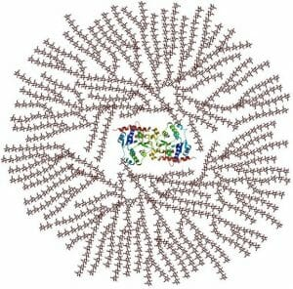
When a glycogen or starch molecule is broken down, the enzymes responsible start at the ends furthest from the center. This is important, as you will notice that because of the extensive branching there are only 2 starting points, but many ends. This means the monosaccharide can be quickly extracted from the polysaccharide and be utilized for energy. The only difference between starch and glycogen is the number of branches that occur per molecule. This is caused by different parts of the monosaccharide forming bonds, and different enzymes acting on the molecules. In glycogen a branch occurs every 12 or so residues, while in starch a branch occurs only every 30 residues.

