Name: ________________________________
Summary and Main Idea Worksheet 1

Directions: Read each passage and…  1. Create a title for the passage related to the main idea.  2. Accurately summarize the text.  3. Your summary must describe all key ideas from the text.  4. Do not include opinions or personal info in your summary.  5. Highlight or underline key ideas in each passage.  Picture this: a herd of elephants flies past you at sixty miles per | 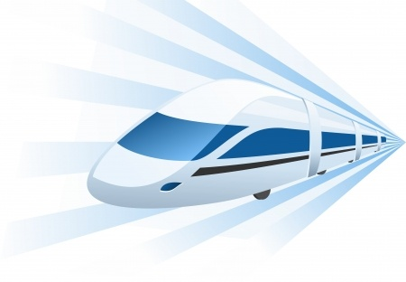
hour, followed by a streak of tigers, a pride of lions, and a bunch of clowns. What do you see? It must be a circus train! One of the first uses of the circus train is credited to W.C. Coup. He partnered with P.T. Barnum in 1871 to expand the reach of their newly combined shows using locomotives. Before circus trains, these operators had to lug around all of their animals, performers, and equipment with a team of more than 600 horses. Since there were no highways, these voyages were rough and took a long time. Circuses would stop at many small towns between the large venues. Performing at many of these small towns was not very profitable. Because of these limitations, circuses could not grow as large as the imaginations of the operators. After they began using circus trains, Barnum and Coup only brought their show to large cities. These performances were much more profitable and the profits went toward creating an even bigger and better circus. Multiple rings were added and the show went on. Today, Ringling Bros. and Barnum and Bailey Circus still rely on the circus train to transport their astounding show, but now they use two.

1. Main idea related title for the passage:

2. Summarize the passage in your own words: _______________________________________________

_____________________________________________________________________________________

_________________________________________________________________________________________

How do you say “Holy cow” in French? The fastest thing in France may just be the fastest ground transportation in the world. The TGV (Train à Grande Vitesse: French for very high speed) is France’s national high speed rail service. On April 3rd, 2007, a TGV test train set a record for the fastest wheeled train, reaching 357.2 miles per hour. In mid 2011, TGV trains operated at the highest speed in passenger train service in the world, regularly reaching 200 miles per hour. But what you may find most shocking is that TGV trains run on electric power not petrol. Now if you’ll excuse me; I have a record to catch.

3. Main idea related title for the passage:

4. Summarize the passage in your own words: _______________________________________________

_____________________________________________________________________________________

_________________________________________________________________________________________
Giddy-up, cowboys and girls! In the Southwest during early half of the 1800s, cows were only worth 2 or 3 dollars a piece. They roamed wild, grazed off of the open range, and were abundant. Midway through the century though, railroads were built and the nation was connected. People could suddenly ship cows in freight trains to the Northeast, where the Yankees had a growing taste for beef. Out of the blue, the same cows that were once worth a couple of bucks were now worth between twenty and forty dollars each, if you could get them to the train station. It became pretty lucrative to wrangle up a drove of cattle and herd them to the nearest train town, but it was at least as dangerous as it was profitable. Cowboys were threatened at every turn. They faced cattle rustlers, stampedes and extreme weather, but kept pushing those steers to the train station. By the turn of the century, barbed wire killed the open range and some may say the cowboy too, but it was the train that birthed him.

5. Main idea related title for the passage:

6. Summarize the passage in your own words: _______________________________________________

_____________________________________________________________________________________

_________________________________________________________________________________________

_________________________________________________________________________________________

Electric trolley cars or trams were once the chief mode of public transportation in the United States. Though they required tracks and electric cables to run, these trolley cars were clean and comfortable. In 1922, auto manufacturer General Motors created a special unit to replace electric trolleys with cars, trucks, and buses. Over the next decade, this group successfully lobbied for laws and regulations that made operating trams more difficult and less profitable. In 1936 General Motors created several front companies for the purpose of purchasing and dismantling the trolley car system. They received substantial investments from Firestone Tire, Standard Oil of California, Phillips Petroleum, and other parties invested in the automotive industry. Some people suspect that these parties wanted to replace trolley cars with buses to make public transportation less desirable, which would then increase automobile sales. The decline of the tram system in North America could be attributed to many things—labor strikes, the Great Depression, regulations that were unfavorable to operators—but perhaps the primary cause was having a group of powerful men from rival sectors of the auto industry working together to ensure its destruction. Fill it up, please.

7. Main idea related title for the passage:

8. Summarize the passage in your own words: _______________________________________________

_____________________________________________________________________________________

_________________________________________________________________________________________

_________________________________________________________________________________________

