What is Impact load? And Impact stress Formula?
Sometimes machine members are subjected to load with a sudden impact due to falling or hitting one object on another. The load produced due to these actions is known as the Impact load. The stress produced in the machine members due to the Impact load is known as the Impact stress.
Usually, there are two types of applying loads, one is gradually applied load and the second one is suddenly applied/Impact load. An impact load is produced due to falling or hitting one object on another. With the following example, we can understand it in a better way.

Impact Stress due to Impact Load
Consider a bar which is hanged to a rigid support as shown in fig and carrying a load of W at a height h and falling suddenly on the bottom plate called collar.
As the weight W fell on the collar which is fixed at the bottom of the bar, An impact load is produced on the collar, it leads the vertical bar to elongate. The deformation in the length of the bar is said as the ẟl. An impact stress is also induced in the Vertical bar which is represented by σi.
Impact Stress Formula Derivation
Consider the following figure
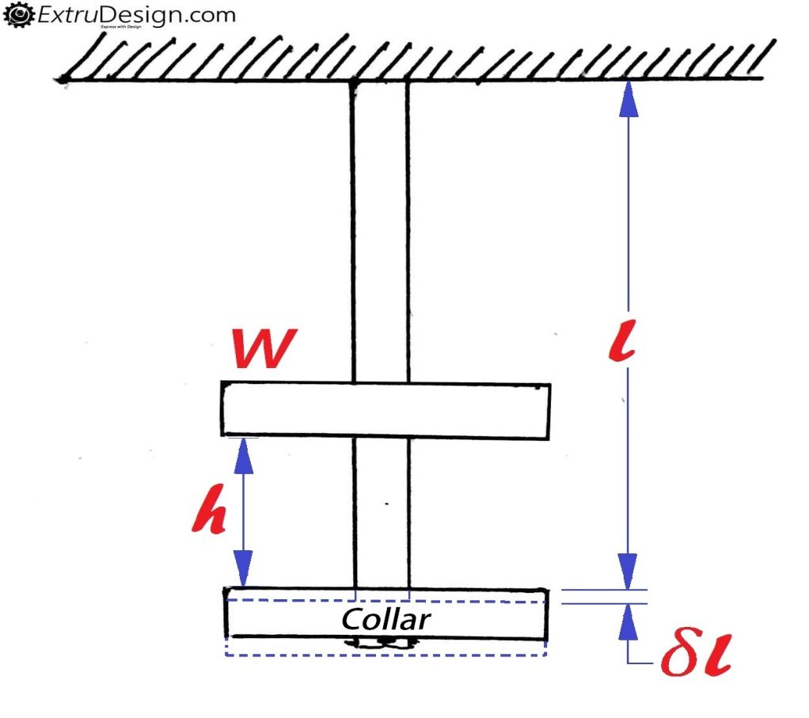
l = Length of the bar.
𝛿l = Deformation of the bar.
E = Young’s modulus of the material of the bar.
h = Height at which the load falls.
A = Cross-sectional area of the bar.
σ_{i} = Impact Stress-induced in the bar due to the application of the impact load.
W = Force at which the deflection is produced.
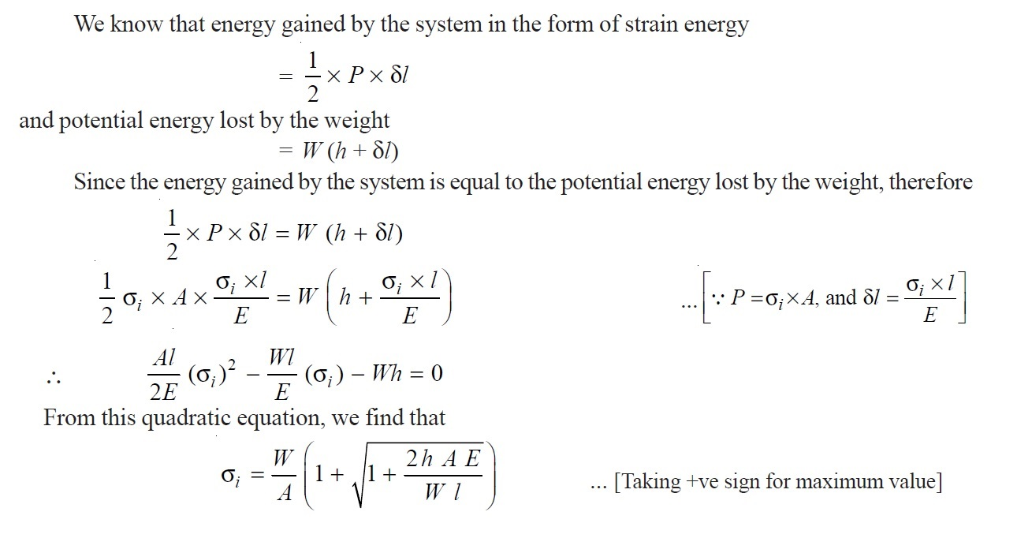

Conclusion
σ_{i} = 2W/A ( ∴Where h = 0)
This means that the stress in the bar when the load is applied suddenly is double of the stress induced due to gradually applied load.

Application of Impact Load in Analysis problems
A common type of structural analysis problem results from an impact load. The impact could be caused by a weight falling on the design object or possibly from the design object falling and striking a hard surface. In both cases, the loads are not obvious but can be easily derived from our knowledge of mechanics. We will start by looking at a weight dropped from a height onto our design object. We know that the weight will deform the design object when it strikes it. The design object will behave like a spring being compressed. The kinetic energy of the falling weight will be transferred to the design object and stored as compression.
Figure 1 shows both a weight suspended above a spring and the same weight and spring after the weight has fallen on the spring and stopped its downward motion. We will assume the weight is at rest before it starts to fall. All if its kinetic energy is derived from the fall. We can write an energy balance as:
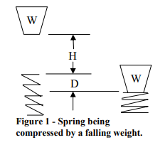
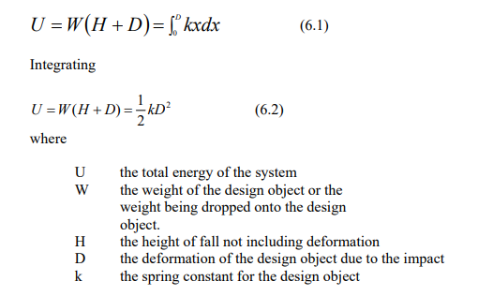
If we assume the deformation of the spring is small compared to the height the weight is dropped then the energy acquired by the weight dropping D is negligible. Our equation becomes

This equation can be used for the problem where a weight is dropping onto the design object or the design object is dropping onto a hard surface. The spring represents the deformation of the design object when it strikes a hard object or an object is dropped onto it. Looking at equation 6.4, the problem statement will usually tell us W and H but we do not know k. We can determine k by using Hook’s law. It says that the force applied

