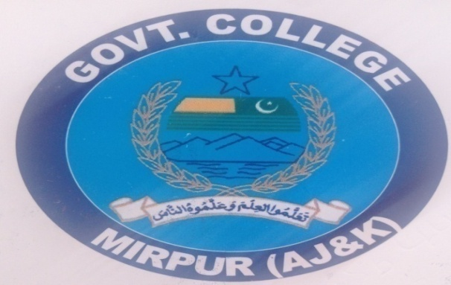

Assignment No. :
(1)

Class:
BS-ENG-IV

Subject:
Public Administration
Topic:
“Administrative Structure of Pakistan”

Submitted to:
“Madam Farmeela”

Submitted by:
Asad Mahmood
Roll No. 05

Administrative Structure of Pakistan

The government in Pakistan is composed of the executive, legislative & judicature branches

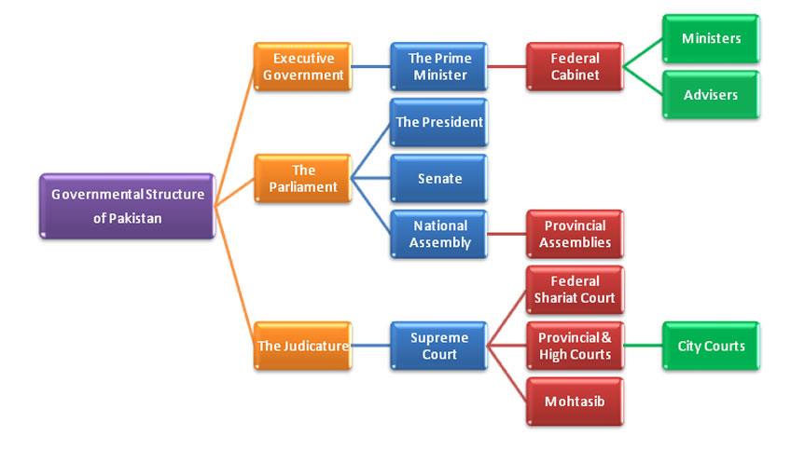

The Executive Government

Prime Minister of Pakistan

The Prime Minister of Pakistan is the Head of Government of Pakistan and designated as the Chief Executive of the Republic, who leads the executive branch of the government, oversees the economical growth, heads the Council of Common Interests as well as the Cabinet, and is vested with the command authority over the nuclear arsenals. He is also a leader of the nation who has control over all matters of internal and foreign policy.
The Prime Minister is appointed by the members of the National Assembly through a vote. The Prime Minister is assisted by the Federal Cabinet, a Council of Ministers whose members are appointed by the President on the advice of the Prime Minister. The Federal Cabinet comprises of the ministers, ministers of state, and advisers.

The Parliament

The bicameral federal legislature consists of the Senate (upper house) and National Assembly (lower house). According to Article 50 of the Constitution, the National Assembly, the Senate and the President together make up a body known as the Majlis-i-Shoora (Council of Advisers).

The President of Pakistan

The President of Pakistan is the ceremonial Head of the State and a figurehead who is a civilian Commander-in-Chief of the Pakistan Armed Forces as per the Constitution of Pakistan and a leader of the nation.
The President is kept informed by the Prime Minister on all the matters of internal and foreign policy as well as on all legislative proposals. Constitution of Pakistan vest the President the powers of granting the pardons, reprieves, and the control of the military; however, all appointments at higher commands of the military must be made by President on a "required and necessary" on consultation and approval from the Prime Minister. In addition, the constitution prohibits the President from exercising the authority of running the government.

The Senate

The Senate is a permanent legislative body with equal representation from each of the four provinces, elected by the members of their respective provincial assemblies. There are representatives from the Federally Administered Tribal Areas (FATA) and from Islamabad Capital Territory. The Chairman of the Senate, under the constitution, is next in line to act as President should the office become vacant and until such time as a new president can be formally elected.
Both the Senate and the National Assembly can initiate and pass legislation except for finance bills. Only the National Assembly can approve the federal budget and all finance bills. In the case of other bills, the President may prevent passage unless the legislature in joint sitting overrules the President by a majority of members of both houses present and voting. Unlike the National Assembly, the Senate cannot be dissolved by the President.

National Assembly of Pakistan

Members of the National Assembly are elected by universal adult suffrage (eighteen years of age). Seats are allocated to each of the four provinces, the Federally Administered Tribal Areas, and Islamabad Capital Territory on the basis of population. National Assembly members serve for the parliamentary term, which is five years, unless they die or resign sooner, or unless the National Assembly is dissolved.
Although the vast majority of the members are Muslim, about 5% of the seats are reserved for minorities, including Christians, Hindus, and Sikhs. There are also 50+ special seats for women now, and women are selected by their respective party heads.

The Jurisdiction

The Judiciary includes the Supreme Court, Provincial High Courts, District & Sessions Courts, Civil and Magistrate Courts exercising civil and criminal jurisdiction. Some Federal and Provincial Courts and tribunals such as Services Court, Income Tax & Excise Court, Banking Court and Boards of Revenue's Tribunals are established in all provinces as well.

Supreme Court

The Supreme Court has original, appellate, and advisory jurisdiction. The Chief Justice of the Supreme Court is appointed by the President; the other Supreme Court judges are appointed by the President after consultation with the Chief Justice. The Chief Justice and other Judges of the Supreme Court may remain in office until age of sixty-eight years.

Federal Shariat Court of Pakistan

The Federal Shariat Court (FSC) of Pakistan is a court which has the power to examine and determine whether the laws of the country comply with Shari'a law. It consists of 8 Muslim judges appointed by the President of Pakistan after consulting the Chief Justice of this Court. Of the 8 judges, 3 are required to be Ulema who are well versed in Islamic law. The judges hold office for a period of 3 years, which may eventually be extended by the President.
If any part of the law is declared to be against Islamic law, the government is required to take necessary steps to amend such law appropriately. The court also exercises revisional jurisdiction over the criminal courts, deciding Hudood cases. The decisions of the court are binding on the High Courts as well as subordinate judiciary. The court appoints its own staff and frames its own rules of procedure.

Provincial and High Courts

Currently all four provinces; Punjab, Sindh, Khyber Pakhtun Khwah and Baluchistan have High Courts. After the approval of 18th Constitutional Amendment in April 2010, a new High Court is established at Federal Capital Islamabad with the name of Islamabad High Court. Judges appointments are proposed by a Parliamentary Commission.
In addition, there are special courts and tribunals to deal with specific kinds of cases, such as drug courts, commercial courts, labor courts, traffic courts, an insurance appellate tribunal, an income tax appellate tribunal, and special courts for bank offences. There are also special courts to try terrorists. Appeals from special courts go to high courts except for labor and traffic courts, which have their own forums for appeal. Appeals from the tribunals go to the Supreme Court.

Ombudsman / Mohtasib

A further feature of the judicial system is the office of Mohtasib (Ombudsman), which is provided for in the constitution. The office of Mohtasib was established in many early Muslim states to ensure that no wrongs were done to citizens. Appointed by the president, the Mohtasib holds office for four years; the term cannot be extended or renewed.
The Mohtasib's purpose is to institutionalize a system for enforcing administrative accountability, through investigating and rectifying any injustice done to a person through maladministration by a federal agency or a federal government official. The Mohtasib is empowered to award compensation to those who have suffered loss or damage as a result of maladministration. This institution is designed to bridge the gap between administrator and citizen, to improve administrative processes and procedures, and to help curb misuse of discretionary powers.

Administrative units of Pakistan:

Administrative units of Pakistan
پاکستان کی انتظامی اکائیاں
Category | Federated state
Location | Islamic Republic of Pakistan
Number | 4 Provinces  2 Autonomous Territories  1 Federal Territory
Populations | Least 2,441,523 (Gilgit-Baltistan) Most 110,012,442 (Punjab)
Areas | Smallest 906.0 km²(349.81 sq mi) (Islamabad Capital Territory) Largest347,200 km² (134,050 sq mi) (Balochistan)
Subdivisions | Divisions, Districts, Tehsils, Union Council

The administrative units of Pakistan (Urdu: پاکستان کی انتظامی اکائیاں‎) consist of four provinces (Balochistan, Khyber Pakhtunkhwa, Punjab, and Sindh), two autonomous territories (Azad Jammu and Kashmir, Gilgit-Baltistan) and one federal territory (Islamabad Capital Territory). Each province and territory is subdivided into divisions, which are further subdivided into districts, which are further subdivided into tehsils, or taluka, which are further subdivided into union councils.

History of Pakistan’s Administrative Structure:
- Pakistan's provinces and territories were inherited from British India at independence on 14 August 1947.
- 2 days after independence, the Muslim-majority district of Murshidabad in Bengal moved from Pakistan to India due to an award by the Radcliffe Commission.
- In 1947, Pakistan consisted of two wings, which were separated by 1600 kilometres of Indian territory. The western wing consisted of the merger of Northwest Frontier Province, West Punjab, and Sindh, the Baluchistan Chief Commissioners Province, thirteen princely state. The eastern wing consisted of East Bengal, the Chittagong Hill Tracts and Sylhet from the former British Raj province of Assam.
- In 1948, Karachi was separated from Sindh to form the Federal Capital Territory.
- In 1950, the Northwest Frontier Province absorbed the princely states of Amb and Phulra while West Punjab renamed itself to Punjab.
- In 1952, the four princely states in the southwest formed the Baluchistan States Union.
- In 1955, the One Unit Policy was launched by Muhammad Ali Bogra, whereby all the provinces and princely states of the western wing were merged and formed West Pakistan, with Lahore as the provincial capital. Simultaneously, East Bengal (including Sylhet and the Hill Tracts) was renamed to East Pakistan, with Dacca as the provincial capital. The One Unit Policy aimed to reduce expenditure and to eliminate provincial prejudices, but the military coup of 1958 signaled difficulties when the first military President, Ayub Khan, abolished the office of Chief Minister of West Pakistan in favour of Governor's rule.
- On 7 September 1958, after four years of negotiations, including six months of intense negotiations, Pakistan purchased the Gwadarenclave from the government of Oman for 5.5 billion rupees/ USD $3 million (approx. $22,410,311.42 in 2017). Gwadar formally became part of Pakistan on 8 December 1958 after 174 years of Omani rule.
- In 1960, the federal capital moved from Karachi to Rawalpindi and in 1961, the Federal Capital Territory was merged into West Pakistan. In 1966, the capital was again moved to Islamabad. In 1962, Dacca was made the legislative capital of the country due to East Pakistan's high population.
- In 1963, Pakistan entered into a treaty with China to transfer part of the Gilgit Agency to China (Shaksgam Valley—the Trans-Karakoram Tract) with the provision that the settlement was subject to the final solution of the Kashmir dispute.
- In 1970, the second military President, Yahya Khan, abolished West Pakistan and established four new provinces: Sindh, Balochistan, Northwest Frontier Province and Punjab.
- In 1971, East Pakistan seceded to form Bangladesh in the Bangladesh Liberation War.
- In 1974, the remaining princely states of Hunza and Nagar were abolished and their territories merged into Gilgit Agency, to form the Northern Areas.
- In 1975, portions of the districts of Peshawar and Dera Ismail Khan were separated to form the Federally Administered Tribal Areas.
- In 1981, the region around Islamabad was separated from Punjab, and renamed to Islamabad Capital Territory.
- In August 2000, divisions were abolished as part of a plan to restructure local government, followed by elections in 2001. Many of the functions previously handled by the provinces had been transferred to the districts and tehsils. In 2008, the government restored the former divisions and appointed commissioners.
- In 2009, the Northern Areas were renamed to Gilgit-Baltistan and became a de facto province.
- In 2010, the Northwest Frontier Province was renamed to Khyber Pakhtunkhwa.
- In 2018, the National Assembly of Pakistan and Khyber Pakhtunkhwa Assembly passed the historic FATA Merger Bill - with the adoption of the Twenty-Fifth Amendment Act of 2018. On 31 May, the final step in the merger of the FATA with Khyber Pakhtunkhwa (KP) was completed, as President Mamnoon Hussain signed the 25th Constitutional Amendment Bill into law. Thus FATA status was abolished as a separate entity and was merged into Khyber Pakthunkhwa province.

Tiers of Pakistan
The diagram below outlines the six tiers of government:
Country
(i.e. Pakistan)
Province
(e.g. Punjab Province)
Division
(e.g. Rawalpindi Division)
District
(e.g. Jhelum District)
Tehsil
(e.g. Sohawa Tehsil)
Union Council
(e.g. Domeli UC)

Current Administrative Units of Pakistan:

English name | Urdu name | Abbreviation | Capital | Population  (2017) | Area  (km²)^{[10]} | Density  (per km²)
Azad Jammu and Kashmir | آزاد جموں و کشمیر | AJK | Muzaffarabad | 4,045,366 | 13,297 | 223.55
Balochistan | بلوچستان | BL | Quetta | 12,344,408 | 347,190 | 37.91
Gilgit-Baltistan | گلگت بلتستان | GB | Gilgit | 2,441,523 | 64,817 | 19.75
Islamabad Capital Territory | اسلام آباد دارالحکومت | ICT | Islamabad | 2,006,572 | 906 | 1,271.38
Khyber Pakhtunkhwa | خیبرپختونخوا | KP | Peshawar | 35,525,047 | 101,741 | 349.17
Punjab | پنجاب | PJ | Lahore | 110,012,442 | 205,344 | 445.01
Sindh | سندھ | SN | Karachi | 47,886,051 | 140,914 | 392.05
Pakistan | پاکستان | PK | Islamabad | 214,261,409 | 874,209 | 223.79

The End

