Citizenship education Report

University of Sargodha (Bhakkar)

Assignment Title: ______________________________________________
Report of project

Citizenship education and community engagement

______________________
Group III
Submitted by:

Submitted to:
Class:
______________________
Ma’am Mehlah Jabdeen

______________________
Bs Mathematics II

Dated:
June 08, 2020
_______________

Report
All the members participate in the project for its success as well as all members efforts for benefits of people. We tried our best for the success of the project. As the virus (covid-19) is spreading at very dangerous rate. The work of every member is described in the following:
Muhammad Shehzad (group leader):-
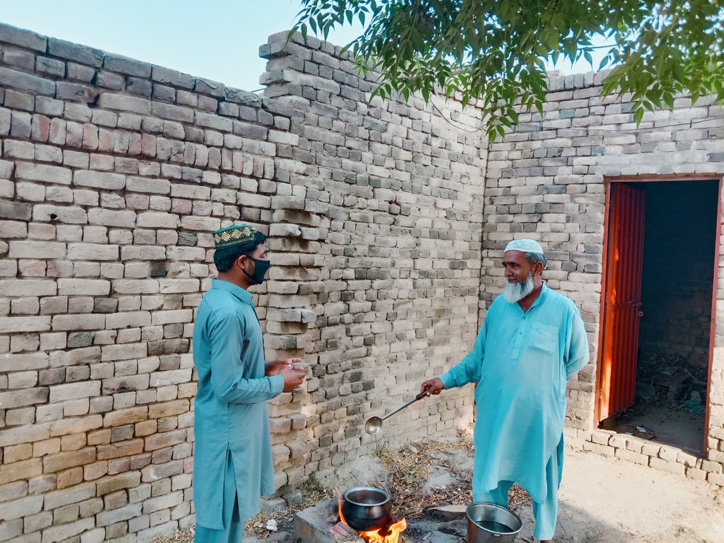
I worked for the benefits of villagers. My village is backward and most people are uneducated. The most difficult that I have done is that I went door to door to inform the people about this fatal virus. Now the cases in Pakistan exceed 1lac. But the villagers think the virus doesn’t exist. Even everybody work according to the daily routine. They did not have any fear about the virus. They have no concern about virus. I went door to door to inform the people about virus although my work in this project tough but I worked for my villagers. Some of them appreciate my effort but many of them discourage me. I did not give up and worked continuously. Some picture that I have captured during my work.

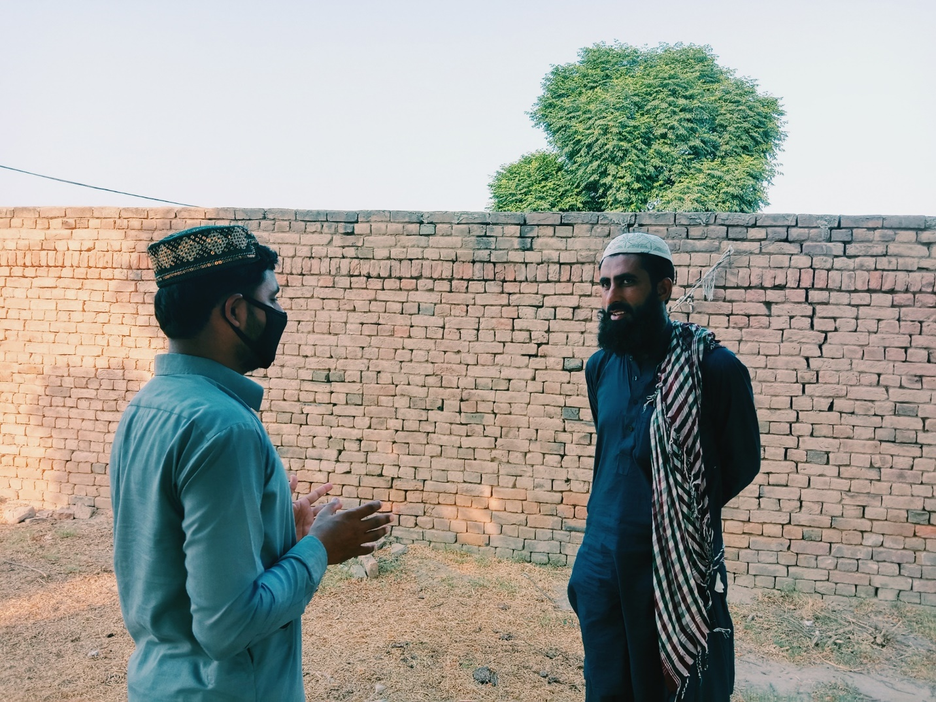

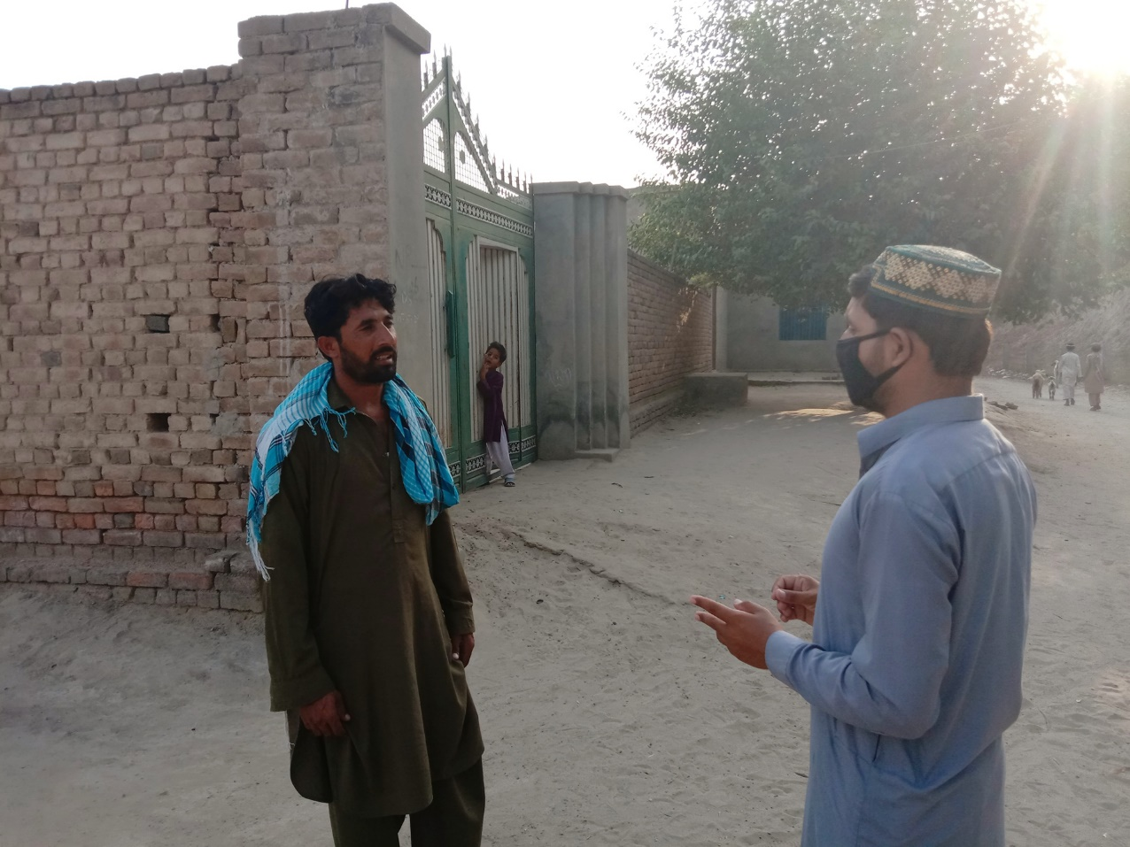

Why I choose survey in this project?
First I want to display charts on public places, but in the lockdown condition there were shortage of charts in my area. So I choose survey as it is best way to convey my message to people. First I observed the people. And I concluded that it is very necessary to inform people. On the occasion of Eid-ul-Fitar the people showed careless. During this occasion I captured some pictures shown below.

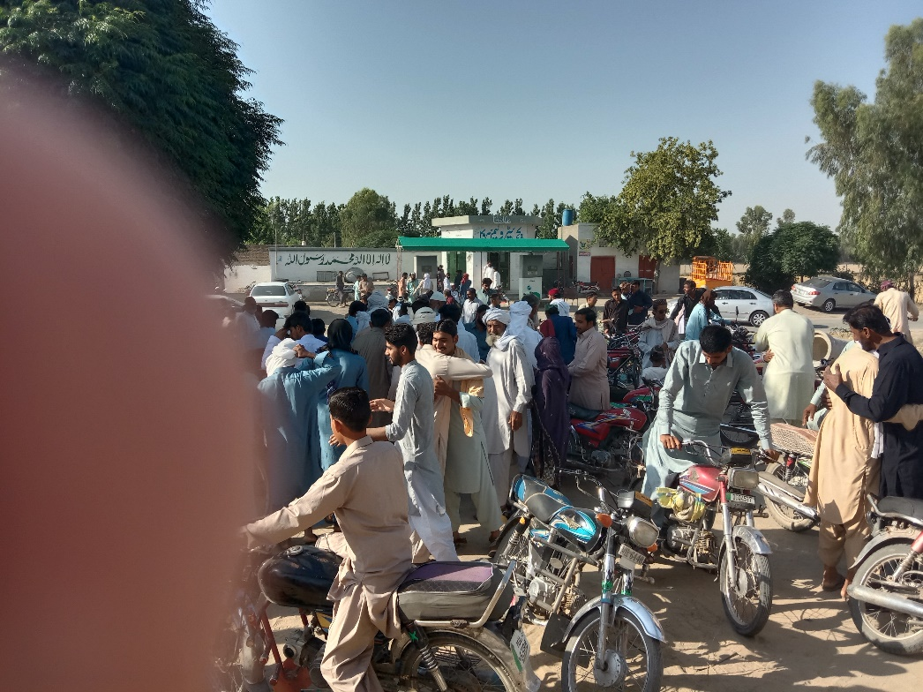

By seeing the above picture everyone realize that survey is the best option to inform people. That’s the solid reasons that why I chose survey.
Difficulties that I faced during project:
Some difficulties that I faced during the project are discussed in the following:
- Most of people discourage me.
- They have no time to talk with me.
- Most of people are uneducated so I faced difficulty to describe about covid-19.
- Most people think that the virus doesn’t exist. They think that media spread fake news. It created more difficulty for me to convince the villagers.

Muhammad Arshian Akram:
My project is about the awareness of Covid-19 that how can we save ourselves form the virus. And what are the precautions on which we have to act upon. Sp in this case I took following steps:
- First of all I went to the villager’s houses and displayed charts on the doors. I also clung the charts on public places.
- I told the people what is written on it.
- I went door to door to aware uneducated people. When I started my work most of villagers laughed at me. I worked in chain pattern. When I knocked the door of villager then one person came out. I told him about covid-19 and requested him to tell about virus to his family members. I continued my work until all villagers came to know about covid-19. I told them about the detail of covid-19and its precautions.
- I downloaded the picture of precautions of covid-19 and posted it in my WhatsApp and Facebook groups, which contain large number of members. In this way I aware large number of people that include my villagers also almost 200 people. Now villagers got benefits of my awareness and acted upon the precautions. I also requested them to spend most of their time in homes to safe from covid_19.
The picture shown my efforts
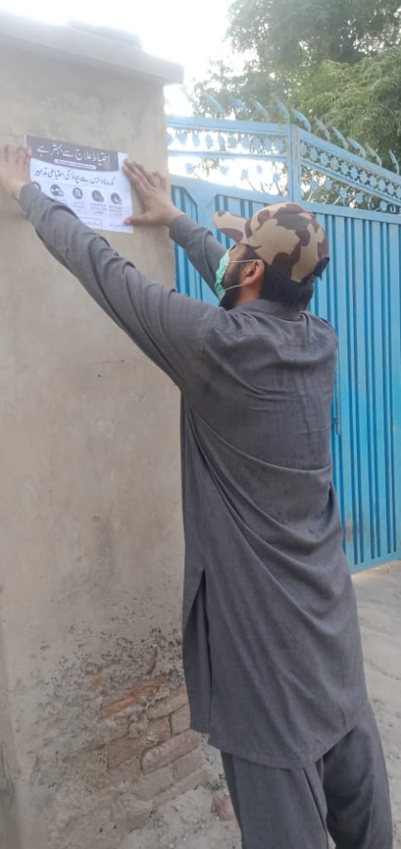
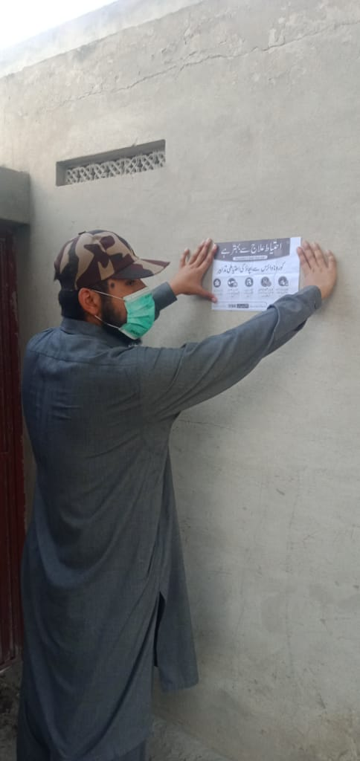
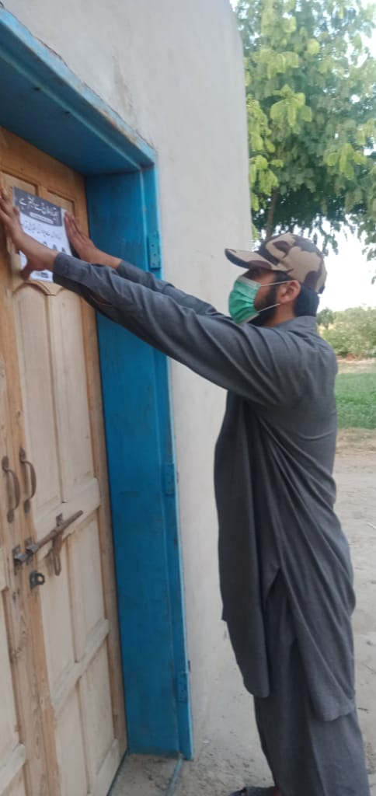

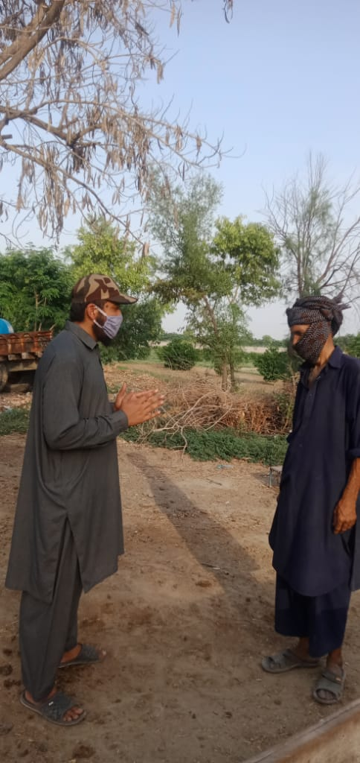
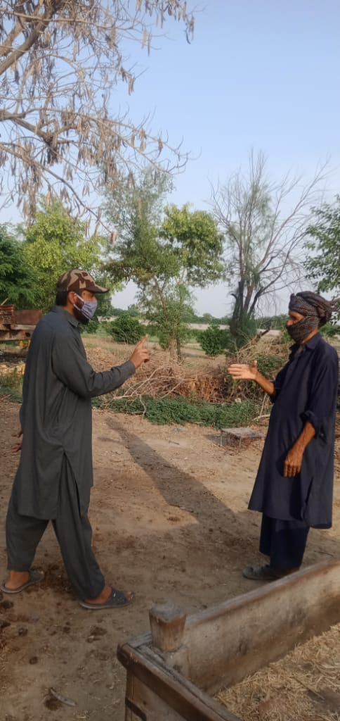
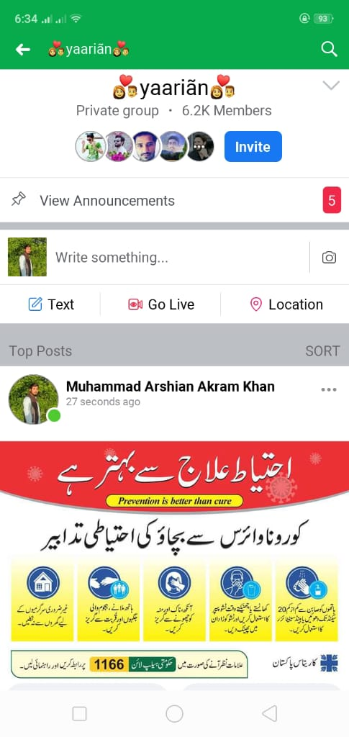

Ahmad Bilal Khan:-
The steps which I took to inform the people about corona virus are discuss in the following:
- First of all I uploaded posts on Facebook to inform people about covid-19. There are many groups which contain large number of members.
- I went to village where my relatives live and they don’t know about the virus. I told them how to protect themselves from virus.
- Due to the lockdown I could not go door to door. I was not able to distribute brochures.
Tassawar Abbas:-
Firstly I would explain to you that my duty was aware the people by survey.
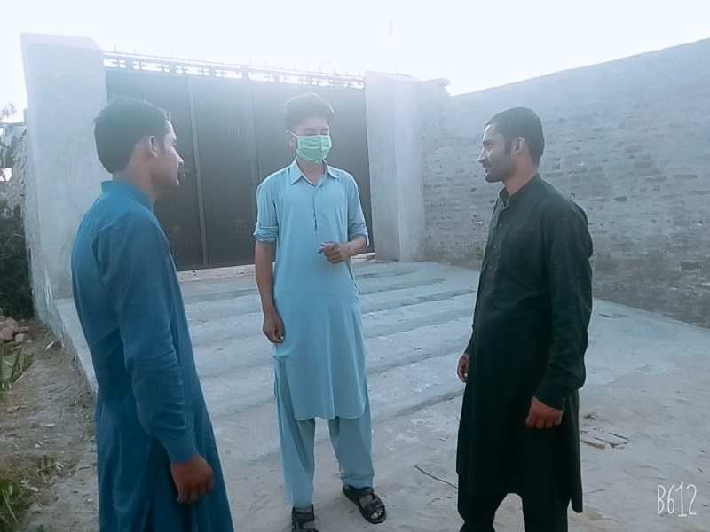
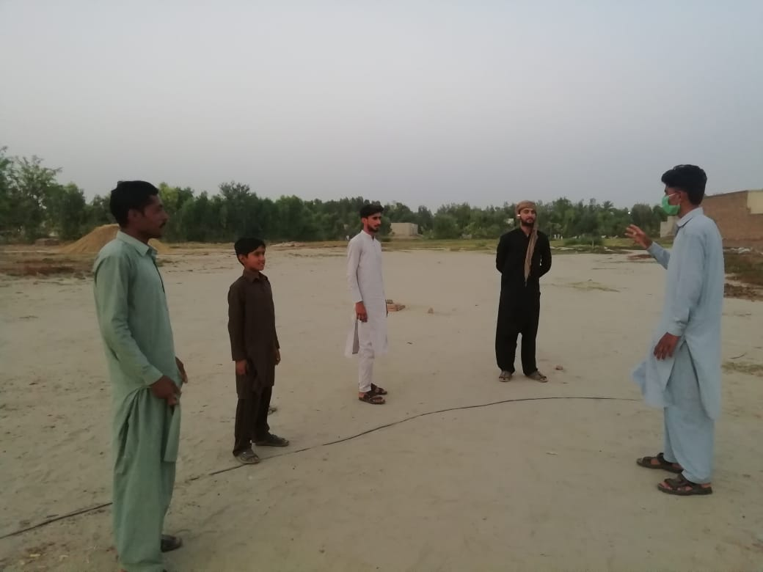
I belong to village where most of people are uneducated, therefore they could not take the necessary steps to protect themselves from this fatal disease. They thought it is just like joke. But actually if we tell the disaster of disease. In this way I have to aware the people to protect themselves and their family. The people of my village kind and friendly. Therefore they help each other in the time of any trouble. They deal any trouble with unity. So the people where I lived picked soon what I wanted to say. I went door to door for this purpose. I wanted that protect people from the disease. I tried my best for the success of the project.
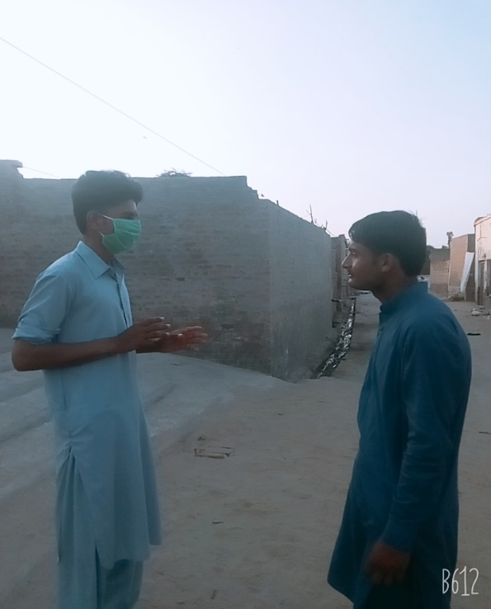

Gulam Mustafa (38):-
I worked to aware my villagers. I chose survey to aware the people. I went door to door for aware the villagers.During this I captured some picture which are in below.
