Assignment
Chapter no 7 : Intelligence :
Name: Shahid
Class: BS Education
Roll no : 012
Subject: PSYCHOLOGY

Summary :

“Mental quality that consists of the abilities to learn from experience, adapt to new situations, understand and handle abstract concepts, and use knowledge to manipulate one’s environment.”
Thurston (1946) rejected the General theory of intelligence and instead presented his own theory.
This theory states that the human intelligence includes 7 primary mental abilities.
Though these abilities appear to be different, they are related to each other. They are:
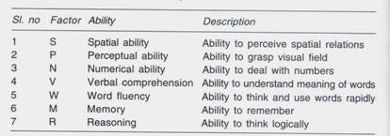
Thurston has developed a test called Primary Mental Abilities test to assess these factors.

“ According to Spearman intelligence is the ability to think constructively. Spearman (1927) proposes that intelligence consists of two abilities, viz. ‘G’- general ability and ‘S’- special ability.
General factor or ability works in conjunction with special ability. In all intellectual activities of the human being along with general ability, there will also be a special ability which is related to such actio .”

“Piaget's theory of cognitive development is a comprehensive theory about the nature and development of human intelligence. It was originated by the Swiss developmental psychologist Jean Piaget (1896–1980). The theory deals with the nature of knowledge itself and how humans gradually come to acquire, construct, and use it..”

““Jerome Bruner, a cognitive psychologist, created a theory of development based upon the idea that the goal of education should be intellectual development. In this theory, he identified three modes of representation. ... Bruner believed development does not consist of discrete stages but is a continuous process.”

“Sternberg's theory identifies three types of intelligence: practical, creative, and analytical. Practical intelligence, as proposed by Sternberg, is sometimes compared to “street smarts.” Being practical means you find solutions that work in your everyday life by applying knowledge based on your experiences.”

1: Analytical (academic problem-solving)
2: Creative intelligence is demonstrated in reacting adaptively to novel situations
and generating novel ideas.
3: Practical intelligence is required for everyday tasks which may be ill – defined
with multiple solutions.

