Course name : citizenship education
Group master: Manahil shamshad
Submission date: 7-6 2020
Submitted to: Mam Mahla jaben
Program and semester: Bs Botany 2nd semester
Session: 2019-2023
Department:. Biological sciences

Citizenship and community engagement project(our project has different tasks). (Ishma ahsan (14)......
Task 1:(distribution of masks and senetizers and playing audio in mosque).
(Manahil shamshad (47) , Asma ajmal(15) , Hira jabbar(42) are doing this task.
- Background of the problem:
Coronavirus is an old virus. At first in 1960 it was found in human. Today a type of coronavirus which is known as covid-19 started from China. It is a very lethal virus which separate throughout the world including Pakistan. Many people had died due to this virus. This virus separate from person to person by touching and enters into the body through mouth and nose. The situation is very critical therefore we started this project.
- Present situation:
The present situation is very critical. Today many people had died due to coronavirus. And still it is spreading in an increasing rate. See in Pakistan the situation is more critical. It is very important to take some solid steps to control this lethal virus.
Justification of the project activity:
- Importance of project activity:
Our project was very important about different point of views.
- Many people in village areas was an aware about this coronavirus so it was very important to aware them about this virus.
- Second they have acted upon our advice and have save from this virus this was the most best importance of our project.
- Today the present situation is very critical and it was very important to realise the people about this coronavirus and it was also very important for Pakistan as a good citizen it was our responsibility to do this for our society.
- Practical implications:
We have done this project in a good way. We made sanitizers and masks at home and have distributed masks and sanitizers to the people of our area. And also provide awareness about coronavirus and about the use of sanitizer and mask. We also have put some sanitizer in the mosques so the people should use these sanitizers before enter into the mosque.
Beside this we also played audio recording in the mosques about the awareness of coronavirus. So the people listen that and act upon that.
- Objectives of the activity:
As we have done this project there were objective behind it.
- The first object was to save people from coronavirus. This was the main object of the project. Because the lives of people are very precious to us and as a citizen it was our responsibility to save the people.
- The second object is to aware the people about this virus so they aware other people and can save them also.
- the engagement of community and safety of people was the main object of our project.

Plan of action:
- How will you do this activity:
We made masks and senetizers at home for distribution. And also record an audio about the awearness of coronavirus. Then we distributed that masks and sanitizers in our area and also awear the people about coronavirus and the use of masks and senetizers. And awear them that to wear masks and use senetizers before going anywhere and keep senetizers. With their self and use this.
We also placed senetizers in the mosques so people use this before coming in the mosques and going out. We record the audio about the awearness of coronavirus and played it in the mosque after azan. So the people remain awear of it.

Home-made masks.
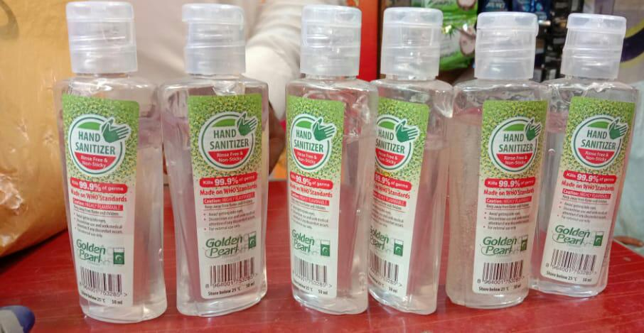
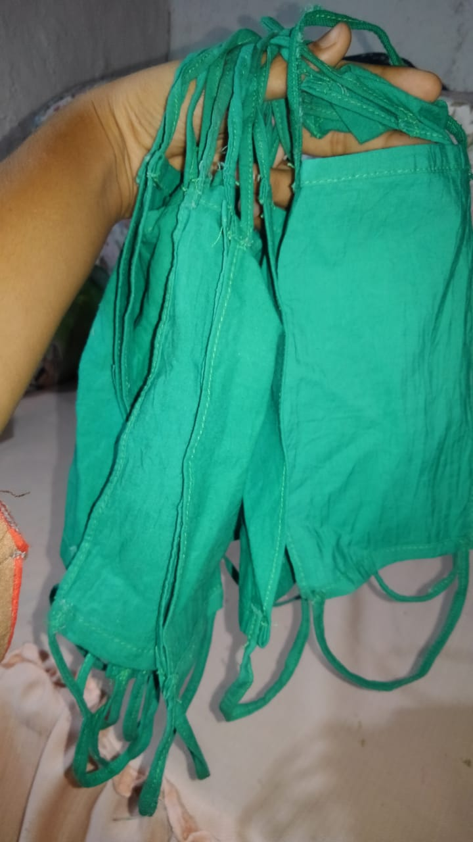
Home-made senetizers.
- Needed resources and source of generation:
We have done this project in group. We are five group members. For the completion of this project some resources we’re needed. Our family members had helped us to meet our expenses and also our group members had helped to full fill needs. All the group members provided money through easypaisa. And we also has spend our pocket money to accomplish this project. .
- Each persons role in the project:
We have done this project in a best way. We have done this project in group. We were five group members each member has participated in this
- Manahil shamshad(BBTF19BM047):
Manahil made masks at home and distributed it in the people.
And also awear them about this virus.

- Asma ajmal (BBTF19BM015):
Asma ajmal made senetizers at home and distributed it in his area. And also placed these senetizers in the mosques. His brother Adnan ND sister Ayesha has helped her.
- Hira jabbar (BBTF19BM042):
Hira jabbar recorded the audio and played in the mosques. This audio was about the awearness of coronavirus. His brother has helped her in audio recording.
- Ishma ahsan (BBTF19BM014):
Ishma had awear the people about coronavirus. And also told them about the use of masks and senetizers . Her brother saqib has helped her to awear people.
- Shabana Bibi (BBTF19BM027):
Shabana also made masks and senetizers at home and have distributed them in his area. His brother has helped her.
- Proposed duration of the project:
We have completed our project step by step . It took twenty days to complete due to lockdown. But we have completed our project in Best way.
- How will you evaluate your project:
We have confirmed our project activity from the people of our area. We have realized this that know people wear masks before going out and also use the senetizers in the mosques . Our brother went to mosques to offer prayer they have seen their that know people use the senetizers in the mosque before going and coming in the mosque.
The audio we have played in the mosque about corona viruses the people had very liked this thing and now they play that recording by their selves and also has tell that now people wear masks and use senetizers properly.
In this way our project accomplished people had get banefit through this project this proves to be beneficial for the people.
(Ishma ahsan (14).....

Task 2:(social awearness through social media like you tube).(Ishma ahsan (14).....
Ishma ahsan(14) is doing this task.

Introduction:
- Background of the problem:
Today the environment of our society. The people have no feelings for each other. As the society and the people living in a society is like a family the family member have some concerns for each other but the people now just know to harm. The society has become very cruel.
And the society has become very cruel and also has away from the education mean now they lack awearness about different things related to life and beneficial for them. Due to these issues we started a project
- Present situation:
the present situation of the society is very critical and bad. Today people kill each other for their sake they have no feelings for the needy people. They lack awearness about different topics and create social issues which damage the environment of the society.
Justification of the project activity:
- Importance of the project activity:
This project was of great importance as it was for the benefit of the society. The people got awearness about different topics as we have awear the people about different social issues. It proved to be very beneficial for them. Today the illiteracy has increased therefore we have given awearness about education to people.
This project was important to change the environment of the society so our society become beautiful and caring for each other.
- Practical implications:
We made a channel on YouTube and then made videos on different topics like coronavirus and illiteracy(importance of education). We uploaded these videos on YouTube channel so the people get awearness about these things may save from this lethal virus and also gave importance to education.
In our project we made videos and still we are making a video on religious discrimination which is the present social issue then we will also upload this on YouTube. We have shared the video to our friends and they have shared this to other in this way our video is shared to many people and we hope that it would be further shared..
- Objectives of the activity:.
As everything has an object. Our project Also has an object.
- First object of our project was to change the negative thinking of the people and make their thinking positive.
- The second object was to awear the people about different social issues. So the people may solve their issues living in a society and make society good and peaceful place.
- This project was to change the environment of the society when people get awearness they try to make good relationship with the people living near to them and make peace in society.
- From all objects the main thing was that the people lack awearness when the get awearness everything become good.
Plan of action:
- How will you do this activity:
We have done this activity step by step and our hopefully to got good results. First we made our YouTube channel and then made a video on about coronavirus and uploaded this on our channel and shared our channel to our friends and they shared this forward and in this way many people will get benefit. We are now making two videos on topics religious discrimination and importance of education and will soon upload them on YouTube.
https://youtu.be/INn1db9uG3E
This is the link of our channel on which we have uploaded videos.
- Needed resources and source of generation:
We made YouTube channel as a source for awearness. Because now a days social media is used so gratefully that their is no other source to awear them. And we made the channel on mobile phone. We didn’t need any heavy source to accomplish our project.
- Each persons role in the project:
Each person has played a specific role in this project.
- Ishma ahsan (BBTF19BM014):
Ishma has made videos and YouTube channel and have uploaded videos on the channel. Her cousin Muhammad Ansar and brother saqib has helped.
- Manahil shamshad (BBTF19BM047):
Manahil helped in Makin videos on different topics and also helped in making videos.
- Asma ajmal (BBTF19BM015):
Asma has helped in making videos.
- Shabana Bibi (BBTF19BM027):
Shabana told some topics and also gave some advices to make this project good as in video.
- Hira jabbar (BBTF19BM042):
Hira also gave ideas to make video good and provide material for making videos.
- Proposed duration of the project:
We made one video within one week and have uploaded it on YouTube. We are working on other videos and will upload those videos in three days. Actually making of videos is a difficult task for us and we were doing that for first time so it took time but we will soon upload other videos .
- How will you evaluate your project:
We have done our project with full confidence. We have evaluate our project by seeing this that how many people have subscribed our channel and liked our videos. We have uploaded video and some people have subscribed and liked our video and we are hopeful that other will also liked it and share it. We have made video very simple so people can understand it . (Ishma ahsan (14).....

Task 3: (free education to children).(Ishma ahsan(14)....
( Manahil shamshad(47) is doing this project.
Introduction:
- Background of the problems:
Coronavirus is a very lethal virus which started from China. Many people had died due to this coronavirus. It is also present in Pakistan and the present situation in Pakistan is very critical due to this schools are closed. The children are free at home. And have away from study. Education for children is very necessary and it is also very important for the development of the country. If the children remain away from education they take interest in other illegal activities so it is very necessary to keep them in contact with studies.
- Present situation:
The number of dying people in Pakistan is increased. Therefore the government has increased the date of opening of schools 250 10th July. Children's are free at home. If they remain away from studies they will lost their interest in studies and it is very bad for their future and for the future of Pakistan. And today the present situation is very critical therefore we started this project.
Justification of the project activity:
- Importance of the project activity:
This project is a great importance because it is related to the future of the children. The children of every country is the future of the country. This project is great importance
- Buy this project the children will remain in contact with the studies in this critical situation and will stay away from bad activities.
- This project is also important for the future of the children.
- this project is also great importance for that children whose families cannot of called the fees of the tuition. Their children get education free it will be helpful in making their future.

- Practical implications:
We have gather the children of our area and then gave them free education. This project was for that children who belongs to poor family and his family cannot afford the fees of the tuition. All family members are with us and they have helped in teaching the children also and we have taught them with full care and attention and also say hi to the preventions from coronavirus and also avoid the children about that virus.
We taught the children for 3 hours in first time. People who healed on their studies because this is for their benefit related to their future. We also had awear the children about virus so they may tell this preventive measures to their family and remain safe from this virus.
- Objectives of the activity:
As we have started this project it has some objective behind it.
- First due to coronavirus schools was closed and childrens were free at home they were away from studies therefore it was very important to connect them with studies therefore we started this project.
- Second object of that project was that some families cannot afford the fees of the tuition therefore we give free education to their children so that children can get education also.
- These were the main objects of our project because we thought that children are the future of our country and due to coronavirus schools are closed and it was very important to continue their education.
Plan of action:
1. How will you do this activity:
We have done activity very clearly. We gather the children of area and assure their parents about giving free education to their children and then started teaching their children at home for 3 hours in first time. Our brothers and sisters are also helping us in teaching these children. Some children which cannot for the expenses of books also have provided them with these books and started teaching them.

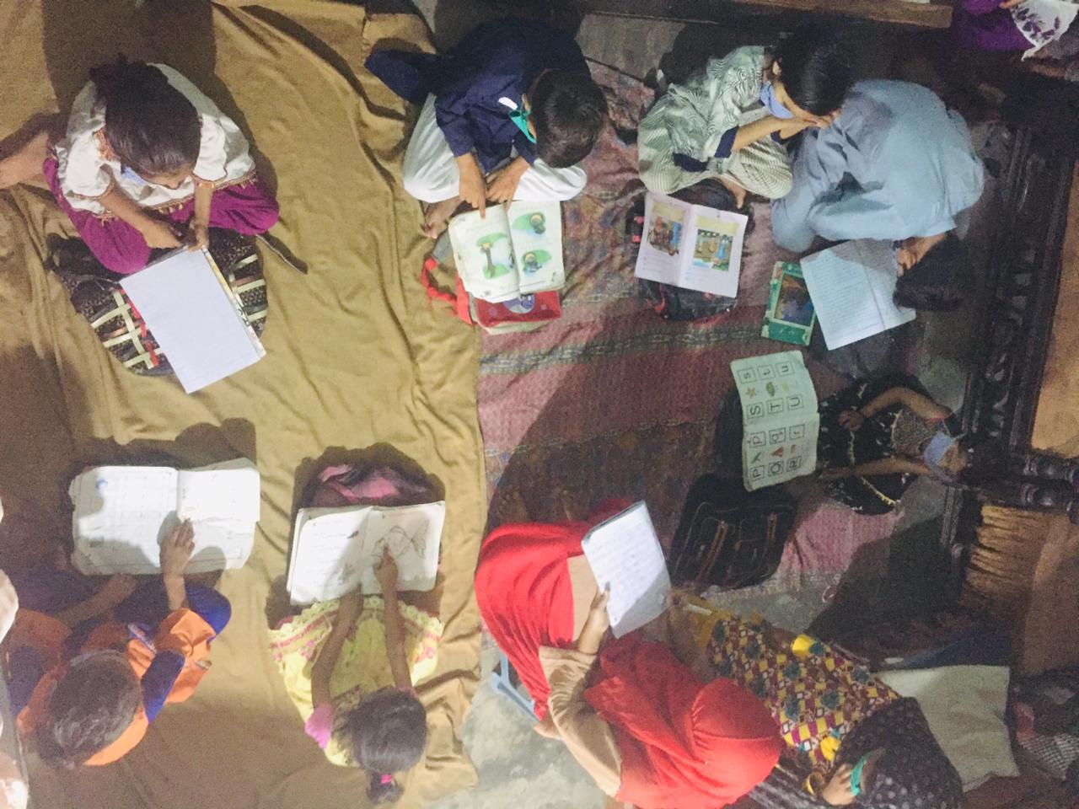
- Needed resources and source of generation:
Some sources like books were need to provide the children for this purpose our family members had helped us. And also has spent a part of pocket money to it.
- Each person role in the project:
Manahil shamshad (BBTF19BM047):
Manahil shamshad has done this project. His sister Muskan and his brother has helped her in this project.
All other group members(Asma ajmal, Hira jabbar , Ishma ahsan) cannot provide any support because they live in different. This project is handled by Manahil shamshad with the help of his sister Muskan and his brother.
- Proposed duration of the project:
We have started this project from last month and it will remain continue till the opening of schools.
- How will you evaluate you project:
We have evaluate our project from the parents of the children. And they appreciated us for such a good project and they are assured of it and they also had told us that now their children study at home and never waste their time in bad activities roaming etc.
We have done our project with good care and will keep on working like this. And parents of the children are satisfied with this this is very joyful for us.(Ishma ahsan(14)...

Task 4:. (Teaching of Holy Quran and Islamic education).(Ishma ahsan(14)..
Asma ajmal (BBTF19BM015) and Shabana Bibi (BBTF19BM027). Have done this project.
Introduction:
1 Background of the problem:
Allah has created the human to worship him. Allah has gave us a gift of Holy Quran. It is our first obligation to read the Holy Quran and to understand it’s saying. Our religion is Islam but today human has forgot the sayings of Islam and doesn’t know the write way to read the Holy Quran. And as a Muslim this is very shameful for us
2.Present situation:
The present situation is not good people had forgotten the sayings of Islam and doesn’t know how to read the Holy Quran.
This situation is not satisfied and good for us as a Muslim. As a Muslim we have to teach this to other people but first it is necessary to know the true method to read it .
Justification of the project activity:
- Importance of the project activity:
This project is most important as it is related to Islam as the knowledge of the world is important for our future the Islamic knowledge is also most important to get the Allah’s happiness. Our first priority must be the Islam and it’s saying so it is the most important project because it makes us successful after death.
- Practical implications:
We have gathered the children and taught them holy Quran at home. And the women who cannot read Holy Quran we have also gathered them and taught them also. And we also has gave some Islamic education mean have gave information about Islam to the children.
We have tried our best for this project and taught the Holy Quran. And the women are very happy at this. We taught them at different times means when they are free.
- Objectives of the activity:
Their were some object to start this project:
- The first object is to teach the women who can’t learn the Holy Quran.
- The second object is to teach Quran to children at home because these children have an age to learn so it is very necessary to teach them Holy Quran.
- Third and main objective is that we are Muslims and Our religion is Islam. It is obligatory to read and teach the Holy Quran and understand it’s sayings. This is the main knowledge for us.
Plan of action:
- How will you do this activity:
We have gathered the children and women who cannot read Holy Quran and taught them Holy Quran. And children read Holy Quran at both first and second time for one hour but women read it when they are free from their work.

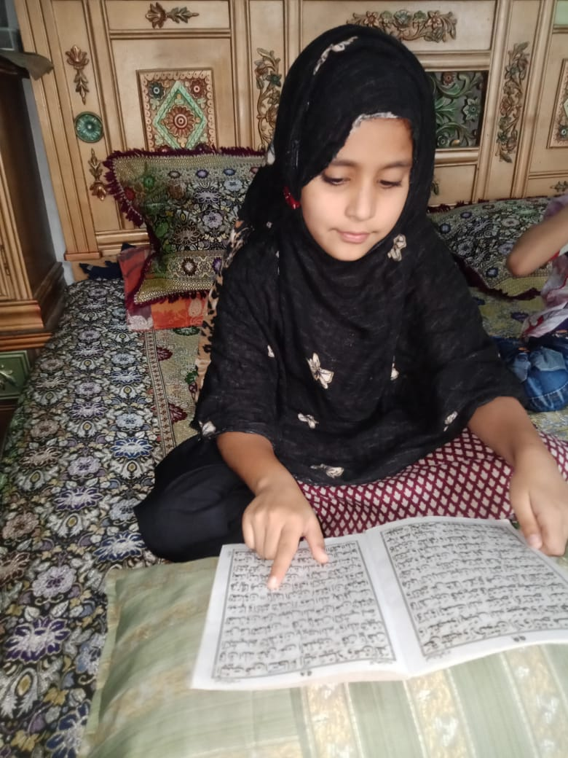
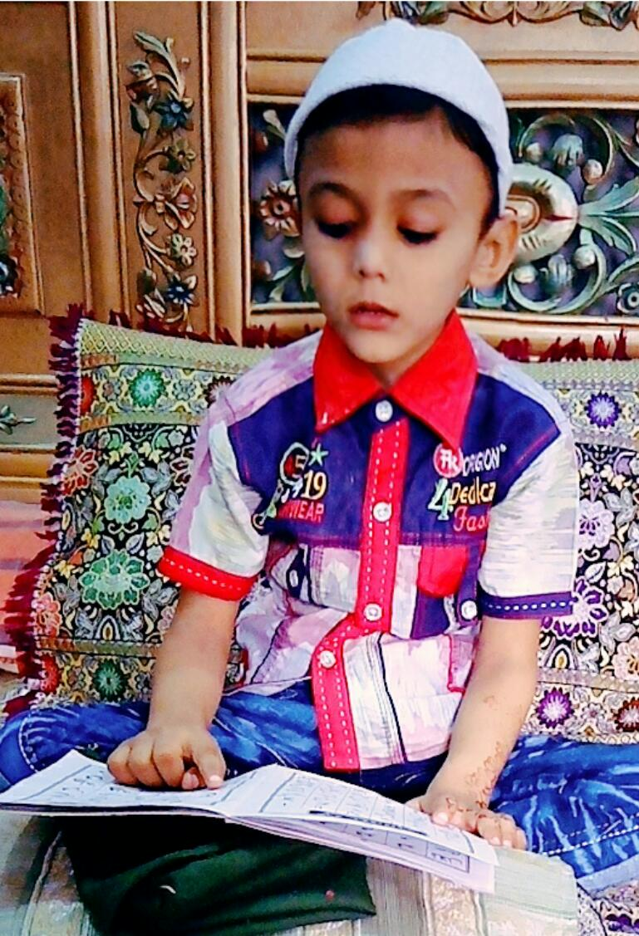
- Needed resources and source of generation:
This project doesn’t needed any heavy sources some of our family members means sister are also helping in teaching the children.
- Each persons role in the project:
Asma ajmal (BBTF19BM015):
Asma ajmal has taught the children of his area. And also gave them Islamic education .His sister Ayesha has helped in teaching children.
Shabana bibi:
Shabana Bibi teach the Holy Quran to women who cannot learn Holy Quran.
Manahil shamshad, Ishma ahsan , Hira jabbar have didn’t play any specific role in this manahil and Asma belongs to same area Manahil has helped Asma.
- Proposed duration of the project:
This project was to have the people Islamic education and teaching of Holy Quran this is still continued we will teach them till they completely know the method to learn the Holy Quran.
- How will you evaluate your project:
We have evaluate our project from the women who learn Holy Quran and from the parents of the children the parents have told us that now their children are learning Holy Quran and also doing good activities they also offer prayers.
(Ishma ahsan (14).

Task 5 (shabana. 27
Introduction:

- Background of the problem:-

There is lack of instant of medical services in the villages. The small cuts cause great lose of blood from the body. There is no facilities of the sphagmometer for checking the blood pressure. For little medical problem, people do not tend to go to hospitals. It cause serious diseases like cancer from small cut due to the bacteria. The open situation of the wound irritate the patient so much and cause great disaster for the patient. There is also no management of the first add boxes for the side road accident. Due to our neglecticity, many people had lost their lives in front of the situation.
- Present situation:-

The present situation is not well at all. Many people had died due to the road accident. There no not emergency management near the road-side for accidents. When the patient was taken to hospital, he lost his live on the way. Many families are ruined due to road side accident neglect. Sometime, people got cuts or wounds during different works in mosques. There is no first-add box for bandage them. It cause great blood loss. Now, in the Corona situation, we cannot easily go to the hospitals for the bandage. This virus is spreading through the touch. Because Corona is spreading everywhere in present situation. So, we should handled small cuts at the spot rather than from going to the hospitals.
Justification of the project activity:-
Importance of the project activity:
Our project is very important from different point of views which are explained below.
- Firstly, many people were slipped in mosques which cause injuries and cuts in many old agers. So, we were distributing the first add boxes in different mosques of different villages. This first add boxes helped the people deal with the small cuts and injuries on the spot during this Corona situation.
- First add boxes were also distribute in the houses which are near the road. Sometime, road accidents took place. This first add boxes also helped those persons which were suffering from the accidents and save them from the big disaster.
- In the present situation, due to Corona virus, this project helped many people and save them to go from hospitals. The reason was that the hospitals were filled with the Corona patients. This virus were increasing day by day from person to person.
Practical Implications:-
We have done this project for the sake of peace and soul pleasure in the best way. We have made first add boxes and distributed them in the mosques of different villages and also kept these boxes in homes which were on the road. The people can use this these first add boxes during emergency conditions.
We also have made charts on which the emergency numbers are written. We have placed these charts on the walls of different villages. Through this act, if there was any emergency condition, people can connect for the help from different institutes.
Objectives of the activity:-
Obviously we have done this project for some objectives. The objectives behind this project given as,
- The first objective of this activity was to help the people who were injured or got cuts during slipping or another act in mosques. This project saved the people from larger damage. These people had no need for going to hospitals only for small problems.
- This project helped the people who were suffering from accidents till the ambulance came. This act also saved likes of many people who have met with the accidents.
- By applying charts on different wall, we award the people for emergency numbers. This act helped the community during any emergency condition like firing and accident.
- The safety of our community and engagement between community was our main objective of this project.
Plan of action:-
How will you do this activity:
We made first add boxes at homes and distributed them in different mosques of villages and also in the houses which were near the road. The first add boxes in mosques helped the people to manage different wounds and cuts during slipping and other action. The first add boxes in the houses which were near the road helped the people during the accidents situation to save the people from dying.
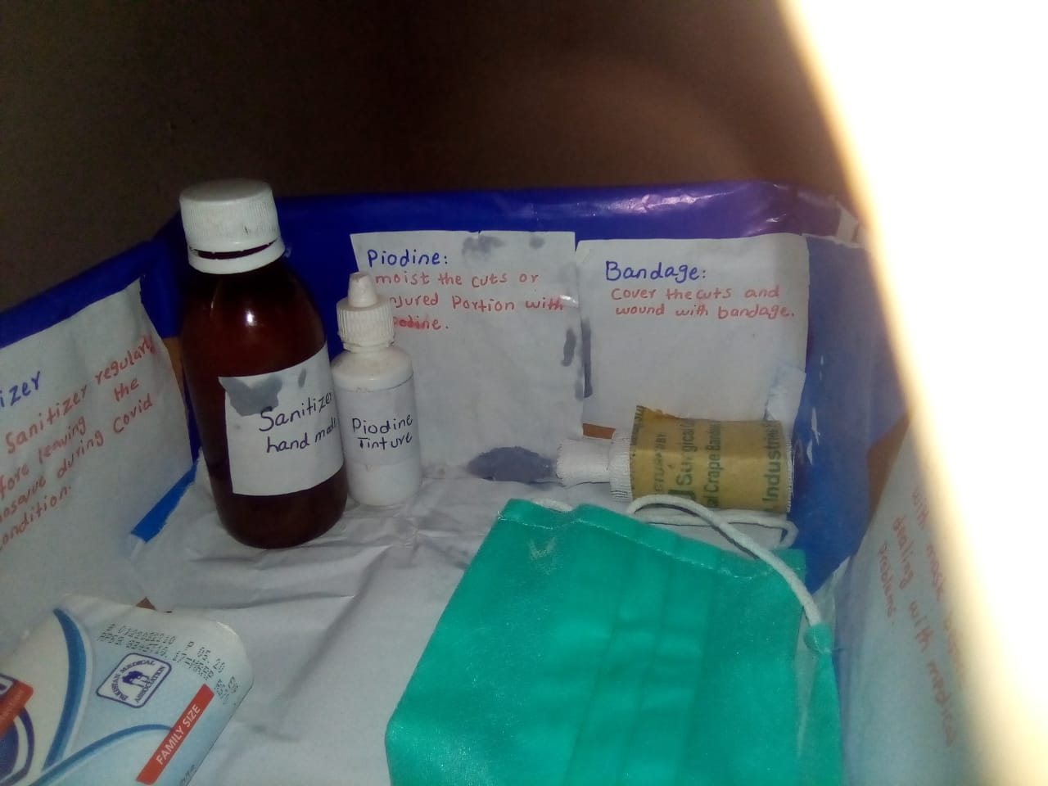

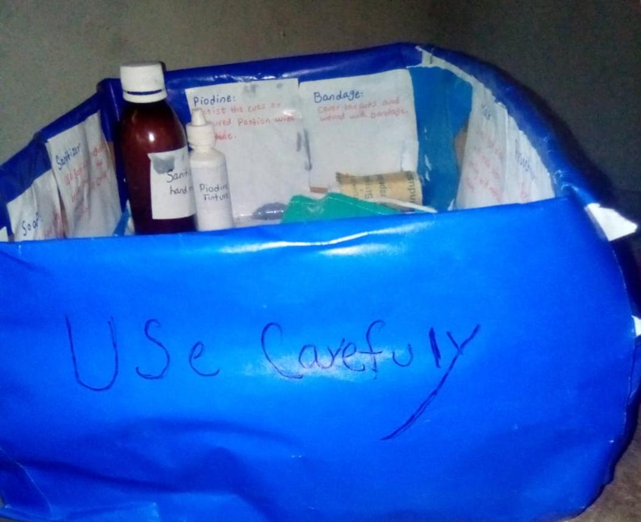

We were placing charts on which emergency numbers were placed. These charts were placed on the walls of different villages to aware the people of villages. They could contact to any required institute during emergency situation .

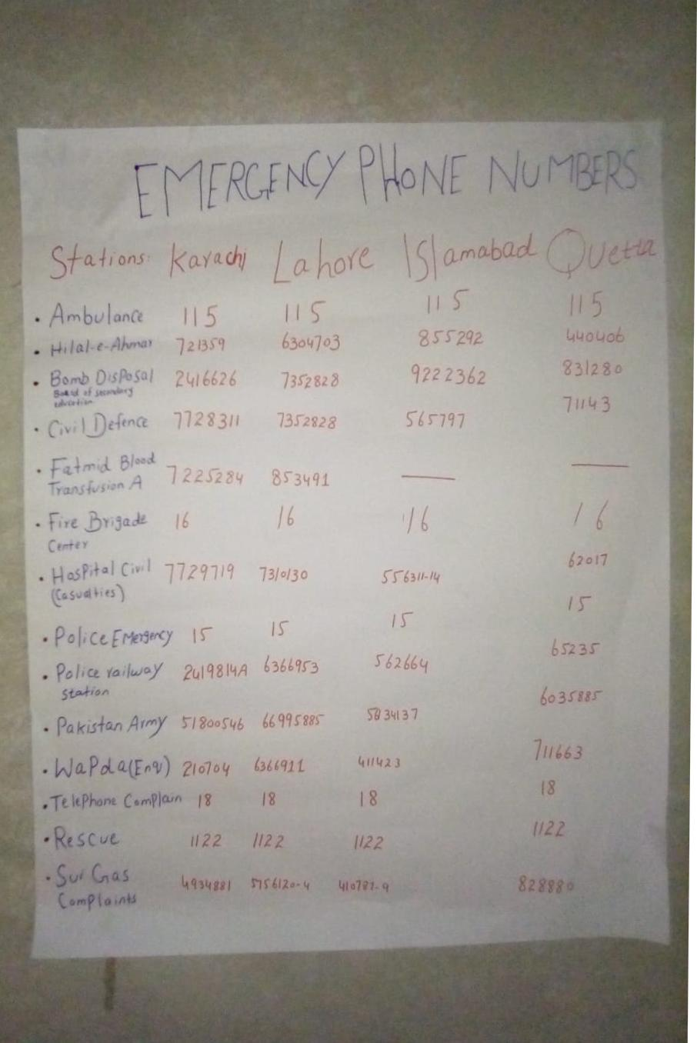
Needed resources and source of generation:-
We have done this project in the group. We were five group members. We needed some resources to complete this project. Our family members helped us to complete this project and we all also used our pocket money to complete this project. My other group members send me money through Easypaisa to fulfil the needs of this project.
Each person role in this project:-
We all group members were living in different places. In such lockdown situation, we cannot met each other to complete this project.
- Asma Ajmal:
Asma ajmal send me money through Easypaisa and helped me to complete this project.
- Manahil Shamshad:
Manahil Shamshad send me money through Easypaisa and helped me to complete this project.
- Ishma Ahsan:
Ishma Ahsan also send me money through Easypaisa and helped me to complete this project.
- Hira Jabbar:
She also send me money through Easypaisa and helped me to complete this project.
- Shabana Bibi:
I have completed this project with full efforts. I prepared first add boxes and distributed them in different mosques and in houses near the road.
- Muhammad Ramzan helped me financially to complete this project.
- Mr. Rizwan helped me in hanging charts on the walls of different villages.
Proposed duration of the Project:-
We have completed this project in best way by engaging community. We have completed this project in two weeks due to the Lockdown in Corona situation.
How will you evaluate this Project:-
We have confirmed the our project activity from the people of our area that how much they have get benefit from this project. My brothers were also going to the mosques for prayer. They told me when the old-agers got injured they used first add boxes for prevention of blood loss.
(Hira jabbar (42)……..
Written by:
Ishma ahsan (BBTF19BM014)
Hira jabbar ( BBTF19BM042)

Thank you

