Thin layer chromatography

A pencil line is drawn near the bottom of the plate and a small drop of a solution of the dye mixture is placed on it. Any labelling on the plate to show the original position of the drop must also be in pencil. If any of this was done in ink, dyes from the ink would also move as the chromatogram developed.
When the spot of mixture is dry, the plate is stood in a shallow layer of solvent in a covered beaker. It is important that the solvent level is below the line with the spot on it.
The reason for covering the beaker is to make sure that the atmosphere in the beaker is saturated with solvent vapour. To help this, the beaker is often lined with some filter paper soaked in solvent. Saturating the atmosphere in the beaker with vapour stops the solvent from evaporating as it rises up the plate.
As the solvent slowly travels up the plate, the different components of the dye mixture travel at different rates and the mixture is separated into different coloured spots.
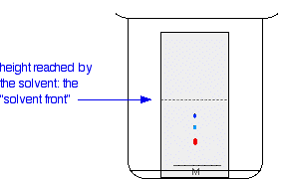
The diagram shows the plate after the solvent has moved about half way up it.
The solvent is allowed to rise until it almost reaches the top of the plate. That will give the maximum separation of the dye components for this particular combination of solvent and stationary phase.
Measuring R_{f} values
If all you wanted to know is how many different dyes made up the mixture, you could just stop there. However, measurements are often taken from the plate in order to help identify the compounds present. These measurements are the distance travelled by the solvent, and the distance travelled by individual spots.
When the solvent front gets close to the top of the plate, the plate is removed from the beaker and the position of the solvent is marked with another line before it has a chance to evaporate.
These measurements are then taken:
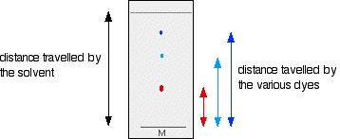
The R_{f} value for each dye is then worked out using the formula:
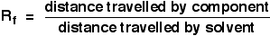
For example, if the red component travelled 1.7 cm from the base line while the solvent had travelled 5.0 cm, then the R_{f} value for the red dye is:
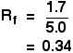
If you could repeat this experiment under exactly the same conditions, then the R_{f} values for each dye would always be the same. For example, the R_{f} value for the red dye would always be 0.34. However, if anything changes (the temperature, the exact composition of the solvent, and so on), that is no longer true. You have to bear this in mind if you want to use this technique to identify a particular dye. We'll look at how you can use thin layer chromatography for analysis further down the page.
What if the substances you are interested in are colourless?
There are two simple ways of getting around this problem.
Using fluorescence
You may remember that I mentioned that the stationary phase on a thin layer plate often has a substance added to it which will fluoresce when exposed to UV light. That means that if you shine UV light on it, it will glow.
That glow is masked at the position where the spots are on the final chromatogram - even if those spots are invisible to the eye. That means that if you shine UV light on the plate, it will all glow apart from where the spots are. The spots show up as darker patches.
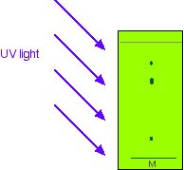
While the UV is still shining on the plate, you obviously have to mark the positions of the spots by drawing a pencil circle around them. As soon as you switch off the UV source, the spots will disappear again.
Showing the spots up chemically
In some cases, it may be possible to make the spots visible by reacting them with something which produces a coloured product. A good example of this is in chromatograms produced from amino acid mixtures.
The chromatogram is allowed to dry and is then sprayed with a solution of ninhydrin. Ninhydrin reacts with amino acids to give coloured compounds, mainly brown or purple.
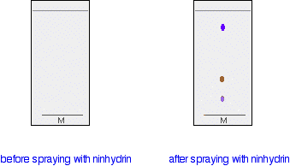
In another method, the chromatogram is again allowed to dry and then placed in an enclosed container (such as another beaker covered with a watch glass) along with a few iodine crystals.
The iodine vapour in the container may either react with the spots on the chromatogram, or simply stick more to the spots than to the rest of the plate. Either way, the substances you are interested in may show up as brownish spots.
Using thin layer chromatography to identify compounds
Suppose you had a mixture of amino acids and wanted to find out which particular amino acids the mixture contained. For simplicity we'll assume that you know the mixture can only possibly contain five of the common amino acids.
A small drop of the mixture is placed on the base line of the thin layer plate, and similar small spots of the known amino acids are placed alongside it. The plate is then stood in a suitable solvent and left to develop as before. In the diagram, the mixture is M, and the known amino acids are labelled 1 to 5.
The left-hand diagram shows the plate after the solvent front has almost reached the top. The spots are still invisible. The second diagram shows what it might look like after spraying with ninhydrin.
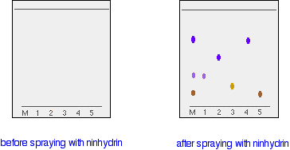
There is no need to measure the R_{f} values because you can easily compare the spots in the mixture with those of the known amino acids - both from their positions and their colours.
In this example, the mixture contains the amino acids labelled as 1, 4 and 5.
And what if the mixture contained amino acids other than the ones we have used for comparison? There would be spots in the mixture which didn't match those from the known amino acids. You would have to re-run the experiment using other amino acids for comparison.

