INTRODUCTION AND AIMS OF ECOLOGY
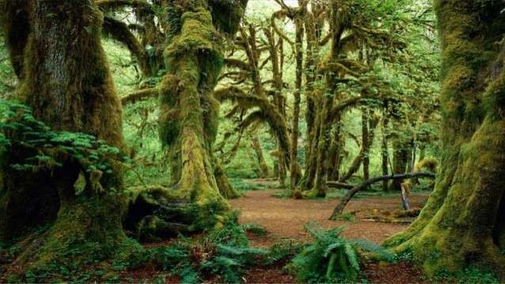

MAWRA AFTAB
BBOF18M014
PROF. ASGHAR ALI
ANSARI
BS BOTANY 4TH
SEMESTER (REG)
Introduction:
The word ecolog was drived from Greek "oikos" meaning "household" and "logos" meaning "science": the study of the household of nature.
"Ecology is a branch of science that deals with interactions between living organisms with each other and their surroundings" .
Ecology systems are studied at several different levels from individual and population to ecosystem and biosphere level. The living organisms are are found all over the world. The live in a particular environment. Everything that is present around the living organisms whic affects their life is called environment, such as air, light, temprature and soil. These are the factors of environment and presence and absense of any factor brings change in life of living organism.So ecology deals with the organism and the place where it living.
The term ecology was proposed by a zoologist Reiter in 1885. However, Hackel, another zoologist defined ecology as the study of interaction between organisms and their environment. As the living organisms are of two types, plants and animals, ecology is divided into two types that is plant ecology and animal ecology.
Objective of ecology:
- It is important for humanity to understand its environment because we have ability to modify the environment through the use of technology, and through overexploitation of natural resources as a result of greed and sheer pressure of numbers. Therefore ecology is more than just the understanding of the interrelationships between organisms and their environment; it also has social, political and economic dimensions.
- It also is a study of evolutionary development of the organisms, the biological productivity and energy flow in the natural system.
HISTORY OF ECOLOGY:
Following person played important role in history of ecology:
Arcadian and imperial ecology :
Arcadian ecology advocates for a "simple, humble life for man" and a harmonious relationship for humans and nature.
Charles Darvin
- 1809-1882
- Founder of the hypothesis of the evolution by means of natural slection, founder of ecological studies of science.
Elizabeth Catherine Thomas Carne:
- 1817-1873
- Geologist, mineralogist and philosopher who observed rural vs urban living spatially and culturally, finding in the country living the best attack on suffocating class divides, healthier living, and best access to natural education.
Herbert Spenser:
- 1820-1903.
- Early founder of social ecology, coined the phrase 'survival of the fittest'.
Karl Mobius
- 1825-1908
- Invented the term ecology, popularized research links between ecology and evolution.
Victor Hensen
- 1835-1924
- Invented term plankton, developed quantitative and statistical measures of productivity in the seas.
Eugenius Warming
- 1841-1924
- Early founder of ecological plant geography.
Ellen Swallow Richards: • 1842-1911
- Pioneer and educator who linked urban ecology to human health.
- Charles Darwin's work also contributed to the science of the ecology and Darvin is often attributed with progressing the discipline more than anyone else in its young history.
- Ecological thoughts expanded even more in the early 20th century.
- Major contributions incuded: Eduard Suess' and Vladimir Vernadsky's work with the biosphere, Arthur Tansley's ecosystem, Charles Elton's animal ecology, Henry Cowles ecological succession.
TYPES OF ECOLOGY:
There are two types of ecology:
1)Plant ecology
2)Animal ecology
Plant ecology:
Plant ecogy deals with the study of relationship between the plants and their environment.
Animal ecology:
Animal ecology deals with the study of relationship between the organisms and their environment.
Branches of ecology:
These are the branches of ecology.
Behavioral ecology:
- It studies the ecological and evolutionary basis for animal behaviour and role of behaviour in enabling animals to adapt to their ecological niches.
Population ecology:
- Deals with the dynamics of population within species and the interactions of these populations with environmental factors.
Community ecology:
- Studies the interactions between the species within an ecological community.
Landscape ecology:
- Studies the interactions between discrete elements of landscape.
Ecosystem ecology:
- It studies the flow of energy and matter through ecosystem.
Global ecology:
- It looks at the ecological questions at the global level often asking macroecological questions.
Other specialized branches of ecology includes:
Chemical ecology:
- It deals with the ecological role of biological chemicals used in wide range of areas including defense against predators and attraction of mates.
- System ecology and biogeochemists which focus on the flow of energy and nutrients within and among ecological units.
Ecophysiology:
- It studies the relations between a single type of organism and the factors of it's environment.
Evolutionary ecology:
- It deals at evolutionary changes in the context of the populations and communities in which organism exists.
Molecular ecology:
- It attempts to adress ecological questions at molecular level, usually through by looking at DNA or allozymes.
Paleoecology:
- To understand the relationship between the species in fossil assemblages and in so doing gain insight into the way these species might have been shaped by their interactions with other species. Habitat ecology:
- It deals with the study of different habits on earth where life is present.
Genecology:
- It deals with the study of variations of species based upon their genes.
Ethology:
- It is the study of behaviour of living organisms.
Categories of ecology:
- Broadly ecology is divided into following categories.
Physiological ecology:
- It deals with the response of single species to environmental conditions such as temprature and light.
Population ecology:
- Usually focusing on the abundance and distribution of individual species and the factors that cause such distribution.
Community ecology:
- It deals with the number of species found at given location and their interactions.
Ecosystem ecology:
- It deals with the structure and functions of entire suit of microbes, plants and animals, and their abiotic environment and how the parts interact to generate the whole. This branch of ecology often focuses on the energy and nutrient flows of ecosystem. When this approach is combined with computer analysis and stimulation we often call it system ecology.
LEVEL OF ORGANIZATION:
Ecology deals with the level of biological organization. These levels are as follows:
  - Organism
  - Population
  - Community
  - Ecosystem
  - Biosphere
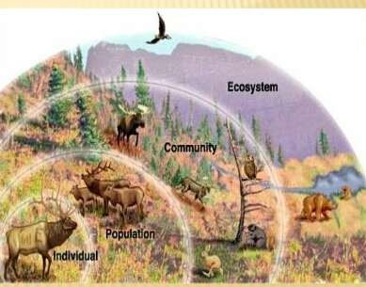
Organism:
Organism is individual living body which consists of tissue systems, tissues, cells, molecules etc.
Population:
Population is a group of similar organisms or species which live together at the same place under similar environment is called population.These are fully adjusted in their environment.
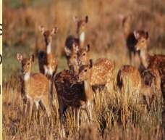
Community:
A community is a group of similar or dissimilar species living together under more or less similar environmental condition.
A forest with various trees, shrubs, herbs, animals, insects, birds and microorganisms is considered as a community. A community is a desirable unit of vegetation.
In a biotic community, the plants, animals and microorganisms all interact with each other and can not be separated.Forbes was first who proposed the word community in 1844. While Mobius recognised the biotic nature of the community.The study of plant community is generally known as phyto sociology.
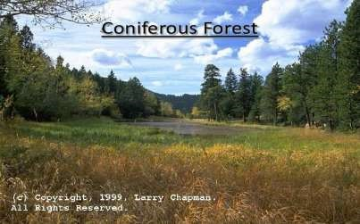
Ecosystem:
The ecosystem is basic functional unit in ecology which consists of both living and non living environment. They interact with each other, each of which influences the properties of the other.
An exchange of materials occur between a community and it's environment thus a system is developed, known as ecosystem.The word ecosystem was first used by Tansely in 1935. According to this system a flow of energy and materials remains continue between living and nonlivings.
Natural ecosystem is present in a pond, river, sea, plain or forest.Artificial ecosystem may be seen in a crop field or fruit garden, flower garden or aquarium.
Character of ecosystem:
The characters of ecosystem are as follows:
- Ecosystem is a fundamental and active unit of ecology.
- The structure of ecosystem depends upon different types of animals. In simple ecosystem few types of animals are present, while in large and complicated ecosystem many types of living organisms are present.
- Ecosystem depends upon natural cycles such as nitrogen cycle, carbon cycle, oxygen cycle etc. And also on the flow of energy around it.
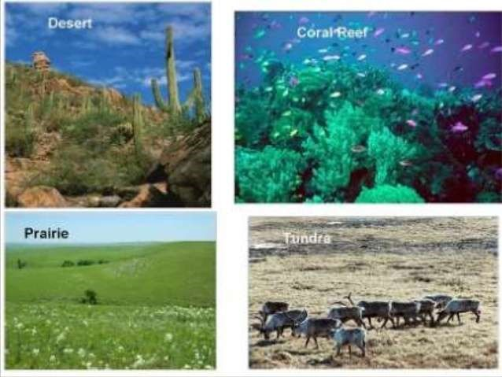
Components of ecosystem:
Ecosystem consists of two components:
- Abiotic component
- Biotic component
Abiotic component:
They include non-living materials of environment. The abiotic components are light, air, water, sunlight, temprature, gravity, soil and fire
Biotic components:
They are the living organisms of ecosystem.They include producers, consumers and decomposers.
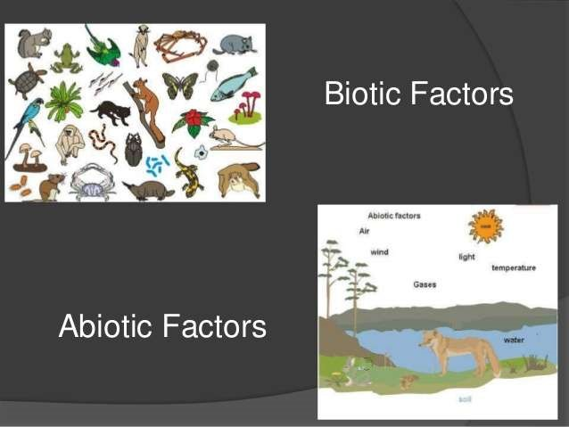
Biosphere:
• The whole world can be classified into two types:
    - Abiotic world
    - Biotic world
The abiotic world consists of three components, atmosphere, lithosphere and hydrosphere. While the biotic world is the biosphere or ecosphere. The biosphere covers most of the world in the form of a thin covering. It is composed of different biotic communities from simple to complex, aquatic to terrestrial and tropical to polar.
Terms of ecology:
  - Environment.
  - Habitat.
  - Ecological niche.
  - Biomes.
  - Biosphere.
Environment:
The term environment comes from French word "Environ" and meaning everything
which surrounds us.
Environment is the area in which we live.
Natural environment:
Natural environment is in which an organism lives naturally on the earth.
In other words wildness is called natural environment of organisms.
Why we need environment?
  - Environment has played very important role to make able to survive for all biotic and abiotic components in earth. While taking about the advantages of environment, it has much more benefit let take the example of this benefit, we human being are social animal as well as powerfull than other animals on earth.
  - Good environment is good for living things same as polluted environment is very harmful for living things.
  - We human being need food to live, air to breath, water to drink etc. All these we get from the environment. If there were no suitable environment on earth then it will be unable for human being to live on earth.
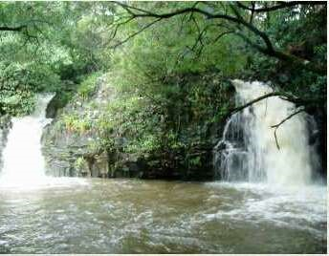
Types of environment:
  - Natural environment
  - Man-made environment
Natural environment:
The components of natural environment are air, water, soil, land,radiation, forest, wildlife, fauna and flora.
Man-made environment:
It includes transportation, housing, agriculture, livestock farms, aquatic farms, industries, dams, energy such as hydro thermal nuclear energy plants.
Components of the environment:
  - Biotic components
  - Abiotic components
  - Biophysical components
  - Energy components
Habitat:
The place where a particular living organisms or group of organisms is present, called habitat. Such as pond, Rocky shore, rain forest etc. Habitat may be aquatic or terrestrial.
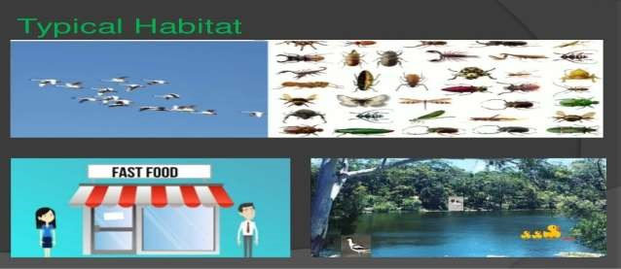
Ecological niche:
The role and position of specie in an environment.
Factors:
- Energy.
- Nutrition.
- Timing of activity.
- What they eat?
- Nest.
- Condition of temprature and moisture.
Types of ecological niche:
- Fundamental niche.
- Realized niche.
Fundamental niche:
- Range of environmental conditions in which each of the species survives and reproduce ➢ It is larger.
- It elaborates various role of species.
- Full niches of species.
Realized niche:
- Range of environmental conditions in which species is really found.
- It is smaller.
- Portion of fundamental niche that is actually filled.

Habitat vs. niche:
Habitat:
- Actually where the organism lives including biotic and abiotic factors.
- All of the parameters.
- Addresses of the organisms.
Niche:
- All the factors which organism requires living and reproducing in a healthy way in a particular area.
- Selective parameters.
- Profession or job of the organisms.
Biomes:
A biome is a major region that is characterized by its climate, soil, type and the dominant plants animals, and other organisms that live there. A biome is madeup of many individual ecosystems.
Types of biomes:
- Tundra.
- Desert.
- Grassland.
- Coniferous forest.
- Temprate deciduous forest.
- Tropical rainforests.
Temperature of each biome is different like:
- Tundra has cold temprature ➢ While desert has hot temprature
- Grassland has moderate temperature.
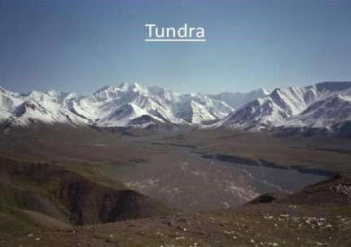
Biosphere:
Biosphere is global sum of the entire ecosystem. It can also be termed the zone of life on earth, a closed system and largely self regulating.
The term biosphere was coined by a geologist Eduard Suess in 1875, which he defined as:
The place on earth where life dwells.

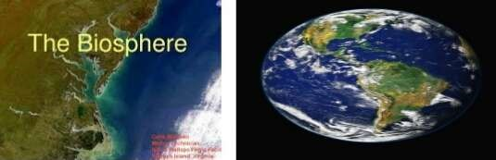
Scope of ecology:
- Ecology is modern development of the field biology. It plays an important role in the human welfare.
- It describes the home life of living organisms.
- Ecology is considered as environmental science. The relationship of the organisms with their environment can be studied at various levels.
- In this field, effect of environment , as light, water or nutrients on the living organisms is studied.
- Ecology is concerned with the populations, commuities and ecosystems. However in the particular region, the living and non-living organisms interact with each other.
- There is great scope of ecology in soil science. The nature of the soil can change the type of vegetation. It can be applied in the conservation of soil.
- This science can be applied in the organization of human society.Because it is relevant to the study of man's ecology.
- Ecology has great concerned with the environmental pollution which influences the health of man and other living organisms.
Ecology is very vast field. It has scope in different fields such as:
- Agriculture.
- Forestry.
- Fishery.
- Wild life.
- Management of grasslands.
- Water supplies.
- Biological surveys.
- Pest control.
- Environmental pollution.

