CONTENTS:
DEFINITION
ANATOMY
DISCOVERY
STEPS
TYPES
ADVANTAGES
SIMILARITIES b/w C3& C4
DISADVANTAGES
EXAMPLES
CONCLUSION
REFERENCES

HATCH-SLACK PATHWAY /C₄ CYCLE
DEFINITION:
The C4 cycle is the photosynthetic pathway in those
Plants in which no photorespiration occur and
as a result of carbon fixation, a stable 4 carbon(4C)
compound is formed that is oxaloacetic acid.
This pathway is also known as HATCH-SLACK pathway as it is discovered in 1966 and also called as DICARBOXYLIC ACID PATHWAY.
ANATOMY:
C4 plant has different leaf anatomy that is KRANZ LEAF ANATOMY.
- In leaves, tissue is equivalent to spongy mesophyll cells that is clustered in ring form around leaf veins outside the bundle sheath cell.
- Dimorphic and bifunctional chloroplast. Chloroplast in MESOPHYLL cells are smaller and have Grana. But in BUNDLE SHEATH cells lack Grana and have large chloroplast.
- In C4 plants, cuticle on both sides of epidermis and stomata also on upper and lower epidermis, termed as ISOBILATERAL LEAVES.
- Guard cells are of dump-bell shaped and extra sheath is present on guard cells.
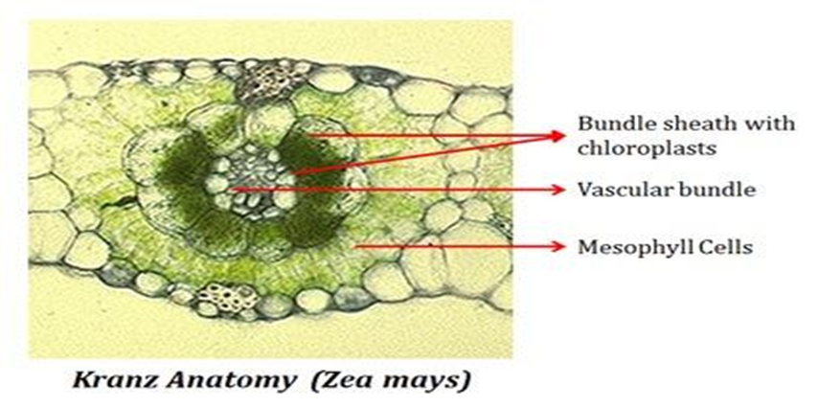
ENZYMES are also different in this cycle. PEP Carboxylase present in mesophyll cell. In hot and dry environment CO2conc. Inside leaf decreases when stomata totally or partially closed by plants. PEP Carboxylase has great affinity for CO2 than Rubisco has. So, C4 plants loses less water than other plants.
Although mostly C₄ plants exhibit kranz anatomy but some plants are operated limited C₄ cycle with the absence of bundle sheath tissue. Saueda aralocaspica, Bienertia cycloptera, Bienertia sinuspersici & Bienertia kavirense (all chenopods) are included in terrestrial plants that inhabit dry and hot environment in the desert of middle east. All these plants operate single C₄ cycle for fixing carbon dioxide. Actually, cytology of both genera are different from each other slightly but the basic principle is to separate the cell into two areas by fluid filled vacuoles. Carbon fixing enzyme in cytosol is kept different from decarboxylase enzyme and Rubisco that is present in the chloroplast and a barrier(diffusive) is established between chloroplast and cytosol. This enables a single cell either mesophyll or bundle sheath type area for the purpose of a single cell. Though, it is inefficient because much of leakage of carbon dioxide around RuBisCo. There is also some plants which do inducible C₄ pathway that are non-kranz aquatic plants. Hydrilla Verticillata perform inducible C₄ photosynthesis under warm conditions but minimized the carbon dioxide concentration is really uncertain.
DISCOVERY:
In the early 1960’s, Marshall Hatch and his colleague Roger Slack worked at Colonial Sugar Refining Company’s David North Plant Research Centre in Brisbane became aware of complex photosynthesis in sugarcane by the interaction with Hugo Kortschak Planters Research laboratory in Honolulu. In the late 1950’s, after a few years of Calvin’s pioneer studies, the Hawaiian had seen some different patterns of labelling of products that are results of when leaves of sugar cane do carbon fixation in the light. They did not find any much unusual behaviour in forming 3 carbon compound by Calvin cycle. But they find this thing in 4 carbon compound that is malate and asparate. But nothing was published for several years.
Hatch stated that in the late 1960’s after 3 or 4 years of starting study the C₄ photosynthesis by them, they became aware a report that is published about ten years earlier by a Russian scientist Y. Karpilov in the 1960 Annual Report of a Russian Agriculture Research Institute. He found that zea-mays leaves are allowed to assimilate ¹⁴CO₂ in the light for short duration, most of resulted product is malate and asparate with a small percentage of 3PGA. About 3 years later, Karpilov and his colleague stated that such results related to faulty killing or extraction procedure there the matter rested.
In the next decade, Marshal Hatch, Roger Slack along with a PhD student Hilary Johnson and John Andrews had given evidences of the mechanism, enzymes used in this process and regulation of alternative photosynthetic product in sugarcane leaves while working at the Brisbane laboratory of the Colonial Sugar Refining Co Ltd. They named this process as C₄ photosynthesis because the resulted first product is 4 carbon compound oxaloaceticacid. Some monocotyledons families also observed with same process. The alternative NADP-ME is one of three sub-types identified in latter year.
After the experiment in laboratory at Brisbane in 1970, Marshall Hatch had started study on this process after his retirement in the CSRIO Division of Plant Industry. During this time, major contributions are resolution of mechanism and their aspects, detail of regulation of mechanism and then enzymology used in this whole process. He and his colleagues identified one of ten major enzymes involved in this process. He received many awards and honours for this work and also elected as a Fellow of the Royal Society and a Foreign Associate of the National Academy of Science (USA).
In 1956, a pathway is found through which carbon dioxide is fixed in plants. That pathway is CALVIN CYCLE that uses RUBISCO enzyme to fix CO₂. Then, this cycle is accounted for the assimilation of CO₂ in plants. After that, 14CO₂ labelling experiments revealed in some plants(sugarcane) in which 1st labelled product is malate and Asp. The significant understanding was not developed until the model proposed by MARSHAL HATCH &ROGER SLACK. They found two types of chloroplast in sugar cane.
According to HATCH-SLACK model, in C4 plants PEP Carboxylase take part in this process it works in leaf mesophyll cell cytoplasm. This enzyme catalyzes the carboxylation of C3 compound, termed as PHOSPHOENOL PYRUVATE(PEP). The product of this carboxylation is (4C) compound that is oxaloacetate.

STEPS:
- Carboxylation
- Breakdown
- Splitting
- Phosphorylation

Carboxylation:
In the chloroplast of mesophyll cells, CO2 is accepted by PHOSPHOENOL PYRUVATE as a result formation of Oxalic acetate occur. Because it is four carbon compounds, that’s why known as C4 mechanism. PEP Carboxylase is used in this reaction that catalyzes this reaction.
Phosphoenol pyruvate(3C) +CO₂+H₂O ^{PEP Carboxylase} oxaloacetate(4C) +H₃PO₄

Breakdown:
Oxaloacetate is converted to Malate by the action of enzyme NADP-malate dehydrogenase and also converted to Asparate by transminase. Then malate is transferred to the chloroplast of bundle sheath cells. The both resulted compounds are 4 carbon compounds.
Oxaloacetate (4C) transminase & malate dehydrogenase Aspartate (4C) + Malate (4C)

Splitting:
Malate is converted to PYRUVATE by combining with NADP and produce CO2. That CO2 is used in Calvin cycle to form sugar. Actually it is decarboxylation process because carbon dioxide is released in this splitting process.

Malate ^{Decarboxylation} CO2 + Pyruvate

That CO₂ is received by the 5C carbon compound Ribulose diphosphate in the presence of enzyme and form 3C compound that is 3 phosphoglycerates, which is the yield of Calvin cycle.

Phosphorylation;
The resulted pyruvate molecule is transferred to the mesophyll cells of leaf in which it is phosphorylated in the presence of ATP& pyruvate phosphokinase in phosphoenol pyruvate.

Pyruvate + ATP +P_{i} phosphoenol pyruvate +AMP+ pyrophosphate

In C₄, plants carbon fixation occurs in MESOPHYLL CELLS, while CO2enters the CALVIN CYCLE in the bundle sheath cells.
This energetic cost of the C4 pathway is that it is tried to maximize the concentration of CO2 at the site of RUBISCO. This carbon concentrating mechanism prevent oxygen from binding the active site of RUBISCO. Thus, it reduces the process of PHOTORESPIRATION, which in C3 plants can reduce the yield of photosynthesis by upto 40%. So, C4 plant has its own significance for plants that needs a lot of water for their normal functions in the dry environment.
So, every CO₂ molecule has to fix twice by PEPC enzyme in mesophyll cells while by RuBisCo in bundle sheath cells, the more energy is used in C₄ pathway than C₃ pathway. C₃ pathway requires 18 ATP for the formation of 1 glucose molecule while C₄ pathway (NADP-ME) used 30 molecules of ATP in sugar cane and maize. In some tropical plants, it is an adaptive mechanism for minimizing the loss.

PHYSIOLOGY:
C₄ plants use more efficient light than C₃ plants. C₄ Cycle is more successful in areas where light intensity is high, temperature is high, low water and low nutrients. In C₃ plants, it is used only a fraction of sunlight to pull out CO₂ for formation of sugar in Calvin cycle but in C₄ plants, it is continuously used sunlight to turn CO₂ into formation of carbohydrates. C₄ plants use more efficiently nitrogen and water for physiological process. The C₄ plants has mostly kept their stomata closed and opened again when runs low on CO₂ for photosynthesis. This meant that C₄ plants even grow on nitrogen-poor soil with low nutrients.

DIAGRAM:
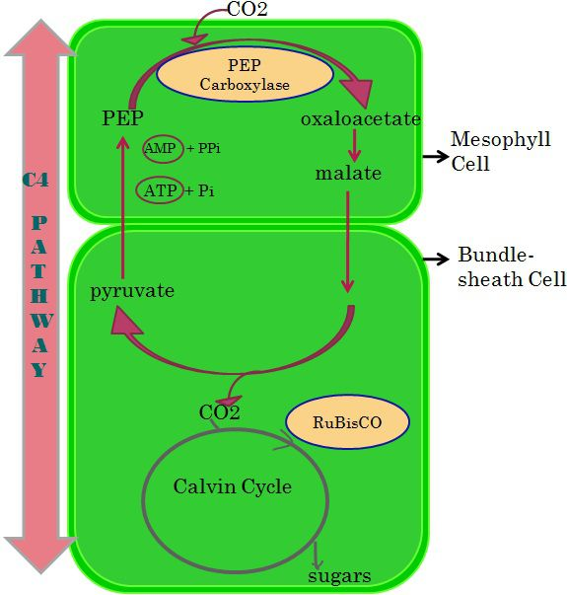

Figure 1:: C₄ pathway; in which carbon fixation in mesophyll cells, while CO₂ is delivered to CALVIN CYCLE for the manufacture of sugar.

TYPES:
- NADP-ME
- NAD-ME
- PEPCK
PEPC (PHOSPHOENOL PYRUVATE CARBOXYKINASE) is the first enzyme that is common to all three subtypes. The product of PEPC is oxaloacetate that can be converted into malate by malate dehydrogenase or asparate by asparate amino-transferase.
NADP-ME:
In this type, malate is converted into pyruvate and carbon dioxide and formation of NADPH that’s catalyzed by NADP-ME.
- Pyruvate is converted to PEP by PEP CARBOXYLASE, that is converted to oxaloacetate, that is converted to malate.
- In this type, cells layers between bundle sheath and mesophyll cell is absent & suberin is present between cell wall of bundle sheath cells.
- Chloroplast with reduced grana arranged centripetally in dicotyledons and centrifugally in monocots.
- Single layer of bundle sheath cell is derived from procambium & mesophyll cell derived from meristem. Oxaloacetate is converted into malate in bundle sheath cells
- FOR EXAMPLE: ZEA-MAYZ, SUGARCANE, etc.
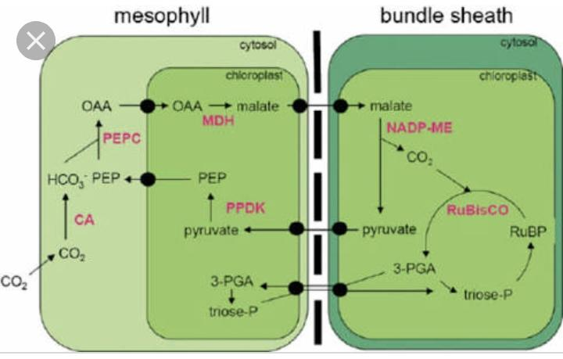
Figure 2: NADP-MALIC ENZYME
NAD-ME:
In this type, oxalic acetic acid is converted to malate by the catalysis of malate dehydrogenase as a result release of CO₂ and pyruvate formation take place in mitochondria. NAD-ME can also balance the number of amino groups between cells of mesophyll and bundle sheath via the return of alanine to mesophyll cells. So, asparate takes in one amino group from mesophyll to bundle sheath cells, oxaloacetate generated by asparate can be used in two ways. One is explained below in next type (PEPCK) and the other is that oxaloacetate converted to malate which is next carboxylated to pyruvate by NAD-ME.
- Double sheath is present between MCs & BSCs.
- Chloroplasts have developed grana present in centripetal form.
- Both bundle sheath and mesophyll cells developed from meristem and mestome sheath is developed by procambium.
- FOR EXAMPLE: SWITCH-CRASS, PEARL MILLET, etc.

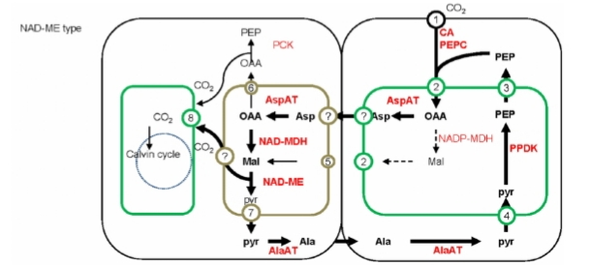
Figure 3: NAD-MALIC ENZYME

PEPCK:
In this type, most of oxaliacetic acid is changing to PHOSPHOENOL PYRUVATE by the action of phosphoenol pyruvate carboxykinase (PEPCK) in bundle sheath cells and CO₂ is deliberated. NAD-ME is continuously providing NADH for the generation of ATP which is considered as fuel for this process. In the process in which oxaloacetate generated by asp used in two ways. One is that PEPCK form PEP, which directly return to mesophyll cells without amino group.
PEPCK -type C₄ photosynthesis is not beneficial because the requirements of energy in bundle sheath cells can’t be fulfilled because continuously providing shade by mesophyll cells.
FOR EXAMPLE: PANICUM Maximum, etc.
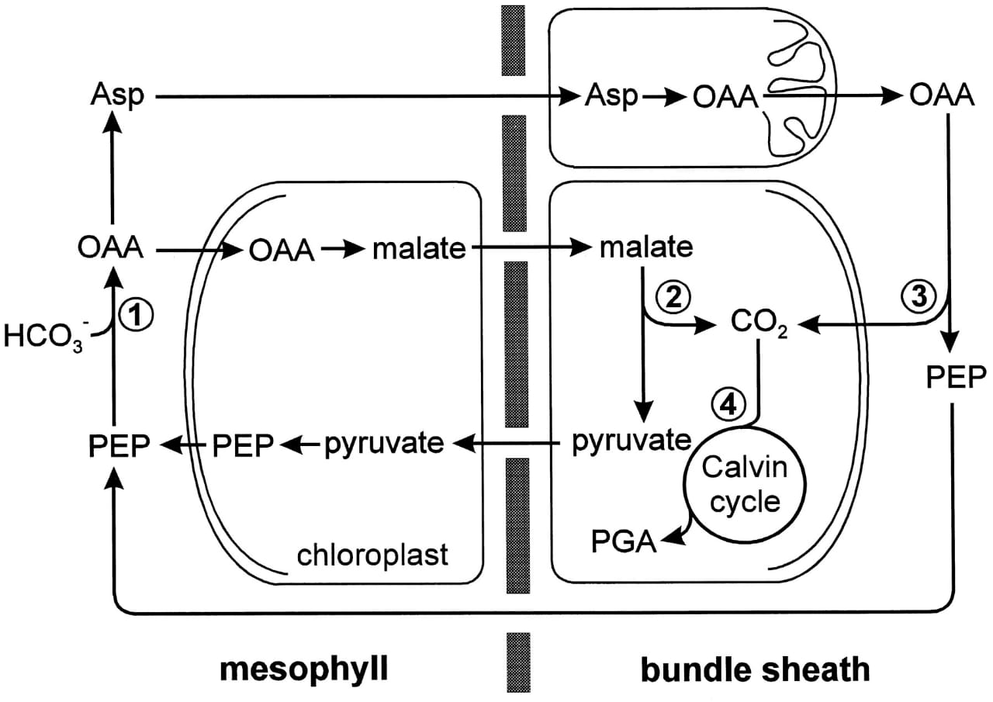
Figure 4: PEPCK type C₄ PHOTOSYNTHESIS.

ADVANTAGES:
C₄ photosynthesis is more efficient than C₃ photosynthesis in hot and dry environment. The reasons are; first one is that photorespiration does not take place in C₄ cycle. Second is that plants keep their stomata close for most of the time thus, avoiding water loss.
- C₄ plants are abundant in tropical condition.
- C₄ plants can do photosynthesis even in closed condition of stomata.
- The optimum temperature is high for these plants, ranges to32-55(C).
- Photorespiration absent.
- The CO₂ compensation point is low in these plants.
- The CO₂ fixation is comparatively faster in it.
- The rate of translocation of end products of C₄ photosynthesis is high.
- C₄ cycle is recently originated about 12 million years ago.
SIMILARITES:
Similarities between C₃ and C₄ plants;
- C₃ & C₄ are types of dark reaction of photosynthesis.
- Both fix sunlight energy.
- The general equation is similar in both.
- End product is similar i.e., 3C compound.
- Both requires chloroplast for reactions.
- Light reaction of photosynthesis is similar.
- RuBP is acceptor for CO₂ in both types.

EVOLUTION:
WHY C₃ PLANTS ARE CONVERTING TO C₄ PLANTS?
Because C₄ plants are efficiently do carbon fixation than C₃ plants.C₄ plants are found by engineers with dense topology, higher robustness, better modularity, higher CO₂ usage and radiation use efficiency.
WHY C₄ PLANTS EVOLVE?
It is originated in arid regions of low latitude, with the conditions of drought, salinity and heat that promote C₄ evolution. Low atmospheric CO₂ is a significant higher factor because it is required for higher rates of photorespiration.

STEPS;
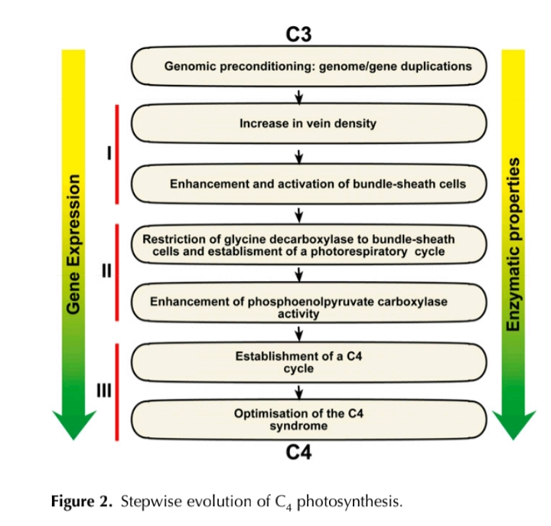
This diagram reveals out how C3 plants are converting into C4 plants in the presence of which conditions, what factors are involved in this conversion, what changes are adopted by plants in converting themselves from C3 towards C₄ plants.

DISADVANTAGE;
- C₄ is not true in moist and cool areas.
- Complex & and more steps
- Require specialized anatomy
Because of these reasons, though the problems of photorespiration and water loss C₃ is more effective. So, most plants used C₃ instead of C₄ cycle.

C₄ PLANTS:
C₄ photosynthesis is found in angiosperms about 8,000 members in 17 families that is almost 3% of all land plants. The grasses, sedges, combined consist of 79% of total no. of species that have C₄ cycle. They are present in monocots as well as eudicots plants. Now a days, C₄ plants consists nearly 5% of earth’s biomass and 3% of its known plant species. Except this scarcity, it performs 23% carbon fixation of all terrestrial plants.
A group of scientists from the world institutions are working on the RICE project to produce a strain in which C₃ plant is converting to C₄ plant. As, the rice is the world’s most human food for half of the planet; it is fulfilling the human food for over the planet. The team claims that C₄ rice could produce over 50% more grain and be able to produce it with less water and nutrients.
The researchers have already identified the genes for C₄ photosynthesis in rice and looking toward developing a new type of C₄ rice plant. In 2012, the government of UNITED KINGDOM along with BILL AND MELINDA GATES FOUNDATION provided 14 million US dollars for three years towards the C₄ rice project at the INTERNATIONAL RICE RESEARCH INSTITUTE.
C₄ CYCLE IN SUGAR-CANE:
Sugarcane is one of the world’s most productive crops because it is common crop of tropics and sub-tropical region where water availability and hot environment support maximum growth rates. It has required long growing season that is 24 months. Its leaf area is dense so that it gets most of sunlight and then uses C₄ pathway of photosynthesis.
Sugarcane follows NADP-ME type of C₄ photosynthesis. In old plants of sugarcane having less nitrogen and exposed leaf surface so that their input is not as much successful than other C₃ plants. But plants having reduced leaf area they get more output than sugarcane by C₄ photosynthesis. So, new sugarcane plants having more leaf area but excess nitrogen makes them more productive than other C₃ plants by doing C₄ photosynthesis.
In sugarcane, C₄ photosynthetic metabolism starts by rapid hydration of CO₂ to bicarbonates by the enzyme carbonic anhydrase in the mesophyll cells of leaf. The substrate of PEP Carboxylase is bicarbonates which bind to PEP as a result formation of oxalic acetic acid occurs. Oxaliacetic acid is unstable and degraded to malate or asparate. This unstability of oxaliacetic acid is a problem for C₄ plants, because the 4-carbon compound that give CO₂ must be stable enough to create a steep gradient for rapid diffusion of it into the bundle sheath cells. As compared to oxalicacetic acid malate and asparate are stable compounds. In sugarcane, oxaliacetic acid is converted to malate by oxidation of NADPH produced by light reaction in the presence of malate-dehydrogenase. The malate is transferred to bundle sheath cells by plasmodesmata where it is decarboxylated by NADP-ME. So, CO₂ released is reused by Rubisco that leaks out from bundle sheath cells reducing photosynthetic efficiency. To overcome that suberin is present in the bundle sheath cells. NADP-ME released pyruvate which is phosphorylated to PEP, this step is catalyzed by pyruvate phosphate di-kinase (PPDK) by using ATP.
DIAGRAM:
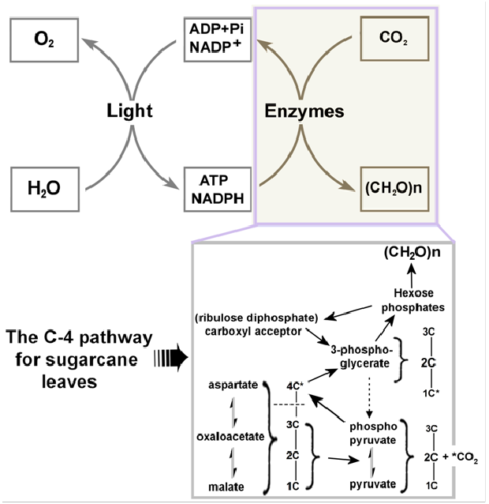Figure 3: SUGAR-CANE CYCLE
In conclusion, sugar-cane has high rate of photosynthesis but below than maize and operates with C₄ cycle. It has broad leaf surface area so that it is adapted such conditions which follows C₄ photosynthetic way.
EXAMPLES:
FAMILIES (MONOCOTS):
- Cyperaceae
- Hydrocharitaceae
- Poaceae / Graminae
FAMILIES(EUDICOTS):
- ACANTHACEAE
- AIZOACEAE
- AMARANTHACEAE
- ASTERACEAE
- BORAGINACEAE
- CAPPARIDACEAE
- CARYOPHYLLACEAE
- EUPHORBIACEAE
- MOLLUGINACEAE
- NYCTAGINACEAE
- POLYGONACEAE
- ZYGOPHYLLACEAE
- SCROPHULARIACEAE
- PORTULACACEAE

EXAMPLES:
ZEA-MAYS, SUGARCANE, SORGHUM MILLETS, SWITCHGRASS, NUTGRASS, BERMUDA GRASS, BARNYARD GRASS, GOOSEGRASS, JOHNSON GRASS, COGON, CRABGRASS, CARABAO GRASS, ITCHGRASS, TUMBLEWEED, etc.

CONCLUSION:
C₄ plants can do photosynthesis in much better way than C₃ plants in excess light. The photosynthetic saturation point in C₄ plants is higher however the light compensation point is lower than in C₃ plants. It is due to that C₄ plants perform well in intense light. This is due to no photorespiration in C₄ plants so caused by excess O₂ from the light reaction. No photorespiration in these plants due to not undergoing out CALVIN CYCLE. As C₄ plants are suited with the environment that has higher light intensities (tropical environment) so they perform well in the conditions of drought, salinity and of excess heat intensities. The cycle having all components are modified for the hot and arid environment and the product is also obtained efficiently. This cycle is tested in many plants and the results are of best qualities. This cycle is mainly designed for those plants which have to grow in tropical environment.

