Experiment no#10
Objective:
To investigate the result on discharge and total head of operating pumps in parallel pump.
Apparatus:
Series and parallel pumps demonstration unit.
Theory:
Parallel pump installations, where two or more pumps take suction from a common manifold and discharge into a common header, are very common in many industries, including the Municipal Water and Wastewater markets. Pumps are operated in parallel as a means of flow control and for emergency backup (installed spare). However, if the pumps are not properly selected for parallel operation, or operated in the most optimum combinations, pump reliability and overall system energy efficiency can be compromised. Operating the wrong pumps in parallel can even cause one of the pumps to operate at shut off, resulting in overheating and failure.
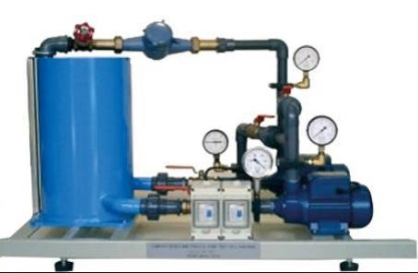
Procedure:
- Allow water to circulate until all air has been flushed from the system.
- When all the equipment in setup than open the valve 1 and the valve 2 and close the valve 3 because in the demonstration unit if the valve 3 is open than pumps are in series so ensure that the valve 3 is closed safely
- Start the pumps with electric power and first measure the flow rate in LPM. This was measured with the Rota meter. Then find the pressure or dial gauge 1 this is always 0. And then find the p₂ from the gauge 2 and p₃ from the gauge 3.
- Now calculate the flow rate in m³ /sec with the following formulas.
- Similar calculate the pump head (H), power of fluid, and electric power from given parameter.
- Find the efficiency of the pump with the following formula.
𝑝𝑜𝑤𝑒𝑟 𝑜𝑓 𝑓𝑙𝑢𝑖𝑑
𝜂 = × 100
𝑒𝑙𝑒𝑐𝑡𝑟𝑖𝑐 𝑝𝑜𝑤𝑒𝑟 𝑜𝑓 𝑝𝑢𝑚𝑝
Observations:
Sr  # | Flow rate  (lpm) | P₁bar | P2 bar | P3 bar | Flow rate m³/sec | Pump head h | g | densi ty  𝜌 | Power of fluid w | Electric power w | Efficiency  𝜂
1
2
3

Calculations:
𝑚3
𝑄 = 1𝐿𝑃𝑀 = 1.667 × 10−5
𝑠𝑒𝑐
𝐻 = 10.197 × 𝑃₃
𝑝𝑜𝑤𝑒𝑟 𝑜𝑓 𝑓𝑙𝑢𝑖𝑑
𝜂 = × 100
𝑒𝑙𝑒𝑐𝑡𝑟𝑖𝑐 𝑝𝑜𝑤𝑒𝑟 𝑜𝑓 𝑝𝑢𝑚𝑝
𝑒𝑙𝑒𝑐𝑡𝑟𝑖𝑐 𝑝𝑜𝑤𝑒𝑟 = 𝐼 × 𝑉
Conclusions:

