Lecture 1: Still life Drawing of chair with pencil shading

Subject: Foundation Drawing-II
Class: BS Textile 2nd
Instructor: Ms. Nadia Abbasi

Assignment 1
Draw still life of a chair with any other still life (optional) with complete shading.
Size: ¼ scholar or any available sheet

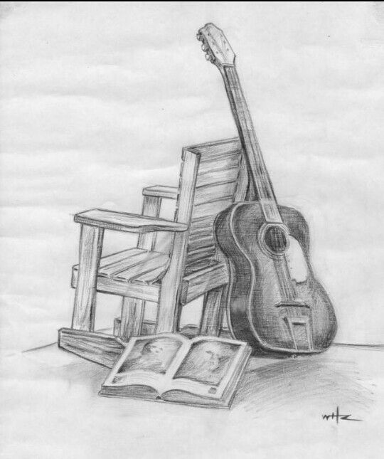
Assignment No: 2
Study any chair with different angles and draw at least 5 sketches on sketch book.

