IMMUNITY

Submitted by
Wajeeha khan
Mahnoor Ayub
(1st semester M.Phil Pharmacology)

Submitted to
Sir Taseer Ahmed
Advanced Immunopharmacology

Table of Contents
Definition of Immunity: 3
Functions of Immune System: 3
Lines of Defense against Foreign Pathogens: 3
1. Physical and Chemical Barriers (Innate Immunity): 3
Physical Barriers: 3
Chemical Barriers: 4
2. Nonspecific Resistance (Innate Immunity): 4
Phagocytic cells: 4
3. Specific Resistance (Acquired Immunity): 5
Main components of Innate and Adaptive immunity 5
Steps in an immune response: 6
Cytotoxic T Cell Pathway: 7
Characteristics of active and passive immunity: 8
Major functions of T Cells and B Cells: 8
Difference between Innate and Acquired immunity: 9
Characteristics of Innate immunity: 9
Characteristics of Acquired immunity: 9
Anti-Bodies: 10
Types of Antibodies: 10
Antibody Structure: 10
Mechanisms of Antibody Reaction: 12
Important functions of immunoglobulins 13
IgG: 13
IgA: 13
IgM: 13
IgD: 13
IgE: 13
Antigens and Immunogens: 14
Autoimmunity: 14
Complement System: 14
Role of Complement system: 15
Activation of Complement: 15
Different Types of Complement Pathways: 15
Role of Complement in Diseases: 15
Diseases associated with complement deficiencies: 16
Hyper-Sensitivity: 18
Classification of hypersensitivity 18
1. Type I or Anaphylactic Response: 18
Common allergens: 19
The immediate response: 19
Late-phase reaction: 19
2. Type II or Cytotoxic-Mediated Response: 19
3. Type III or Immunocomplex Reactions: 20
Pathogenesis of type III immunity: 20
Clinical examples of type III: 21
Arthus Reaction: 21
4. Type IV hypersensitivity reaction: 21

IMMUNITY

Definition of Immunity:
- It is the natural or acquired resistance of the body to a certain disease or pathogenic organism or foreign particles produced by Immune system.
- It is the defense system of the body that produces resistance or response against any foreign particles or micro-organisms.
“Lymphocytes are the cornerstone of immune system”

Functions of Immune System:
Functions of immune system are as follows;
- Scavenge dead, dying body cells
- Destroy abnormal (cancerous)
- Protect from pathogens & foreign molecules: parasites, bacteria, viruses

Lines of Defense against Foreign Pathogens:
The Immune System has three lines of defense against foreign pathogens:
- Physical and Chemical Barriers (Innate Immunity)
- Nonspecific Resistance (Innate Immunity)
- Specific Resistance (Acquired Immunity)

Physical and Chemical Barriers (Innate Immunity):
Physical and chemical barriers form the first line of defense when the body is invaded.

Physical Barriers:
- The skin has thick layer of dead cells in the epidermis which provides a physical barrier. Periodic shedding of the epidermis removes microbes.
- The mucous membranes produce mucus that trap microbes.
- Hair within the nose filters air containing microbes, dust, pollutants
- Cilia lines the upper respiratory tract traps and propels inhaled debris to throat
- Urine flushes microbes out of the urethra
- Defecation and vomiting -expel microorganisms.

Chemical Barriers:
- Lysozyme, an enzyme produced in tears, perspiration, and saliva can break down cell walls and thus acts as an antibiotic (kills bacteria)
- Gastric juice in the stomach destroys bacteria and most toxins because the gastric juice is highly acidic (pH 2-3)
- Saliva dilutes the number of microorganisms and washes the teeth and mouth
- Acidity on skin inhibit bacterial growth
- Sebum (unsaturated fatty acids) provides a protective film on the skin and inhibits growth
- Hyaluronic acid is a gelatinous substance that slows the spread of noxious agents

Nonspecific Resistance (Innate Immunity):
The second line of defense is nonspecific resistance that exist prior to exposure to the microbe(antigen), it includes:
- Host defenses such as barrier to infectious agent (e.g. skin and mucous membrane)
- Certain cells (e.g. natural killer cells)
- Certain proteins (e.g. the complement cascade and interferons)
- Phagocytosis
- Inflammation

Phagocytic cells:
Phagocytic cells ingest and destroy all microbes that pass into body tissues.
For example:
- Macrophages are cells derived from monocytes (a type of white blood cell)
- Macrophages leave the bloodstream and enter body tissues to patrol for pathogens
Inflammation is a localized tissue response that occurs when your tissues are damaged and in response to other stimuli. Inflammation brings more white blood cells to the site where the microbes have invaded. The inflammatory response produces swelling, redness, heat, pain.
Fever inhibits bacterial growth and increases the rate of tissue repair during an infection.

Specific Resistance (Acquired Immunity):
The third line of defense is specific resistance, this system relies on antigens, which are specific substances found in foreign microbes
- Most antigens are proteins that serve as the stimulus to produce an immune response.
- The term "antigen" comes from anti-body generating substance
- Adaptive immunity occurs after exposure to an agent, improves upon repeated exposure, and is Specific
- It is mediated by antibody produced by B lymphocytes and by two types of T lymphocytes:
- Helper T cells
- Cytotoxic T cells
- Cells involve in adaptive immunity have long-term memory for a specific antigen
- Adaptive immunity can be active or passive

Main components of Innate and Adaptive immunity
Table 1. Main components of Innate and adaptive immunity
 | Humoral Immunity | Cell-Mediated Immunity
Innate Immunity | Complement & neutrophils | Macrophages and natural killer cells
Adaptive Immunity | B cells and antibodies (made by plasma cells) | Helper T cells and cytotoxic T cells

- The cell-mediated arm consists primarily of T lymphocytes (e.g, helper T cells and cytotoxic T cells)
- The antibody mediated arm consists of antibodies(immunoglobulins) and B lymphocytes that can differentiate into plasma cells

Steps in an immune response:
Steps involved in an immune response are;
- When an antigen is detected by a macrophage, this causes the T-cells to become activated. The activation of T-cells by a specific antigen is called cell-mediated immunity. The body contains millions of different T-cells, each able to respond to one specific antigen.
- The T-cells secrete interleukin 2. Interleukin 2 causes the proliferation of certain cytotoxic T cells and B cells.
- From here, the immune response follows 2 paths: one path uses cytotoxic T cells and the other uses B cells.

Cytotoxic T Cell Pathway:
- The cytotoxic T cells are capable of recognizing antigens on the surface of infected body cells.
- The cytotoxic T cells bind to the infected cells and secrete cytotoxins that induce apoptosis (cell suicide) in the infected cell and perforins that cause perforations in the infected cells.
- Both of these mechanisms destroys the pathogen in the infected body cell.

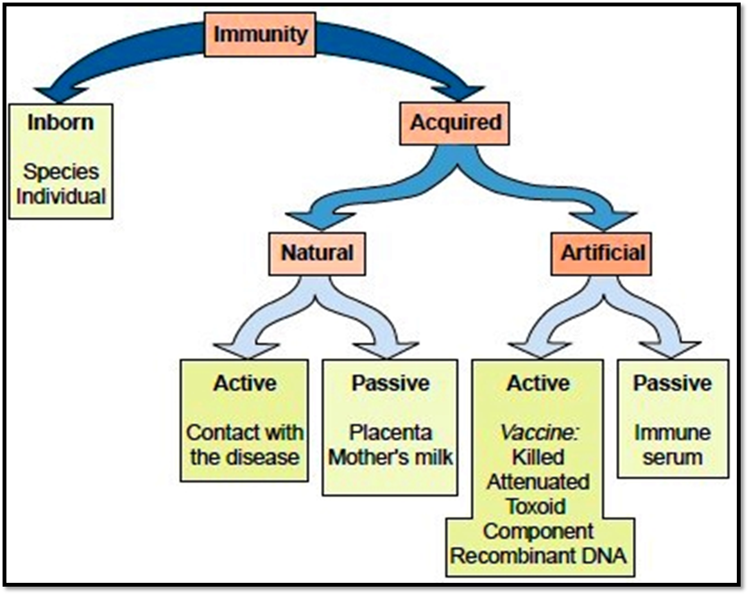

Characteristics of active and passive immunity:
Table 2. Characteristics of active and passive immunity
 | Mediators | Advantages | Disadvantages
Active immunity | Antibody and T cells | Long duration (years) | Slow onset
Passive immunity | Antibody only | Immediate availability | Short duration (months)

Major functions of T Cells and B Cells:
Table 3. Major functions of T Cells and B Cells
Antibody-Mediated Immunity (B Cells) | Cell-Mediated Immunity (T Cells)
- Host defense against infection (opsonize bacteria, neutralize toxins and viruses) | - Host defense against infection (especially M. tuberculosis, fungi and virus infected cells)
- Allergy (hypersensitivity) (e.g. hay fever, anaphylactic shock) | - Allergy (hypersensitivity e.g. poison oak)
- Autoimmunity | - Graft and tumor rejection  - Regulation of antibody response (help and suppression)

Difference between Innate and Acquired immunity:

Characteristics of Innate immunity:
- Acts within minutes
- Exists prior to exposure to the microbe(antigen)
- Does not improve after exposure to an antigen
- It has no memory cells
- Its mediators destroy microbes and secrete cytokines
- Non specific
For example:
- Respiratory cilia: elevate mucus-containing trapped organisms
- Low pH in stomach: retard growth of microbes

Characteristics of Acquired immunity:
- Highly specific
- Requires several days before becoming effective
- Occurs after exposure to an antigen
- Improves on repeated exposure
- It is characterized by long-term memory
- Its mediators present antigens to CD4-positive helper T cells
For example:
- IgG passed from mother to fetus during pregnancy
- IgA passed from mother during breast feeding

Anti-Bodies:
- Antibodies are globulin proteins (immunoglobulins [Ig]) are Y-shaped proteins that circulate through the blood stream and bind to specific antigens, thereby attacking microbes
- The antibodies are transported through the blood and the lymph to the pathogen invasion site
- The body contains millions of different B cells, each able to respond to one specific antigen
- They make up about 20% of the protein in blood plasma
- Blood contains 3 types of globulins [Alpha, beta and Gamma] based on their electrophoretic migration rate
- Antibodies are gamma globulins

Types of Antibodies:
There are 5 classes of antibodies (listed from most common to least common) based on differences in their heavy chain:
- IgG
- IgM
- IgA
- IgD
- IgE

Antibody Structure:
- The simplest antibody has a Y shaped structure
- Each antibody is made of four polypeptide (protein) chains: 2 heavy chains and 2 light chains
- The term light and heavy refers to molecular weight; light chain have molecular weight of about 25,000 whereas heavy chains have molecular weight of 50,000 to 70,000
- Both heavy chains are identical to each other and both light chains are identical to each other
- Each contains a constant region and a variable region.
- The constant region forms the main part of the molecule while the variable regions forms the antigen-binding site
- Each antibody has 2 antigen-binding sites
- The constant region of the heavy chain is responsible for various biologic functions (e.g. complement activation and binding to cell surface receptors)

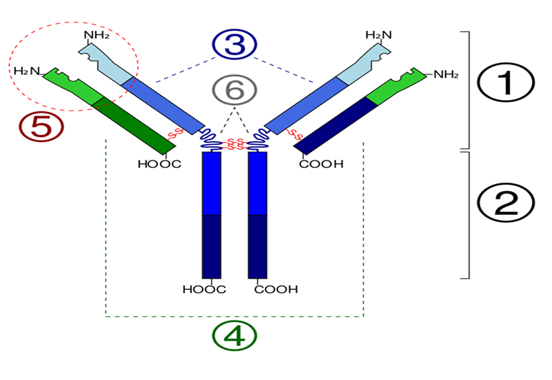
- Fab region
- Fc region
- Heavy chain (blue)
- Light chain (green)
- Antigen binding site (paratope)
- Hinge regions

Mechanisms of Antibody Reaction:
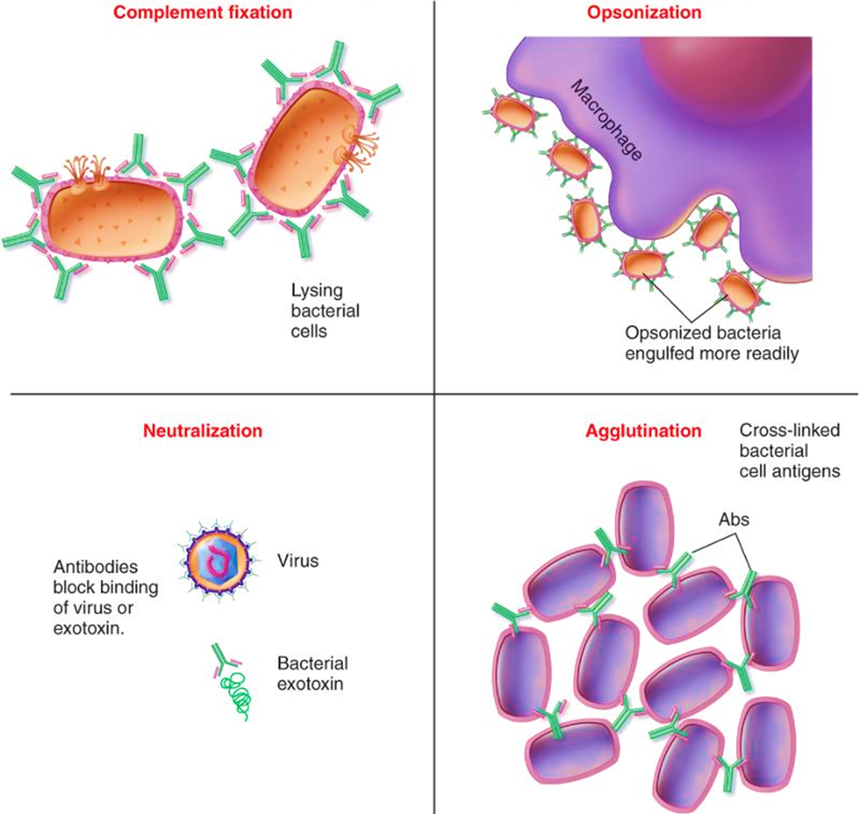

Important functions of immunoglobulins

IgG:
- Opsonizes bacteria, neutralizes bacterial toxins and viruses, crosses the placenta, fixes complement

IgA:
- Main antibody in the secretions such as colostrum, saliva, tears and respiratory, intestinal and genital secretions
- Prevent attachment of bacteria and viruses to mucous membranes, does not fix complement

IgM:
- Produced in the primary response to an antigen, does not cross the placenta, antigen receptor on the surface of B cells, fixes complement

IgD:
- Found on the surface of many B cells as well as in serum

IgE:
- Mediates immediate hypersensitivity, defend against worm infections, does not fix complement

Antigens and Immunogens:
- Toxins or foreign substances that induces an immune response in the body, esp. the production of antibodies
- Antigens include foreign proteins, nucleic acids, lipids, polysaccharides
- Antigens have immunogenicity
- Immunogens are molecules that induce immune response
- Antigens are immunogens and the term are used interchangeably but there are some exceptions (e.g. Penicillins are haptens)
- Haptens are not immunogenic because they cannot activate helper T cells

Autoimmunity:
- The Immune System defends the body against infections and certain other diseases.
- It consists of different organs, cells and proteins known as Anti-Bodies
- Sometimes the Immune system makes a mistake and attacks the body’s own tissues or organs known as autoimmunity
Examples of Auto-Immune Diseases:
  - Type-I Diabetes, Systemic Lupus Erythematosus(SLE)
  - Rheumatoid Arthritis

Complement System:
- Complement was discovered by Jules Bordet as a heat-labile component of normal plasma that causes the Opsonization (enhancement of phagocytosis) and killing of bacteria
- The complement system refers to a series of >20 proteins, circulating in the blood and tissue fluids
- These proteins complement (i.e., augment) the effects of other components of the immune system (e.g., antibody)
- Complement is an important component of our innate host defenses
- Complement protein synthesized mainly by the liver

Role of Complement system:
There are three main effects of complement system:
- Lysis of cells such as bacteria , allografts and tumor cells
- Generation of mediators that participate in inflammation and attract neutrophils
- Opsonization (enhancement of phagocytosis)

Activation of Complement:
- Most of the proteins are normally inactive,and are proenzymes
- In response to the recognition of molecular components of microorganisms they become sequentially activated in an enzyme cascade
- The activation of one protein enzymatically cleaves and activates the next protein in the cascade
- Activation of complement system can be initiated either by antigen-antibody complex or by a variety of nonimmunologic molecules e.g., endotoxin

Different Types of Complement Pathways:
- Classical Pathway
- Alternative Pathway
- Mannose-binding Lectin Pathway
- Lytic Pathway

Role of Complement in Diseases:
- The complement system plays a critical role in inflammation and defense against some bacterial infections.
- Complement may also be activated during reactions against incompatible blood transfusions
- During the damaging immune responses that accompany autoimmune disease
- Opsonization: microbes are phagocytized much better in the presence of C3b because there are C3b receptors on the surface of many phagocytes
- C5a and C5,6,7 complex attract neutrophils, C5a also enhances the adhesiveness of neutrophils to the endothelium

Diseases associated with complement deficiencies:
Table 4. Diseases associated with complement deficiencies
Complement Deficiency | Disease
C3 and Factor B | Severe bacterial infections
C3b-INA, C6 and C8 | Severe Neisseria infections
Deficiencies of early C components C1, C4, C2. | Systemic lupus erythematosus (SLE), glomerulonephritis and polymyositis
C1-inhibitor | Hereditary angioedema

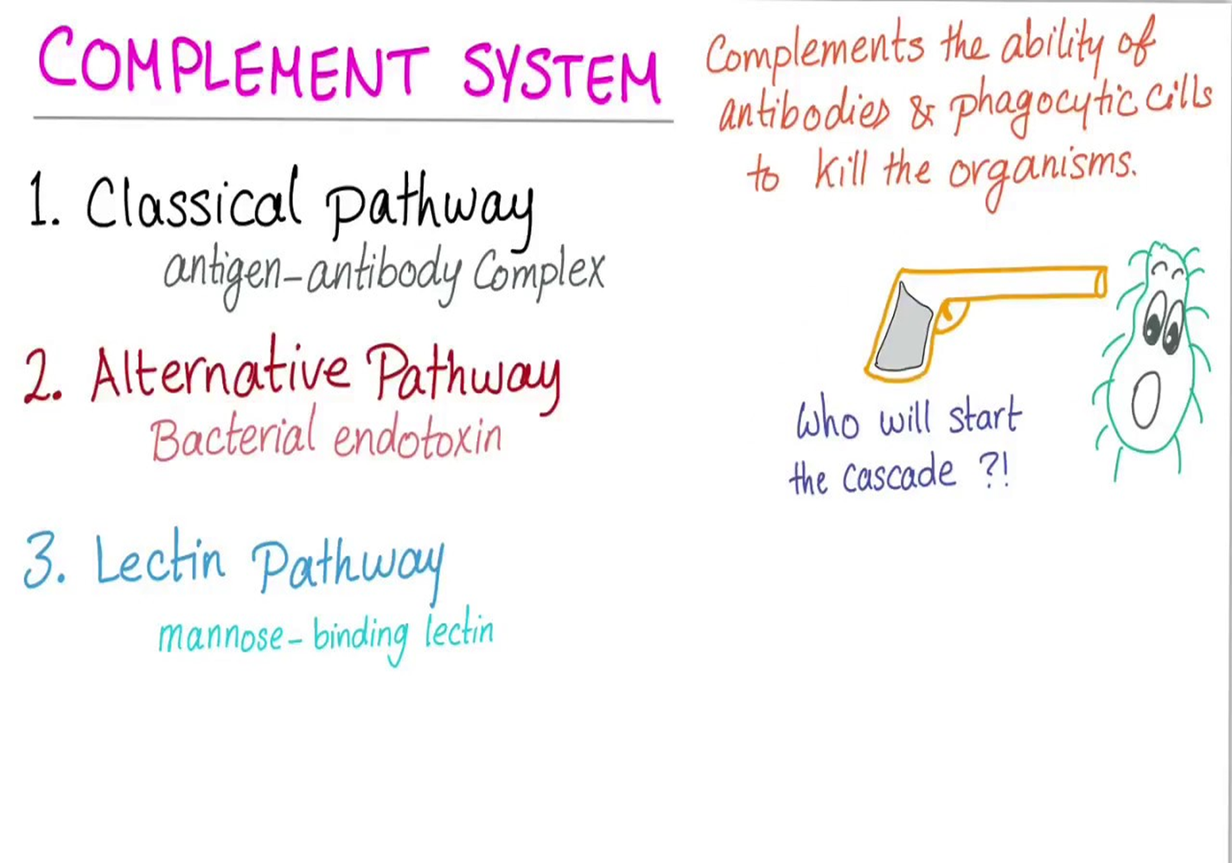
Table 5. Classic and Alternative pathways
Classic Pathway | Alternative Pathway
- Specific acquired immunity  - Initiated by antibody  - Interaction of all components | - Non-specific innate immunity  - Bacterial endotoxin, capsule  - C1, C4, C2 are by-passed

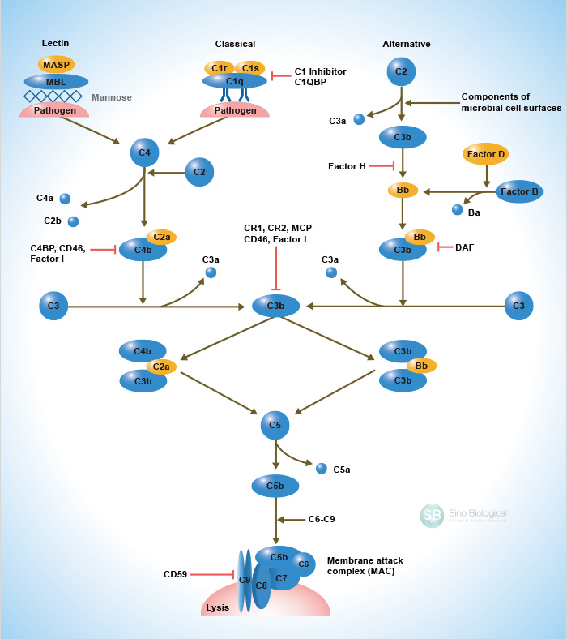

Hyper-Sensitivity:
- Hypersensitivity reactions (HR) are immune responses that are exaggerated or inappropriate against an antigen or allergen
- Hypersensitivity immune responses are capable of causing tissue injury and diseases that are called “hypersensitivity diseases”
- Hypersensitivity reactions occur in response to external stimuli(antigen) whereas autoimmune reactions occur in response to internal stimuli(antigens)
- The term allergy is often equated with hypersensitivity

Classification of hypersensitivity
Coombs and Gell classified hypersensitivity reactions into four forms:
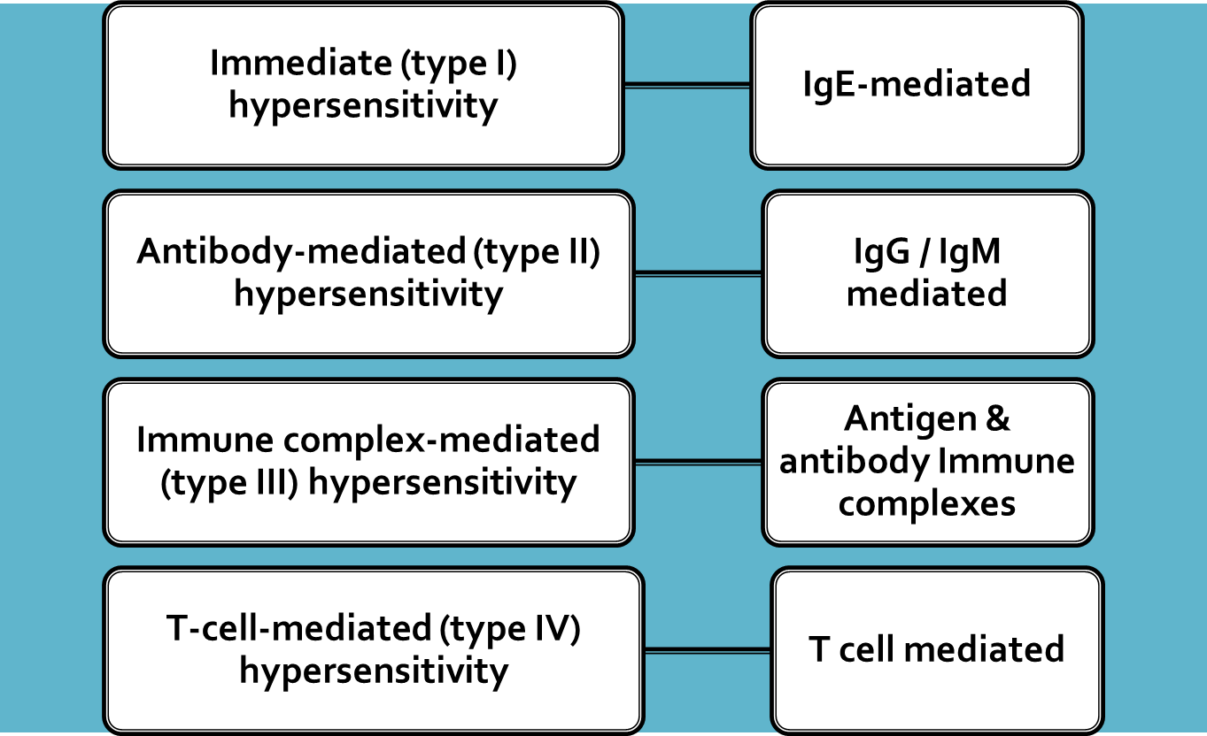

Type I or Anaphylactic Response:
Anaphylactic Responses mediated by IgE antibodies that are produced by the immune system in response to environmental proteins (allergens) such as pollens, animal danders or dust mites. These antibodies (IgE) bind to mast cells and basophils, which contain histamine granules that are released in the reaction and cause inflammation bronchial asthma, allergic rhinitis, allergic dermatitis, food allergy, allergic conjunctivitis, and anaphylactic shock may take place.

Common allergens:
- Skin contact (Pollen,latex,animal scratches,poison plants)
- Injection (bees sting)
- Ingestion (medication,nuts)
- Inhalation (pollen,dust,animal dander)

The immediate response:
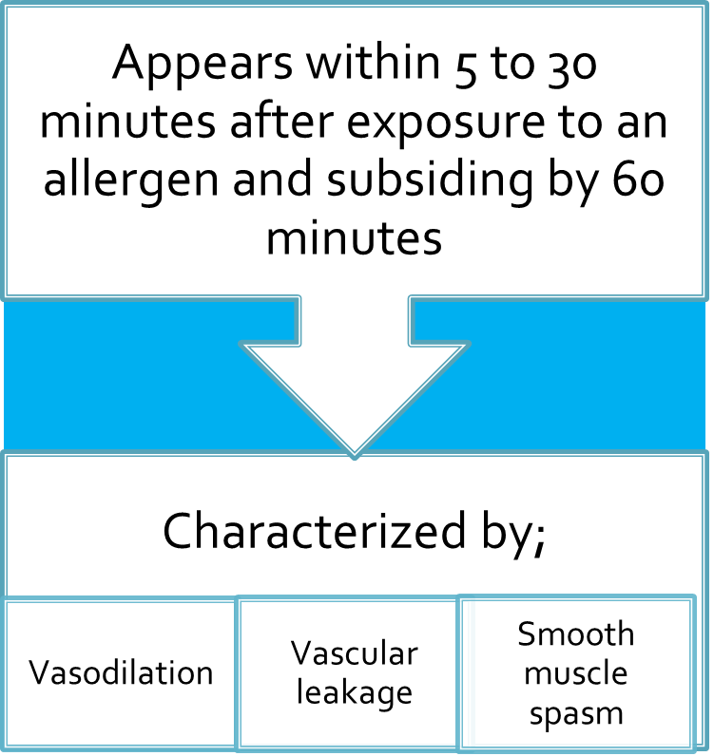

Late-phase reaction:
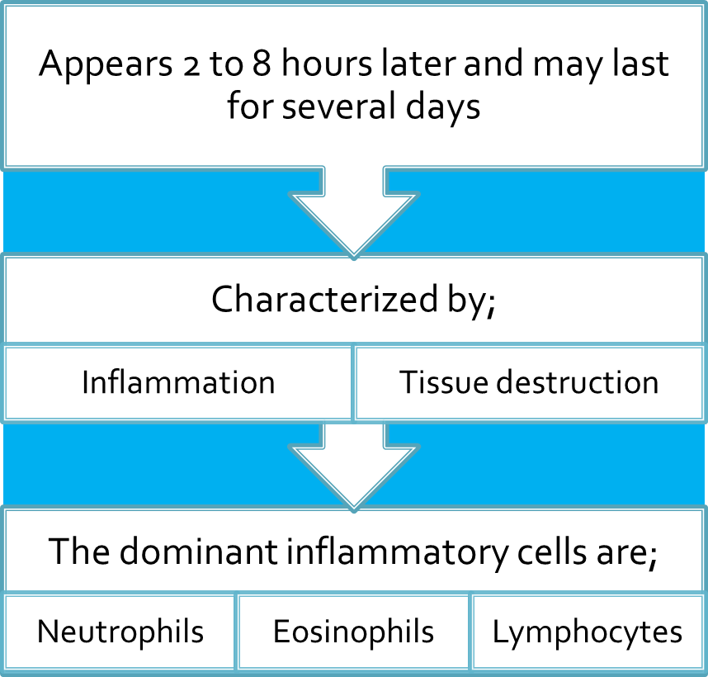

Type II or Cytotoxic-Mediated Response:
- IgG and IgM mediate cytotoxic-mediated response against cell surface and extracellular matrix proteins
- The immunoglobulins involved in this type of reaction damages cells by activating the complement system or by phagocytosis
- Type II hypersensitivity reactions can be seen in immune thrombocytopenia, autoimmune hemolytic anemia, and autoimmune neutropenia

Type III or Immunocomplex Reactions:
- These are also mediated by IgM and IgG antibodies that react with soluble antigens forming antigen-antibody complexes
- The complement system becomes activated and releases chemotactic agents that attract neutrophils and cause inflammation and tissue damage as seen in vasculitis and glomerulonephritis
- Type III hypersensitivity reactions can classically be seen in serum sickness and Arthus reaction

Pathogenesis of type III immunity:
- Immune complex hypersensitivity occurs when antigen–antibody complexes induce an inflammatory response in tissues.
- Antigen-antibody (immune) complexes that are formed in the circulation, may deposit in tissues, leading to complement activation and acute inflammation.
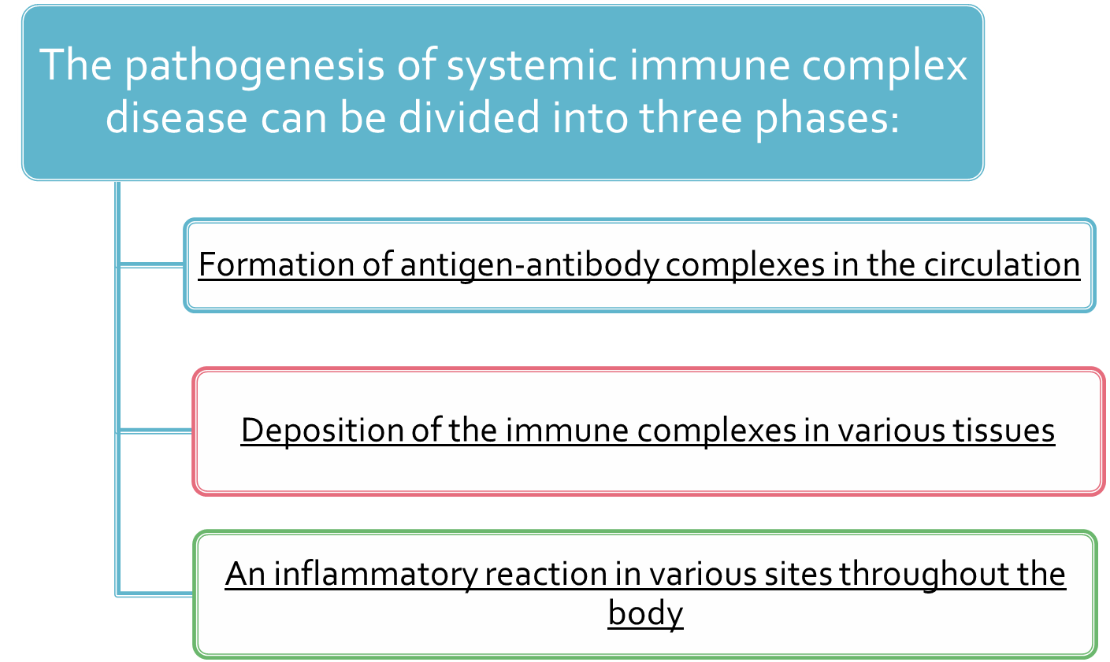

Clinical examples of type III:
Table 6. Clinical examples of type III
Disease | Antigen Involved
Systemic lupus erythematosus | Nuclear antigens
Post streptococcal glomerulonephritis | Streptococcal cell wall antigen
Polyarteritis nodosa | Hepatitis B virus antigens
Reactive arthritis | Bacterial antigens (e.g. Yersinia)
Serum sickness | Various proteins e.g. foreign serum protein
Arthus reaction (experimental) | Various foreign proteins

Arthus Reaction:
- A type of local type III hypersensitivity reaction
- A local vasculitis associated with deposition of immune complexes and activation of complement
- Is produced by intradermal injection of an antigen into the skin of a previously immunized individual
- Occur 4–12 hours after injection
- Characterized by severe pain, swelling, induration, edema, hemorrhage, and occasionally by necrosis
- Reported after vaccination against diphtheria and tetanus

Type IV hypersensitivity reaction:
- Type IV hypersensitivity reaction is also called delayed type hypersensitivity reaction because it takes 2 to 3 days for the reaction to develop after exposure to the particular substance.
- Cell-Mediated Type of hypersensitivity is initiated by antigen activated T lymphocytes including; CD4+ T cells and CD8+ T cells.
- Two types of T-cell reactions are capable of causing tissue injury and disease:
- Delayed-type hypersensitivity: initiated by CD4+ T cells
- Direct cell cytotoxicity: mediated by CD8+ T cells

Main immune cells involved | Important disease | Pathologic or Clinical Features | Common inducing agents
CD4 (helper) T cells and macrophages | Tuberculosis, coccidiodomycosis | Granuloma | Constituents of bacterim or fungus
CD8(cytotoxic) T cells | Contact dermatitis  Steven Johnson syndrome  Toxic epidermal necrolysis | Pruritic  Vesicular rash  Target lesion | Oil of poison oak or poison ivy, topical drugs, soaps, heavy metals jewelry, herpes simplex virus 1, sulfonamides

