Multiple Optimal Solutions: Graphical Method of Linear Programming
Maximize z = x₁ + 2x₂
subject to
x₁ ≤ 80
x₂ ≤ 60
5x₁ + 6x₂ ≤ 600
x₁ + 2x₂ ≤ 160
x₁, x₂ ≥ 0.

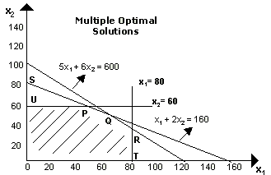
In the above figure, there is no unique outer most corner cut by the objective function line. All points from P to Q lying on line PQ represent optimal solutions and all these will give the same optimal value (maximum profit) of Rs. 160. This is indicated by the fact that both the points P with co-ordinates (40, 60) and Q with co-ordinates (60, 50) are on the line x₁ + 2x₂ = 160. Thus, every point on the line PQ maximizes the value of the objective function and the problem has multiple solutions.
2. Infeasible Problem Linear Programming (LP)
In some cases, there is no feasible solution area, i.e., there are no points that satisfy all constraints of the problem. An infeasible LP problem with two decision variables can be identified through its graph. For example, let us consider the following linear programming problem (LPP).
Minimize z = 200x₁ + 300x₂
subject to
2x₁ + 3x₂ ≥ 1200
x₁ + x₂ ≤ 400
2x₁ + 1.5x₂ ≥ 900
x₁, x₂ ≥ 0
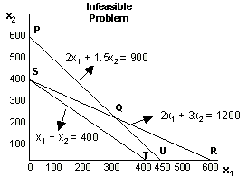
The region located on the right of PQR includes all solutions, which satisfy the first and the third constraints. The region located on the left of ST includes all solutions, which satisfy the second constraint. Thus, the problem is infeasible because there is no set of points that satisfy all the three constraints.
3. Unbounded Solution: Graphical Method in LPP
It is a solution whose objective function is infinite. If the feasible region is unbounded then one or more decision variables will increase indefinitely without violating feasibility, and the value of the objective function can be made arbitrarily large. Consider the following model:
Minimize z = 40x₁ + 60x₂
subject to
2x₁ + x₂ ≥ 70
x₁ + x₂ ≥ 40
x₁ + 3x₂ ≥ 90
x₁, x₂ ≥ 0
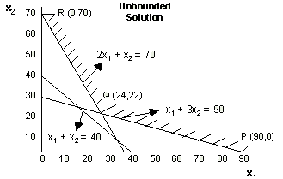
The point (x₁, x₂) must be somewhere in the solution space as shown in the figure by shaded portion.
The three extreme points (corner points) in the finite plane are:
P = (90, 0); Q = (24, 22) and R = (0, 70)
The values of the objective function at these extreme points are:
Z(P) = 3600, Z(Q) = 2280 and Z(R) = 4200

THE END

