EXPERIMENT NO.4
Calibration of bourdon tube pressure gauges
Theory:
Bourdon tube:
Pressure measurement is the analysis of an applied force by a fluid (liquid or gas) on a surface. Pressure is typically measured in units of force per unit of surface area. Many techniques have been developed for the measurement of pressure and vacuum. Instruments used to measure and display pressure in an integral unit are called pressure meters or pressure gauges or vacuum gauges. A manometer is a good example, as it uses the surface area and weight of a column of liquid to both measure and indicates pressure. Likewise the widely used Bourdon gauge is a mechanical device, which both measures and indicates and is probably the best known type of gauge.
Use:
Bourdon tube pressure gauges are the most common type in many areas and are used to measure medium to high pressures. They cover measuring spans from 600 mbar to 4,000 bars. The measuring element is a curved tube with a circular, spiral or coiled shape, commonly called a bourdon tube.
Working principle:
The Bourdon pressure gauge operates on the principle that, when pressurized, a flattened tube tends to straighten or regain its circular form in cross-section. When a gauge is pressurized, the Bourdon creates the dial tip travel to enable pressure measurement.

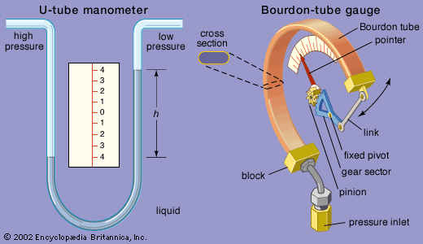

Apparatus:
The Bourdon pressure gauge
Procedure:

Calculation table:
Sr.no | Weight  (w) | Pressure increasing  Gauge(p) Gauge(E) |  | Pressure decreasing  Gauge(P) Gauge(E)
1
2
3
4
5

Conclusions:

