linear programming:
LP stand for linear programing. It was developed by George B. Dantzig in 1947. It is a method to achieve the best outcome such as maximum profit or lowest cost in a mathematical model, whose requirements are represented by linear relationships. LP is a special case of mathematical programming.
LP is one of the simplest ways to perform optimization. It help us to solve some very complex optimization problems by making a few simplifying assumptions. LP may not provide a desired optimal solution, when the underlying assumptions are removed from the problems. LP is very interesting topic, it starts with simple problems, but it can get very complex. For some reason, LP does not get as much attention as it deserves while learning data science.LP is one of the most beneficial, powerful and useful techniques for making administrative decisions.
For example, sharing a bar of chocolates between siblings is a simple optimization problem.
LP is used for obtaining the most optimal solution for a problem with given constrains. In LP, we formulate our real life problems into a mathematical model. It involve an objective function, linear inequalities with subject to constraints
LP can be applied to various field of study. It is widely used in a verity of applications, like production planning, investment planning, scheduling, education, engineering problems, marketing, sales, advertising, business, economics, energy, government etc. LP has also been used to determinethe combination of pollution control method that will cost the least and maintain an acceptable production level.
For example, we must determine how to allocate our time among activities like studying, sleeping, eating and enjoyment. Most of we are on a limited financial budge and have to make difficult decisions and planning regarding the utilization of our funds.

Chapter 3
Question# 23
MASTI, a popular music group has decide to buy some amplifiers. There are models available presently in the market and their details are as follows:

Model | Cost (in Rs) | Space Requiredon stage(meterssq.) | Electric power (watts)
Little big horns | 50 | 0.7 | 55
Big big horns | 120 | 0.8 | 90

MASTI can buy any number of each type but they have only Rs.600 to spend and total space available on stage is 5.6 square meter.
Solve the following graphically:
- Determine the number of each type MASTI should buy in order to maximize the output power?
- Determine the number of each type MASTI should buy in order to minimize storage space required but give a total power output of at least 200 watts?

Solution:
(a)

Objective function:

Max p = 55$X_{1}$+90$X_{2}$

Constraints S/t:-

50$X_{1}$+120$X_{2}$≤ 600 (12, 0) (0, 5)
0.7$X_{1}$+0.8$X_{2}$≤ 5.6 (8, 0) (0, 7)

$X_{1}$,$X_{2}$≥0

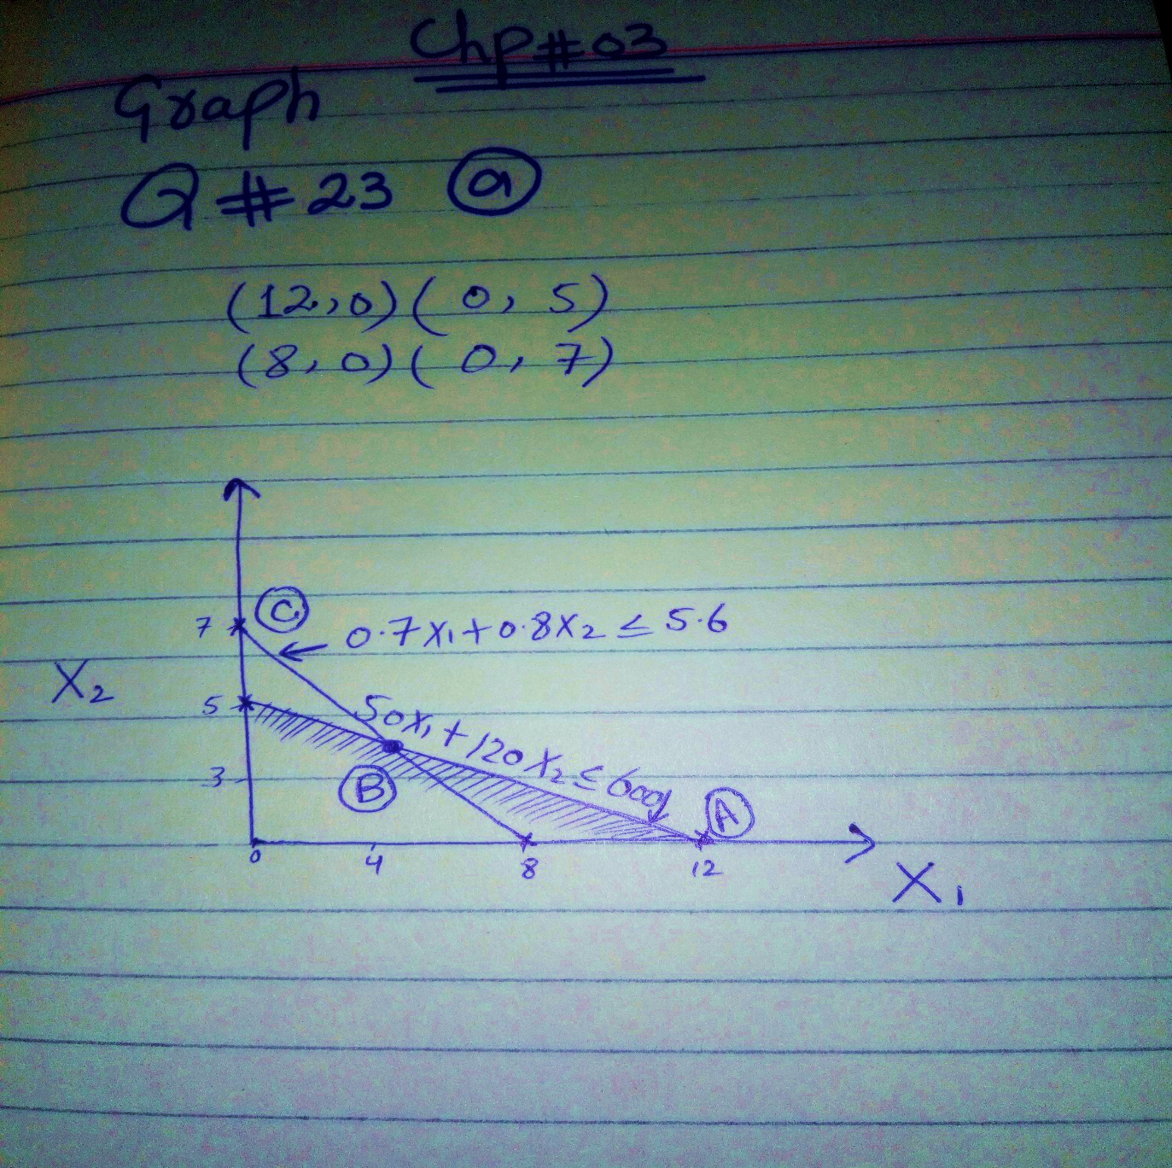

Interpretation:-

Firstly we select the scale from greater and lower values like 4,8,12 and 3,5,7. Then draw the corner points of every constraints, then check that the every constraints full fill the every condition of feasible formation. So here,in this graph every constraints full fill the every condition of feasible formation.Then the graph gives the B point that is the feasible region.

(b)

Objective function:

Min c = 0.7$X_{1}$+0.8$X_{2}$

Constraints S/t:-

50$X_{1}$+120$X_{2}$≤ 600 (12, 0) (0, 5)
55$X_{1}$+90$X_{2}$≥ 200 (3.63, 0)(0, 2.22)

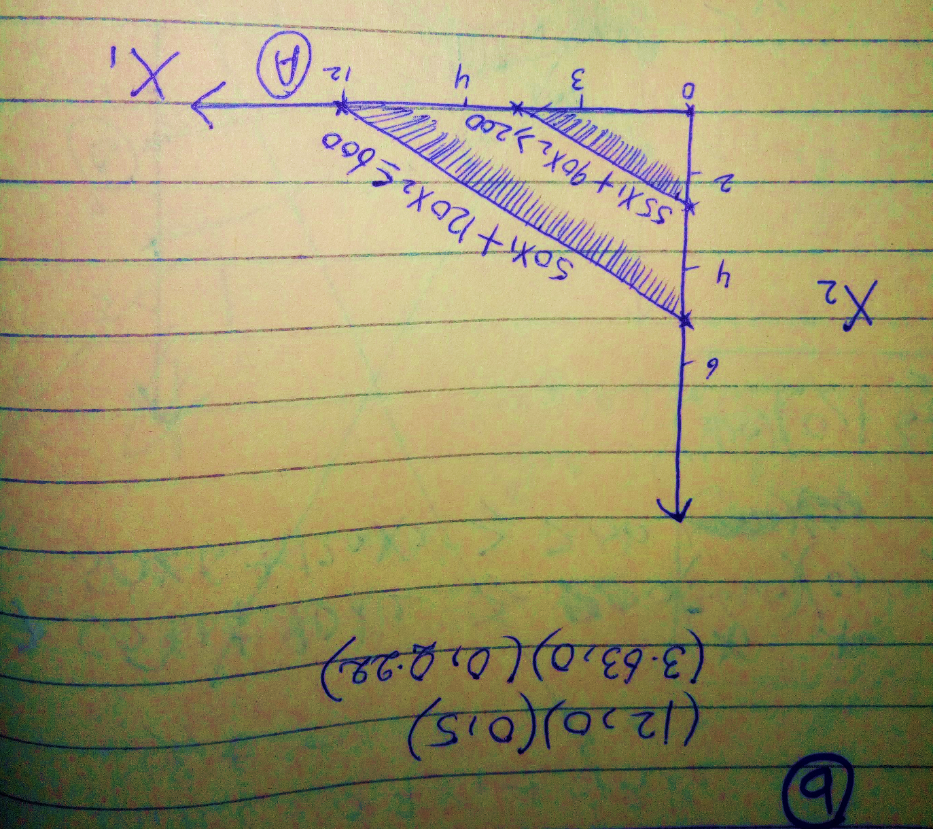

Interpretation:-
Firstly we put the values in the graph and draw the corner lines of every constraints, then the graph gives the Parallels lines. If any line plot Parallels and this line touches the extreme points of feasible region. Then this line according to all constraints that gives the maximum profit from all lines then these.

Linear Programming (LP) by Graphical Method

- The graphical method of solution:-

The graphical method of solving a linear programming problem is used when there are only two decision variables. If the problem has three or more variables, the graphical method is not suitable. In that case we use the simplex method. There are some important definitions and concepts that are used in the methods of solving linear programming problems.

- Solution:-
A set of values of decision variables satisfying all the constraints of a linear programming problem is called a solution to that problem.

- Feasible solution:-
Any solution which also satisfies the non-negativity restrictions of the problem is called a feasible solution.

- Optimal feasible solution:-
Any feasible solution with maximize or minimize the objective function is called an optimal feasible solution.

- Feasible region:-
The common region determined by all the constraints and non-negativity restriction of a LP is called a feasible region.

- Corner point:-
A corner point of a feasible region is a point in the feasible region that is the intersection of two boundary lines.

