Experiment No-10
Power factor improvement by using static capacitors.
Objective:
- To understand the power factor meaning
- Disadvantages of low power factor.
- Cause/ elements of low power factor
- How we can improve low power factor.
Apparatus:-
- Loads
- Motor
- Ammeter
- Voltmeter
- Power factor meter
- Capacitor banks

Theory:
Power Factor: The power factor of an AC electrical power system is defined as the ratio of the real power flowing to the load, to the apparent power in the circuit, and is a dimensionless number between -1 and 1.
Real Power is the capacity of the circuit for performing work in a particular time.
Apparent Power is the product of the current and voltage of the circuit.
Apparent Power is always greater than Real Power: Due to energy stored in the load and returned to the source, or due to a non-linear load that distorts the wave shape of the current drawn from the source, the apparent power will be greater than the real power.
Negative Power Factor: It occurs when the device which is normally the load generates power which then flows back towards the device which is normally considered the generator.
Low Power Factor: In low power factor system draws more current. The higher currents increase the energy lost in the distribution system, and require larger wires and other equipment. Because of the costs of larger equipment and wasted energy, electrical utilities will usually charge a higher cost to industrial or commercial customers where there is a low power factor.
High Power Factor: In high power factor system draws less current.

Linear loads with low power factor (such as induction motors) can be corrected with a passive network of capacitors or inductors. Non-linear loads, such as rectifiers, distort the current drawn from the system. In such cases, active or passive power factor correction may be used to counteract the distortion and raise the power factor. The devices for correction of the power factor may be at a central substation, spread out over a distribution system, or built into power-consuming equipment.

Cause of Low Power Factor:
As we know, utilities typically charge additional costs to customers, who have a low power factor. But which caused low power factor?
- Low power factor is caused mainly by induction motors.
- Also by inductive loads, such as transformers and magnetic lighting ballasts, cause low power factor.
- Line voltage can also cause a low power factor. Increasing line voltage of motors and transformers above rated voltage will increase the consumption of reactive energy. Power factor decreases 20% if there is an increase of 10% rated voltage.
Resistive loads that create work entirely by consuming watts (w) or kilowatts (kw), the inductive loads require some current to create a magnetic field, and the magnetic field facilitates the desired work. The total or apparent power required by an inductive device is a composite of the following:
- Real power (measured in kilowatts, kW)
- Reactive power associated with components that alternately store energy and release it back to the line during each AC cycle (which is measured in kilovars, kVAR).
The relation of these factors: formula of power factor:
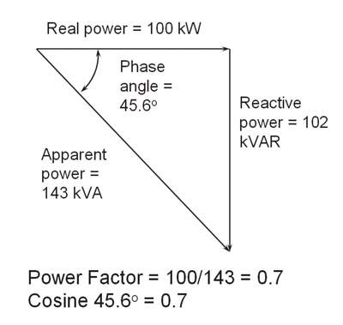
Reactive power, which is required by inductive loads, increases the amount of apparent power (measured in kilovolt amps, kVA) in the distribution system. The increase in reactive and apparent power is reflected by the increase of the angle between the two, causing the power factor to decrease.
Power factor is 0.7; it means that 70% of your power is being used to do useful work.
Leading, Lagging and Unity Power factor:
The power in an AC circuit is expressed in terms of the RMS (root-mean-square) voltage and current and the power factor:-
P = E I cos φ
Where: P = RMS power
E = RMS voltage
I = RMS current
φ = The phase angle between the voltage and current vectors
The term (cos φ) is called the power factor.
The product of the voltage and current E I (usually called VA) is often quoted together with the "real" power P. VA relates to the voltage and current actually supplied by the power source, whereas P is the useful power consumed by the load.
- If VA and P are not equal, the power factor cannot be unity.
- When the circuit is purely resistive, the phase angle is zero. Therefore cos φ = 1 and
P = E I.
- If the circuit is purely inductive, the phase angle is -90° (lagging power factor), cos φ = 0 and therefore P = 0, although E I has a finite value.
- If the circuit is purely capacitive, the phase angle is +90° (leading power factor), cos φ = 0 and P = 0, with E I again having a finite value. Clearly, a device with a leading power factor can be used to compensate for one having a lagging power factor and vice versa.
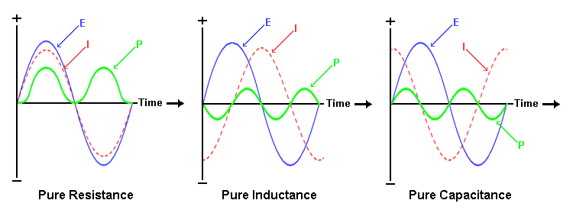
- A power factor of one, or "unity power factor", is the goal of any electric utility company since if the power factor is less than one, they have to supply more current to the user for a given amount of useful power consumed (VA is greater than P).

Power factors of different devices:
Distribution Transformer:
- Power factor of a transformer is a function of load. An unloaded transformer would be very inductive and have a very low power factor.
Lightening:
- Incandescent lamp ~ Unity power factor
- Fluorescent lamp ~ Usually low power factor
- Mercury lamp ~ 40% to 60%
Electric Motors:
- Induction motors ~ Their power factor is a function of load
- Synchronous motors ~ Good power factor when excitation is perfect
Welding:
- Welding~ Usually low power factor
Power Factor Improvement Methods:
There are following methods that are used for power factor improvement.
- Reduce the amount of reactive energy, eliminate unloaded transformers and motors.
- Use static capacitors for power factor improvement.
- Use synchronous motor for power factor improvement.
Capacitor power factor improvement:
Power factor correction is achieved by addition of capacitors in parallel with the device. This is a simple method of providing power factor improvement. It is often applied to areas where machines using electric motors are used. These motors are inductive. Applying a capacitor neutralizes the power factor error. And improve the power factor of the different electrical devices. Often these systems monitor the power factor and switch in further reactance (capacitive) to provide the required power factor improvement.
Synchronous motor power factor improvement:
The use of synchronous motors is another method of providing power factor improvement. The motors are run without a load and are able to provide the capacitive load required to ensure the power factor is improved. This form of power factor improvement operates because the reactive power drawn by the synchronous motor is a governed by its field winding excitation. This can be altered to provide a variable capacitive load. This type of load factor correction has now generally been superseded by other solid state methods.
Observations and Calculations:
The loads are
L = 1 H
R = 2K Ω
C = 6 uF

With 1R+1L:
- Add capacitor banks to improve power factor of the resistive and inductive load.

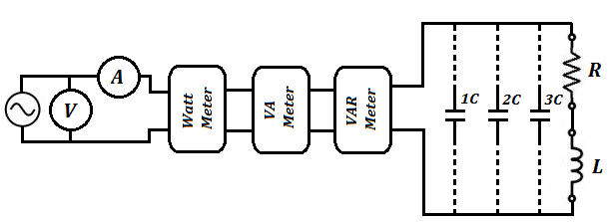

With 1R+2L:
- Add capacitor banks to improve power factor of the resistive and inductive load.

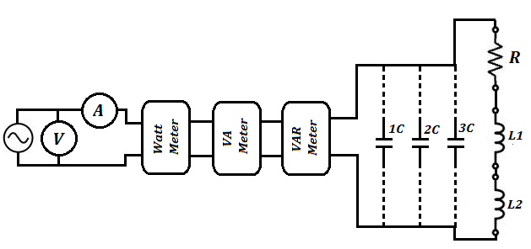

Observation Table:
S.No | Load | Voltage  (V) | Current  (A) | Power |  |  | Power  factor | Capacitor  ( uF)
 |  |  |  | Watt | VAR | VA
1 | 1R+2L
2 | 1R+3L

Conclusion:

Comments:

