PROJECT report of(GROUP NO. 05) BS. BOTANY ii

Course Name
Citizenship and Community Engagement
Proposal Title
Community Engagement through
Street Lightening, Awareness about First Aid, Speed Breakers
Submission Date
07-june-2020
Group Members
- Malaika Hussaini
- Haseeb Ahmed
- Hina Nazir
- Iqra Zulfiqar
- Aneesa Arooj

Submitted To
Prof. Mehlah Jabeen
University
University of Sargodha sub campus Bhakkar
Project Idea Template
Citizenship Education and Community Engagement BS Botany
- Name of Students and Roll numbers:
- Malaika Hussaini(BBTF19BM011),
- Aneesa Arooj (BBTF19BM017),
- Iqra Zulfiqar(BBTF19BM025),
- M.Haseeb Ahmed(BBTF19BM028),
- Hina Nazir(BBTF19BM029)

Program: BS Botany
Session: 2019-2023

Title of the Project
Community engagement

Introduction
- Awareness to females with regard to First aid
- Speed breakers
- Installing street light

Background of the problem
- Installing street light or Bulb:
The nighttime accidents and economic loss has gone on increases. Our society is facing many problem and many communities suffer due to the absence of the street light and hence: the quality of life has decreased in our area during night hours. The road user faces a risk in the darkness. in our society robbers taking the advantage of this darkness and recently many robberies are reported in our society.( Ref: Molalla trkhana wala and Tibia Habib Shah nzd dera moor kotla jam, bhakkar) due to the absence of the street light. If street lights are not present. Many CCTV cameras are working during night. It prevents the accident on road and it increases the safety of life It reduces the crime on road.
- Awareness to females with regard to First aid:
In our society women’s are not aware about the prevention so. They meet accidents and causalities. Sudden trauma occurs in our society the women are not able to rescue other in such a harsh suiation. They must know what to do in these accidental conditions. It is better to save life then, to be sorry. These are the lack of the train women in our society to rescue other and even him/herself in trauma suiation. Some in juries require quick and simple solution but when they doest know the actual problem they go with their home made remedies and after this the risk of problems increase instead of decreasing the risk of the problem. The suiation becomes worse.( https://scholar.google.com.pk/)
- Speed breakers;
There are many streets that join each other at piazzas or there are link roads with every main road. These main roads lack speed breakers due to which many people lay their lives on roads. Moreover there are various shops with the sides of the road. Children, old men women, even the teenagers meet road accidents due to high speed of vehicles. Many accidents occur on the road due to the lack of the speed breaker. Death occurs on the road due to the unawareness of the rules and regulation of the passengers of the road
. https://en.wikipedia.org/

Present situation
- Street lightning;
- Yesterday due to darkness in the streets there happens a robbery in street (Ref.Aneesa Arooj) the man was hit by a bike and they took away his money.
- Awareness regarding First Aid:
- There happened an accident (Ref. Hina Nazir) in which a women was deeply injured, there were all men around and Ambulance was late and that pity soul died at the spot due to lack of awareness.
- Speed breaker:
- We have seen that at piazzas people while passing from streets don’t decrease the speed of their vehicles (usually bikes) so that they face the loss of their lives and thus not only they, their families suffer too
Justification of the Project
- Importance of the Project Activity
- Importance of First aid:
- It can save lives.
- Reduce the number of workplace accidents.
- Positive work environment.
- Your company will be safer place to work.
- First aid kits are used properly.
- It can reduce recovery time.
- It can keep employees safe outside of the workplace
- Its great team building exercise.
- Providing quick medical treatment until professional assistance arrives.
(https://medium.com/)
- Importance of street lightning:
- Elimination in night time accident and economic loss.
- Aid to police protection and in enhanced sense of personal security.
- Facilitation of smooth traffic flow.
- Promos ion of business activities’ sand the use of public interactions during the night hours.
- The drivers feel more confident in driving under in proper street lighting.
- It make the street attractive
- It increase the community value of the street
(https://www.engineeringenotes.com/)
(https://en.wikipedia.org/)
- Importance of speed breaker:
Speed humps are traffic calming device which play a vital role in safely slowing the speed of vehicles to avoid any accident, these are placed on the road to break the speed of any vehicle up to 90% and making it safe for the people to walk around. (https://en.wikipedia.org/)

- Practical implications (Who will get benefits of the activity?)
We did this project for the welfare of the community.
Awareness of first aid will help a lot in daily routine life especially women. We have shared solutions of daily routine problems as in the case of burn, minor cuts , fracture of bone ,sprain or snake bite etc. It will be effective in emergency situations.
Street lights and speed breaker also will help a lot in reducing accidents and environment become smooth and calm. It also helpful for pedestrian.

Objectives of the Project
- Installing street light or bulb:
Street light played an important role in our daily life. Specially, at night, lightning fixed on the road to provide visibility to the vehicles and pedestrians. Somehow, street lightning reduced the crime on the road. (In 2011 reported in London). Street lights can improved the traffic conditions, reduce driver fatigue, and help improve road capacity and ensure traffic safety ( https://www.slideshare.net/ ).It promoted the pedestrians safety and will improved the standard of life. It enhanced the personal security issues. The main objective of the maked the traffic flow smooths. The privacy protection is increased by installing the street light. (https://www.ukessays.com)

- Awareness to the female with regard to first aid:
Awareness and desire to be accident free kept you more safe and secure. It reduced the number of causalities and accidents. It enabled you to assist persons who become injured in the event of an accident or emergency situation until help arrived. First aid gived to any person suffering in a sudden illness or injury as a result provided to preserve the life of a person. As a human, it is our moral duety to rescue our lives. Our 1st priority is to preserve humanity Because it is our duety to preserve life ( https://specialties.bayt.com/).
It promoted a scene of responsibility in the person.
- It promoted the scene of safety.
- Quick Treatment.
- Help to preserve life.
- Makes people feel secure.
- It promoted the security in urban area
- During the hour of darkness, it increases the risk of the life.
- At high traffic condition, the light level should increase
(https://www.fstraining.co.uk/)
- Speed breaker:
The first aim of the speed breaker was to provided safety and to secure road. It had promoted the Road safety measures. We Traffic threshold are the common name for a family of traffic calming devices that use vertical deflection to slow motor-vehicle traffic in order to improve safety conditions. Variations include the speed hump, speed cushion, and speed table. Speed humps are intended to reduce driver speeds down to 10–15 miles per hour over the hump, and 25–30 miles per hour between humps in a series.( https://en.wikipedia.org/)
Plane of Action
- How did we accomplish this task?
We did this project with the help of our friends moreover we got financial aid of people in our surroundings for speed breakers.
- Requirements and sources
- Requirements
We required the money,street bulb, holders, wires, gravels, cements, clay, First aid kit, gloves, gaze roll and pads, elastic bandages, emergency blankets, adhesive tape, safety pins, thermometer, scissors, tweezers and antiseptic wipes.
- Resources
Malaika Hussaini Father: Niaz Hussain
HinaNazir Father: Nazir Ghouri
Aneesa Arooj Father: Hafiz Aziz Ur Rahman
Iqra Zulfiqar Father: Zulfiqar Ali
Haseeb Ahmad Friends: Ukash, Maaz, Usman, Ali butt, Shoaib, Ghufr
- Individual’s role in project
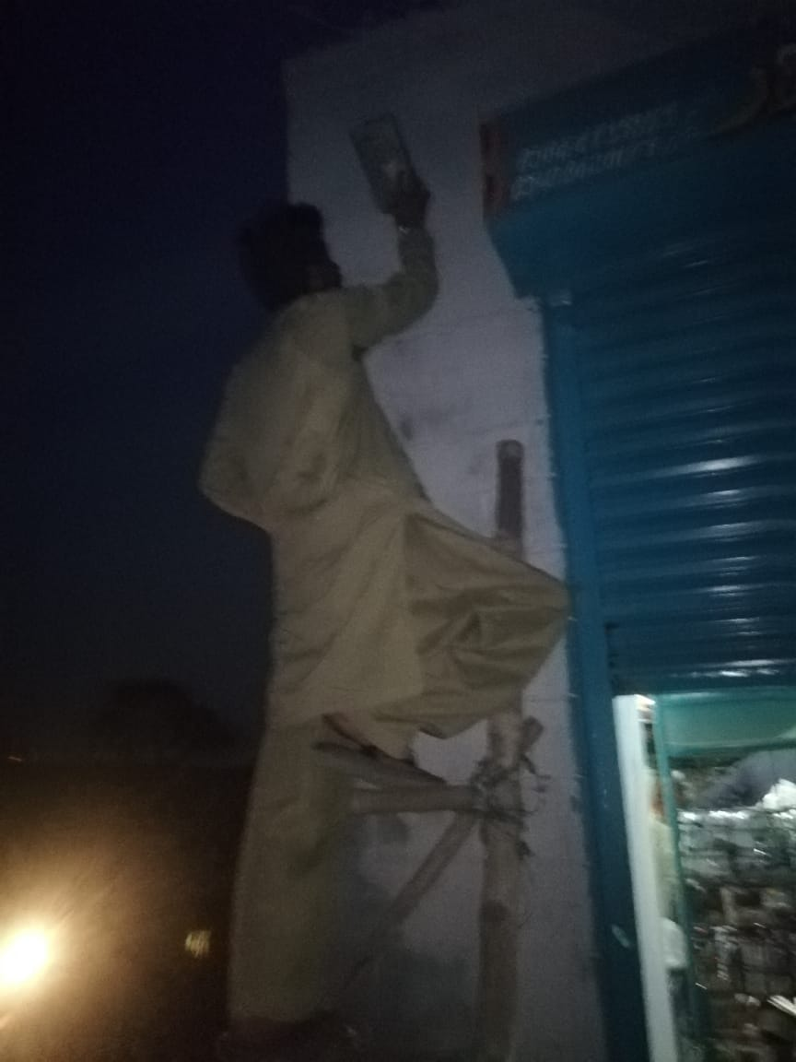
We were 5members in our group and we completed our tasks with our best.
- Malaika Hussaini:
She played a good role in this project by putting on street lights in the area of so that people should get benefited. She did this in order to preserve our community from the accidents happenings due to darkness. She did this with the help of her father; Niaz hussain.

- Haseeb Ahmed:
He played his role in this project by making seed breakers in his area and also convinced people to do so for the sake of lack of road accidents due to high speed vehicles .He completed his task with the help of his friends; Ukaash, Maaz, Usman, Ali butt, Shoaib,
Ghufran. He made speed breaker near Nrsp office mandi town Bhakkar.
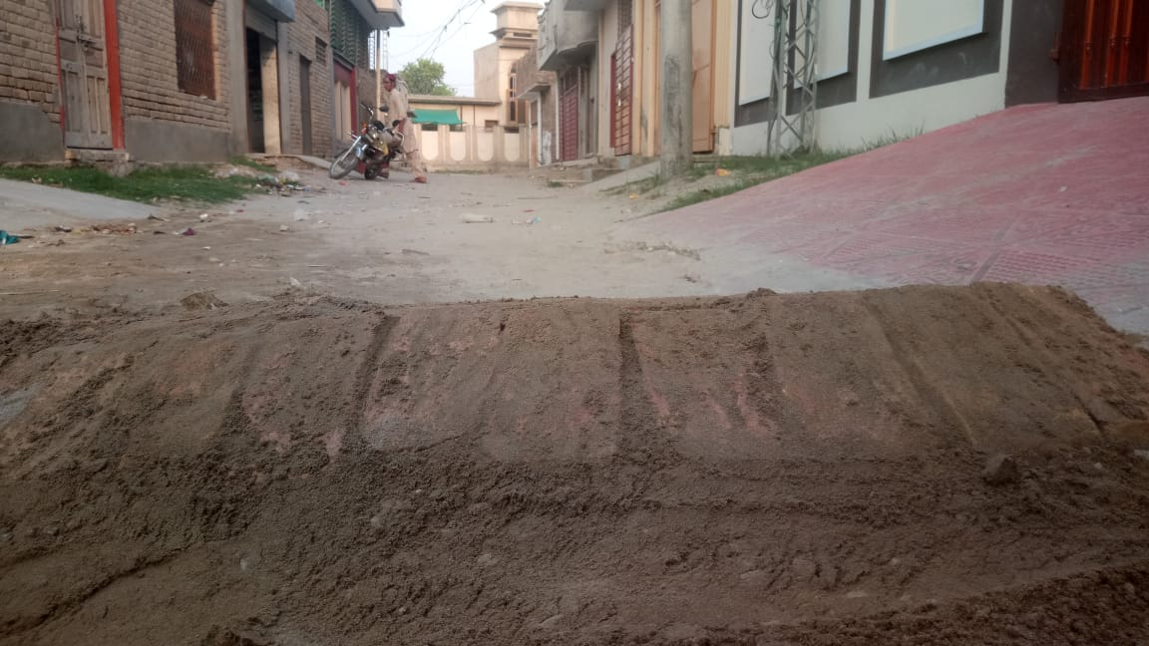
- Iqra zulfiqar:
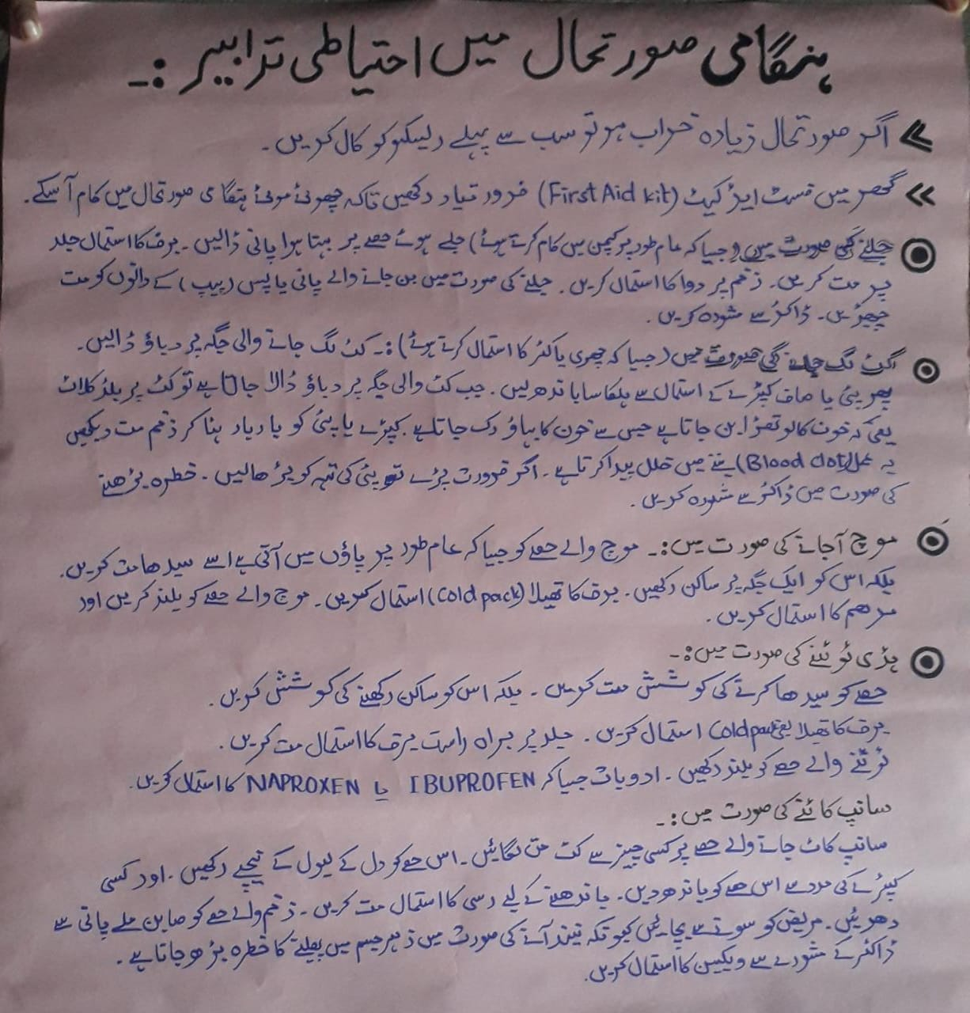
She played her role in this project by giving awareness to the people regarding first aid by making first aid kit. She also gave awareness to the peoples of her Molalla Tar khan wala. She completed her task with the help of her father and sister; Zulfiqar Ali and Ayesha

- HinaNazir:
She played her role in this project by giving awareness about serious issues which were a part of our daily life such as road accidents, snake biting, fire burning etc. She made contact with Rescue Team 1122 and made videos for the ease of people of our community so that the people should get more benefits by watching videos. She completed her task with the help of her father and teacher; Nazir Ghouri and Sir Bilal.
Proof: (Videos is paste in the separate folder)
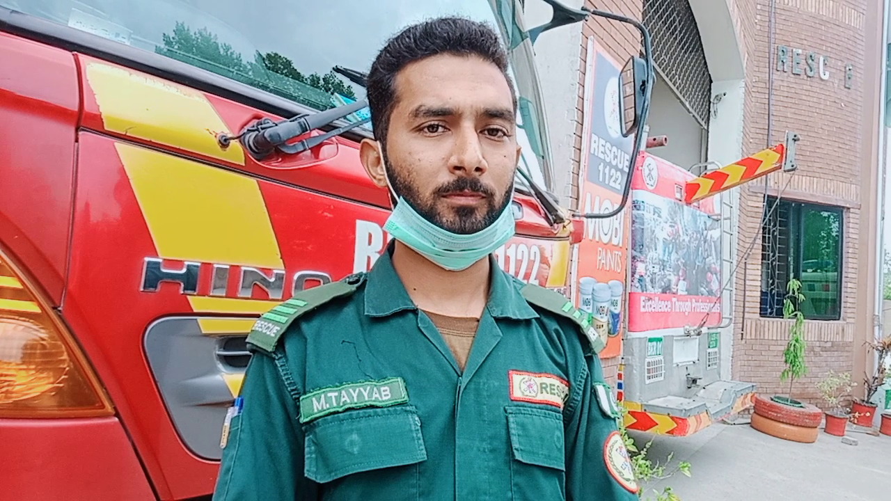

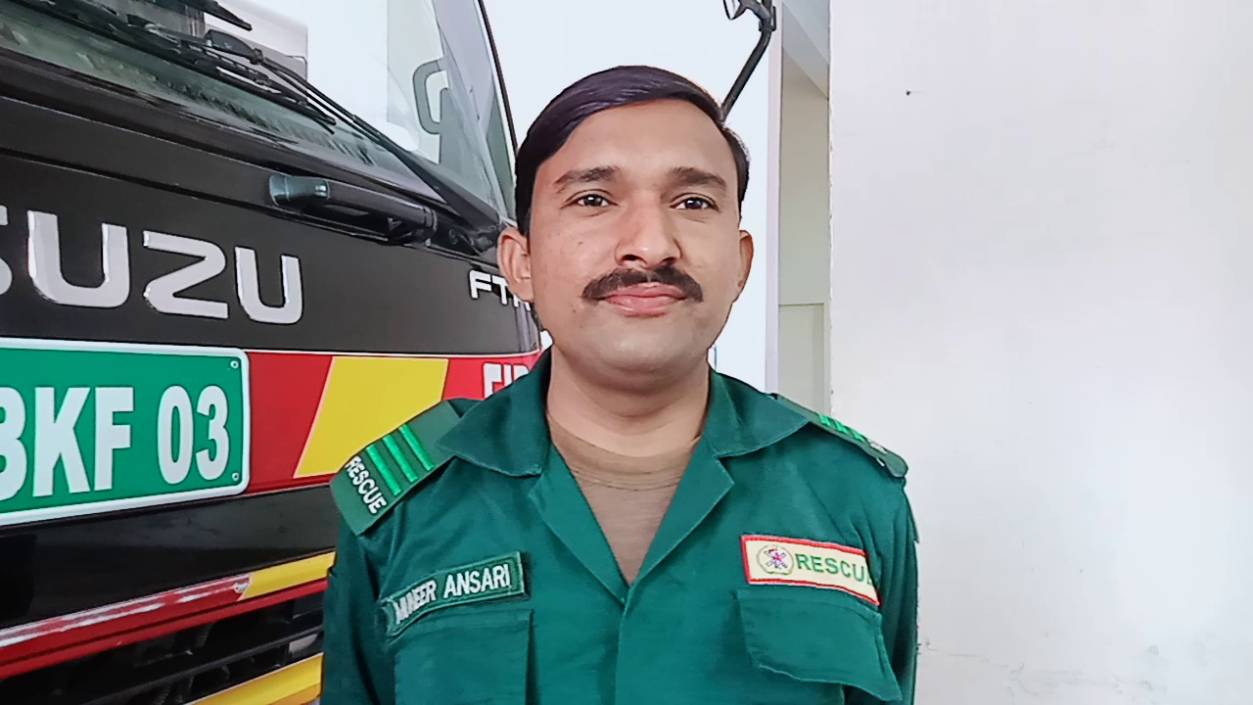

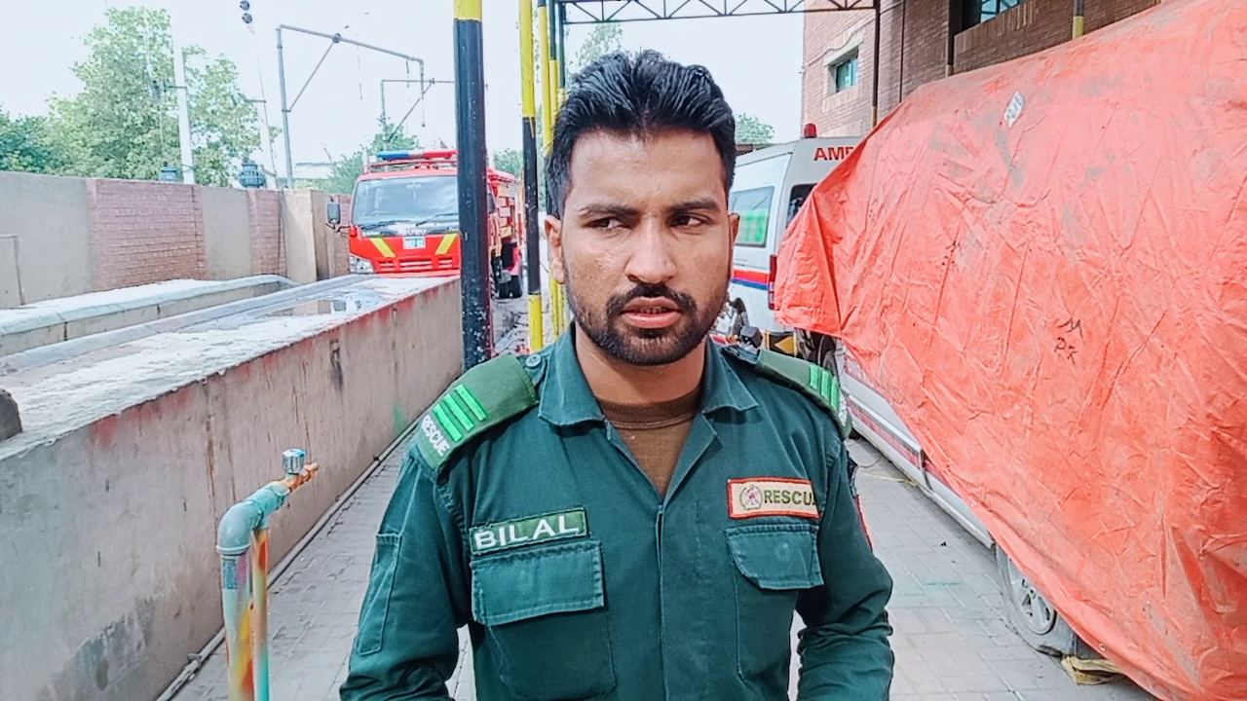
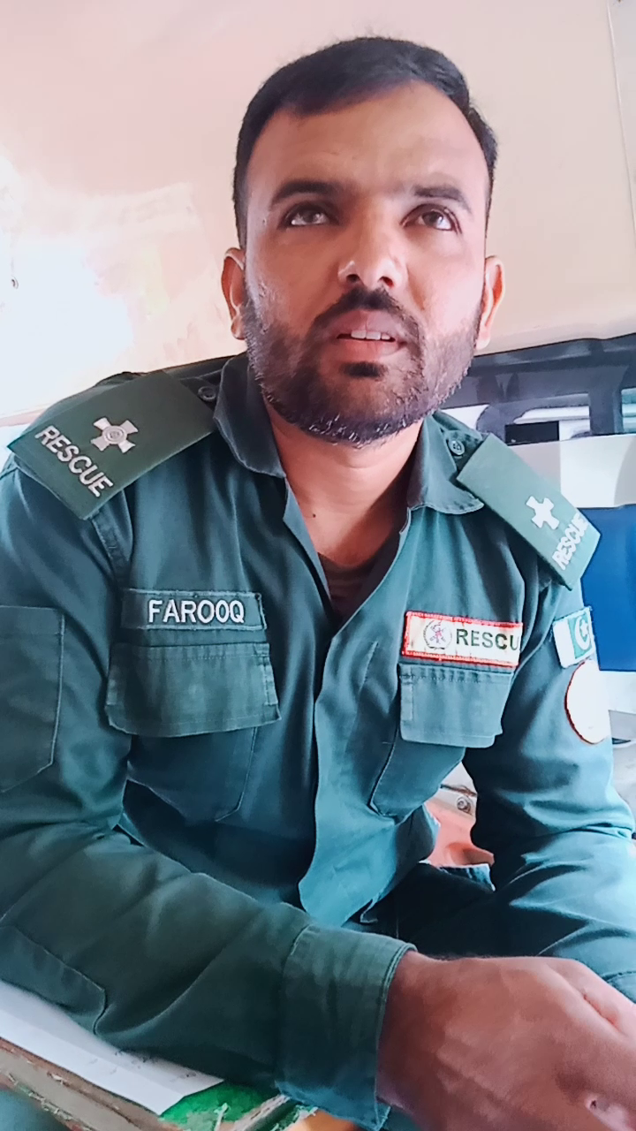
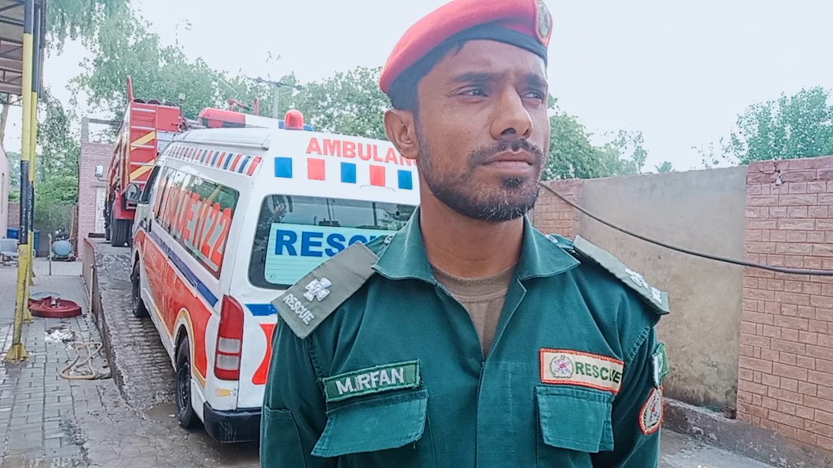
- Aneesa Arooj:
She played her role in this project by putting on street bulbs in her area Mohall Hafiz Abad and her surroundings in order to protect people from any kind of miss happenings i.e., Robbery, Stealing ,Any kind of street crime etc. She also gave awareness to the people regarding First Aid by making charts. She completed her task with the help of her brother Atiq Athar.

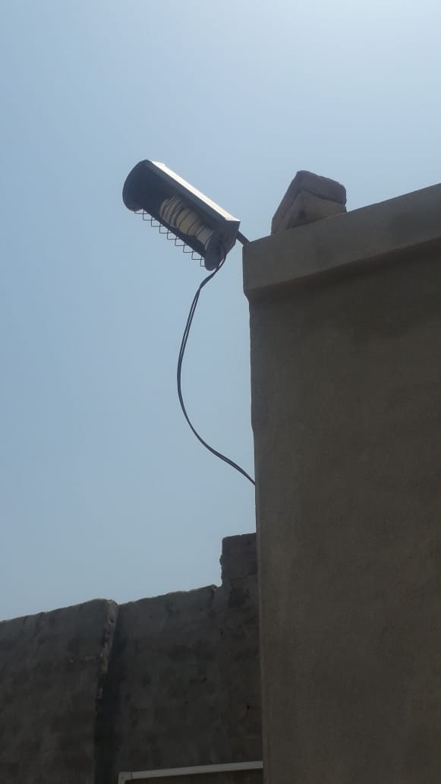
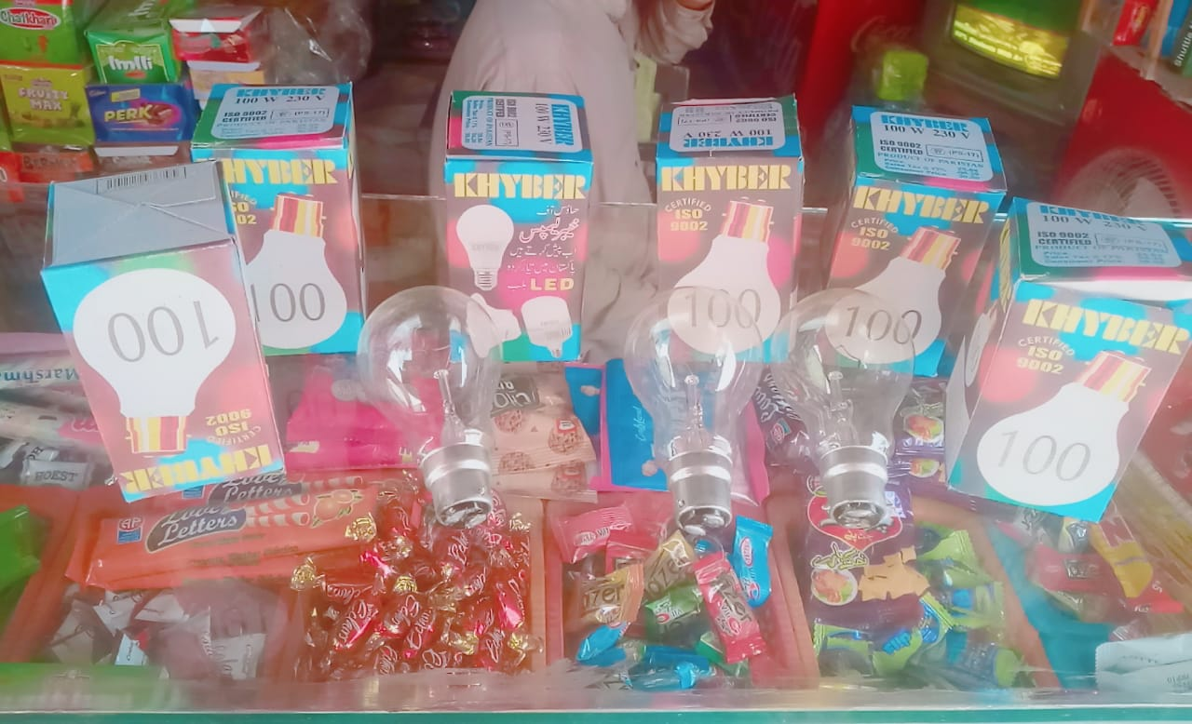

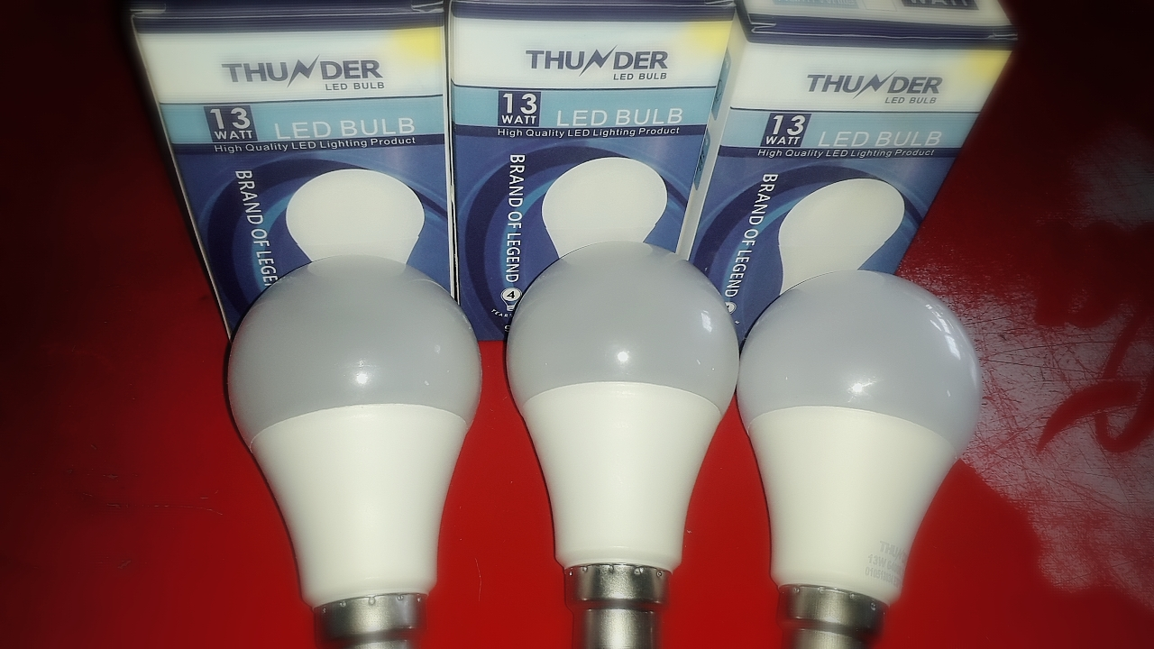

Proposed duration of the project
We did this project this project within 2 weeks. We did this project with the help of the family and friends.
How will you evaluate your project for possible outcomes?
Street lightning:
I had met a pedestrian in my street. He was very old. He said that when I had gone towards the Masjid( Ref: Muslim Masjid) there was no source of light. Even a single bulb is not put there. Due to lack of street we have faced a lot of difficulties in passing through the street. But, now there is not difficulty. He gave me bundle of thanks. I had felt very proud that I could able to do something for my society.
Speed breakers:
We had launched speed breaker in Mandi Town. A shopkeeper (Ref: Naizi Gernal store) felt me proud by saying that in this street accidents had been reduces to some extent. The life of many people is secured now. This speed breaker is now put hold on many accidents. Hence this project proved beneficial for the society.
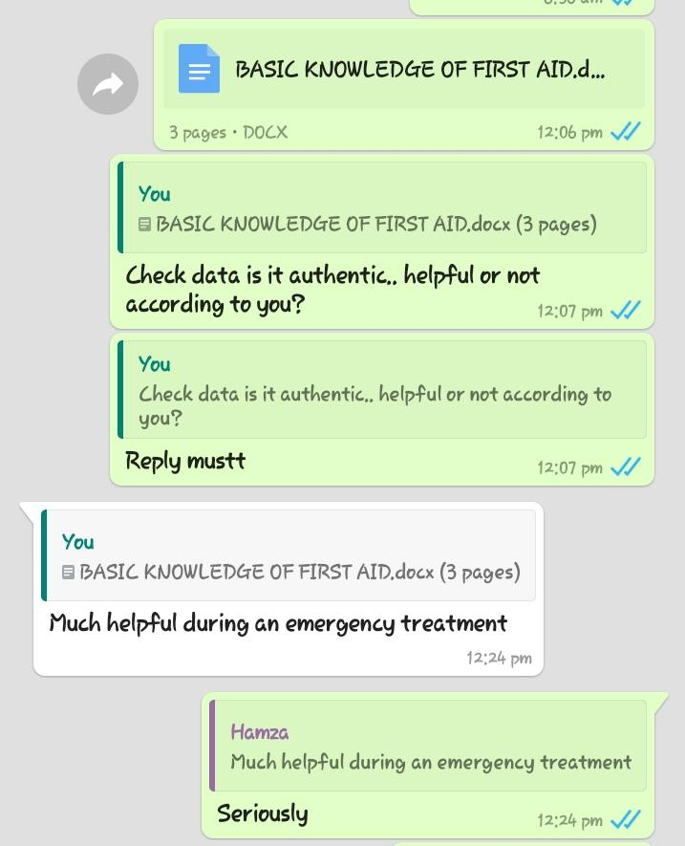
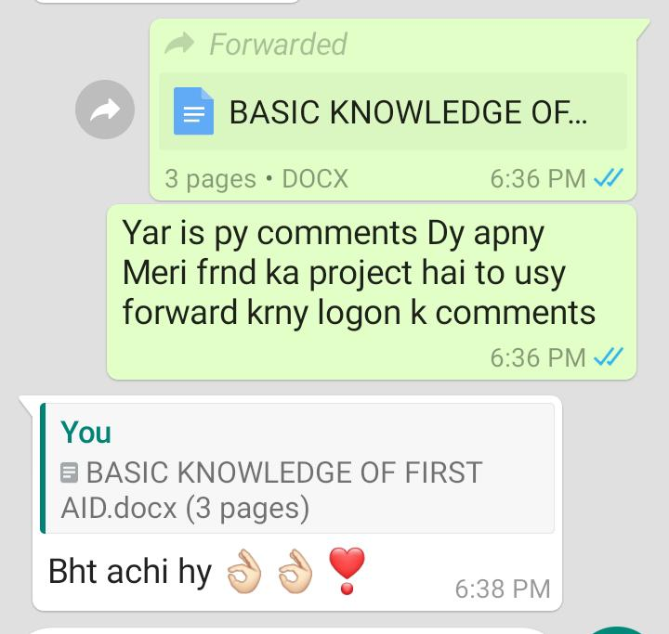
Awareness regarding First Aid:
These are the proofs of the awareness regarding First aid.
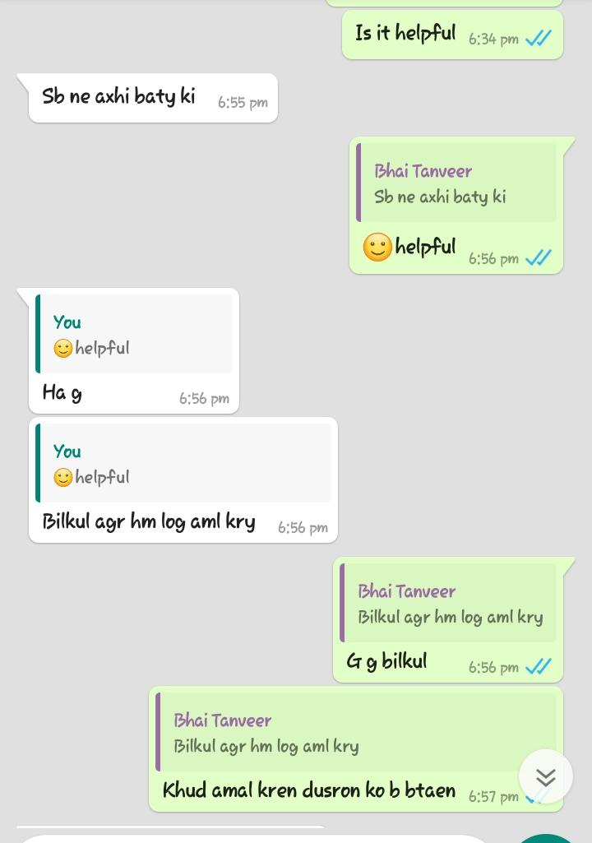
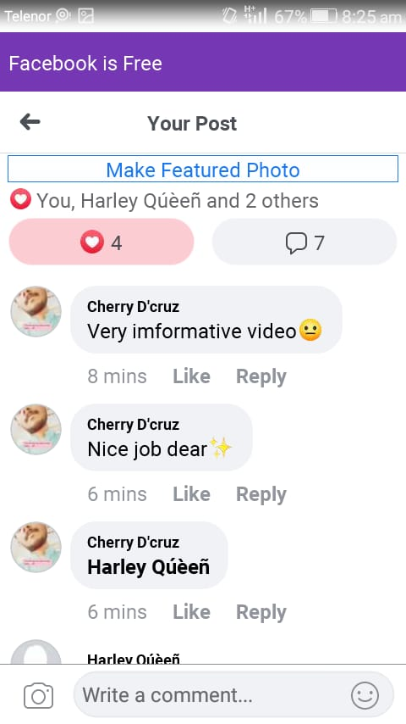
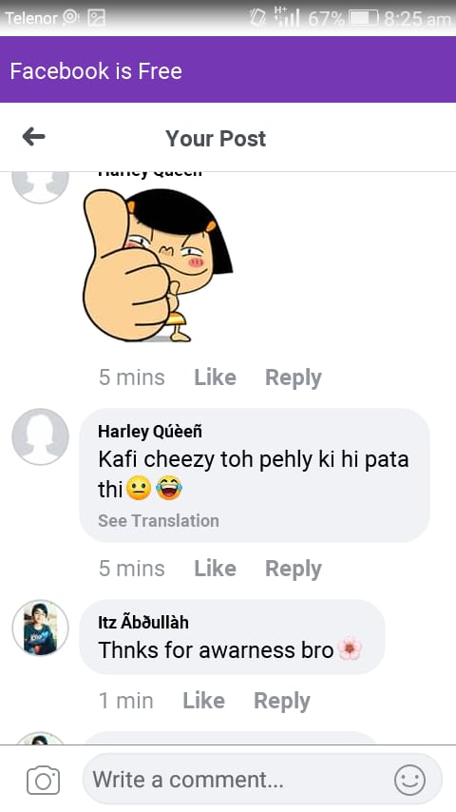
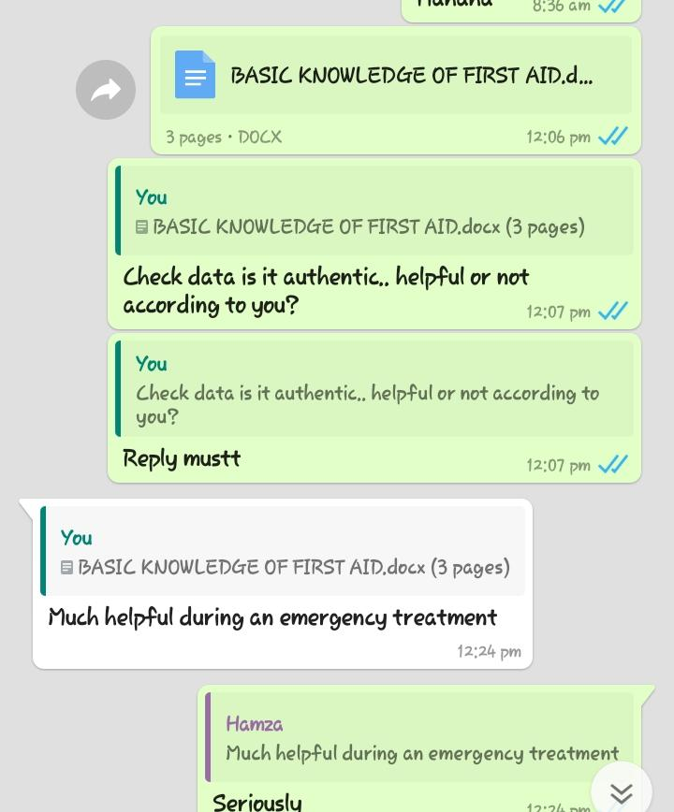
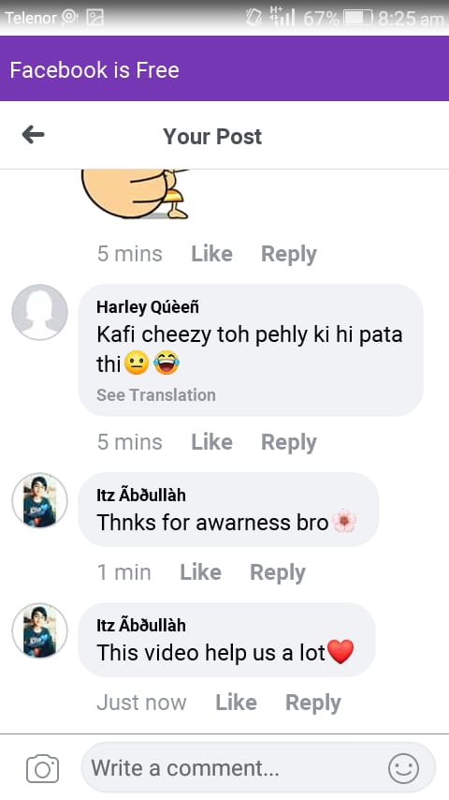
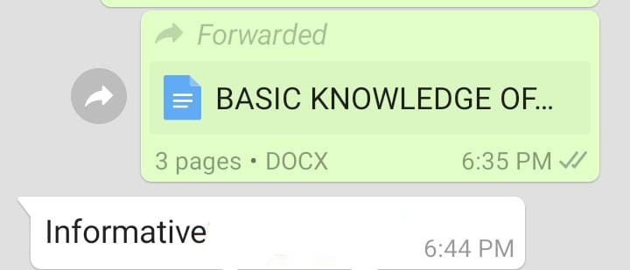
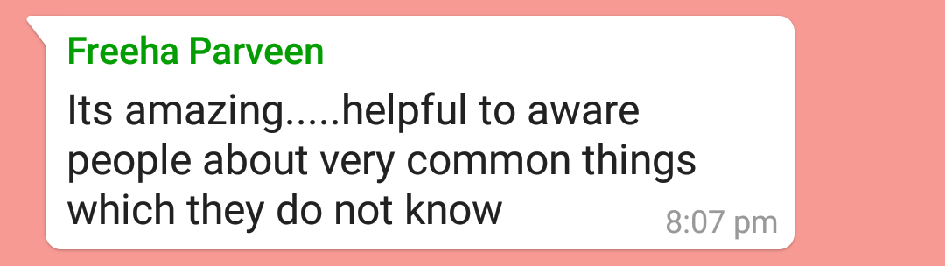
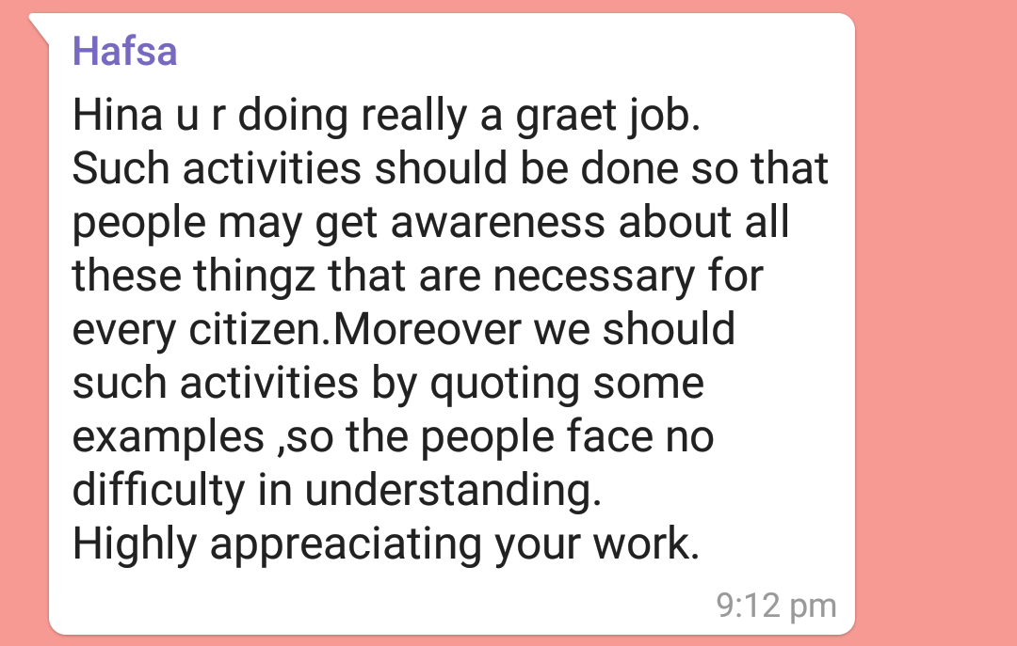
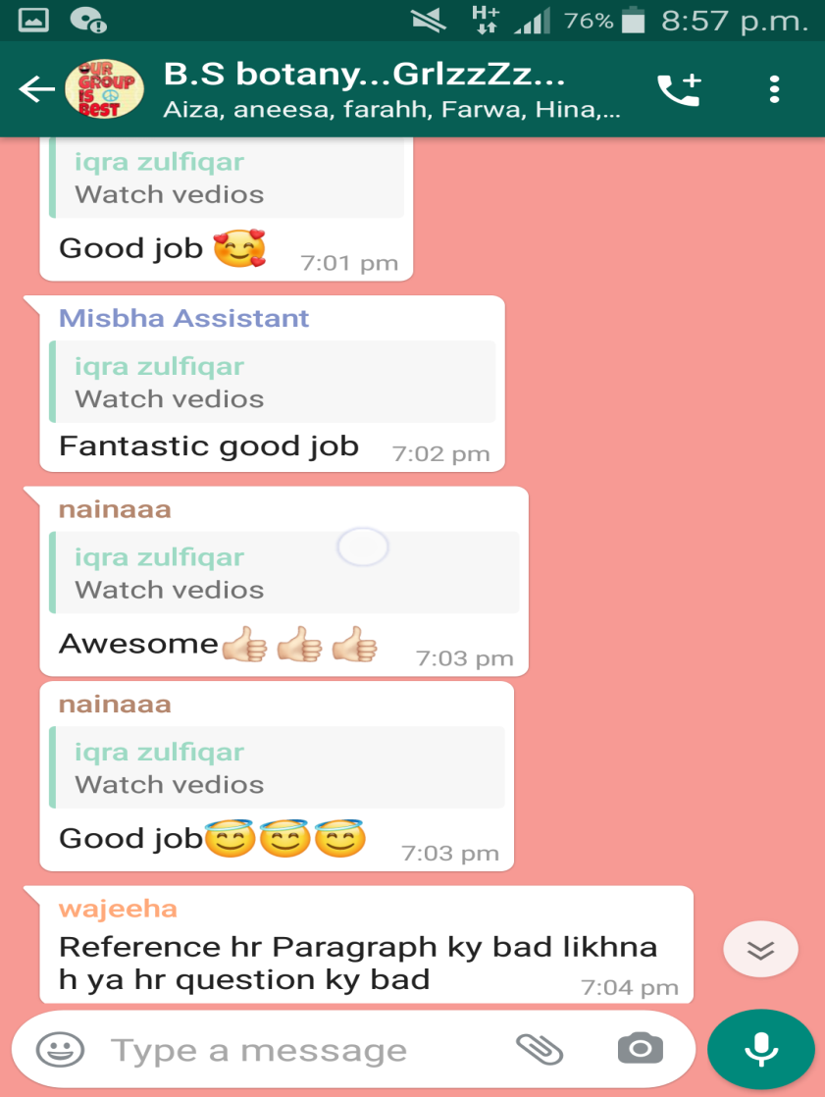
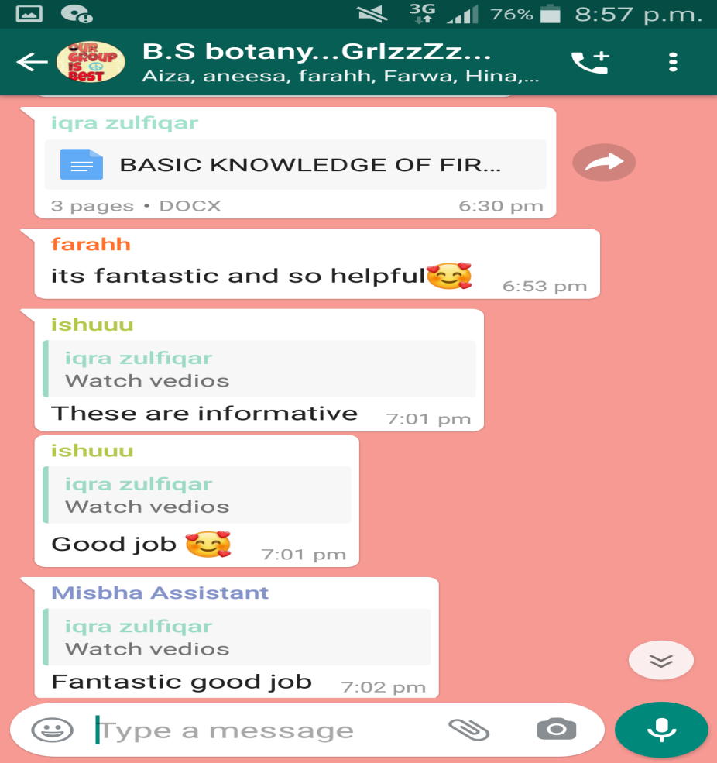
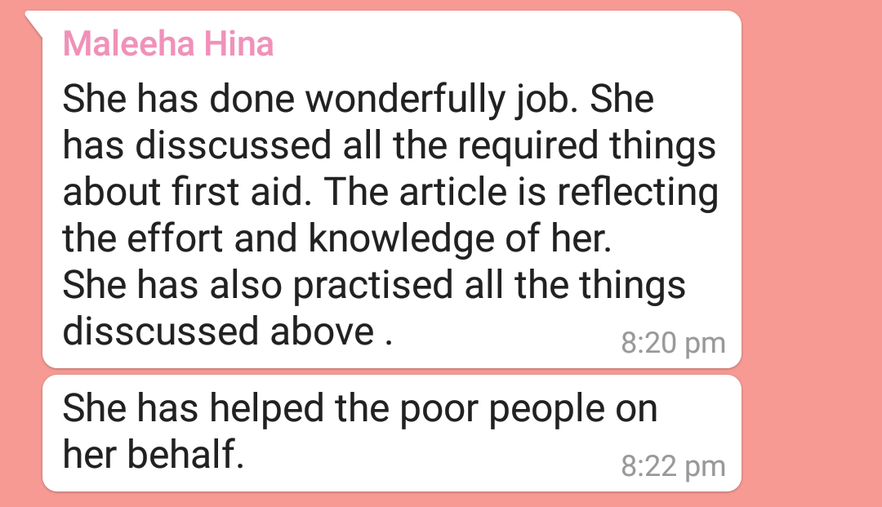
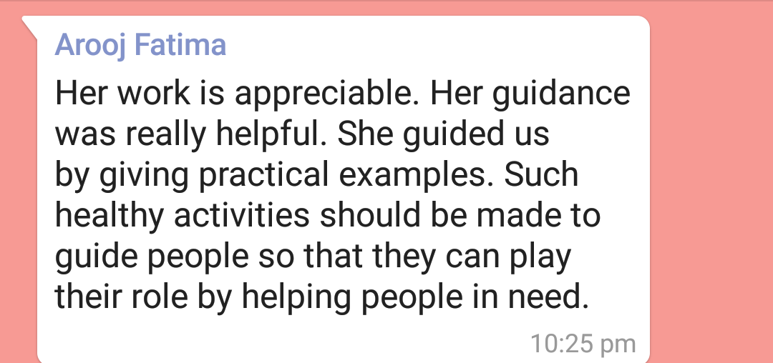
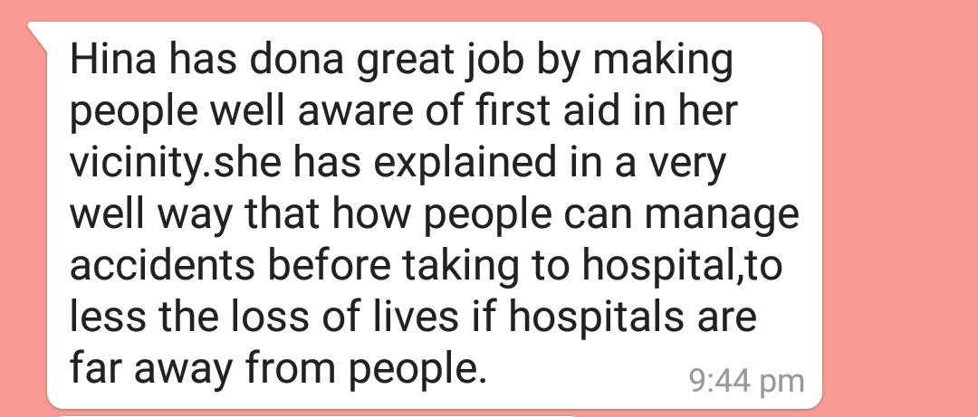
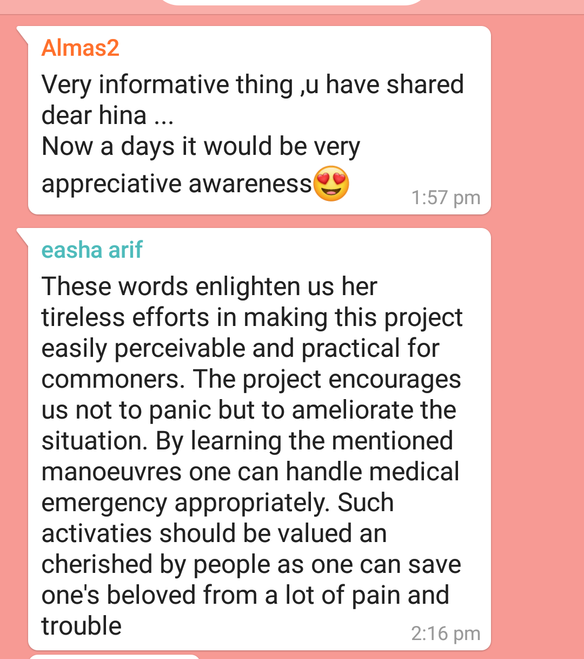
REFERENCE:
Malaika Hussaini Father: Niaz Hussain
HinaNazir Father: Nazir Ghouri
Aneesa Arooj Father: Hafiz Aziz Ur Rahman
Iqra Zulfiqar Father: Zulfiqar Ali
Haseeb Ahmad Friends: Ukash, Maaz, Usman, Ali butt, Shoaib, Ghufr
- https://www.sciencedirect.com/science/article/abs/pii/S0038012115000609
- https://medium.com/@isolardesign/importance-of-street-lighting-in-road-safety-effae66cc27f
- https://www.ukessays.com/essays/construction/the-importance-of-street-lighting-construction-essay.php
- https://www.rospa.com/road-safety/Advice/Roads/Street-Lighting
- https://www.fstraining.co.uk/level-3-first-aid-aims-and-objectives/
- https://www.engineeringenotes.com/illumination-engineering/street-lighting/street-lighting-objects-principles-and-l
- https://en.wikipedia.org/
- https://www.slideshare.net/IshantGautam/advanced-speed-breaker
- https://scholar.google.com.pk/scholar?q=www.ncbi.nlm.nih.gov&hl=en&as_sdt=0&as_vis=1&oi=scholart

