Topic: DNA Replication

Introduction of DNA:
DNA was first isolated by Friedrich Miescher in 1869. Its molecular structure was first identified by Francis Crick and James Watson at the Cavendish Laboratory within the University of Cambridge in 1953, whose modelbuilding efforts were guided by X-ray diffraction data acquired by Raymond Gosling, who was a post-graduate student of Rosalind Franklin at King's College London. DNA is used by researchers as a molecular tool to explore physical laws and theories, such as the ergodic theorem and the theory of elasticity. The unique material properties of DNA have made it an attractive molecule for material scientists and engineers interested in micro- and nano-fabrication. Among notable advances in this field are DNA origami and DNA-based hybrid materials.

Deoxyribonucleic acid ( DNA) is a molecule composed of two polynucleotide chains that coil around each other to form a double
helix carrying genetic instructions for the development, functioning, growth and reproduction of all known organisms and many viruses. DNA and ribonucleic acid (RNA) are nucleic acids. Alongside proteins, lipids and complex carbohydrates (polysaccharides), nucleic acids are one of the four major types of macromolecules that are essential for all known forms of life.

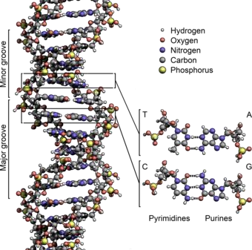

The structure of the DNA double helix. The atoms in the structure are colour-coded by element and the detailed structures of two base pairs are shown in the bottom right.
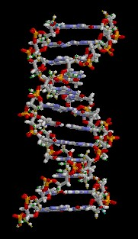
The structure of part of a DNA double helix

The two DNA strands are known as polynucleotides as they are composed of simpler monomeric units called nucleotides. Each nucleotide is composed of one of four nitrogencontaining nucleobases (cytosine [C], guanine [G], adeni ne [A] or thymine [T]), a sugar called deoxyribose, and a phosphate group. The nucleotides are joined to one another in a chain by covalent bonds (known as the phospho-diester linkage) between the sugar of one nucleotide and the phosphate of the next, resulting in an alternating sugar-phosphate backbone. The nitrogenous bases of the two separate polynucleotide strands are bound together, according to base pairing rules (A with T and C with G), with hydrogen bonds to make doublestranded DNA. The complementary nitrogenous bases are divided into two groups, pyrimidines and purines. In DNA, the pyrimidines are thymine and cytosine; the purines are adenine and guanine.
Both strands of double-stranded DNA store the same biological information. This information is replicated as and when the two strands separate. A large part of DNA (more than 98% for humans) is noncoding, meaning that these sections do not serve as patterns for protein sequences. The two strands of DNA run in opposite directions to each other and are thus antiparallel. Attached to each sugar is one of four types of nucleobases (informally, bases).

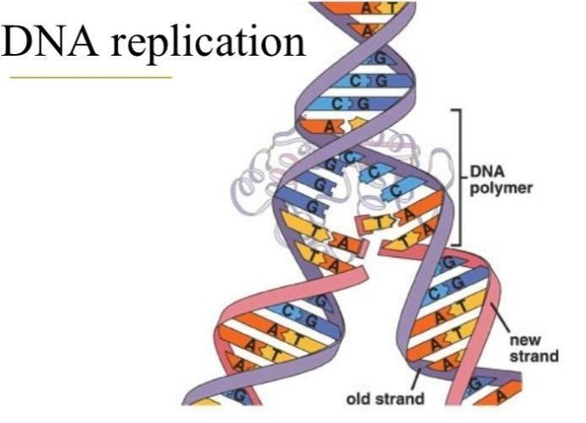

Definition:
“DNA replication is a process in which nuclear DNA duplicates itself in different steps so that each daughter cell may get equal amount of DNA after division of parent cell”

Explanation:
DNA, short of Deoxyribonucleic acid, is the self-replicating material which is present in nearly all living organisms as the main constituent of chromosomes. It is the fundamental carrier of genetic information, present in virtually every cell in your body.
Double-helix DNA is made of two asymmetrical strands. Each strand is made of nucleotides lined up one after the other, and these nucleotides are bound to corresponding once on the other strand to create a ladder-like structure. DNA is made up of four nucleotides—the building blocks of nucleic acid – which are composed of a nitrogenous base, a five carbon sugar ( ribose or deoxyribose), and at least one phosphate group.
Adenine (A) , Thymine (T) , Guanine (G) and Cytosine (C) are called “nucleotides”.
A and G are called purines while T and C are called pyrimidines.
○ According to the rules of base pairing, A always pairs with T and C always pairs with G.

Why DNA replication takes place?

Before a cell duplicates or divides, through either mitosis or meiosis, DNA must be replicated to ensure that each new cell receives the correct number of chromosomes. This process occurs in all living organisms and is the basis for biological inheritance.

Phases of DNA Replication:

There are three main phase for the completion of DNA replication:
- Initiation Phase
- Extension/Elongation/Polymerization Phase
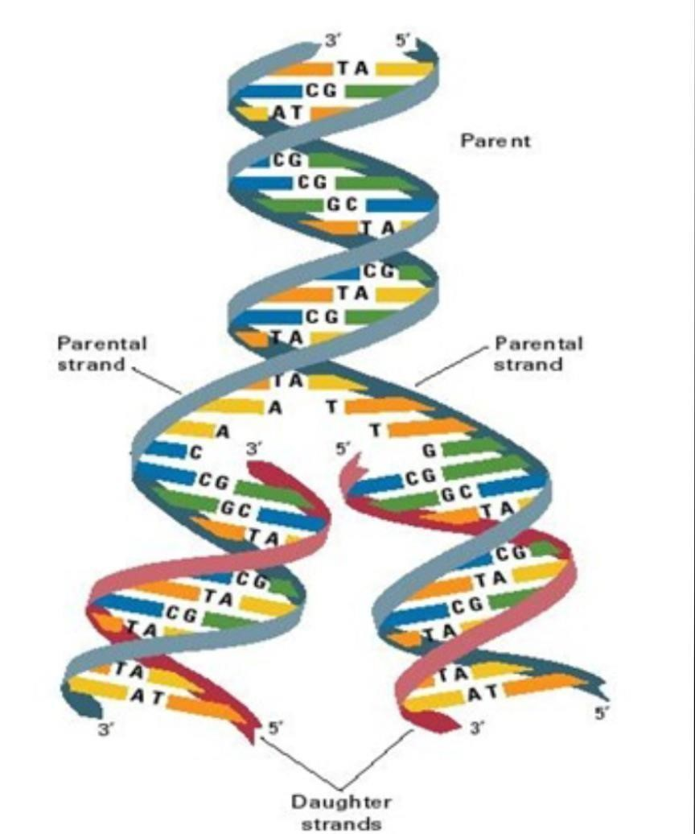
- Termination Phase

Protein Assisting the DNA replication:

Following proteins assist in the synthesis of DNA:
  - DNA polymerase
  - Ligase
  - Primase
  - Helicase
  - Single strand binding protein

Following are the three main phases of DNA replication:

Initiation Phase

Initiation phase is the starting phase of DNA replication. It completes in the presence of different enzymes and protein.
The process of DNA replication initiates at a specific site on DNA strand which is known as origin of replication.
• Origin of Replication
The origin of replication of
DNA molecule begins at special sites, these special sites are specific sequence of nucleotides and are called origin of replication.
The eukaryotic DNA contains thousand of such replication origins. A protein initiates DNA replication.
- An enzyme known as DNA Gyrase or Topoisomerase it attaches to the origin of replication, recognizing the sequence of nucleotides. It opens the turns of DNA from spiral ladder to straight ladder.
- When two strands are opened they form a replication bubble. Now two strands are open to form a bubble structure but they are still attached through the H-bonding present between the nitrogenous bases of both strands. Multiple replication bubbles are
formed in eukaryotes. These bubbles fuse with each other. The replication of DNA proceeds in both directions and entire molecule is copied.
- There is replication fork at the end of each end of a replication bubble. It is a Y-shaped region. New strands of DNA elongates on these replication fork.
- DNA Helicase is an enzyme that breaks down the H-bonds of nitrogenous bases present at replication bubble. When the bonds have broken the nitrogenous bases are exposed for the attachment of new nitrogenous base and to form bonds.
- A protein called single strand binding protein, SSB is used to prevent reunion of unzipped strands.
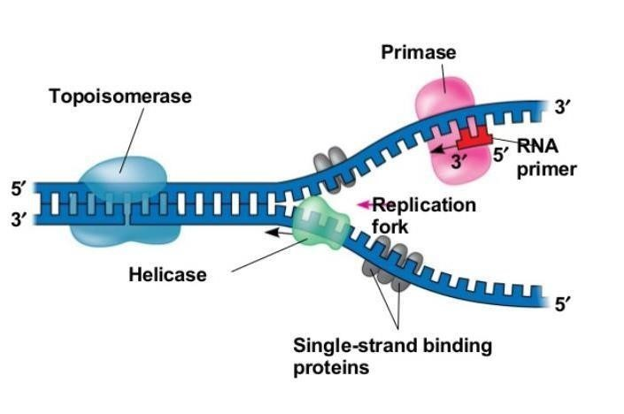

Extension/Elongation/ Polymerization Phase

In extension phase of DNA replication, nucleotides align with complementary basis on
“old” template strands of DNA.
 An enzyme DNA polymerase catalyzes elongation of new DNA at a replication fork. The new nucleotides are added by DNA polymerase one by one. The rate of elongation is about 500 nucleotides per second in human cells.
The substrates for DNA are nucleoside triphosphate. The nucleoside triphosphates have three phosphate groups like ATP. Each monomer loses two phosphates and joins to the growing end of a DNA strand. Hydrolysis of the phosphate is the exergonic reaction. Therefore, it drives polymerization of nucleosides to form DNA.
There are three types of DNA polymerase, which are useful in DNA polymerization process:
- DNA Polymerase I ( helps in termination of DNA during replication, also support DNA Polymerase III).
- DNA Polymerase II (helps in repairing of DNA strand, if any damage occurs during lifetime).
- DNA Polymerase III ( main enzyme, that helps in synthesis of new strands) The problem of Antiparallel DNA strands There is a problem of DNA synthesis at the replication fork. The two DNA strands are antiparallel (3-5 and 5-3). Their sugar phosphate backbones run in opposite directions. Phosphate group if each nucleotide is attached to the 5’ carbon of deoxyribose. The phosphate groups of one nucleotide is joined to the 3’ carbon of adjacent nucleotide. Therefore, there is a different mechanism of replication in both strands:
Leading strand: The enzyme DNA
Polymerase can only add nucleotides to the free 3’ end of DNA strand. It can never add it to the 5’ end. Thus, a new DNA strand is formed in 5’—3’ directions. The DNA polymerase can synthesize a continuous complementary strand along 5’—3’ direction. This DNA strand is called “leading strand”. It is also called continuous strand.
Lagging strand: The DNA polymerase move away from the replication fork to elongate in 3-5 strand of DNA. The DNA synthesized as a series of segments. These pieces are called “Okazaki fragments”. These fragments were discovered by Japanese scientist Okazaki. These fragments are about 100 to 200 nucleotides long in eukaryotes. It is also called discontinuous strand.
RNA Primer

There is an other problem for DNA polymerase. It can only add a nucleotide to a polynucleotide that is already correctly paired with the complementary strand. This means that DNA polymerase cannot actually initiates synthesis of DNA strand. Nucleotides must me added to the end of an already existing chain. This chain of nucleotides is called a primer. The primer is the short stretch of
RNA. It is synthesized by an other enzyme primase. It is about 10 nucleotides long in eukaryotes. Only one primer is required for the leading strand of new DNA. Each fragment must have separate primer in lagging strand.
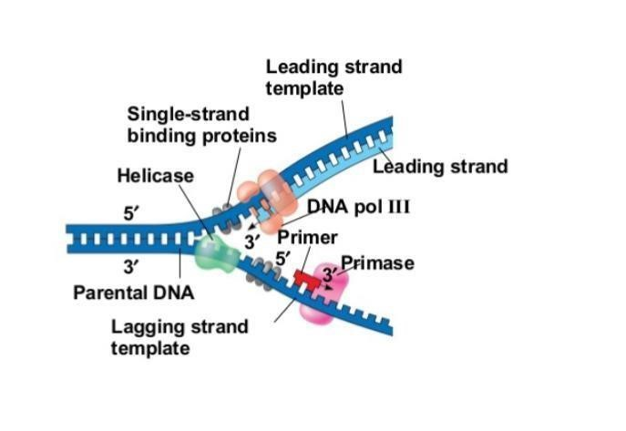
Proofreading
If any error occurs in DNA molecule, that has to be corrected, it is done by an enzyme called DNA polymerase II. These errors are only one in billion nucleotides. This process of removing errors by enzyme is called “proofreading”.
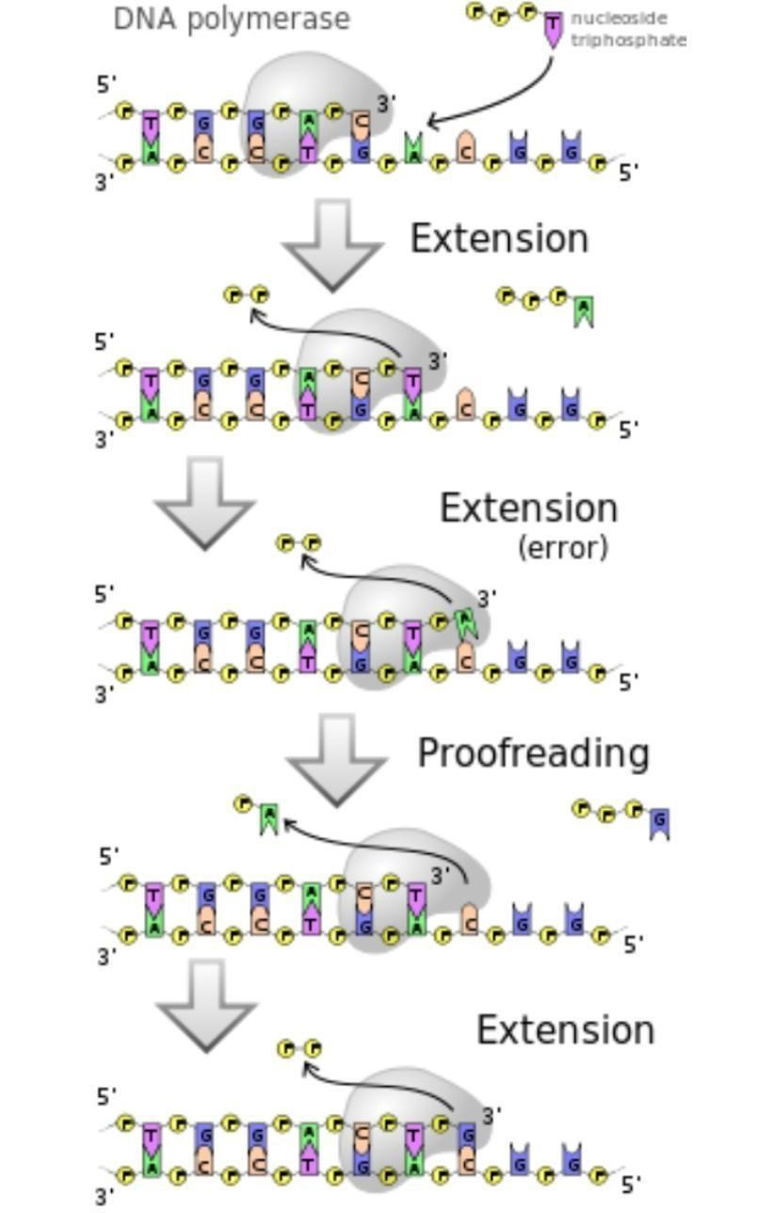

Termination Phase

Termination phase is the end phase of DNA replication. In this phase new DNA molecules are formed properly.

The small, newly formed molecules of DNA which were called Okazaki fragments, have to be combined to form a long chain.
- Therefore, an enzyme called DNA polymerase I or exonuclease removes the primers present between fragments, by breaking the bonds between the small daughter strands and primers.
- It also fills up the spaces between fragments by placing nucleotides in spaces, but it does not join the fragments chemically.
- An other enzyme called Ligase creates the bonds between the extended segments and forms a continuous strand.
- Eukaryotes initiate DNA replication at multiple points in the chromosome, so replication forks meet and terminate at many points in the chromosome. Because eukaryotes have linear chromosomes, DNA replication is unable to reach the very end of the chromosomes. Due to this problem, DNA is lost in each replication cycle from the end of the chromosome. Telomeres are regions of repetitive DNA close to the ends and help prevent loss of genes due to this shortening. Shortening of the telomeres is a normal process in somatic cells. This shortens the telomeres of the daughter DNA chromosome. As a result, cells can only divide a certain number of times before the DNA loss prevents further division. (This is known as the Hayflick limit.) Within the germ cell line, which passes DNA to the next generation, telomerase extends the repetitive sequences of the telomere region to prevent degradation. Telomerase can become mistakenly active in somatic cells, sometimes leading to cancer formation. Increased telomerase activity is one of the hallmarks of cancer.
- Termination requires that the progress of the DNA replication fork must stop or be blocked. Termination at a specific locus, when it occurs, involves the interaction between two components: (1) a termination site sequence in the DNA, and (2) a protein which binds to this sequence to physically stop DNA replication. In various bacterial species, this is named the DNA replication terminus site-binding protein, or Ter protein.

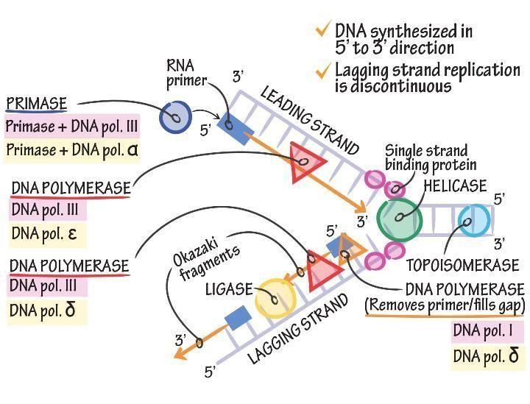

Multiple Choice Questions

- The accepted hypothesis for DNA replication is
    - conservative theory
    - dispersive theory
    - semi-conservative theory
    - evolutionary theory
Answer: option C

- When DNA polymerase is in contact with guanine in the parental strand, what does it add to the growing daughter strand?
  - Phosphate
  - Cytosine
  - Uracil
  - Guanine
Answer: Option B

- Telomeres are usually rich in which nucleotide?
  - Adenine
  - Guanine
  - Thymine
  - Cytosine
Answer: Option B

- Which is the largest among the followings?
  - Nucleotide
  - Nitrogenous base
  - Phosphate
  - Carbon
Answer: Option A

- DNA replication takes place in which direction?
    - 3' to 5'
    - 5 'to 3'
    - Randomly
    - Vary from organism to organism
Answer: Option B

- In DNA, there are five bases known as adenine, guanine,
A.
thymine, tryptophan and cytosine four bases known as adenine, guanine,
B.
thymine and cytosine three bases known as adenine, guanine and
C.
cytosine
D. only two bases known as adenine and cytosine
Answer: Option B

- In DNA, guanine pairs with
    - Adenine
    - Cytosine
    - Thymine
    - Uracil
Answer: Option B

¹₅8.Which of the following is incorrect?
.
⁸ A. In DNA double helix, two strands of the DNA are spirally arranged.
- Adenine always pairs with thymine
- Guanine always pairs with the cytosine
- None of the above
Answer: Option D

49. Which of the following enzyme adds .complementary bases during replication?

    - Helicase
    - Synthesase
    - Replicase
    - Polymerase
Answer: Option D

10. Which DNA polymerase removes RNA primers in DNA synthesis?
A. Polymerase I
2 B. Polymerase II
5
. C. Polymerase III

D. none of these
Answer: Option A.

