Estimating experimental uncertainty

Estimating experimental uncertainty for a single measurement
Any measurement you make will have some uncertainty associated with it, no matter the precision of your measuring tool. So how do you determine and report this uncertainty?
The uncertainty of a single measurement is limited by the precision and accuracy of the measuring instrument, along with any other factors that might affect the ability of the experimenter to make the measurement.
For example, if you are trying to use a meter stick to measure the diameter of a tennis ball, the uncertainty might be
± 5 mm,
but if you used a Vernier caliper, the uncertainty could be reduced to maybe
± 2 mm.
The limiting factor with the meter stick is parallax, while the second case is limited by ambiguity in the definition of the tennis ball's diameter (it's fuzzy!). In both of these cases, the uncertainty is greater than the smallest divisions marked on the measuring tool (likely 1 mm and 0.05 mm respectively). Unfortunately, there is no general rule for determining the uncertainty in all measurements. The experimenter is the one who can best evaluate and quantify the uncertainty of a measurement based on all the possible factors that affect the result. Therefore, the person making the measurement has the obligation to make the best judgment possible and report the uncertainty in a way that clearly explains what the uncertainty represents:

Measurement = (measured value ± standard uncertainty) unit of measurement

where the ± standard uncertainty indicates approximately a 68% confidence interval (see sections on Standard Deviation and Reporting Uncertainties).
Example: Diameter of tennis ball =
6.7 ± 0.2 cm.

ESTIMATING UNCERTAINTY IN REPEATED MEASUREMENTS
Suppose you time the period of oscillation of a pendulum using a digital instrument (that you assume is measuring accurately) and find: T = 0.44 seconds. This single measurement of the period suggests a precision of ±0.005 s, but this instrument precision may not give a complete sense of the uncertainty. If you repeat the measurement several times and examine the variation among the measured values, you can get a better idea of the uncertainty in the period. For example, here are the results of 5 measurements, in seconds: 0.46, 0.44, 0.45, 0.44, 0.41.
( 5 )
Average (mean) =
x₁ + x₂ + + x_{N}
N

For this situation, the best estimate of the period is the average, or mean.
Whenever possible, repeat a measurement several times and average the results. This average is generally the best estimate of the "true" value (unless the data set is skewed by one or more outliers which should be examined to determine if they are bad data points that should be omitted from the average or valid measurements that require further investigation). Generally, the more repetitions you make of a measurement, the better this estimate will be, but be careful to avoid wasting time taking more measurements than is necessary for the precision required.
Consider, as another example, the measurement of the width of a piece of paper using a meter stick. Being careful to keep the meter stick parallel to the edge of the paper (to avoid a systematic error which would cause the measured value to be consistently higher than the correct value), the width of the paper is measured at a number of points on the sheet, and the values obtained are entered in a data table. Note that the last digit is only a rough estimate, since it is difficult to read a meter stick to the nearest tenth of a millimeter (0.01 cm).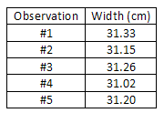

Average =
sum of observed widths
no. of observations
=
155.96 cm
5
= 31.19 cm

This average is the best available estimate of the width of the piece of paper, but it is certainly not exact. We would have to average an infinite number of measurements to approach the true mean value, and even then, we are not guaranteed that the mean value is accurate because there is still some systematic error from the measuring tool, which can never be calibrated perfectly. So how do we express the uncertainty in our average value?One way to express the variation among the measurements is to use the average deviation. This statistic tells us on average (with 50% confidence) how much the individual measurements vary from the mean.
( 7 )
d =
|x₁ − x| + |x₂ − x| + + |x_{N} − x|
N

However, the standard deviation is the most common way to characterize the spread of a data set. The standard deviation is always slightly greater than the average deviation, and is used because of its association with the normal distribution that is frequently encountered in statistical analyses.

STANDARD DEVIATION
To calculate the standard deviation for a sample of N measurements:
- 1
Sum all the measurements and divide by N to get the average, or mean.
- 2
Now, subtract this average from each of the N measurements to obtain N "deviations".
- 3
Square each of these N deviations and add them all up.
- 4
Divide this result by
(N − 1)
and take the square root.
We can write out the formula for the standard deviation as follows. Let the N measurements be called x₁, x₂, ..., x_{N}. Let the average of the N values be called
x.
Then each deviation is given by
δx_{i} = x_{i} − x, for i = 1, 2, , N.
The standard deviation is:

s =
(δx₁² + δx₂² + + δx_{N}²)
(N − 1)

=
δx_{i}²

(N − 1)

In our previous example, the average width
x
is 31.19 cm. The deviations are: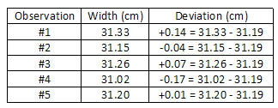The average deviation is:
d = 0.086 cm.
The standard deviation is:
s =
(0.14)² + (0.04)² + (0.07)² + (0.17)² + (0.01)²
5 − 1

= 0.12 cm.

The significance of the standard deviation is this: if you now make one more measurement using the same meter stick, you can reasonably expect (with about 68% confidence) that the new measurement will be within 0.12 cm of the estimated average of 31.19 cm. In fact, it is reasonable to use the standard deviation as the uncertainty associated with this single new measurement. However, the uncertainty of the average value is the standard deviation of the mean, which is always less than the standard deviation (see next section).Consider an example where 100 measurements of a quantity were made. The average or mean value was 10.5 and the standard deviation was s = 1.83. The figure below is a histogram of the 100 measurements, which shows how often a certain range of values was measured. For example, in 20 of the measurements, the value was in the range 9.5 to 10.5, and most of the readings were close to the mean value of 10.5. The standard deviation s for this set of measurements is roughly how far from the average value most of the readings fell. For a large enough sample, approximately 68% of the readings will be within one standard deviation of the mean value, 95% of the readings will be in the interval
x ± 2 s,
and nearly all (99.7%) of readings will lie within 3 standard deviations from the mean. The smooth curve superimposed on the histogram is the gaussian or normal distribution predicted by theory for measurements involving random errors. As more and more measurements are made, the histogram will more closely follow the bellshaped gaussian curve, but the standard deviation of the distribution will remain approximately the same.
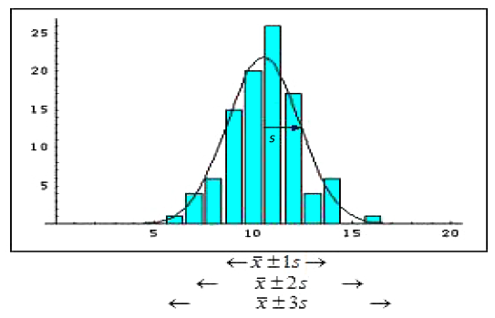
Figure 1

STANDARD DEVIATION OF THE MEAN (STANDARD ERROR)
When we report the average value of N measurements, the uncertainty we should associate with this average value is the standard deviation of the mean, often called the standard error (SE).
( 9 )
σ_{x} =
s
N

The standard error is smaller than the standard deviation by a factor of
1/
N
.
This reflects the fact that we expect the uncertainty of the average value to get smaller when we use a larger number of measurements, N. In the previous example, we find the standard error is 0.05 cm, where we have divided the standard deviation of 0.12 by
5
.
The final result should then be reported as:
Average paper width = 31.19 ± 0.05 cm.

