Experiment no 12
To the study of mechanical power of Pelton wheel turbines
INTRODUCTION
Energy may exist in various forms. Hydraulic energy is that which may be possessed by a fluid. It may be in the form of kinetic, pressure, potential, strain or thermal energy. Fluid machinery is used to convert hydraulic energy into mechanical energy or mechanical energy into hydraulic energy. This distinction is based on the direction of energy transfer and forms the basis of grouping fluid machinery into two different categories. One is power producing machines which convert hydraulic energy into mechanical energy like turbines and motors; the other is power consuming machines doing the reverse like pumps, fans and compressors. Another classification for fluid machinery can also be done based on the motion of moving parts. These are rotodynamic machines and positive displacement machines. A detailed chart is given below explaining the classifications.
The turbines, a sub group of rotodynamic machines, are used to produce power by means of converting hydraulic energy into mechanical energy. They are of different types according to their specification. Turbines can be subdivided into two groups, impulse and reaction turbines. Moreover due to working fluid used, turbines can be named as steam turbines, gas turbines, wind turbines and water turbines. The water turbines convert the energy possessed by the water to mechanical energy. Pelton turbine (or Pelton wheel), an impulse turbine, is one of the well-known type of water turbines.
THEORY
In the impulse turbines, the total head available is first converted into the kinetic energy. This is usually accomplished in one or more nozzles. The jets issuing from the nozzles strike vanes attached to the periphery of a rotating wheel. Because of the rate of change of angular momentum and the motion of the vanes, work is done on the runner (impeller) by the fluid and, thus, energy is transferred. Since the fluid energy which is reduced on passing through the runner is entirely kinetic, it follows that the absolute velocity at outlet is smaller than the absolute velocity at inlet (jet velocity). Furthermore, the fluid pressure is atmospheric throughout and the relative velocity is constant except for a slight reduction due to friction. The Pelton wheel is an impulse turbine in which vanes, sometimes called buckets, of elliptical shape are attached to the periphery of a rotating wheel, as shown in Fig. 2. One or two nozzles project a jet of water tangentially to the vane pitch circle. The vanes are of double-outlet section, as shown in Fig. 3, so that the jet is split and leaves symmetrically on both sides of the vane. This type of turbine is used for high head and low flow rates. It is named after the American engineer Lester Pelton.

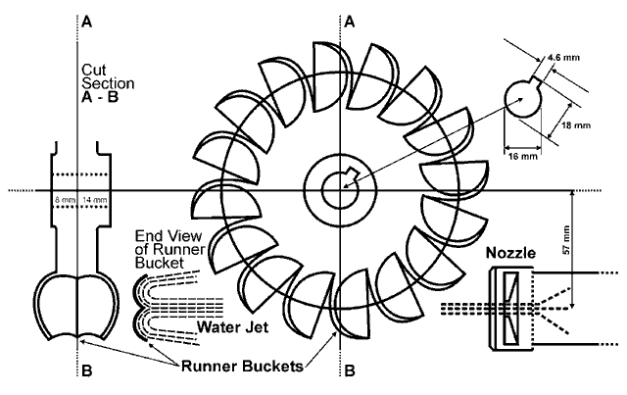
Components of the Pelton turbine:
Runner with bucket: Runner (also named impeller) of Pelton turbine consists of a circular disc on the periphery of which a number of buckets are fixed.
Nozzle: The water coming from the reservoir through penstock is accelerated to a certain velocity by means of a nozzle.
Spear: The spear is a conical needle which is operated either by a hand wheel or automatically in an axial direction depending upon the size of the unit. The amount of water striking the buckets of the runner is controlled the spear in the nozzle.
Casing: Casing is used to prevent the splashing of the water and to discharge water to tail race. It is made up of cast iron or steel plate.
Breaking jet: When the nozzle is completely closed by moving the spear in the forward direction the amount of water striking the runner reduce to zero. However, the runner due to inertia goes on revolving for a long time. To stop the runner in a short time, a small nozzle is used which directs the jet of water on the back of buckets. This jet of water is called breaking jet.
Governing mechanism: The speed of turbine runner is required to be maintained constant so that electric generator can be coupled directly to turbine. Therefore, a device called governor is used to measure and regulate the speed of turbine runner.
Power, Efficiency and Specific Speed Expressions:
From Newton’s second law applied to angular motion,
Angular momentum = (Mass)(Tangential velocity)(Radius)
Torque = Rate of change of angular momentum
Power = (Torque)(Angular velocity)
Considering the water jet striking the runner generates a torque of and rotates the runner with (rev/m), then power obtained from the runner can be expressed as:
P_{OUT}=T$ω\left[W\right]$
$$ω=\frac{2πN}{60}\left[rad/s\right]$$
The total head available at the nozzle is equal to gross head less losses in the pipeline leading to the nozzle (in the penstock) and denoted by H. Then available power input to the turbine becomes:
P_{in=}pgOH
Where:
Pin=Power input to turbine
H= Total available head [m]
p=density of water [kg/m3 ]
Q=volume flow rate of water [m3 /s]
G=gravitational acceleration [m/s2 ]
During conversion of energy (hydraulic energy to mechanic energy or vice versa) there occur some losses. They can be in many form and main causes of them are friction, separation and leakage. For a turbine:
Fluid Input Power = (Mechanical loss) + (Hydraulic losses) + (Useful shaft power output) Where: Hydraulic Losses = (Impeller loss) + (Casing loss) + (Leakage loss) considering all losses as one term:

P_{in}=P_{lost}+P_{out}
Then, overall efficiency of turbine becomes:
Calculation of Pelton Turbine Efficiency
Measurement No: | ₁ | ₂
Rotational speed, [rev/min]
Force, [N]
Water flow rate, [L/h]
Head,H, [m]

