Sugar Manufacturing

Introduction

The word "sugar" used in everyday life refers to the chemical sucrose. Sucrose is a member of a group of substances generally known as sugars, which contain up to ten monosaccharide units (monosaccharides are carbohydrates that cannot be further hydrolysed). These, in turn, are part of a wider group of carbohydrates which account for 75% of the dry weight of the plant world. All carbohydrates are compounds built up from the elements carbon, hydrogen and oxygen. All sugars are crystalline, water soluble and sweet tasting. Some common examples are glucose, sucrose (table sugar), fructose (fruit sugar) and lactose (milk sugar). Sucrose has the chemical formula C12H22O11. It may be readily converted by acid or enzymatic hydrolysis into a mixture of the two simpler sugars, glucose and fructose, each with the formula C6H12O6.
C12H22O11 + H2O → C6H12O6 + C6H12O6
In sugar refining, glucose and fructose are regarded as impurities due to the difficulty in crystallising them from solution. Strict process control, particularly of pH, must be maintained to avoid loss of sucrose in processing through its chemical hydrolysis to the unwanted sugars glucose and fructose.
Manufacture of sugar from cane originated in India and cane cultivation then spread westwards to Egypt. In the 18th century the West Indies became the main source of production. The raw sugar refined in New Zealand today originates from Australia, Fiji, the West Indies and South America.
Refining Process
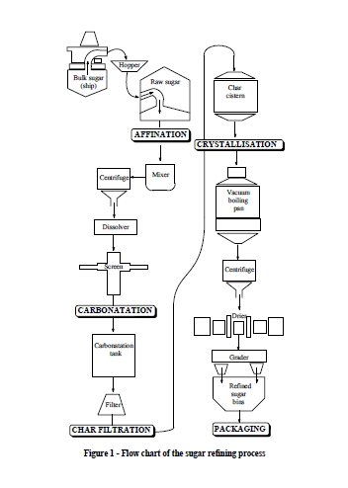
Categories of Cane Sugar Factories

It has been estimated that out of the cumulative sugar production in the world, around 65% comes out from cane sugar industries. The contribution of beet sugar is comparatively less and it mainly comes from the continents of America and Europe which are relatively cold. Sugarcane planting and subsequent extraction units for white sugar are very much spread throughout various parts of the globe including Australia, India, Latin America etc. Many parts of the Asian continent exercising equatorial temperature and humidity conditions are also ideal for cane growth. On the basis of sugar production, classification of sugar factories are done in four groups like:
➢ Raw Sugar: In many sugar producing areas raw sugar of 98-99 purity is produced from cane, which is sent to refineries or exported. This sugar being unsuitable for direct consumption is later converted into refined sugar of very high purity.
➢ Refined Sugar: White and sparkling in appearance the refined sugar is of 99.9% purity and is used directly for human consumption, besides a small proportion for pharmaceutical and chemical industries. A substantial portion of the total sugar produced for direct human consumption is manufactured in refineries with a normal capacity range of 200—2000 tons per day. These are mostly situated in urban areas which are major consuming centres.
➢ Raw Sugar Factories-cum refineries: In these factories, for producing raw sugar from sugarcane, small refining units are installed for processing the raw sugar and manufacture of refined sugar. The refinery can operate throughout the year even though the raw sugar production is confined to the crushing campaign restricted to dry periods of the year. ➢ Plantation white sugar factories: In India and some other developing countries, white sugar is manufactured from cane for direct consumption employing more complicated techniques in clarification of juice and also in crystallisation of sugar. The sugar produced is of 99.8% purity and contains slightly higher amount of impurities than the refined sugar. These plants can also produce raw sugar either for export or supply to refineries.
Cane sugar establishments are usually setup in the areas near to the cane fields and away from cities, the only exception being refineries for crude sugar. For expressing the capacity of such factories, a term is defined as per day crushing of cane. Its usual range is 1000-20000 and, in some cases, more even. Effectively the TCD is dependent on availability of sugarcane as well as market situations. The white sugar is an essential commodity in sweets served as a food item. Depending on the living standards of a population, its per capita sugar consumption will also change.

