LIQUID BETA SCINTILLATION COUNTING TECHNIQUE
DEFINITION:
Liquid Beta Scintillation Counting Technique is a standard laboratory method for measuring radiation from beta-emitting radioactive isotopes or to quantify radioactivity of B-emitting isotopes.
OR
Liquid Beta scintillation counting is an analytical technique which is defined by the incorporation of the radio labelled analyte with a liquid chemical medium that is capable of converting the kinetic energy of nuclear emissions(beta rays) into light energy. [1]
What are Isotopes?
Isotopes are elements having same atomic number but different atomic masses that is they have same number of protons and electrons but different number of neutrons.
Why Isotopes are Radioactive?
Most isotopes are stable and do not emit radiations but few isotopes have too many or too few neutrons and are unstable so they undergo changes by emitting rays in try to stabilize them so they are radioactive. [2]
PRINCIPLE:
LSC is based on the principle of transforming some of the kinetic energy of the beta-particle into light photons. These photons are collected on a photocathode in a photomultiplier tube. In PMT these light photons release electrons. The number of electrons are further increased by a multiplication process and the result will be an electric pulse which is further amplified, sorted and finally counted. [3]
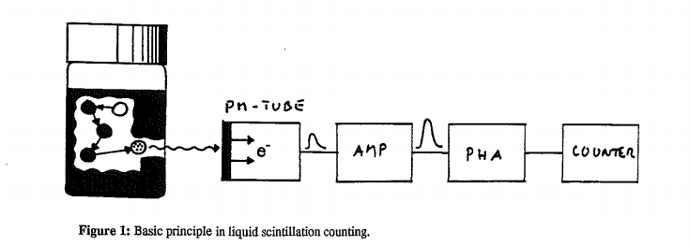

PROCEDURE:
Step 1:
The radio-active sample together with scintillation cocktail (solvent and solute) is added to the counting vial. The molecules of solvents are 200 times greater than that of solute particles in scintillation cocktail so that they will absorb all energy from beta particles. The unstable radioactive isotopes will start emitting beta radiation in first step.
Step 2:
Typically a beta radiation will take only a few nanoseconds to dissipate all its kinetic energy. The energy is absorbed by the solvent medium. Beta rays strike with solvent molecules and all kinetic energy of beta rays is absorbed by solvent molecules and become excited (not ionized). The number of molecules of solvent system that are excited depend on energy with Beta radiations that are emitted.
Step 3:
Once molecule of solvent system absorb energy it become excited and once it get excited it tend to return back to ground state as excited state is highly unstable so it again transmits energy to nearby molecule of solvent system and in this way solvent molecules are excited.
Step 4:
Then these excited solvent molecules will transfer energy to the solute molecule called Flours. Thus disturbing electronic cloud of flours and make them excited. The energy absorbed from one flour is transferred to other and will produces excited states of the electrons, which decay to the ground state and produce a light pulse which comprises of photons. The light is detected by the photomultiplier tube (PMT) of the liquid scintillation counter and signal is further amplified.
Step 5:
The amplitude of the electrical pulse is converted into a digital value and the digital value, which represents the beta particle energy, passes into the analyzer where it is compared to digital values for each of the LSC’s channels.
Step 6:
The number of pulses in each channel is printed out or displayed on a CRT. In this manner, the sample is analyzed and the spectrum can be plotted to provide information about the energy of the radiation or the amount of radioactive material dissolved in the cocktail. [2, 4]
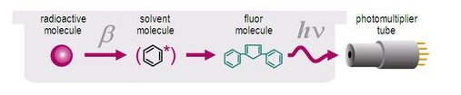
USEFUL ISOTOPES STUDIED BY LIQUID BETA SCINTILLATION COUNTING TEHNIQUE:
- For biological research: ¹⁴ Carbon, ³Hydrogen and ³²Phosphorus
- Other B-emitting nuclides: ²²Na, ²⁴Na, ⁴²K, ⁴⁷Ca, ⁵⁹Fe, ⁶⁴Cu, ⁸²Br, ¹³¹I, ⁵²Pb etc.
COMPONENTS OF LIQUID BETA SCINTILATION COUNTING TECHNIIQUE:
- Scintillation Cocktail:
The terms "scintillation cocktail" refers to liquid solution comprises of both solvent and solute particles. Scintillation Cocktail = solvent + solute(scintillator) [5]
- Solvents:
Scintillation solvents play an important role in determining the scintillator efficiency and good scintillator solvents have property of complete energy transmission. 60-90% of solvent is present in liquid scintillators. [5]
Furst et al rated solvents as effective, moderate, and poor based upon the fluorescence intensity of a solution comprising the solvent and a suitable solute. [6]
- Efficient solvent systems => benzene, toluene, p-xylene benzonitrile etc
- Moderate solvent systems=> naphthalene its derivatives and isopropylbiphenyl etc
- Poor solvent systems=> alkanes like cyclopropane, hexane etc. [6]
High efficiency is attributed to the presence of aromatic pie electrons, which are mobile within the molecular frame and undergo easily excitation. [7]
Characteristics of Scintillation Solvent:
- Optical transparent.
- Minimum toxicity and high flash point in order to minimize health and fire hazards.
- Adequate solubility for the solute . [5]
- Solutes: (Scintillators)
Solutes molecules are also known as fluor/ lumiphors/scintillators and they constitute 0.3-1% scintillation cocktail. There are two types of solutes. [5]
Primary Solutes:
The solute with the fluorescence level highest in energy is called the Primary solute.
The primary solutes are substituted fluorescent polyaryls used for the detection of ionizing radiation as scintillators and these scintillators are capable of converting nuclear energy into light photons.
2,2 diphenyl oxazole (PPO), 2,5-diphenyl 1,3 oxdiazole (PDO), p-terphenyl (TP) are most common primary solutes.
Secondary Solutes:
Scintillation solutes that are added to liquid scintillators in addition to the primary solute are called secondary solutes. Their function is to shift the emission spectrum of the system to longer wavelengths in order to match the spectral response of the multiplier photocathode; for this reason they are known as wavelength shifters. [5]
Nephthalene and benzene derivatives are common secondary solutes. [5]
Properties of Scintillators: (solutes)
- An efficient scintillator should have high photon yield.
- Good solubility profiles in distinct solvents.
- A low sensitivity to quenching agents. [5]
3- Additives
Additives are a group of substances added to the liquid scintillator to enhance its efficiency either by increasing its solubilizing power for the sample specimen or by stabilizing it as a suspension.
Additives are basically stabilizers or surfactants.
Methanol, ethanol, ethylene glycol, methyl glycol and di-butyiphosphate etc are common additives. [5]
Sample Preparation:
Sample preparation is critical process in success of liquid scintillation counting technique. Sample can be prepared by two processes
1- Homogenous Sampling: Homogenous sample is formed if radioactive substance is directly soluble in scintillation solvent. Homogenous sampling is ideal condition as radioactive substance is uniformly distributed in the sample.
2- Heterogenous Sampling: Heterogenous sampling involve formation of suspension or emulsion of radioactive substance with scintillation cocktail by addition of surfactants.
COUNTING VIALS:
- Counting vials play an important role in liquid scintillation counting by contributing to background count rate and transmitting light photons.
- Counting vials are made of common glass, borosilicate glass, polyethylene nylon, quartz and Teflon. [12]
GLASS VIALS ARE USED:
- Impermeability to solvent
- Suitable for aggressive reagent .
- Optically clear.
- Inert nature.
- But adsorb lipids & amino acids on their surface.
PLASTIC VIALS ARE USED:
- Safer to use in Laboratory.
- Not liable to breakage.
- But they are permeable. [13,14]
SCINTILLATION PROCESSES:
Passage of nuclear particles in a liquid scintillator creates photophysical and photochemical changes. Four stages may be distinguished .
- Absorption of energy by the solvent.
- Formation of the solvent excited state.
- Energy transfer from solvent to solute.
- Fluorescence emission by the solute. [15]
Absorption of Energy by the Solvent:
In liquid scintillation systems, solvent molecules are present in overwhelmingly large numbers. Their function is to absorb the energy emitted in form of Beta Rays and then convert this kinetic energy of the nuclear emissions into molecular excitation energy. [15]
Formation of the solvent excited state:
The mechanism of energy migration between solvent molecules may be described by the Birks-Conte model which postulates the migration of excitation energy by means of the successive formation and dissociation of excimers.
That is Solvent molecule is initially in ground state which become excited after absorbing energy from nuclear emission and this excited molecules are known as excimers but excited state is highly unstable so molecules again return back to ground state by transferring their kinetic energy to nearby molecule of solvent system and thus energy remain oscillating b/w solvent molecules. [15,16]
Energy Transfer from Solvent to Solute Molecules
Transfer of Energy from solvent to solute molecules can be explained by Forster resonance mechanism which explains the energy transfer b/w molecules of solute and solvent are connected to each other through dipole-dipole interaction or direct molecular collision.
In fact solute and solvent molecules are tightly bound by dipole-dipole forces and excitation energy is transmitted from solvent to solute molecule by emission of electron from solvent and acceptance of electron by solute molecules. But Forster resonance mechanism states that for this purpose it is necessary that there must be overlapping between emission spectrum of solvent molecules and absorption spectrum of acceptor molecule. [17]
Molecular collision is only fruitful if excited solvent molecule will collide with solute molecule & transfer it energy.
Fluorescence emission by the solute molecules
As solute molecules absorb energy they are also excited and once they come to ground state they will emit fluorescence or light photons which are further detected on photodiode tube.[15,16]
Patterns of Light Emission/Fluorescence
Activation of only one scintillator results in production of one photon so Multiple Photons are emitted as a result of activation of multiple scintillators(solute molecules) by higher energetic beta radiation which activates many solute molecules. The number of photon produce are directly related to energy with which Beta particles are emitted thus intensity of light impulse is correlated with emission energy and number of pulses produced per second which is directly related to number of radioactive emission.
[15, 16]
PHOTOMULTIPLIER TUBE:
The photons emitted by scintillators are directed at the photomultiplier tube's photocathode, which emits electrons by the photoelectric effect.
These electrons are electrostatically accelerated and focused by an electrical potential so that they strike the first dynode of the tube. The impact of a single electron on the dynode releases a number of secondary electrons which are in turn accelerated to strike the second dynode. Each subsequent dynode impact releases further electrons, and so there is a current amplifying effect at each dynode stage. Each stage is at a higher potential than the previous to provide the accelerating field. The resultant output signal at the anode is in the form of a measurable pulse for each photon detected at the photocathode, and is passed to the processing electronics.[1,2]
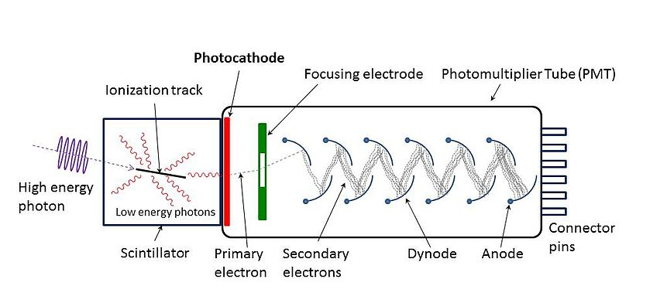

PULSE ANALYSIS:
The pulses generated by PMT are then entered to analyzer which further consist of three channels and these channels record impulse as count per minute (CPM). Each channel corresponds to specific energy of Beta radiation and thus channels are catagorized into medium, low and high energy channels.
Low energy channels corresponds to H³ emisssion and High energy Channels corresponds to P32 emission and CPM directly indicates quantity of isotopes present in sample.
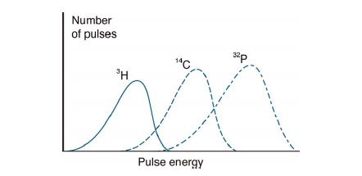

SCINTILLATION EFFICIENCY:
The term "scintillation efficiency" refers to the power of a scintillation system to convert all incident radiation energy into light photons so that a sufficient number of light photons must impinge upon photo multiplier photocathodes to generate significant signal pulse. [8]
COUNTING EFFECIENCY:
CE is described as number of particles counted by Digital analyzer per minute. CE is described in percentage and it is ratio of Counting per minute to Disintegration per minute into 100.
Simply we can say those substances that have poor scintillation efficiency they have poor counting efficiency.[8]
PHOTON YIELD:
The term "photon yield" is frequently used to express scintillation efficiency in a restricted sense. Photon yield is related to pulse height which can be measured in reference to a known system.[8]
PROCESSES THAT REDUCE CPM COUNT:
- QUENCHING:
Quencher is any substance that interfere with energy transfer from beta-emitting particles to the scintillator and Quenching is loss of counts per minute due to interference by sample or cocktail characteristics. [18]
Quenchers are of two types:
Chemical Quenchers:
Chemical quenching occurs due to presence of substance in solution that interfere with radioactive particles decay and prevent transfer of absorbed energy to flours. Eg: Halogens [18]
Color Quenchers:
Color Quenchers absorb some photons emitted by flours as a result the number of photons reducing photomultiplier tube decreases.[18]
In both types of quenching the energy of light pulses will reduce and as result total CPM is reduced.

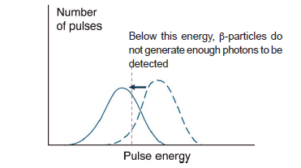
Quench correction- [18]
Internal Standard Method: An internal standard is added which has known radioactivity level and will increase DMP by predictable amount. The difference between decrease in DMP and that was due to quenching is calculated that gives accurate CPM.
E=(Cs+i-Cs)/Ai
Where As= Cs/E
Cs – count rate of sample , Cs+i– count rate of sample after addition of internal standard
– As, Ai – activity of sample and internal standard
Color Quenching can be corrected by adding some decolorizing agent which include bleaching agent.
- LUMINESCENCE: [1, 8]
Is further of two types
Chemiluminescence:
Random single photon generated as a result of chemical interaction between components of sample and scintillator cocktail is called Chemiluminescence.
Photoluminescence:
Photoluminescence is also single photon event as result of the exposure of the sample to UV light.
Luminescence control
- Chemical methods –neutralization with nonoxidizing acid before adding a cocktail
- Temperature control – cooling slows down the reaction [1,8]

- BACKGROUND ERROR:
Background error occurs due to minor error in instrument, scintillation vials and all assembly.
It can be reduced by temperature control which result in reduction of noise of PMT or by changing plastic vial to glass vial to reduce background error.
Or before performing experiment add water to sample and measure its absorbance and then again perform experiment and then subtract background error.
ADVANTAGES:
- Liquid scintillation counting is the most sensitive and versatile technique for the detection and measurement of radioactivity.
- Desired amount of solvent and scintillators can be added into vial to measure radioactive decay.
- It is also used for counting of Radioactive gases (CO₂, H₂S) and volatile materials labeled with 1 C and other nuclides can be counted in liquid scintillation systems by virtue of their solubility in the solvent.
- It is also used for standardization of radionucleotides because of its accuracy.[1,2,8]
APPLICATIONS:
LSC technique has number of applications in field of medical sciences and environmental sciences. It is widely used in treatment of cancer, metabolic processes and detection of radiolabelled isotopes in urine and blood samples.
- C14-nitrogen mustard is administered intra-arterial to treat rapidly growing tumors. LSC is used in determination of level of C14-nitrogen mustard in normal and tumor tissues.
- In thyroid Cancer LSC is used to determine levels of I₁₃₁ and I₁₂₉ when given during radiotherapy. [19]
- Radio labelled 2-Deoxy 2-glucose which is for studying glucose transport for measuring cellular activity can be also measured by this technique.
- Aminoacid transport is also detected by measuring levels of Arginine [H3] by LSC. [20]
- Fe₆₉, Na₂₂ and other isotopes may possibly have their clinical and diagnostic applications can be also detected by LSC. Fe⁶⁹ is important for anemic patients where as Na²² is important isotopes used in detection of kidney failure. [21]
- Liquid scintillation beta technique is also used in measurement of radio labelled DNA precursors having H₃ or C ₁₄ radio labelled isotope in rapidly dividing DNA strand during cell proliferation technique.[21]
- LSC is also used for monitoring the environmental lead Pb ⁵² that is associated with environmental pollution. [21]
- LSC is widely used in studying distribution and metabolism of distinct drugs in isolated tissues like effect of nor-epinephrine is studied in isolated heart tissue and its release and reuptake behavior. [21]
- LSC is also used to study dissolution profile of distinct drugs in the body. Dissolution of cholesterol in stimulated bile can be measured by this technique. [21]
- LSC is also applicable to measure pharmacokinetics of radiolabelled drugs like it is used to study protein binding characteristics of radiolabelled ¹⁴C-Phenytoin. [21]
- LSC is most promising technique for in vivo whole body counting which has wide clinical applications like LSC is broadly used to measure correlated potassium levels in extracellular fluid and intracellular fluids along with detection of total potassium levels in blood. [21]
- LSC is frequently used to detect protein and DNA molecules when they are labelled with radiotracer, that are collected as precipitate on micro-cellulose filter after analysis of blood sample.[22]
- LCS is used to detect different samples fractionated in polyacrylamide gels [22]
References:
- MILWAUKEE et al, University of Wisconsin - Madison, Radiation Safety for Radiation Workers Handbook, 1998.
- Bricks. J.B, Thepry and Practicing of Liquid Scintillation, 1964. Pergammon Press Oxford. UK
- Sten Carlsson. Report on Liquid Scintillation Counting 1993 . Dept of Radiation Physlcs/ Linköping Unlverslly Sweden. UddevalIa,Svveden
- Verrezen, V. and Hurtgen, C. A multiple window deconvolution technique for measuring low-energy beta activity in samples contaminated with high-energy beta impurities using liquid scintillation spectrometry. Appl.Rad. and Isotopes 53 (2000) 289-296.
- C.T.Peng. Sample Preparaton in Liquid Scintillation Counting Tehique. Department of Pharmaceutical Pharmacy, School of Pharmacy, Sanfrancisco, California 94143.
- Furst M. and Kallmann, H. J. Chm. Phys.(1995),23-607
- Birks, J.B and Poullis, G.C. Principles in Liquid Scintillation Counting, Vol 2. Proc. Symp 1971.
- Chin Tzu Peng, Donald L. Horrocks, Edward. L. Alpen. Liquid Scintillation Counting. Recent Applications and Development. Volume 2, Academic Press 1980.
- Davidson J.D and Feigelson,P. Int. J. Appl. Radiot. Isotopes, 1-2, 1957.
- Pollay. M and Stevens.F.A. The current status of liquid scintillation counting. P 207. Newyork 1970
- Winkelman. J, Slater.G. Anal Biochem (1997),PP 365.
- Eakins. J. D, Brown. D. A, Int. J Appl.Radiat. Isotopes, (1996), Pp 391
- CALF. G.E. Int. Journal App. Radiot Isotopes (1969). Pp 611.
- Sharkis.A.A, Paeda. R.I. Instum. Exp. Tech1970 Vol(2) PP 407
- Klein, J. Nucl. Instrum, Methods (173) , 112-117.
- Bricks, J.B, Conte, J.C. Proc. Royal Soc, Ser A(1968), 85.
- Forster, Th. Flourescence Organischer Verbindundgen. Gottingen, Vadenhoeck and Rupercht, (1951), PP 312.
- Jock Thomas. Use and Preparation of Quench Curves in Liquid Scintillation counting. Packard Bioscience, 2001.
- I.U.Boone, B.S.Rogers, J.B.Storer Nitrogrn mustard and triethylene melamine content in normal and tumor tissues after intra-arterial and intra-venous injections in rats. Cancer res.
- González-Muñoz E., López-Iglesias C., Calvo M., Palacín M., Zorzano A., Camps M. 2009.Endocrinology Vol. 150, nº8, 3493-3502.
- Wright H. Langham. Applications odf liquid Scintillation counting to Biology and medicine Los Alamos Scientific laboratory, University of California.
- Application of liquid scintillation counting technique. A primer for orientation. National Diagnostics2004

