(PRODUCER)
- An individual are organization that creates good and services is called producer.
- A producer is a person or business that makes good or provide services.
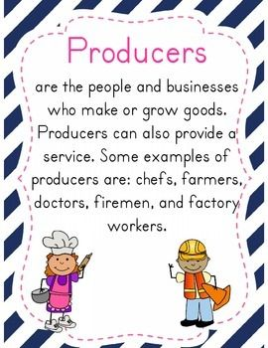
Certain Problems:
The certain problem of what and how much produce, how to produce and for, whom to produce.
- What To Produced:
Let us consider the first question is that which commodities are produced and in what quantity?
The commodities which do not command positive price in the market would nor produced .
Therefore only those commodities with positive price are to be produced.
Quantity:
The quantity in which commodity is to be produced is set according to demand and supply, if quantity produced more or less than equilibrium than there would be disturbance.
Hence to maintain stable equilibrium price it becomes necessary to make demand and supply equal this rule is applicable for each commodity in this way first problem is solved. In quantity we check total population and total requirements

Quality:
In quality we required total population purchasing power ,income and requirements. In this factor producer required all these things
Producer check specific area for specific commodity. He check which commodity is better for better production he check.

How to produced:
Which technique are to be adopted? Technology means the correct proportion in which the different factor of production are to be employed .
There are two types of techniques.
- Labour intensive
- Capital intensive
Labour Intensive
In Economics, labour is the all human efforts in the production. Labour does not only mean the labourers in an industrial site. If we take an example of a tourist resort, labour includes the receptionists, bell boys, bartenders, waiters, admin assistants, telephone operators etc.
Labour-intensive production means that the way that a good or service is produced depends more heavily on labour than the other factors of production, such as capital.
Labour intensive method of production is usually used for individual or personalised products, or to produce on a small scale.
Examples of labour-intensive production are hotels, restaurants, small scale farming, pole-and-line fishing, mining etc.
Mean more labour and less capital.in this technique due to small investment work is done by labour. A producer earn less profit than capital intensive.

Advantages of labour-intensive production
1. Can provide tailor made products / services for different customer needs and wants. Machinery is not flexible enough to provide custom made products / services for individual customers.
2. Labour can provide feedback, that provides ideas for continuous improvement. Workers can adapt to introduce new ideas.
Disadvantages of labour intensive production
1 Labour relation problems, e.g. may go on strike.
2. There could be a shortage of skilled labour, unlike machinery.
3. Problems in personal life could easily affect the performance at work.
Capital Intensive
Capital-intensive processes are those that require a relatively high level of capital investment compared to the labour cost.
These processes are more likely to be highly automated and to be used to produce on a large scale.
An industry that is capital intensive is – oil refining, manufacturing.
Mean more capital and less labour. In capital intensive investment in large amount and work is done by machinery .they can make different things with the help of machinery and earn a large amount of profit.

Advantages of capital intensive production
1.No problems with labour shortages / planning labour
2. Reduces human error – more accurate production.
3.Greater speed (efficiency) and uniform effort / output.

Disadvantages of capital intensive production
1.Initial high costs of investment and possible training costs.
2.Lack of flexibility in responding to a change in demand. In contrast, labour can be used flexibly, e.g. using temporary workers.
.Whom to produce
The solution of this problem is very easy commodity can be consumed only by the people how have more purchasing power.
When the price of every commodity and every factor of production is determined the third problem is solved.

(CONSUMERS)
Definition:
- Consumers are that who trade money to buy things to fulfill the needs of life is called consumers.
- A consumer is a person or business that uses goods or services.
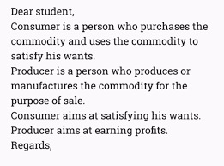
because the study of individual groups of organization and process they used to select products ,services experiences and ideas to satisfy needs and the imp process is the act on the consumers and society .
- Every development is based on consumer thinking and behavior and according to their culture. For example,
In Asia
People wear shalwarkameez.
In Europe
People wear western clothes here producer produce goods according to people culture, behavior, and their taste which clothes are liked or not.
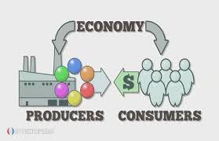
- Family:
In family there are two classes ,
Joint family: Their purchasing power is high due to high income quantity is also high.
Neutral family: their income is low, purchasing power is low and the quantity is also low.
- Sate:
There is a relationship between one country and the other in various aspects.
- Social Media:
Advertisement is the best example through it one culture transform into other in on time.
- Likes and dislike of people:
The things which are liked by people more preferable or used by us.
The things which are not liked gradually finished from our personality.

