Cell cycle with reference to miosis

Cell cycle

Introduction
The cell cycle is a series of events involving cell growth and cell division that produces two new daughter cells.
These events include the duplication of its DNA and some of its organelles, and the cytoplasm is also divide and other components into two daughter cells in a process called cell division.
Cell division is the process in which the parent cell is divided into two or more daughter cells. Cell division usually occurs as part of a larger cell cycle. In eukaryotes, there are two distinct types of cell division: a vegetative division, whereby each daughter cell is genetically identical to the parent cell, and a reproductive cell division, in which the number of chromosomes in the daughter cells is reduced by half to produce haploid gametes by meiosis. Meiosis results in four haploid daughter cells by undergoing one round of DNA replication followed by two divisions. Homologous chromosomes are separated in the first division, and sister chromatids are separated in the second division. Both of these cell division cycles are used in the process of sexual reproduction at some point in their life cycle. Both are believed to be present in the last eukaryotic common ancestor.
In eukaryotic cell or cell with nuclei, the cell cycle is divided into two main stages: interphase and the mitotic phase. During interphase, the cell grows, accumulating nutrients needed for mitosis, and replicates its DNA and some of its organelles. During the mitotic phase, the replicated chromosomes, organelles, and cytoplasm separate into two new daughter cells. To ensure the proper replication of cellular components and division, there are control mechanisms known as cell cycle checkpoints after each of the key steps of the cycle that determine if the cell can progress to the next phase.
In cells without nuclei, for example bacteria and archaea, the cell cycle is divided into the B, C, and D periods. The B period extends from the end of cell division to the beginning of DNA replication. DNA replication occurs during the C period. The D period refers to the stage between the end of DNA replication and the splitting of the bacterial cell into two daughter cells.
The cell-division cycle is a vital process by which a single-celled fertilized egg develops into a mature organism, as well as the process by which hair, skin, blood cells, and some internal organs are renewed. After cell division, each of the daughter cells begin the interphase of a new cycle. Although the various stages of interphase are not usually morphologically distinguishable, each phase of the cell cycle has a distinct set of specialized biochemical processes that prepare the cell for initiation of the cell division.

Phases of cell cycle
The eukaryotic cell cycle consists of four distinct phases: G₁ phase, S phase, G₂ phase and M phase.
An active eukaryote undergo these steps as it grows and divides. After completing the cycle, the cell either starts the process again from G1 or exists the cycle through G0.from G0 the can undergo terminal differentiation.
State | Phase | Abbreviation | Description
Resting | Gap 0 | G₀ | A phase where the cell has left the cycle and has stopped dividing.
Interphase | Gap 1 | G₁ | Cells increase in size in Gap 1. The G₁ checkpoint control mechanism ensures that everything is ready for DNA synthesis.
 | Synthesis | S | DNA replication occurs during this phase.
 | Gap 2 | G₂ | During the gap between DNA synthesis and mitosis, the cell will continue to grow. The G₂ checkpoint control mechanism ensures that everything is ready to enter the M (mitosis) phase and divide.
Cell division | Mitosis | M | Cell growth stops at this stage and cellular energy is focused on the orderly division into two daughter cells. A checkpoint in the middle of mitosis (Metaphase Checkpoint) ensures that the cell is ready to complete cell division.

Mitosis vs meiosis
Eukaryotes are capable of two types of cell division: mitosis and meiosis
Mitosis allows for cells to produce identical copies of themselves, which means the genetic material is duplicated from parent to daughter cells. Mitosis produces two daughter cells from one parent cell.
Single-celled eukaryotes, such as amoeba and yeast, use mitosis to reproduce asexually and increase their population. Multicellular eukaryotes, like humans, use mitosis to grow or heal injured tissues.
Meiosis, on the other hand, is a specialized form of cell division that occurs in organisms that reproduce sexually. As mentioned above, it produces reproductive cells, such as sperm cells, egg cells, and spores in plants and fungi.
In humans, special cells called germ cells undergo meiosis and ultimately give rise to sperm or eggs. Germ cells contain a complete set of 46 chromosomes (23 maternal chromosomes and 23 paternal chromosomes). By the end of meiosis, the resulting reproductive cells, or gametes, each have 23 genetically unique chromosomes.
The overall process of meiosis produces four daughter cells from one single parent cell. Each daughter cell is haploid, because it has half the number of chromosomes as the original parent cell.
Unlike in mitosis, the daughter cells produced during meiosis are genetically diverse. Homologous chromosomes exchange bits of DNA to create genetically unique, hybrid chromosomes destined for each daughter cell.
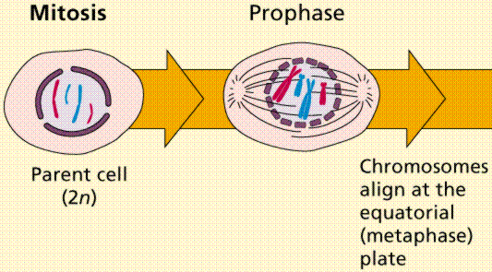
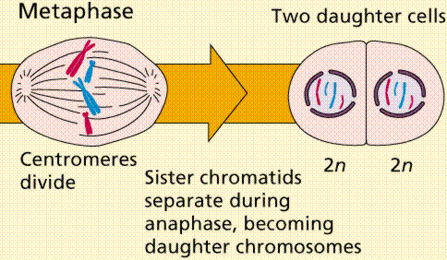
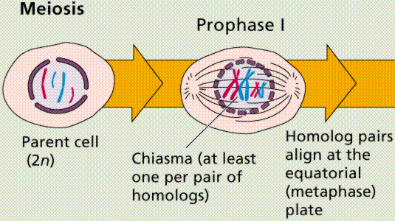
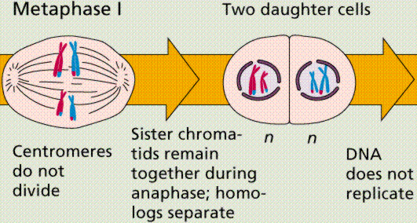
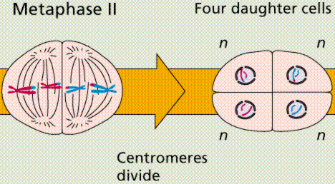

Meiosis
Meiosis is the form of eukaryotic cell division that produces haploid sex cells or gametes which contain a single copy of each chromosome from diploid cells which contains two copies of each chromosome.the process takes the form of one DNA replication followed by two succesive nuclear and cellula divisions meiosis I and meiosis II.

Ploidy
Haploid and diploid are terms referring to the number of sets of chromosomes in a cell. Gregor Mendel determined his peas had two sets of alleles, one from each parent. Diploid organisms are those with two sets. Human beings except for their gametes, most animals and many plants are diploid. We abbreviate diploid as 2n. Ploidy is a term referring to the number of sets of chromosomes. Haploid organisms/cells have only one set of chromosomes, abbreviated as n. Organisms with more than two sets of chromosomes are termed polyploid. Chromosomes that carry the same genes are termed homologous chromosomes. The alleles on homologous chromosomes may differ, as in the case of heterozygous individuals. Organisms receive one set of homologous chromosomes from each parent.
Meiosis is a special type of nuclear division which segregates one copy of each homologous chromosome into each new "gamete". Mitosis maintains the cell's original ploidy level. Meiosis, on the other hand, reduces the number of sets of chromosomes by half, so that when gametic recombination occurs the ploidy of the parents will be reestablished.
Most cells in the human body are produced by mitosis. These are the somatic or vegetative cells. Cells that become gametes are referred to as germ cells. The majority of cell divisions in the human body are mitotic, with meiosis being restricted to the gonads.

Phases of Meiosis
There are two phases of meiosis:
Meiosis I
Meiosis II
Bivalent – a pair of homologous chromosomes held together by a chiasma.
Chiasma- point of crossing over when chromosomes exchange the genetic material.
Centromere- the point of attachment of chromosomes.
Dyad- the half of a tetrad, one half of homologous chromosomes.
Homologous chhromosomes- pair of chromosome is formed by original chromosomes and its duplication.
Metaphase plate the mid line of cell.
Monad- after separation, each chromosome of tetrad form a monad, a dyad without the synapsis to its homologous chromosome.
Nuclear envelope- the double membrane which enclose the nucleus.
Sister chromatids- two identical chromatids which form chromosome.
Spindle fibers- bundle of microtubules running from one pole of the cell to the other end.
Synapsis- the process in which two homologous chromsomes come into physically contact with one another.
Tetrad- a pair of homologous chromosome held by a chiasma.

Meiosis I

Meiosis I segregates homologous chromosomes, which are joined as tetrads, producing two haploid cells which each contain chromatid pairs. Because the ploidy is reduced from diploid to haploid, meiosis I is referred to as a reduction division. Meiosis II is an equational division analogous to mitosis, in which the sister chromatids are segregated, creating four haploid daughter cells.
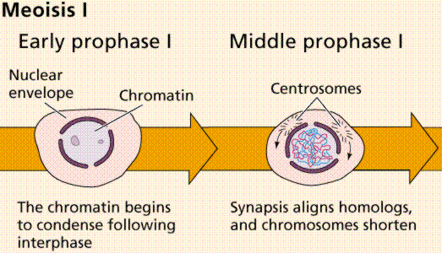

Prophase I
Prophase I is typically the longest phase of meiosis. During prophase I, homologous chromosomes pair and exchange genetic material. This often results in crossing over of chromosomes. This process facilitates pairing between homologous chromosomes and hence accurate segregation of the chromosomes at the first meiosis division. The new combinations of DNA created during crossover are a significant source of genetic variation, and result in new combinations of alleles, which may be beneficial. The paired chromosomes are called as tetrad, which have two chromosomes and four chromatids, each chromosome comes from one parent. The process of pairing the homologous chromosomes is called synapsis.crossing over occurs at the point where the chromosomes are attached with eachother at the point of chiasmata. Prophase I of meiosis is divided into five different stages.

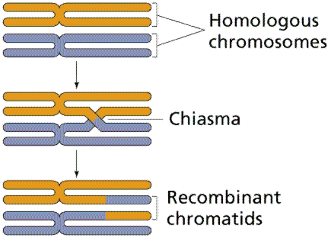

Prophase I is further divided into five stages:

Leptotene
- leptotene phase, leptonema; Greek, leptotene = "thin threads"
- the duplicated paired chromosome homologs condense.

Zygotene
- zygotene phase, zygonema, Greek, zygotene = "paired threads"
- homologous chromosomes become closely associated by synapsis to form pairs of chromosomes consisting of four chromatids.
- the synaptonemal complex begins to form between the two sets of sister chromatids in each bivalent (the duplicated chromosome paired with its homologous duplicated chromosome).
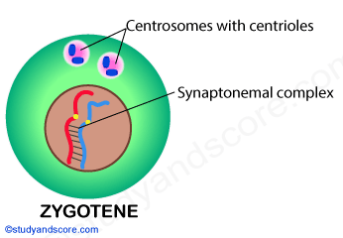

Pachytene
- pachytene phase, pachynema; Greek, pachytene = "thick threads"
- crossing over between pairs of homologous chromosomes to form chiasmata.
- synaptonemal complex is complete and can be stable for some time.
- Autosomal non-sister chromatids of homologous chromosomes can now extensively exchange segments in regions of homology.
- Only small regions of non-paired sex chromosomes interact
- Mutations that compromise meiotic recombination in male spermatocytes result in arrest and apoptosis at this stage.
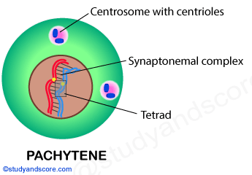

Diplotene
- diplotene phase, diplonema; Greek, diplonema = "two threads"
- homologous chromosomes begin to separate but remain attached by chiasmata.
- synaptonemal complex degrades and the chromosomes separate from one another a small amount giving this appearance.
- It is possible that some chromosome uncoiling may also occur allowing some gene transcription.
  - In the developing human ovary, oocytes remain at the diplotene stage from fetal life through postnatal childhood, until puberty when the luteinizing hormone surges stimulate the resumption of meiosis.
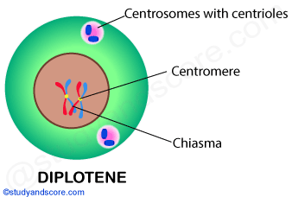

Diakinesis
- diakinesis phase; Greek, diakinesis = "moving through"
- homologous chromosomes continue to separate, and chiasmata move to the ends of the chromosomes.
- prophase I ends and chromosomes now recondense, transcription stops and the transition to metaphase occurs.
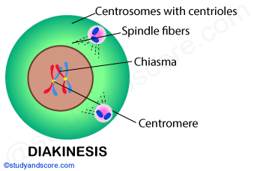

Prometaphase I
Spindle apparatus formed, and chromosomes attached to spindle fibres by kinetochores.

Metaphase I
Homologous pairs move together along the metaphase plate: As kinetochore microtubules from both centrosomes attach to their respective kinetochores, the paired homologous chromosomes align along an equatorial plane that bisects the spindle, due to continuous counterbalancing forces exerted on the bivalents by the microtubules emanating from the two kinetochores of homologous chromosomes. This attachment is referred to as a bipolar attachment. The physical basis of the independent assortment of chromosomes is the random orientation of each bivalent along the metaphase plate, with respect to the orientation of the other bivalents along the same equatorial line. The protein complex cohesin holds sister chromatids together from the time of their replication until anaphase. In mitosis, the force of kinetochore microtubules pulling in opposite directions creates tension. The cell senses this tension and does not progress with anaphase until all the chromosomes are properly bi-oriented. In meiosis, establishing tension ordinarily requires at least one crossover per chromosome pair in addition to cohesin between sister chromatids.

Anaphase I
Kinetochore microtubules shorten, pulling homologous chromosomes to opposite poles. Nonkinetochore microtubules lengthen, pushing the centrosomes farther apart. The cell elongates in preparation for division down the center. Unlike in mitosis, only the cohesin from the chromosome arms is degraded while the cohesin surrounding the centromere remains protected by a protein, what prevents the sister chromatids from separating. This allows the sister chromatids to remain together while homologs are segregated.

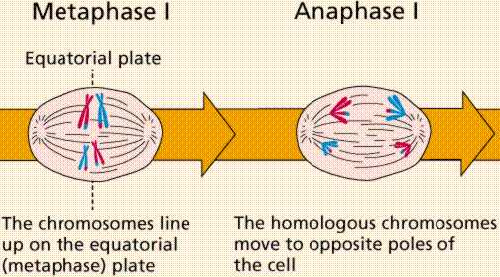

Telophase I
The first meiotic division effectively ends when the chromosomes arrive at the poles. Each daughter cell now has half the number of chromosomes but each chromosome consists of a pair of chromatids. The microtubules that make up the spindle network disappear, and a new nuclear membrane surrounds each haploid set. The chromosomes uncoil back into chromatin. Cytokinesis, the pinching of the cell membrane in animal cells or the formation of the cell wall in plant cells, occurs, completing the creation of two daughter cells. Sister chromatids remain attached during telophase I.
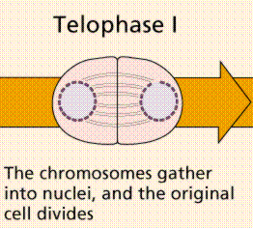

Meiosis II

Meiosis II is the second meiotic division, and usually involves equational segregation, or separation of sister chromatids. Mechanically, the process is similar to mitosis, though its genetic results are fundamentally different. The end result is production of four haploid cells from the two haploid cells produced in meiosis I.
The four main steps of meiosis II are: prophase II, metaphase II, anaphase II, and telophase II.

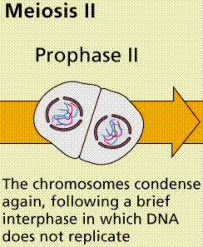

Prophase II
In prophase II, nuclei disappear and the nuclear envelope again as well as the shortening and thickening of the chromatids. Centrosomes move to the polar regions and arrange spindle fibers for the second meiotic division.

Metaphase II
In metaphase II, the centromeres contain two kinetochores that attach to spindle fibers from the centrosomes at opposite poles. The new equatorial metaphase plate is rotated by 90 degrees when compared to meiosis I, perpendicular to the previous plate.

Anaphase II
This is followed by anaphase II, in which the remaining centromeric cohesin, not protected by Shugoshin anymore, is cleaved, allowing the sister chromatids to segregate. The sister chromatids by convention are now called sister chromosomes as they move toward opposing poles.

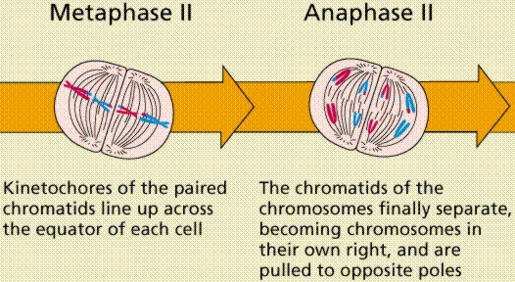

Telophase II
The process ends with telophase II, which is similar to telophase I, and is marked by decondensation and lengthening of the chromosomes and the spindle is disorganized.
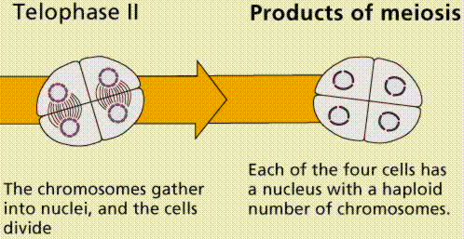

Purpose of meiosis
The word meiosis originates from the Greek language. It means to lessen; this refers to the reduction of the number of chromosomes within the cell. Meiosis is the process of chromosomal reduction in eukaryotic cell, which leads to the production of germ cells needed for sexual reproduction. In meiosis, a diploid number of chromosomes is reduced to half number of chromosomes to produce germ cells or spores. When these combine in sexual reproduction, the resulting zygote is a diploid. In this way, the chromosomal number of the species is conserved through sexual reproduction.

Why?
It comes down to chromosomal numbers. If a human, with n = 46 chromosomes, or two pairs of n = 23 chromosomes, were to reproduce without chromosomal reduction, the egg cell and sperm cell would both have n = 46 chromosomes. When these fuse to become a gamete, the zygote would have n = 92 chromosomes, or double the number necessary! This would result in genetic abnormalities in the child. Further, imagine if this child were to reproduce with another child with n = 92 chromosomes: their child would have 184 chromosomes! This number would be ever-increasing. Thus, a chromosomal reduction is necessary for each species’ continued existence.
Before meiosis begins, the chromosomes in the nucleus of the cell undergo replication. This is because meiosis produces four daughter cells with half the chromosomes of the parent cell; or four haploid cells from a single diploid cell. Remember, haploid and diploid refer to the number of chromosomes in the cell: haploid cells contain one set of chromosomes while diploid cells contain two full sets of chromosomes. As you can see, the math doesn’t quite work out: the parent cell must first be converted to a 4n tetraploid cell before division begins. So a cell with n = 46 chromosomes will be converted to a cell with n = 92 chromosomes, which, after meiosis, will produce four cells with n = 23 chromosomes.
Meiosis begins much the same as mitosis does. After chromosomal replication, all chromosomes separate into sister chromatids. However, here the similarities end. In meiosis, an additional process occurs: that of recombination or crossing over. In recombination, the pairs of chromosomes line up and recombine, so that each chromosome has a piece of another in it. In this way, genetic diversity is ensured.

Gametogenesis
Gametogenesis is the process of forming gametes from diploid cells of the germ line. Spermatogenesis is the process of forming sperm cells by meiosis in specialized organs known as gonads, in males these are termed testes. After division the cells undergo differentiation to become sperm cells. Oogenesis is the process of forming an ovum, in female is egg by meiosis in specialized gonads known as ovaries. Whereas in spermatogenesis all 4 meiotic products develop into gametes, oogenesis places most of the cytoplasm into the large egg. The other cells, the polar bodies, do not develop. This all the cytoplasm and organelles go into the egg. Human males produce 200,000,000 sperm per day, while the female produces one egg each menstrual cycle.

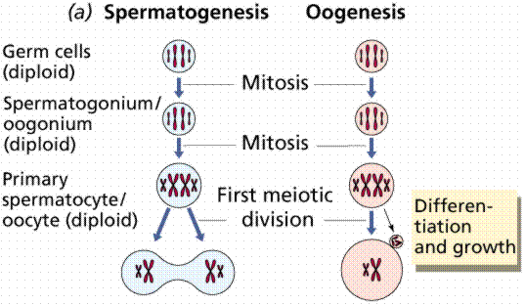
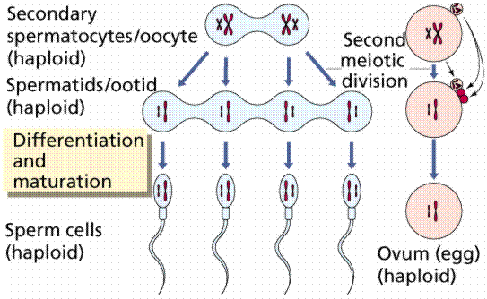

Variation
The normal separation of chromosomes in meiosis I or sister chromatids in meiosis II is termed disjunction. When the segregation is not normal, it is called nondisjunction. This results in the production of gametes which have either too many or too few of a particular chromosome, and is a common mechanism for trisomy or monosomy. Nondisjunction can occur in the meiosis I or meiosis II, phases of cellular reproduction, or during mitosis.
Most monosomic and trisomic human embryos are not viable, but some aneuploidies can be tolerated, such as trisomy for the smallest chromosome, chromosome 21. Phenotypes of these aneuploidies range from severe developmental disorders to asymptomatic. Medical conditions include but are not limited to:
- Down syndrome – trisomy of chromosome 21
- Patau syndrome – trisomy of chromosome 13
- Edwards syndrome – trisomy of chromosome 18
- Klinefelter syndrome – extra X chromosomes in males – i.e. XXY, XXXY, XXXXY, etc.
- Turner syndrome – lacking of one X chromosome in females – i.e. X0
- Triple X syndrome – an extra X chromosome in females
- Jacobs syndrome – an extra Y chromosome in males.

