INFLAMMATION
Prepared by: Maira Ahmad, M.Phil. Pharmacology
Inﬂammation is a protective response involving host cells, blood vessels, and proteins and other mediators that is intended to eliminate the initial cause of cell injury, as well as the necrotic cells and tissues resulting from the original insult, and to initiate the process of repair. (Vinay Kumar, 2013)
When tissue injury occurs, whether caused by bacteria, trauma, chemicals, heat, or any other phenomenon, multiple substances are released by the injured tissues and cause dramatic secondary changes in the surrounding uninjured tissues. This entire complex of tissue changes is called inflammation. (Hall, 2016)
Inﬂammation is a collection of events that rapidly occurs following tissue injury or infection. There are several inﬂammatory pathways; many of the individual steps of inﬂammation are controlled by cytokines or other small regulatory molecules that are often referred to as inﬂammatory mediators. The inﬂammatory response is largely protective, although in certain circumstances, such as hypersensitivity reactions and autoimmune diseases, inﬂammation can be the major mechanism of harm to the body. (Shargel & Mutnick, 2013)
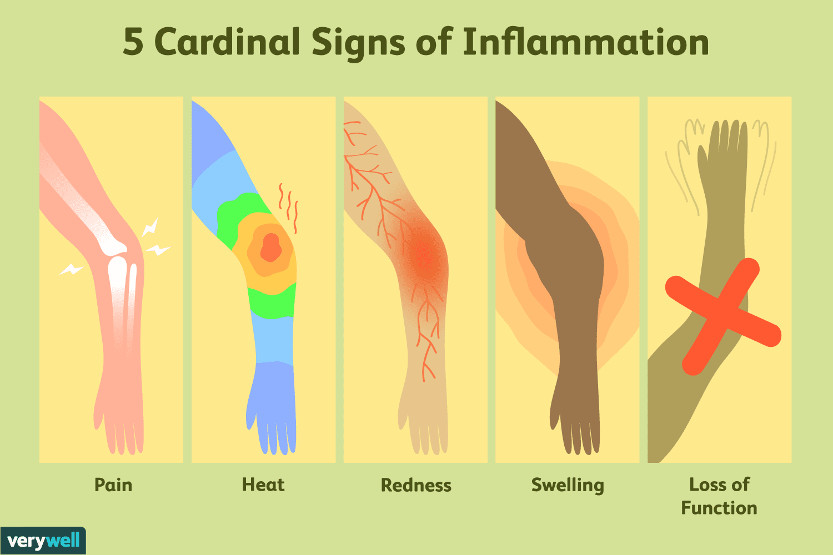
The external manifestations of inﬂammation often called cardinal signs of inﬂammation:
- Redness (Rubor)
- Heat (Calor)
- Swelling (Tumor) Pain (Dolor).
- Loss of Function ( Functio Laesa) (Vinay Kumar, 2013)
These features correspond to inﬂammatory events of vasodilation, edema and tissue damage.
(Strayer & Rubin, 2015)

Inflammation is best viewed as an ongoing process that can be divided into phases.

■ Initiation results in a stereotypic, immediate response termed acute inflammation. Characterized by the rapid flooding of the injured tissue with fluid, coagulation factors, cytokines, chemokines, platelets and inflammatory cells.
■ Amplification depends on the extent of injury and the activation of mediators, such as kinins and complement components. Additional leukocytes and macrophages are recruited to the area.
■ Destruction of the inciting agent by phagocytosis and enzymatic or non-enzymatic processes reduces or eliminates foreign material or infectious organisms. At the same time, damaged tissue components are also removed, paving the way for repair to begin.
■ Termination of the inflammatory response is mediated by intrinsic anti-inflammatory mechanisms that limit tissue damage. It allows for either restoration of tissue, with return to normal physiologic function, or repair and the development of a scar in place of normal tissue. (Emanuel Rubin, 2014)
Some types of injury trigger sustained immune and inﬂammatory responses if injured tissue and foreign agents are not cleared. Such persistent responses are called chronic inﬂammation. Acute and chronic inﬂammatory infiltrates often coexist. (Strayer & Rubin, 2015)
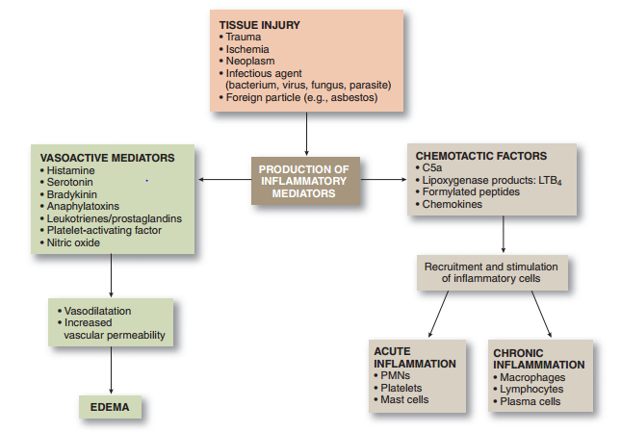
Mediators of the
inflammatory response.

Tissue injury stimulates the production of inflammatory mediators in plasma, which are released in the circulation.
Additional factors are generated by tissue cells and inflammatory cells.
These vasoactive and chemotactic mediators promote edema and recruit inflammatory cells to the site of injury.
LTB4, leukotriene B4; PMNs, polymorphonuclear neutrophils.
(Emanuel Rubin, 2014)

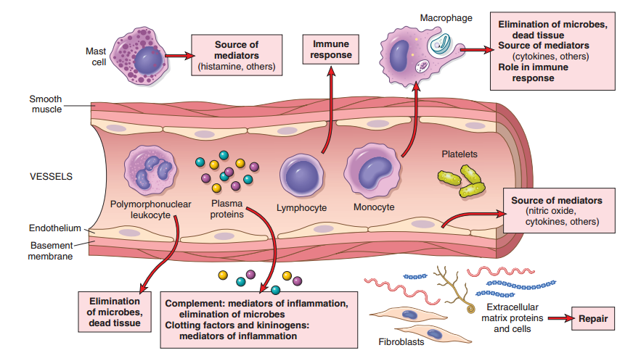
The components of acute and chronic inﬂammatory responses and their principal functions. (Vinay Kumar, 2013)
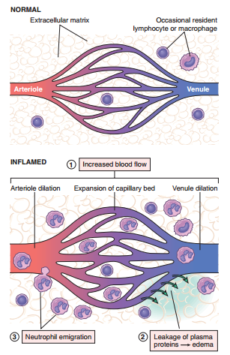
ACUTE INFLAMMATION
Acute inﬂammation has two major components
- Vascular changes:
  - Alterations in vessel caliber resulting in increased blood ﬂow (vasodilation).
  - Changes in the vessel wall that permit plasma proteins to leave the circulation
(increased vascular permeability).
  - Endothelial cells are activated, resulting in increased adhesion of leukocytes and migration of the leukocytes through the vessel wall.
- Cellular events:
  - Emigration of the leukocytes from the circulation and accumulation in the focus of injury (cellular recruitment).
  - Activation of the leukocytes, enabling them to eliminate the offending agent.
The principal leukocytes in acute inﬂammation are neutrophils (polymorphonuclear leukocytes). (Vinay Kumar, 2013)
Vascular Changes:
The main vascular reactions of acute inﬂammation are increased blood ﬂow, secondary to vasodilation and increased vascular permeability, designed to bring blood cells and proteins to sites of infection or injury. (Vinay Kumar, 2013)
(1) Vascular dilation & increased blood ﬂow (erythema & warmth)
(2) Extravasation of plasma ﬂuid and proteins (edema)
(3) Leukocyte (mainly neutrophil)
emigration and accumulation.

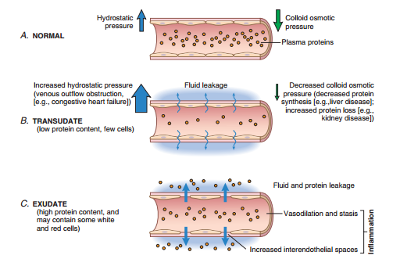
Changes in Vascular Caliber and Flow
Arteriolar vasodilation occurs, resulting in locally increased blood ﬂow and engorgement of the down-stream capillary beds, the cause of the redness (erythema) and warmth characteristic of acute inﬂammation.
Increased Vascular Permeability
Leads to the movement of protein-rich ﬂuid and even blood cells into the extravascular tissues. This increases the osmotic pressure of the interstitial ﬂuid, leading to more outﬂow of water from the blood into the tissues. The resulting protein-rich ﬂuid accumulation is called an exudate.
Fluid accumulation in extravascular spaces, whether from an exudate or a transudate, produces tissue edema. (Vinay Kumar, 2013)
Formation of transudates and exudates.
A. Normal hydrostatic pressure the mean colloid osmotic pressure of tissues is nearly equal to the mean capillary pressure.
B. A transudate is formed when ﬂuid leaks out because of increased hydrostatic pressure or decreased osmotic pressure.
C. An exudate is formed in inﬂammation because vascular permeability increases as a result of the increase in inter-endothelial spaces
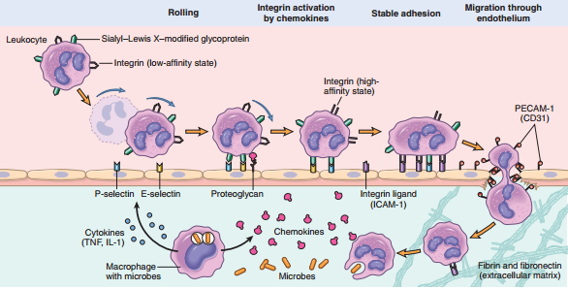
Cellular Changes:

Leukocyte Recruitment
Leukocytes normally ﬂow rapidly in the blood, in inﬂammation, they have to be stopped and brought to the offending agent or the site of tissue damage, which are typically outside the vessels.
The sequence of events in the recruitment of leukocytes, from the vascular lumen to the extravascular space consists of;
- Margination and
rolling along the vessel wall
- Firm adhesion to the endothelium
- Transmigration between endothelial cells
- Migration in interstitial tissues toward a chemotactic stimulus.

Leukocyte Activation
Once leukocytes have been recruited to the site of infection or tissue necrosis, they must be activated to perform their functions. Stimuli for activation include microbes, products of necrotic cells, and several mediators.
Leukocyte activation results in the enhancement of the following functions:
- Phagocytosis of particles
- Intracellular destruction of phagocytosed microbes and dead cells by substances produced in phagosomes,
including reactive oxygen and nitrogen species and lysosomal enzymes
- Liberation of substances that destroy extracellular microbes and dead tissues.
- Production of mediators, including arachidonic acid metabolites and cytokines, that amplify the inﬂammatory reaction, by recruiting and activating more leukocytes. (Vinay Kumar, 2013)
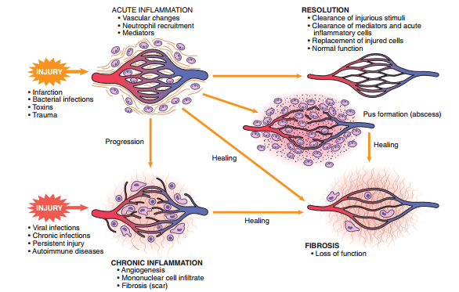
Outcomes of acute inﬂammation: resolution, healing by scarring (fibrosis) or chronic inﬂammation (Vinay Kumar, 2013)
Acute inﬂammation may progress to chronic inﬂammation if the acute response cannot be resolved, either because of the persistence of the injurious agent
or because of interference with the normal process of healing. (Vinay Kumar, 2013)
CHRONIC INFLAMMATION
Chronic inﬂammation is inﬂammation of prolonged duration (weeks to years) in which continuing inﬂammation, tissue injury, and healing, often by fibrosis, proceed simultaneously.

In contrast with acute inﬂammation, which is distinguished by vascular changes, edema, and a predominantly neutrophilic infiltrate, chronic inﬂammation is characterized by a different set of reactions:
- Infiltration with mononuclear cells, including macrophages, lymphocytes, and plasma cells.
- Tissue destruction, largely induced by the products of inflammatory cells.
- Repair, involving new vessel proliferation (angiogenesis) and fibrosis. (Vinay Kumar, 2013)

Infiltration with mononuclear cells:
Macrophages, the dominant cells of chronic inﬂammation, are tissue cells derived from circulating blood monocytes after their emigration from the bloodstream.
Monocytes arise from precursors in the bone marrow and circulate in the blood, when monocytes reach the extravascular tissue, they undergo transformation into macrophages. Tissue macrophages are activated by diverse stimuli to perform a range of functions.
- Ingest and eliminate microbes and dead tissues.
- Initiate the process of tissue repair and are involved in scar formation and fibrosis
- Secrete mediators of inﬂammation, such as cytokines and eicosanoids.
- Display antigens to T lymphocytes and respond to signals from T cells (Vinay Kumar, 2013)

Lymphocytes
The activation of T and B lymphocytes is part of the adaptive immune response in infections and immunologic diseases. In the tissues, B lymphocytes may develop into plasma cells, which secrete antibodies, and CD4+ T lymphocytes are activated to secrete cytokines.
There are three subsets of CD4+ helper T cells that secrete different sets of cytokines and elicit different types of inﬂammation:
• TH1 cells produce the cytokine IFN-γ, which activates macrophages in the classical pathway.
• TH2 cells secrete IL-4, IL-5, and IL-13, which recruit and activate eosinophils and are responsible for the alternative pathway of macrophage activation.
• TH17 cells secrete IL-17 and other cytokines that induce the secretion of chemokines responsible for recruiting neutrophils and monocytes into the reaction. (Vinay Kumar, 2013)
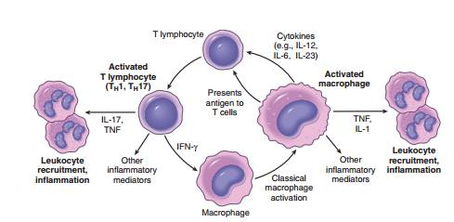
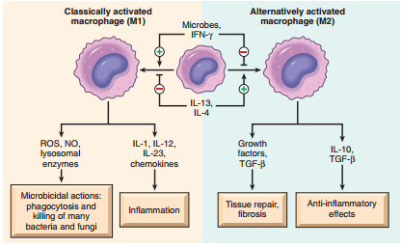

Pathways of macrophage activation. Different stimuli activate macrophages to develop into functionally distinct populations. Classically activated macrophages are induced by microbial products and cytokines, are microbiocidal and involved in potentially harmful inﬂammation. Alternatively activated macrophages are induced by IL-4 & IL-13, produced by TH2 cells (a helper T cell subset) and other leukocytes, and are important in tissue repair and fibrosis.
Macrophage–lymphocyte interactions in chronic inﬂammation.
Activated lymphocytes and macrophages stimulate each other,
both cell types release inﬂammatory mediators that affect other cells.

Tissue Destruction:
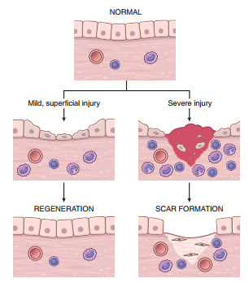
If not appropriately regulated, the products that protect the host by participating in antimicrobial defense and debridement of damaged tissue, may prolong tissue damage and promote chronic inflammation. (Emanuel Rubin, 2014)
Granulomatous inﬂammation is a distinctive pattern of chronic inﬂammation characterized by aggregates of activated macrophages with scattered lymphocytes. (Emanuel Rubin, 2014) The formation of a granuloma effectively “walls off” the offending agent. However, granuloma formation does not always lead to eradication of the causal agent, which is frequently resistant to killing or degradation, and granulomatous inﬂammation with subsequent fibrosis may even be the major cause of organ dysfunction in some diseases. (e.g. tuberculosis, leprosy). (Vinay Kumar, 2013)

Tissue Repair:
Critical to the survival of an organism is the ability to repair the damage caused by toxic insults and inﬂammation. The inﬂammatory response to microbes and injured tissues not only serves to eliminate these dangers but also sets into motion the process of repair. Repair refers to the restoration of tissue architecture & function after injury. It occurs by two types of reactions:
Mechanisms of tissue repair: regeneration and scar formation. After mild injury, that damages the epithelium but not underlying tissue, resolution occurs by regeneration,
but after more severe injury with damage to the connective tissue, repair is by scar formation.
- Regeneration of the injured tissue
- Scar formation by the deposition of connective tissue.

Regeneration;
By proliferation of residual (uninjured) cells that retain the capacity to divide, and by replacement from tissue stem cells.
Scar formation;
If the injured tissues are incapable of regeneration, or if the supporting structures of the tissue are severely damaged, repair occurs by the laying down of connective (fibrous) tissue, a process that results in scar formation. (Vinay Kumar, 2013)

SYSTEMIC MANIFESTATIONS OF INFLAMMATION
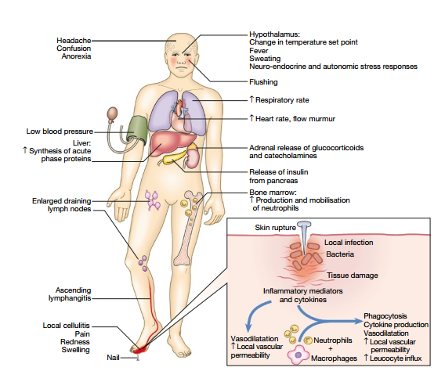
An effective inﬂammatory response will
- Limit the area of injury
- Clear the inciting pathologic agent & damaged tissue
- Restore tissue function.
However, local injury may cause prominent systemic consequences that may themselves be debilitating. These effects may result when a pathogen enters the bloodstream, a separate condition acts synergistically and the combination of a local and a systemic
insult directly or indirectly causes both local and systemic effects of inﬂammation.
The symptoms associated with inﬂammation, including fever, myalgia, arthralgia, anorexia and somnolence, are attributable to these cytokines. (Strayer & Rubin, 2015)
Clinical features of acute inflammation. In this example, the response is to a penetrating injury and infection of the foot. (Colledge, Walker, & Ralston, 2010)
CURRENT TREATMENTS:
Inflammation is a complex response to cell injury that primarily occurs in vascularized connective tissue and often involves the immune response. The mediators of inflammation function to eliminate the cause of cell injury and clear away debris, in preparation for tissue repair. Inflammation also causes pain and, in instances in which the cause of cell injury is not eliminated, can result in a chronic condition of pain and tissue damage such as that seen in rheumatoid arthritis. (Review, 2015)
The nonsteroidal anti-inflammatory drugs (NSAIDs) and acetaminophen are often effective in controlling inflammatory pain. Other treatment strategies applied to the reduction of inflammation are targeted at immune processes. These include glucocorticoids and disease-modifying anti-rheumatic drugs (DMARDs). (Review, 2015)
While generally associated with diseases such as rheumatoid arthritis, it has become clear that inﬂammation forms a significant component of many, if not most, of the diseases encountered in the clinic and consequently anti-inﬂammatory drugs are extensively employed in virtually all branches of medicine. (H P Rang, 2012)

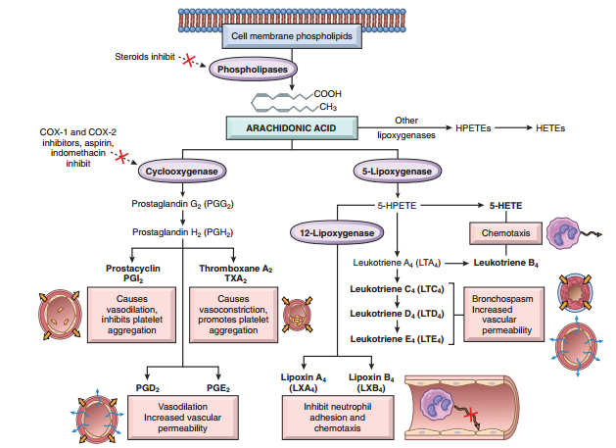
Anti-inﬂammatory
Drugs that Block
Prostaglandin Production.
NSAID inhibit
cyclooxygenase activity, blocking prostaglandin synthesis.
Glucocorticoids inhibit the activity of phospholipase and thus the release of AA from membrane lipids.
(Vinay Kumar, 2013)

Production of arachidonic acid metabolites and their roles in inﬂammation (Vinay Kumar, 2013)

Arachidonic acid is a component of cell membrane phospholipids. It is released from these phospholipids through the action of cellular phospholipases that have been activated by mechanical, chemical, or physical stimuli, or by inﬂammatory mediators. Glucocorticoids inhibit the activity of phospholipase and thus the release of AA from membrane lipids.
AA metabolism proceeds along one of two major enzymatic pathways: Cyclooxygenase stimulates the synthesis of prostaglandins and thromboxanes, and lipoxygenase is responsible for production of leukotrienes and lipoxins. There are two forms of the cyclooxygenase enzyme, COX-1 and COX-2. COX-1 is produced in response to inﬂammatory stimuli and also is expressed in most tissues, where it stimulates the production of prostaglandins that serve a homeostatic function . COX-2 is induced by inﬂammatory stimuli but it is absent from most normal tissues. (Vinay Kumar, 2013) NSAIDs inhibit cyclooxygenase and thereby decrease prostaglandin and thromboxane synthesis throughout the body. (Review, 2015)

The mechanisms of action of most DMARDs in treating rheumatoid arthritis are complex.
- Cytotoxic drugs (eg, methotrexate) probably act by reducing the number of immune cells available to maintain the inflammatory response; many of these drugs are also used in the treatment of cancer.
- Other drugs appear to interfere with the activity of
  - T lymphocytes (eg, sulfasalazine, hydroxychloroquine, cyclosporine,)
  - B lymphocytes (rituximab), or macrophages (gold compounds).
- Biologic agents that inhibit the action of tumor necrosis factor-α (TNF-α), including infliximab, adalimumab, and etanercept, have also shown efficacy in rheumatoid arthritis. (Review, 2015)

RECENT TARGETS:
- The etiology of Parkinson’s disease (PD) is significantly influenced by disease-causing changes in the protein alpha-Synuclein (aSyn). It can trigger and promote intracellular stress and hereby impair the function of dopaminergic neurons. A study conducted explored the current antibody-based approaches to lower the amount of aSyn and thereby alleviate neuroinflammatory responses as novel therapeutic strategy for PD. (Zella, Metzdorf, & Ostendorf, 2019)

- Inflammatory mediators, namely growth factors and cytokines (including transforming growth factor-b (TGF-b), platelet derived growth factor (PDGF), vascular endothelial growth factor (VEGF), interleukin-1alpha (IL-1a), interleukin-2 (IL-2), interleukin-3 (IL-3), interleukin-6 (IL-6), tumor necrosis factor-a (TNF-a) and other proteins , have been implicated in the occurrence and development of PVR (Proliferative vitreoretinopathy).These growth factors and cytokines act as signaling molecules to trigger more mediator secretion, amplify the inflammatory reaction and eventually lead to the formation of proliferative membranes. The study focused that the identification of inflammatory mediators provides novel and efficacious therapeutic targets for the treatment of PVR. (Sun, 2020)

- A defective epithelial barrier is found in patients with allergic rhinitis (AR) and asthma. Histone deacetylase (HDAC) activity has been identified as a crucial driver of allergic inflammation and tight junction dysfunction. The study concluded that blocking HDAC activity is a promising novel target for
therapeutic intervention in patients with airway diseases. (Brecht Steelant, 2019)

- A review article focused on novel drug delivery systems (NDDS) including nanoparticles, liposomes, dendrimers, microspheres etc that can target alveolar macrophage associated with inﬂammation, intracellular infection and lung cancer. The physiochemical properties and functional moieties of the NDDS attributes to enhanced macrophage targeting and uptake. The NDDS are promising for sustained drug delivery, reduced therapeutic dose, improved patient compliance and reduce drug toxicity. [12] (Meenu Mehtaa, 2019)

REFERENCES

Brecht Steelant, P. W. (2019). Blocking histone deacetylase activity as a novel target for epithelial barrier defects in patients with allergic rhinitis. American Academy of Allergy, Asthma & Immunology.
Colledge, N. R., Walker, B. R., & Ralston, S. H. (2010). Davidson's Principles and Practice of Medicine (21 ed.). Edinburgh. London. New York: Churchil Livingstone, Elsevier .
Emanuel Rubin, H. M. (2014). Essential's of Rubin's Pathology (6th ed.). New York, London, Tokyo: Wolters Kluwer I Lippincott Williams & Wilkins.
H P Rang, M. M. (2012). RANG AND DALE’S Pharmacology. London, New York, Oxford: Elsevier Churchill Livingstone.
Hall, J. E. (2016). Guyton and Hall Textbook of Medical Physiology (13th ed.). Elsevier Saunders.
Meenu Mehtaa, D. N. (2019). Interactions with the macrophages: An emerging targeted approach using novel drug delivery systems in respiratory diseases. Chemico-Biological Interactions, 10-19.
Review, K. &. (2015). Anthony J. Trevor, Bertram G. Katzung, . New York, Chicago, Athens: McGraw-Hill Education.
Shargel, L., & Mutnick, A. H. (2013). Comprehensive Pharmacy Review for NAPLEX (8th ed.). New York, London, Tokyo: Lippincott Williams & Wilkins, a Wolters Kluwer business.
Strayer, D. S., & Rubin, E. (2015). Rubin’s Pathology, CLINICOPATHOLOGIC FOUNDATIONS OF MEDICINE (7th ed.). New York, London, Tokyo : Lippincott Williams & Wilkins.
Sun, Y. D. (2020). Inflammatory mediators of proliferative vitreoretinopathy: hypothesis and review. Springer.
Vinay Kumar, A. K. (2013). Robbins Basic Pathology (9th ed.). Elsevier Saunders.
Zella, M. A., Metzdorf, J., & Ostendorf, F. (2019). Novel Immunotherapeutic Approaches to Target Alpha-Synuclein and Related Neuroinflammation in Parkinson’s Disease. Cells MDPI.

