What Is Capital Rationing?
Capital rationing is the act of placing restrictions on the amount of new investments or projects undertaken by a company. This is accomplished by imposing a higher cost of capital for investment consideration or by setting a ceiling on specific portions of a budget.
Companies may want to implement capital rationing in situations where past returns of an investment were lower than expected.

Two Types of Capital Rationing
In general, there are two primary methods for capital rationing:
- The first type of capital, rationing, is referred to as "hard capital rationing." This occurs when a company has issues raising additional funds, either through equity or debt. The rationing arises from an external need to reduce spending and can lead to a shortage of capital to finance future projects.
- The second type of rationing is called "soft capital rationing," or internal rationing. This type of rationing comes about due to the internal policies of a company. A fiscally conservative company, for example, may have a high required return on capital to accept a project, self-imposing its own capital rationing.

Capital Rationing Example
Capital rationing is about putting restrictions on investments and projects taken on by a business. To illustrate this better, let’s consider the following example:
VV Construction is looking at five possible projects to invest in, as shown below:

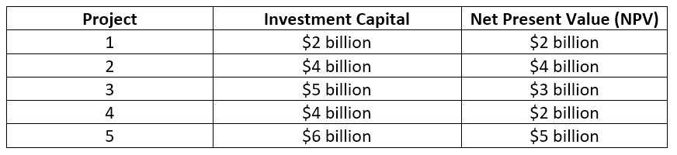

To determine which project offers the greatest potential profitability, we compute each project using the following formula:
Profitability = NPV / Investment Capital

