Draw a figure in under five minutes
Sketching a five-minute pose is a lot of fun because it offers just enough time to capture a strong sense of the pose, but not enough time to overwork (or overthink) the drawing. Keeping things simple and being economical is a recurring theme throughout the five-minute process.
The main thing to remember for a successful quick pose is to keep the gist of the subject, so we'll build it up bit by bit, adding tone right at the end. Let's get started!

01. Construct the torso

Use simple forms to sketch out the torso
Once the gesture is established, separate the torso into rib cage, abdomen and hips. Then, indicate the openings for the limbs. Next, group the muscles using simple forms. Finally, suggest planes to give the torso structure.

02. Define the limbs

Cross-sections and ovals add form to your limbs
Start the limbs as long, tapering rectangular shapes that flow from the torso down to the fingers or toes. Next, add cross-sections to indicate their position and direction of movement. Finally, use simple ovals to add muscles and indicate kneecaps and elbows.
RECOMMENDED VIDEOS FOR YOU...
- video playing
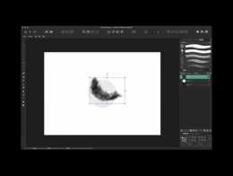
- Affinity Designer: The Export persona
17/10/18
- Affinity Designer: Using constraints
17/10/18
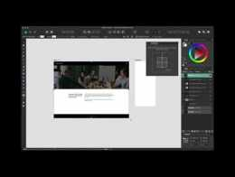
- Affinity Designer: How to use the Pen tool
31/10/18
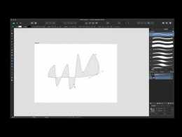
- Affinity Designer: How to use Grids
01/11/18
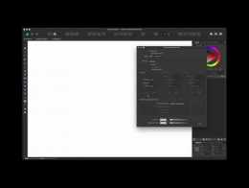
- FumeFX Tutorial: Create A Fire Tornado: Introduction
18/02/16
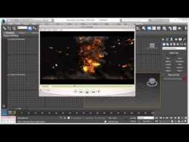

03. Simplify the anatomy

Group the upper-back muscles into simple forms
Starting with the torso, group the upper-back muscles (which surround the shoulder) into simple forms. Where visible, emphasise hip bones, knees and elbows. Finally, emphasise the parts where muscles overlap, as this creates the illusion of more detail and brings the drawing to life.
For advanced anatomy tips, try these articles:
- Perfect your figures with our anatomy masterclass
- Best practice advice for capturing human anatomy

04. Begin the head

Get the head's tilt and rotation right
For quick head sketches, begin with the gesture and outer shape, making sure the tilt and rotation is correct. Next, add the major planes, such as the side of the head and brow. Finally, add in the features and define the neck muscles.

05. Sketch the hands

Start hands off as a simple shape, then refine them
Hands can be complex, so start with either a box or oval shape, depending on how the fingers are arranged. Next, refine the shape, but keep the fingers grouped. To finish, separate the forefinger and thumb, or any finger necessary to make the hand come to life.

06. Sketch the feet

Again, simplify the feet and build up shape
The feet are fairly easily to simplify since the toes are short and clustered together. Start with a triangle shape to capture the gesture, making sure to emphasise the contact point. Next, refine the ankle and shape of the grouped toes. Finally, separate the big toe, or any other toes as needed.

07. Exaggerate overlaps in side view poses

Limbs are great for creating overlaps
In a side view, much of the figure is hidden. To make the drawing work, emphasise and exaggerate overlaps. When available, the limbs are also great tools for creating overlaps at the torso. For more depth, exaggerate the top layers of anatomy, such as the shoulder muscles and hip bones.

08. Use overlaps in foreshortened poses

Emphasise overlaps for foreshortened poses
Similar to a side view, emphasise overlaps for foreshortened poses. If the torso is moving away, emphasise the overlap of the hips and abdomen. If the torso is coming toward you, use the rib cage and anatomy to create overlaps. If visible, the limbs drawn with good cross-sections can also create depth.

09. Focus on contact points in reclining poses
Advertisement

Make reclining poses look natural by emphasising contact points
For reclining and seated poses, you can exaggerate the anatomy that makes contact with the surface. When visible, emphasise the hands making contact by adding more detail at the fingers and wrist.

10. Add tone

Smart toning will bring your figure drawing to life
If the lighting is good, finish your sketch with tone. One way to do this is by blocking in the shadow and filling in the shape with a suitable tone

