Resolution of Experimental Design
We started our discussion with a single replicate of a factorial design. Then we squeezed it into blocks, whether it was replicated or not. Now we are going to construct even more sparse designs. There will be a large number of factors, k, but the total number of observations will be N=2^{k−p}, so we keep the total number of observations relatively small as k gets large.
The goal is to create designs that allow us to screen a large number of factors but without having a very large experiment. In the context where we are screening a large number of factors, we are operating under the assumption that only a few are very important. This is called sparsity of effects. We want an efficient way to screen the large number of factors knowing in advance that there will likely be only two or three factors that will be the most important ones. Hopefully, we can detect those factors even with a relatively small experiment.
We started this chapter by looking at the 2³⁻¹ fractional factorial design. This only has four observations. This is totally unrealistic but served its purpose in illustrating how this design works. ABC was the generator, which is equal to the Identity, (I = ABC or I = -ABC). This defines the generator of the design and from this we can determine which effects are confounded or aliased with which other effects.
Let's use the concept of the generator and construct a design for the 2⁴⁻¹ fractional factorial. This gives us a one half fraction of the 2⁴ design. Again, we want to pick a high order interaction. Let's select ABCD as the generator (I = ABCD) and by hand we can construct the design. I = ABCD implies that D = ABC. First of all, 2⁴⁻¹=2³=8. So, we will have eight observations in our design. Here is a basic 23 design in standard Yates notation defined by the levels of A, B, and C:
trt | A | B | C | D = ABC
(1) | - | - | - | -
a | + | - | - | +
b | - | + | - | +
ab | + | + | - | -
c | - | - | + | +
ac | + | - | + | -
bc | - | + | + | -
abc | + | + | + | +

We can then construct the levels of D by using the relationship where D = ABC. Therefore, in the first row where all the treatments are minus, D = -1*-1*-1 = -1. In the second row, +1, and so forth. As before we write - and + as a shorthand for -1 and +1.
This is a one half fraction of the 2⁴ design. A full 2⁴ design would have 16 factors.
This 2⁴⁻¹design is a Resolution IV design. The resolution of the design is based on the number of the letters in the generator. If the generator is a four letter word, the design is Resolution IV. The number of letters in the generator determines the confounding or aliasing properties in the resulting design.
We can see this best by looking at the expression I = ABCD. We obtain the alias structure by multiplying A×I=A×ABCD=A²BCD which implies A=BCD. If we look at the aliasing that occurs we would see that A is aliased with BCD, and similarly all of the main effects are aliased with a three-way interaction:
B=ACD
C=ABD
D=ABC
Main effects are aliased with three-way interactions. Using the same process, we see that two-way interactions are aliased with other two-way interactions:
AB=CD
AC=BD
AD=BC
In total, we have seven effects, the number of degrees of freedom in this design. The only effects that are estimable from this design are the four main effects assuming the 3-way interactions are zero and the three 2-way interactions that are confounded with other 2-way interactions. All 16 effects are accounted for with these seven contrasts plus the overall mean.
Resolution IV Designs
What you need to know about Resolution IV designs:
- the main effects are aliased with the 3-way interactions. This is just the result of the fact that this is a four letter effect that we are using as the generator.
- the 2-way interactions are aliased with each other. Therefore, we can not determine from this type of design which of the 2-way interactions are important because they are confounded or aliased with each other.
Resolution IV designs are preferred over Resolution III designs. Resolution III designs do not have as good properties because main effects are aliased with two-way interactions. Again, we work from the assumption that the higher order interactions are not as important. We want to keep our main effects clear of other important effects.
The 5 Factor Design
Here we let k=5 and p=1, again, so that we have a one half fraction of a 25 design. Now we have five factors, A, B, C, D and E, each at two levels. What would we use as our generator? Since we are only picking one generator, we should choose the highest order interaction as possible. So we will choose I = ABCDE, the five-way interaction.
Let's use Minitab to set this up. Minitab gives us a choice of a one half or one-fourth fraction. We will select the one-half fraction. It says it is a Resolution V design because it has a five letter generator I = ABCDE or (E = ABCD).
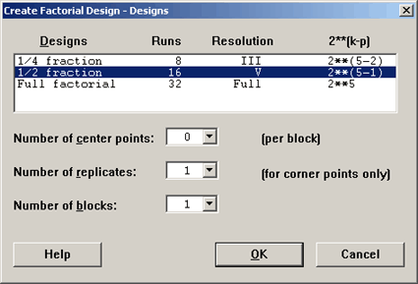
We get a 25−1, so there are 16 observations. Taking a look at the design:
Fractional Factorial Design
Factors: | 5 | Base Design: | 5, 16 | Resolution: | V
Runs: | 16 | Replicates: | 1 | Fraction: | 1/2
Blocks: | 1 | Center pts (total): | 0

Design Generators: E = ABCD
Alias Structure
I + ABCDE
A + BCDE
B + ACDE
C + ABDE
D + ABCE
E + ABCD
AB + CDE
AC + BDE
AD + BCE
AE + BCD
BC + ADE
BD + ACE
BE + ACD
CD + ABE
CE + ABD
DE + ABC
E = ABCD gives us the basis for the resolution of the design.
Let's look at the properties of a Resolution V design. We can see that:
- the main effects are 'clear' of 2-way and 3-way interactions.
- the main effects are only confounded with 4-way interactions or higher, so this gives us really good information, and
- the 2-way interactions are 'clear' of each other but are aliased with 3-way interactions.
The Resolution V designs are everybody's favorite because you can estimate main effects and two-way interactions if you are willing to assume that three-way interactions and higher are not important.
You can go higher, with Resolution VI, VII etc. designs, however, Resolution III is more or less the minimum, and Resolution IV and V are increasing in good properties in terms of being able to estimate the effects.
A One-Fourth Fractional Design, or a (1/2)² Fraction of a 2^{k} design
Let's try to construct a 1/4 fractional design using the previous example where k=4 factors. In this case p=2, therefore we will have to pick 2 generators in order to construct this type of design.
As in the previous example k=4, but now p=2, so this would give us 2⁴⁻²=4 observations. A problem that we can foresee here is that we only have a total of 3 degrees of freedom to estimate. But we have four main effects, so a main effect is going to have to be confounded or aliased with another main effect. Hence, this design is not even a Resolution III. Let's go ahead anyway.
Let's pick ABCD, as we did before, as one generator and ABC as the other. So we would have ABCD × ABC = D as our third generator.
This is not good ... now we have a main effect as a generator which means the main effect would be confounded with the mean .... we can do better than that.
Let's pick ABCD and then AB as a second generator, this would give us ABCD × AB = CD as our third generator. We pick two but we must also include a generalized interaction.
Now the smallest word in our generator set is a two letter word - so this means that this is a Resolution II design. But we found out that a Resolution II designs tell us that the main effects are aliased with each other, ... hence not a good design if we want to learn which main effects are important.
Let's try another example
Let's say we have k=5 and p=2. We have five factors, so again we need to pick two generators. We want to pick the generators so that the generators and their interactions are each as large a word as possible. This is very similar to what we were doing when we were confounding in blocks.
Let's pick the 4-way interaction ABCD, and CDE. Then the generalized interaction is ABCD×CDE=ABE. In this case, in the way we picked them the smallest number of letters is 3 so this is a Resolution III design.
We can construct this design in the same way we had previously. We begin with 2⁵⁻²=2³=8 observations which are constructed from all combinations of A, B, and C, then we'll use our generators to define D and E. Note that I = ABCD tells us that D = ABC, and the other generator I = CDE tells us that E = CD. Now we can define the new columns D = ABC and E = CD. Although D and E weren't a part of the original design, we were able to construct them from the two generators as shown below:
trt | A | B | C | D = ABC | E = CD
(1) | - | - | - | - | +
a | + | - | - | + | -
b | - | + | - | + | -
ab | + | + | - | - | +
c | - | - | + | + | +
ac | + | - | + | - | -
bc | - | + | + | - | -
abc | + | + | + | + | +

Now we have a design with eight observations, 2³, with five factors. Our generator set is: I = ABCD = CDE = ABE. This is a Resolution III design because the smallest word in the generator set has only three letters.
Example: Resolution IV Design
Let's take k=6 and p=2, now we again have to choose two generators with the highest order possible, such that the generalized interaction is also as high as possible. We have factors A, B, C, D, E and F to choose from. What should we choose as generators?
Let's try ABCD and CDEF. The generalized interaction of these two = ABEF. We have strategically chosen two four letter generators whose generalized interaction is also four letters. This is the best that we can do. This results in a 2⁶⁻² design.
In Minitab we can see the available designs for six factors in the table below:
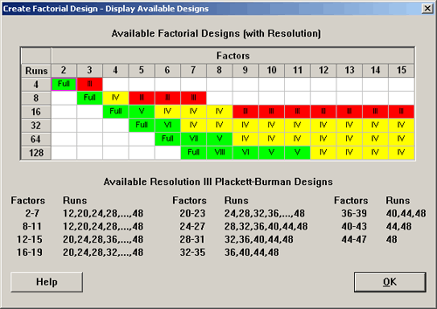
with six factors, a 26−2=24 design, which has 16 observations, is located in the six factor column, the 16 observation row. This tells us that this design is a Resolution IV, (in yellow). We know from this table that this type of design exists, so in Minitab we can specify this design.
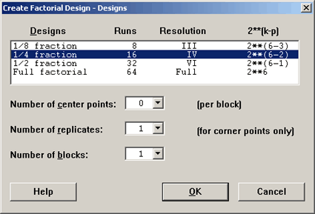
which results in the following output.

Fractional Factorial Design
Factors: | 6 | Base Design: | 6, 16 | Resolution: | IV
Runs: | 16 | Replicates: | 1 | Fraction: | 1/4
Blocks: | 1 | Center pts (total): | 0
Design Generators: E = ABC, F = BCD
Alias Structure
I + ABCE + ADEF + BCDF
A + BCE + DEF + ABCDF
B + ACE + CDF + ABDEF
C + ABE + BDF + ACDEF
D + AEF + BCF + ABCDE
E + ABC + ADF + BCDEF
F + ADE + BCD + ABCEF
AB + CE + ACDF + BDEF
AC + BE + ABDF + CDEF
AD + EF + ABCF + BCDE
AE + BC + DF + ABCDEF
AF + DE + ABCD + BCEF
BD + CF + ABEF + ACDE
BF + CD + ABDE + ACEF
ABD + ACF + BEF + CDE
ABF + ACD + BDE + CEF
In Minitab by default ABCE and BCDF were chosen as the design generators. The design was constructed by starting with the full factorial of factors A, B, C, and D. Minitab then generated E by using the first three columns, A, B and C. Then it could choose F = BCD.
Because the generator set, I=ABCE=ADEF=BCDF, contains only four letter words, this is classified as a Resolution IV design. All the main effects are confounded with 3-way interactions and a 5-way interaction. The 2-way interactions are aliased with each other. Again, this describes the property of the Resolution IV design.

