Case Tool
Name:
Ayesha Arshad
Roll No:
BSEF17E038
Submitted to:
Mr. Abdulgafhar Khan
Submission Date:
01-05-2020
subject:
Comparison of popular case tools
Comparison of popular case tools
- Upper Level case tools:
- Case Complete:
Case compete is a type of analysis tools in upper level tools. These tools help to gather requirements, automatically check for any inconsistency, inaccuracy in the diagrams, data redundancies or erroneous omissions. it is proposed from Serlio Software that allows business analysts and software developers to create and manage Use Cases and Software Requirements. Case Complete provides the ability to edit the textual portion of use cases and requirements in a guided environment and the ability to create various types of diagrams including use case diagrams, wireframes of graphical user interfaces, and flowcharts. The main features for cases are: capture the right amount of detail, from brief to fully dressed, the step editor keeps steps and extensions in sync ,write scenarios as steps or prose, link to external documents or URLs, track open issues and notes, refactor steps into a new use case, capture supplemental fields or add your own custom fields.
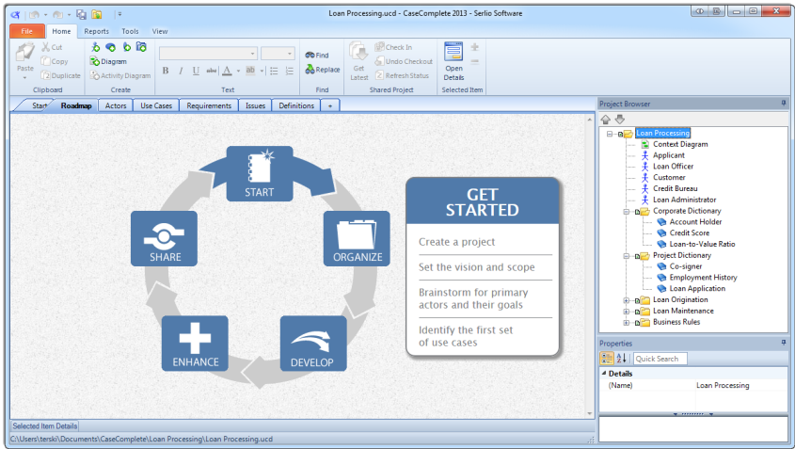

- After Effect:
Adobe After Effects is a digital visual effect, motion graphics, and compositing tool developed by Adobe Systems and used in the post-production process of film making, video games and television production. Among other things, After Effects can be used for keying, tracking, compositing, and animation. It also functions as a very basic non-linear editor, audio editor, and media transcoder. After Effects has extensive plug-in support; a broad range of third-party plug-ins are available. A variety of plug-in styles exist, such as particle systems for realistic effects for rain, snow, fire, etc.
With or without third-party plug-ins, After Effects can render 3D effects. Some of these 3D plug-ins use basic 2D layers from After Effects.
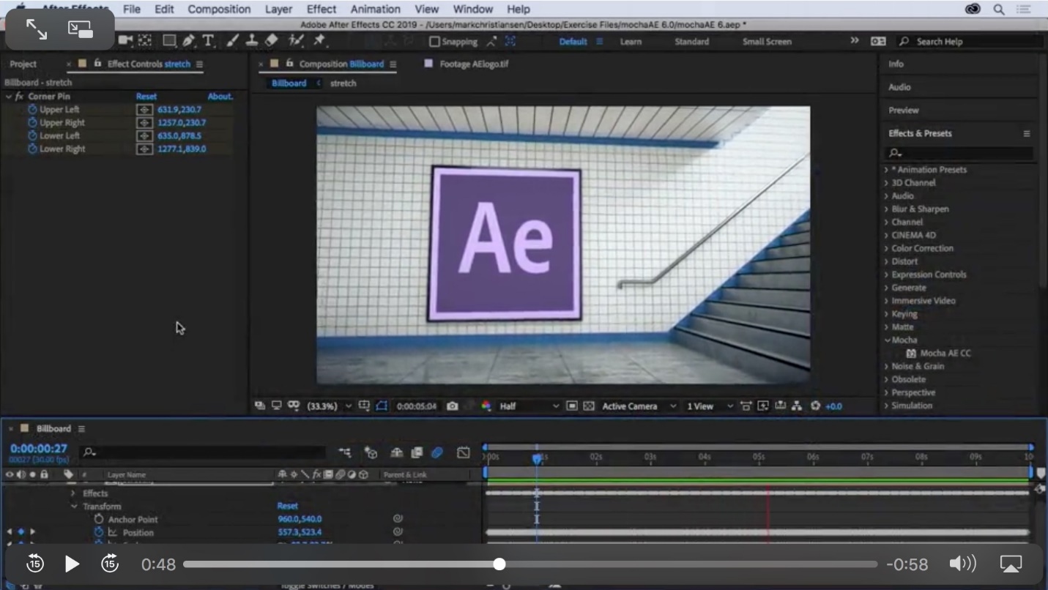

- Integrated case tools:

Computer-Aided Software Engineering (CASE) technologies are tools that provide automated assistance for software development. The goal of introducing CASE tools is the reduction of the time and cost of software development and the enhancement of the quality of systems developed.
- Microsoft visual studio: 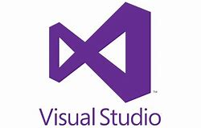
Visual Studio is an Integrated Development Environment (IDE) developed by Microsoft to develop GUI (Graphical User Interface), console, Web applications, web apps, mobile apps, cloud, and web services, etc. With the help of this IDE, you can create managed code as well as native code. It uses the various platforms of Microsoft software development software like Windows store, Microsoft Silverlight, and Windows API, etc. It is not a language-specific IDE as you can use this to write code in C#, C++, VB (Visual Basic), Python, JavaScript, and many more languages. It provides support for 36 different programming languages. It is available for Windows as well as for mac.
There are three editions of Microsoft visual studio;
- Community (community is a free version all others are paid)
- Professional (it is a commercial edition of visual studio)
- Enterprise (It is an integrated, end to end solution for teams of any size with the demanding quality and scale required)
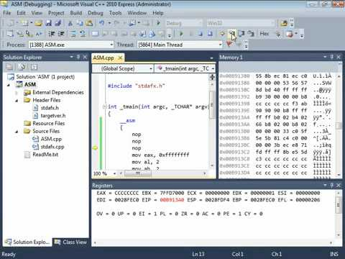
- Tool Box:
The toolbox contains in total 16 different tools. Different types of tools have different purposes, thus rendering it important to understand the best approach and timing in their application to urban development projects. However, it is not always easy to see which tool or approach is the most suitable or useful in each case. Hence, the tools have been further categorized into 1: strategic approaches, 2: planning supporting tools, 3: design/ structural solutions, and 4: assessment tools.
- Strategic approaches and planning supporting tools aim to manage people’s behavior rather than just large infrastructure assets. They are intended to protect the quality or limit the quantity of urban run-off and include planning, education and regulation actions.
- Designed structural solutions are concrete structures that involve construction, moving earth and planting vegetation to reduce or delay stormwater flow and/or remove pollutants. Structural solutions are measures used after the run-off appears.
- Assessment tools include evaluation criteria for stormwater management solutions and a cost benefit analysis (CBA). The evaluation criteria can be applied in the design phase or to evaluate pre-existing structures.

- Lower level case tools:
- Bugzilla:
Bugzilla is a bug- or issue-tracking system. Bug-tracking systems allow individual or group of developers effectively to keep track of outstanding problems with their product. Bugzilla was originally written by Terry Weissman in a programming language called TCL, to replace a rudimentary bug-tracking database used internally by Netscape Communications. Most commercial defect-tracking software vendors at the time charged enormous licensing fees, and Bugzilla quickly became a favorite of the open-source crowd (with its genesis in the open-source browser project, Mozilla).
Advantages of Bugzilla:
- Powerful searching.
- User-configurable email notifications of bug changes.
- Inter-bug dependency tracking and graphing available.
- Excellent attachment management.
- Integrated, product-based, granular security schema.
- Fully security-audited, and runs under Perl's taint mode.
- Completely customizable and localizable web user interface.
- Extensive configurability of software.
- Smooth upgrade pathway between versions.

- Framer:
Framer is one of the most popular prototyping tools. It’s based on the premise that with the code it is possible to prototype anything, resulting in novel and beautiful designs. It provides a seamless workflow, further complemented by device previewing, version control and easy sharing. In case you do not understand, Framer has a very well-structured documentation. Also, there are plenty of how-to videos and courses on Udemy and O’Reilly about the UX prototyping tool. It offers a first-hand view of how flexible and powerful code can be.
Like other tools, Framer supports Sketch, Photoshop projects, and will also preserve your design’s layers. In addition to this, Framer’s Mac App is well designed and provides live previews as you write code, which is encouraging for those who are writing code for the first time. You can also import graphics directly from Sketch, Photoshop or Figma.

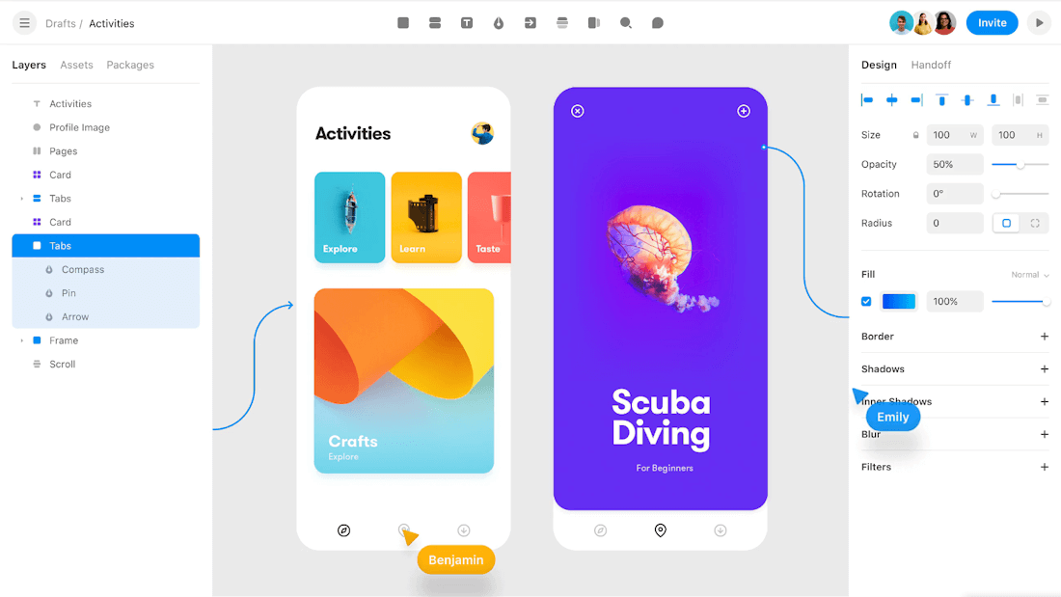

------------------------------------The End-------------------------------------

