CHAPTER 3
DATA COLLECTION

INTRODUCTION:

www.clsa-elcv.ca
Data collection is the process of gathering and measuring information on variables of interest, in an established systematic fashion that enables one to answer stated research questions, test hypotheses, and evaluate outcomes.

VARIOUS TYPES OF DATACOLLECTION:

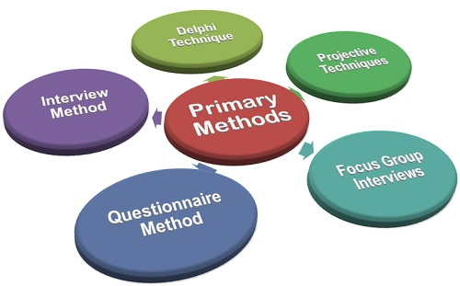

Data Collection Techniques
Information you gather can come from a range of sources. Likewise, there are a variety of techniques to use when gathering primary data. Listed below are some of the most common data collection techniques.

Overview Of Different Data Collection Techniques
Technique | Key Facts | Example
Interviews | - Interviews can be conducted in person or over the telephone  - Interviews can be done formally (structured), semi-structured, or informally  - Questions should be focused, clear, and encourage open-ended responses  - Interviews are mainly qualitative in nature | One-on-one conversation with parent of at-risk youth who can help you understand the issue  Click here to see a sample key informant interview.
Questionnaires and Surveys | - Responses can be analyzed with quantitative methods by assigning numerical values to Likert-type scales  - Results are generally easier (than qualitative techniques) to analyze  - Pretest/Posttest can be compared and analyzed | Results of a satisfaction survey or opinion survey  Click here to see an example of a survey created using the CYFERnetSEARCH Interactive Survey Builder feature.  Click here to see a sample survey on middle school youth risk behavior.
Observations | - Allows for the study of the dynamics of a situation, frequency counts of target behaviors, or other behaviors as indicated by needs of the evaluation  - Good source for providing additional information about a particular group, can use video to provide documentation  - Can produce qualitative (e.g., narrative data) and quantitative data (e.g., frequency counts, mean length of interactions, and instructional time) | Site visits to an after-school program to document the interaction between youth and staff within the program
Focus Groups | - A facilitated group interview with individuals that have something in common  - Gathers information about combined perspectives and opinions  - Responses are often coded into categories and analyzed thematically | A group of parents of teenagers in an after-school program are invited to informally discuss programs that might benefit and help their children succeed
Ethnographies, Oral History, and Case Studies | - Involves studying a single phenomenon  - Examines people in their natural settings  - Uses a combination of techniques such as observation, interviews, and surveys  - Ethnography is a more holistic approach to evaluation  - Researcher can become a confounding variable | Shadowing a family while recording extensive field notes to study the experience and issues associated with youth who have a parent or guardian that has been deployed  Click here for an example of an oral history.  Click here for an additional example of an oral history.
Documents and Records | - Consists of examining existing data in the form of databases, meeting minutes, reports, attendance logs, financial records, newsletters, etc.  - This can be an inexpensive way to gather information but may be an incomplete data source | To understand the primary reasons students miss school, records on student absences are collected and analyzed  Click here for an example of a searchable database of aggregate data on youth risk behavior.

IMPORTANCE:

Regardless of the field of study or preference for defining data (quantitative or qualitative), accurate data collection is essential to maintaining the integrity of research. Both the selection of appropriate data collection instruments (existing, modified, or newly developed) and clearly delineated instructions for their correct use reduce the likelihood of errorsoccurring.
A formal data collection process is necessary as it ensures that the data gathered are both defined and accurate and that subsequent decisions based on arguments embodied in the findings are valid.^{[3]} The process provides both a baseline from which to measure and in certain cases an indication of what to improve.

