Respiration
Respiration refers to the series of complex oxidation reduction reactions; where by living cells obtain energy through the breakdown of organic material like glucose.
Kind of Respiration
The most common fuel used by the cell to provide energy by cellular respiration is glucose. The way glucose is metabolized depends upon the availability of O₂. Prior to entering a mitochondrion the glucose molecule is split to form two molecules of pyruvic acid. This reaction is called glycolysis and occurs in cytosol and is represented by the equation:

C₆ H₁₂ O₆ 2C₃ H₄ O₃ + Energy
The next step is cellular respiration varies depending on the type of the cell and prevailing conditions. Cell processes pyruvic acid in three major ways alcoholic acid fermentation, lactic fermentation and aerobic respiration. The first two reactions occur in the absence of O₂ and referred to as anaerobic (without O₂).
- Aerobic Respiration
It is the kind of respiration that proceeds in the presence of abundant gaseous oxygen. The O₂ is reduced (to water) and usually glucose is oxidized to carbon dioxide water and releasing energy.
C₆ H₁₂ O₆ CO₂ + H2O + Energy
When glucose is oxidized some of its energy is in the form of heat which is wasted as for the cell concerned. The water is usually retained in the cell, while carbon dioxide diffuses out of the cell or is used in photosynthesis.
- Anaerobic Respiration
It is the kind of respiration that proceeds in the absence of gaseous oxygen. It is also called fermentation. Many micro organisms are capable of carrying on incomplete oxidized-reduction without O₂. Only small amount of energy (about 5%) is produced in anaerobic respiration while remaining (95%) energy is retained by the end products which are usually alcohol (e.g. ethanol) or organic acid (e.g. lactic acid) and carbon dioxide.
The overall fermentation reaction is:
2(C₃H₄O₃) 2(C₃H₆O₃)
Pyruvic Acid Lactic Acid

2(C₃H₄O₃) 2(C₂H₅OH) + CO₂
Pyruvic Acid Ethyl Alcohol
Need for Respiration
The living organisms respire to obtain energy. For this purpose various organic substances oxidized like glucose which store energy.
Process of Respiration
During the respiration the glucose molecule is breakdown energy is released used to change ADP to ATP. The breakdown of glucose to make ATP is called cellular respiration, since it take place in the cell. Cellular respiration involves three stages:
- Glycolysis
- Kreb cycle
- Electron transport chain

- Glycolysis
Glycolysis is the breakdown of glucose molecule up to the formation of pyruvic acid. Glycolysis can take place both in the presence and absence of oxygen. In both the end product is pyruvic acid. The breakdown of glucose takes place in a series of steps, each catalyzed by a specific enzyme. All these enzymes are found dissolved in the cytosol. In addition to the enzymes ATP and co-enzyme NAD (Nicotinamide adenine dinucleotide) are also essential.
The first step in glycolysis is the transfer of a phosphate group from ATP to glucose. As a result a molecule of glucose 6-phosphate is formed. An enzyme catalyzed the conversion of glucose 6-phosphate to its isomer, Fructose 6-phosphate. At this stage another ATP molecule transfer a second phosphate group. The product is Fructose 1,6 bisphosphate. The next step in glocolysis is the enzymatic splitting of Fructose 1,6 bisphosphate into two fragments. Each of these molecule is contain 3-carbon atoms, one is called 3-phospho-glyceraldehyde (3 PGAL) or glyceraldehydes 3-phosphate (G3P). While the other is dihydroxy acetone phosphate. These two molecules are isomers and infact are readily interconvertable by yet another enzyme of glycolysis.
The next step in glycolysis is crucial to this process. Two electron or two hydrogen atoms are removed from the molecule of 3-phospho-glyceraldehyde (PGAL) and transfer to a molecule of NAD being reduced. During this reaction, a second phosphate group is donated to the molecule from inorganic phosphate present in the cell. The resulting molecule is called 1,3 bisphosphoglycerate (BPG).
The oxidation of PGAL is an energy yielding process. Thus a high energy phosphate bond is created in this molecule. At the very next step of glycolysis this phosphate group is transferred to a molecule of ADP converting it into ATP. The end product of this reaction is 3-PG. In the next step 3-PG is converted to 2-PG. From 2-PG a molecule of water is removed and the product is phosphoenol pyruvate (PEP). PEP then gives up its high energy phosphate to convert a second molecule of ADP to ATP. The product is pyruvic acid (C₃ H₄ O₃).

Glucose

Fructose 6-phosphate

Fructose I, 6-bisphosphate

Dihydroxyacetone Phosphate (DAP) Glyceraldehyde 3-Phosphate (G3P)

1, 3-bisphosphaoglycerate (BPG) 1, 3-bisphosphaoglycerate (BPG)

3-Phosphoglycerate (3PG) 3-Phosphoglycerate (3PG)

2-Phosphoglycerate (2PG) 2-Phosphoglycerate (2PG)

Phosphoenol Pyruvate (PEP) Phosphoenol Pyruvate (PEP)

Pyruvate Pyruvate

- Kreb`s Cycle
The Kreb cycle take place in the tiny structures within the cell called mitochondria, it only occurs in only aerobic respiration. In Kreb cycle the high energy pyruvic acid pass through a series of reaction that generate more ATPs. At last pyruvic acid broke down completely to the simple end product CO₂ and H₂O.
- Formation of acetyl COA
In the presence of oxygen, 3-C pyruvic acid and molecule oxidized with NAD molecule again accepting to hydrogen and lose one carbon in the form of carbon dioxide. The remaining 2-C acetic acid unities with coenzyme A (COA) to form acetyle-COA.
- Formation of citric acid
The acetyl COA enters the Kreb`s cycle. The acetyl group separates from its COA enzyme, combines with of 4-C molecule called oxaloacetic acid and form 6-C citric acid.
- Cyclic changes in citric acid
The citric acid undergoes a series of cyclic changes and form first α-ketoglutaric acid, then succinic acid, malic acid, finally oxaloacetic acid which is recycled to pick up another acetyl group from the next acetyl COA.

Pyruvic Acid

Acetyl-COA

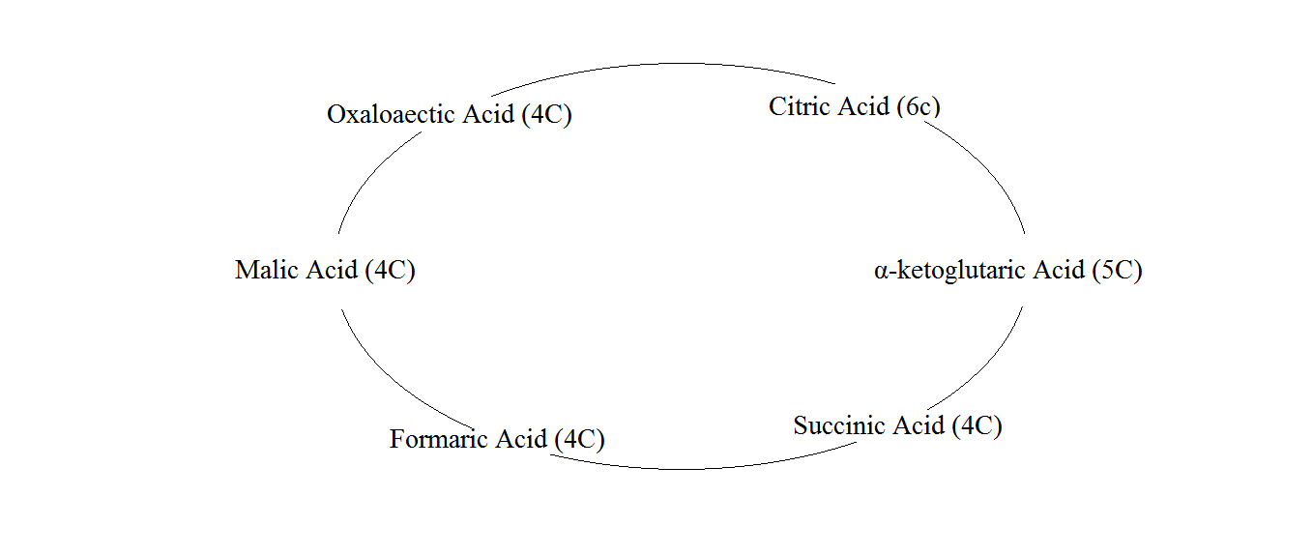

- Electron Transport Chain
In the Kreb cycle NADH and H⁺ are produced from NAD⁺, NADH then transfer the H⁺ atom to the respiratory chain (also called electron transport system) where electrons are transported in a series of molecular oxygen.
It is the last stage of the aerobic respiration which takes place in mitochondria. In this process electron accepted by the NAD and FAD molecules pass through a series of electron carries such as cytochrome “a”, “b”, “c” and “a₃”. These cytochromes can be alternately reduced and oxidized with an energy loss or gain accompanied is at low energy level then the proceeding one. In this process energy of the electron is freed in a step wise manner and then used to from ATP.
At the end of electron transport chain the electrons are accepted by oxygen and combine proton to produced water. Each time one pair of electron pass from NAD_{(red)} to oxygen, three molecules of ATP are formed from ADP and phosphate.

^{2e} Cyto b ^{2e} Cyto c ^{2e} Cyto a ^{2e} Cyto a₃ ^{2e}

