Crime
Crime is the breach of rules or laws for which some governing authority can ultimately prescribe a conviction.

LEARNING OBJECTIVES
Relate cultural change to changing definitions of crime

KEY TAKEAWAYS

Key Points
- While every crime violates the law, not every violation of the law counts as a crime. Breaches of contract and of other civil law may rank as “offenses” or as “infractions. ” Torts are wrongs against private parties that can give rise to a civil cause of action.
- In sociology, a normative definition views crime as deviant behavior that violates prevailing norms, or cultural standards prescribing how humans ought to behave normally.
- Criminalization is a procedure deployed by society as a pre-emptive, harm-reduction device, using the threat of punishment as a deterrent to anyone proposing to engage in the behavior causing harm.
- As cultures change and the political environment shifts, societies may criminalize or decriminalize certain behaviors, which directly affects crime statistics and social perception of crime and deviant behavior..
- Criminology is the scientific study of the nature, extent, causes, and control of criminal behavior in both the individual and in society.
- As cultures change and the political environment shifts, societies may criminalize or decriminalize certain behaviors, which directly affects the crime statistics.
- Crime statistics refers to the collection and calculation on data on crime in a given location.
- Criminology is the scientific study of the nature, extent, causes, and control of criminal behavior in both the individual and in society.

Key Terms
- criminalization: The act of making a previously legal activity illegal.
- Deviant Behavior: The violation of prevailing norms or cultural standards prescribing how humans ought to behave.
- Breaches of Contract: An action in which a binding agreement or bargained-for exchange is not honored by one or more of the parties to the contract by non-performance or interference with the other party’s performance.
Crime is the breach of rules or laws for which some governing authority can ultimately prescribe a conviction. Crimes may also result in cautions, rehabilitation, or be unenforced. Individual human societies may each define crime and crimes differently, in different localities, and at different time stages of the crime. While every crime violates the law, not every violation of the law counts as a crime; for example, breaches of contract and of other civil law may rank as “offenses” or as “infractions. ” Modern societies generally regard crimes as offenses against the public or the state, as distinguished from torts, which are wrongs against private parties that can give rise to a civil cause of action.
In sociology, a normative definition views crime as deviant behavior that violates prevailing norms, or cultural standards prescribing how humans ought to behave normally. This approach considers the complex realities surrounding the concept of crime and seeks to understand how changing social, political, psychological, and economic conditions may affect changing definitions of crime and the form of the legal, law-enforcement, and penal responses made by society.
These structural realities remain fluid and often contentious. For example: as cultures change and the political environment shifts, societies may criminalize or decriminalize certain behaviors, which directly affects the statistical crime rates, influences the allocation of resources for the enforcement of laws, and re-influences the general public opinion. One can view criminalization as a procedure deployed by society as a pre-emptive, harm-reduction device, using the threat of punishment as a deterrent to anyone proposing to engage in the behavior causing harm. The state becomes involved because governing entities can become convinced that the costs of not criminalizing, through allowing the harms to continue unabated, outweigh the costs of criminalizing it, restricting individual liberty, for example, to minimize harm to others.
Similarly, changes in the collection and calculation of data on crime may affect the public perceptions of the extent of any given “crime problem.” All such adjustments to crime statistics, together with the experience of people in their everyday lives, shape attitudes on the extent to which the state should use law or social engineering to enforce or encourage any particular social norm. Criminology is the scientific study of the nature, extent, causes, and control of criminal behavior in both the individual and in society.

Types of Crime
Criminal law, as opposed to civil law, is the body of law that relates to crime and that defines conduct that is not allowed.

LEARNING OBJECTIVES
Identify and differentiate between different types of crimes

KEY TAKEAWAYS

Key Points
- In criminal law, an offense against the person usually refers to a crime which is committed by direct physical harm or force being applied to another person.
- A violent crime is a crime in which the offender uses or threatens to use violent force upon the victim.
- Sex crimes are forms of human sexual behavior that are crimes. Someone who commits one is said to be a sex offender.
- Property crime involves the taking of money or property, and does not involve force or threat of force against a victim.
- Hate crimes occur when a perpetrator targets a victim because of his or her perceived membership in a certain social group, usually defined by racial group, religion, sexual orientation, disability, class, ethnicity, nationality, age, sex, or gender identity.
- Organized crime is the transnational, national, or local grouping of highly centralized enterprises run by criminals for the purpose of engaging in illegal activity.
- Virtual crime refers to a virtual criminal act that takes place in a massively multiplayer online game (MMOG).
- Organized crime are transnational, national, or local groupings of highly centralized enterprises run by criminals for the purpose of engaging in illegal activity

Key Terms
- Property Crime: Property crime is a category of crime that includes, among other crimes, burglary, larceny, theft, motor vehicle theft, arson, shoplifting, and vandalism. Property crime only involves the taking of money or property, and does not involve force or threat of force against a victim.
- organized crime: A set of large criminal organizations (often competing for markets and territories) that deal in illegal goods and services.
- Violent Crime: A violent crime, or crime of violence, is a crime in which the offender uses or threatens to use violent force upon the victim. This entails both crimes in which the violent act is the objective, such as murder, as well as crimes in which violence is the means to an end, (including criminal ends) such as robbery. Violent crimes include crimes committed with and without weapons.
Criminal law, as opposed to civil law, is the body of law that relates to crime. It could be defined as the body of rules that defines conduct that is not allowed because it is held to threaten, harm or endanger the safety and welfare of people, and that sets out the punishment to be imposed on people who do not obey these laws. Criminal law is distinctive for the uniquely serious potential consequences, or sanctions, for failure to abide by its rules.

Offenses Against the Person
In criminal law, an offense against the person usually refers to a crime which is committed by direct physical harm or force being applied to another person. They are usually analyzed by division into fatal offenses, sexual offenses, or non-fatal non-sexual offenses. Although most sexual offenses will also be offenses against the person, sexual crimes are usually categorized separately. Similarly, although many homicides also involve an offense against the person, they are usually categorized under the more serious category.

Violent Crimes
A violent crime is a crime in which the offender uses or threatens to use violent force upon the victim. Violent crimes include crimes committed with and without weapons. They also include both crimes in which the violent act is the objective, such as murder, as well as crimes in which violence is the means to an end, such as robbery. The United States Department of Justice Bureau of Justice Statistics (BJS) counts five categories of crime as violent crimes: murder, forcible rape, robbery, aggravated assault, and simple assault. According to BJS figures, the rate of violent crime victimization in the United States declined by more than two thirds between the years 1994 and 2009. On September 30, 2009, 7.9% of sentenced prisoners in federal prisons were in for violent crimes; 52.4% of sentenced prisoners in state prisons at yearend 2008 were in for violent crimes; and 21.6% of convicted inmates in jails in 2002 were in for violent crimes.

Sex Crimes
Sex crimes are forms of human sexual behavior that are crimes. Someone who commits one is said to be a sex offender. Some sex crimes are crimes of violence that involve sex. Others are violations of social taboos, such as incest, sodomy, indecent exposure or exhibitionism. There is much variation among cultures as to what is considered a crime or not, and in what ways or to what extent crimes are punished.

Property Crimes
Property crime is a category of crime that includes burglary, larceny, theft, motor vehicle theft, arson, shoplifting, and vandalism. Property crime only involves the taking of money or property, and does not involve force or threat of force against a victim. Although robbery involves taking property, it is classified as a violent crime, since force, or threat of force, on an individual is involved, in contrast to burglary which typically takes place in an unoccupied dwelling or other unoccupied building. In 2005, only 18% of reported cases of larceny/theft were cleared in the United States.

Hate Crimes
Hate crimes occur when a perpetrator targets a victim because of his or her perceived membership in a certain social group, usually defined by racial group, religion, sexual orientation, disability, class, ethnicity, nationality, age, sex, or gender identity.

Virtual Crimes
Virtual crime refers to a virtual criminal act that takes place in a massively multiplayer online game (MMOG). The huge time and effort invested into such games can lead online “crime” to spill over into real world crime, and even blur the distinctions between the two. Some countries have introduced special police investigation units to cover such “virtual crimes. ” South Korea is one such country, and looked into 22,000 cases in the first six months of 2003.

Organized Crime
Organized crime is the transnational, national, or local grouping of highly centralized enterprises run by criminals for the purpose of engaging in illegal activity, most commonly for monetary profit. Sometimes criminal organizations force people to do business with them, as when a gang extorts money from shopkeepers for “protection. ” An organized gang or criminal set can also be referred to as a mob.
Handcuffs: Handcuffs pictured on the ground outside the courthouse
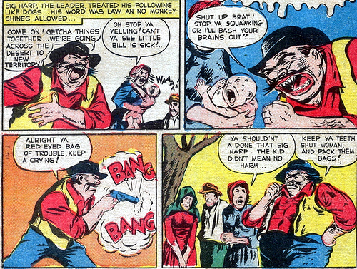
Crime Does Not Pay: Shooting a Baby: “Crime Does Not Pay” was one of the primary targets of Dr. Fredrick Wertham’s crusade against comics books, and were often cited in his writing and during the Senate inquiries into the comic book industries corruption of the innocent. The general theme of “Crime Does Not Pay” is exactly what the title of the series suggests – criminals rise to power, but come to an often violent end. This panel is from issue 22 of the series.
Crime Dog: Anti-crime campaign using the crime dog cartoon

Crime Statistics
Crime statistics attempt to provide statistical measures of the crime in societies.

LEARNING OBJECTIVES
Evaluate U.S. crime statistics and the various ways law enforcement officials gather them

KEY TAKEAWAYS

Key Points
- The two major methods for collecting crime data are law enforcement reports and victimization statistical surveys.
- Statistics from law enforcement organizations are normally readily available and are generally reliable in terms of identifying what crime is being dealt with by law enforcement organizations.
- Victimization surveys are useful because they show some types of crime are well reported to law enforcement officials, while other types of crime are under reported.
- The U.S. has two major data collection programs: the Uniform Crime Reports from the FBI, and the National Crime Victimization Survey from the Bureau of Justice Statistics.

Key Terms
- Victimization Statistical Surveys: The survey results are used for the purposes of building a crime index.
- crime: a specific act committed in violation of the law
- Uniform Crime Reports: The UCR Program is a nationwide, cooperative statistical effort of over 18,000 city, university and college, county, state, tribal, federal, and other law enforcement agencies who voluntarily report data on crimes brought to their attention.
- Crime Statistics: The collection and/or calculation of data on crime.
Crime statistics attempt to provide statistical measures of the crime in societies. Several methods for measuring crime exist, including household surveys, hospital or insurance records, and compilations by police and similar law enforcement agencies. Typically official crime statistics refer to the latter, but some offences are likely to go unreported to the police. Public surveys are sometimes conducted to estimate the amount of crime not reported to police. Given that crime is usually secretive by nature, measurements of it are likely to be inaccurate. The two major methods for collecting crime data are law enforcement reports and victimization statistical surveys.
Crime statistics are gathered and reported by many countries and are of interest to several international organizations, including Interpol and the United Nations. Law enforcement agencies in some countries, such as the Federal Bureau of Investigation (FBI) in the United States and the Home Office in England & Wales, publish crime indices, which are compilations of statistics for various types of crime. The U.S. has two major data collection programs: the Uniform Crime Reports from the FBI and the National Crime Victimization Survey from the Bureau of Justice Statistics. The National Crime Victimization Survey has its use, but it also limited in its scope. For example, it only collects data on the following crimes – assault, burglary, larceny, motor vehicle theft, rape and robbery. The U.S. has no comprehensive infrastructure to monitor crime trends and report the information to related parties, such as law enforcement.
Crime can generally be broken down into 2 categories – violent and nonviolent. Violent crimes involve harm to another person, generally done intentionally. The seriousness of the crime is determined by the amount of harm; use of a weapon also increases the seriousness. By contrast, nonviolent crime involves harm to property and/or possessions. Fraud or certain drug charges are examples of nonviolent crimes.
Because of the difficulties in quantifying how much crime actually occurs, researchers generally take two approaches to gathering statistics about crime. First, they often use statistics from law enforcement organizations. These statistics are normally readily available and are generally reliable in terms of identifying what crime is being dealt with by law enforcement organizations, as they are gathered by law enforcement officers in the course of their duties, and are often extracted directly from law enforcement computer systems. However, these statistics often tend to reflect the productivity and law enforcement activities of the officers concerned, and may bear little relationship to the actual amount of crime. One way in which victimization surveys are useful is that they show some types of crime are well reported to law enforcement officials, while other types of crime are under reported. These surveys also give insights as to why crime is reported, or not. This allows degrees of confidence to be assigned to various crime statistics.
Research using a series of victim surveys in 18 countries of the European Union in 2005, funded by the European Commission, has reported that the level of crime in Europe has fallen back to the levels of 1990, and notes that levels of common crime have shown declining trends in the U.S., Canada, Australia and other industrialized countries as well. The European researchers say a general consensus identifies demographic change as the leading cause for this international trend. Although homicide and robbery rates rose in the U.S. in the 1980s, by the end of the century they had declined by 40%.
FBI Seal: The U.S. has two major data collection programs: the Uniform Crime Reports from the FBI, and the National Crime Victimization Survey from the Bureau of Justice Statistics.

Juvenile Crime
Juvenile delinquency is participation in illegal behaviors by minors. A juvenile delinquent is typically under the age of 18.

LEARNING OBJECTIVES
Describe the factors that influence the development of delinquency in youth and the ways the legal system deals with this delinquency

KEY TAKEAWAYS

Key Points
- A juvenile delinquent is a person who is typically under the age of 18 and commits an act that otherwise would have been charged as a crime had they been an adult.
- There are three categories of juvenile delinquency: delinquency, criminal behavior, and status offenses. Delinquency includes crimes committed by minors which are dealt with by the juvenile courts and justice system.
- Criminal behavior are crimes dealt with by the criminal justice system.
- Status offenses are offenses which are only classified as such because the person is a minor; they also dealt with by the juvenile courts.
- Poverty is a large predictor of low parental monitoring, harsh parenting, and association with deviant peer groups, all of which are in turn associated with juvenile offending. Family factors also have an influence on delinquency.
- Delinquency prevention is the broad term for all efforts aimed at preventing youth from becoming involved in criminal or other antisocial activity.
- Poverty is a large predictor of low parental monitoring, harsh parenting, and association with deviant peer groups, all of which are in turn associated with juvenile offending.
- Family factors which may have an influence on offending include: the level of parental supervision, the way parents discipline a child, particularly harsh punishment, parental conflict or separation, criminal parents or siblings, parental abuse or neglect, and the quality of the parent-child relationship
- Delinquency prevention is the broad term for all efforts aimed at preventing youth from becoming involved in criminal, or other antisocial, activity.

Key Terms
- Delinquency Prevention: Delinquency prevention is the broad term for all efforts aimed at preventing youth from becoming involved in criminal or other antisocial activity. Prevention services may include activities such as substance abuse education and treatment, family counseling, youth mentoring, parenting education, educational support, and youth sheltering. Increasing availability and use of family planning services, including education and contraceptives helps to reduce unintended pregnancy and unwanted births, which are risk factors for delinquency.
- Status Offenses: A status offense is an action that is prohibited only to a certain class of people, and most often applied to offenses only committed by minors.
- juvenile delinquency: Participation in illegal behaviour by minors.

Juvenile Delinquency
Juvenile delinquency is participation in illegal behavior by minors. Most legal systems prescribe specific procedures for dealing with juveniles, such as juvenile detention centers and courts. A juvenile delinquent is a person who is typically under the age of 18 and commits an act that would have otherwise been charged as a crime if the minor was an adult. Depending on the type and severity of the offense committed, it is possible for persons under 18 to be charged and tried as adults.
Juvenile delinquency can be separated into three categories:
- Delinquency: crimes committed by minors that are dealt with by the juvenile courts and justice system;
- Criminal behavior: crimes dealt with by the criminal justice system;
- Status offenses: offenses which are only classified as such because one is a minor, such as truancy, also dealt with by the juvenile courts.
Young men disproportionately commit juvenile delinquency. Feminist theorists and others have examined why this is the case. One suggestion is that ideas of masculinity may make young men more likely to offend. Being tough, powerful, aggressive, daring, and competitive becomes a way for young men to assert and express their masculinity. Alternatively, young men may actually be naturally more aggressive, daring, and prone to risk-taking. According to a study led by Florida State University criminologist Kevin M. Beaver, adolescent males who possess a certain type of variation in a specific gene are more likely to flock to delinquent peers. The study, which appeared in the September 2008 issue of the Journal of Genetic Psychology, is the first to establish a statistically significant association between an affinity for antisocial peer groups and a particular variation (called the 10-repeat allele) of the dopamine transporter gene (DAT1).
There is also a significant skew in the racial statistics for juvenile offenders. When considering these statistics, which state that Black and Latino teens are more likely to commit juvenile offenses, it is important to keep the following in mind: poverty is a large predictor of low parental monitoring, harsh parenting, and association with deviant peer groups, all of which are in turn associated with juvenile offending. The majority of adolescents who live in poverty are racial minorities.
Family factors that may have an influence on offending include:
- the level of parental supervision,
- the way parents discipline a child,
- particularly harsh punishment,
- parental conflict or separation,
- criminal parents or siblings,
- parental abuse or neglect,
- the quality of the parent-child relationship.
Delinquency prevention is the broad term for all efforts aimed at preventing youth from becoming involved in criminal or other antisocial activity. Because the development of delinquency in youth is influenced by numerous factors, prevention efforts need to be comprehensive in scope. Prevention services may include activities like substance abuse education and treatment, family counseling, youth mentoring, parenting education, educational support, and youth sheltering. Increasing availability and use of family planning services, including education and contraceptives, helps to reduce unintended pregnancy and unwanted births—which are risk factors for delinquency.
Juvenile Delinquency: Juvenile delinquency refers to antisocial or illegal behavior by children or adolescents, for dealing with juveniles, such as juvenile detention centers. There are a multitude of different theories on the causes of crime, most if not all of which can be applied to the causes of youth crime.
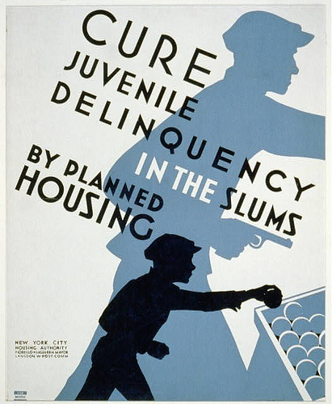
Cure Juvenile Delinquency by Planned Housing: Poster promoting planned housing as a method to deter juvenile delinquency, showing silhouettes of a child stealing a piece of fruit and as an older minor involved in armed robbery.

Violent Crime
A violent crime is a crime in which the offender uses or threatens to use violent force upon the victim.

LEARNING OBJECTIVES
Explain how the United States Department of Justice classifies violent crime

KEY TAKEAWAYS

Key Points
- The United States Department of Justice Bureau of Justice Statistics (BJS) counts five categories of crime as violent crimes: murder, forcible rape, robbery, aggravated assault, and simple assault.
- Violent crimes include crimes committed with and without weapons. With the exception of rape, males are the primary victims of all forms of violent crime.
- The rate of violent crime victimization in the United States declined by more than two thirds between the years 1994 and 2009.

Key Terms
- Simple Assault: In law, assault is a crime which involves causing a victim to apprehend violence.
- aggravated assault: Assault with disregard for the value of life, or with a deadly weapon.
- Forcible Rape: A type of sexual assault usually involving sexual intercourse, which is initiated by one or more persons against another person without that person’s consent.
A violent crime is a crime in which the offender uses or threatens to use violent force upon the victim. This entails both crimes in which the violent act is the objective, such as murder, as well as crimes in which violence is the means to an end, such as robbery. Violent crimes include crimes committed with and without weapons. With the exception of rape (which accounts for 6% of all reported violent crimes), males are the primary victims of all forms of violent crime.
The comparison of violent crime statistics between countries is usually problematic due to the way different countries classify crime. Valid comparisons require that similar offences between jurisdictions be compared. Often this is not possible because crime statistics aggregate equivalent offences in such different ways that make it difficult or impossible to obtain a valid comparison.
The United States Department of Justice Bureau of Justice Statistics (BJS) counts five categories of crime as violent crimes: murder, forcible rape, robbery, aggravated assault, and simple assault. According to the BJS, the rate of violent crime victimization in the United States declined by more than two thirds between the years 1994 and 2009. Nearly 8% of sentenced prisoners in federal prisons on September 30, 2009 were in for violent crimes; 52.4% of sentenced prisoners in state prisons at yearend in 2008 were in for violent crimes; and 21.6% of convicted inmates in jails in 2002 were in for violent crimes.
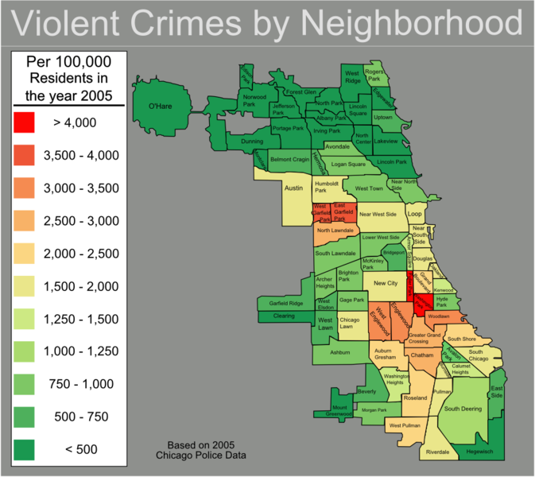
Chicago Violent Crime Map: Map of violent crimes in 2005 in Chicago community areas per 100,000 residents.
Since the 13th century AD, evidence shows large long-term declines in the rate of murder, from one hundred people to one person per 100,000 between 1200 and 2000 AD. By contrast, there is a widespread belief that violent crime is on the rise, due largely to a mass media, which disproportionately reports violent crime.

Property Crime
Property crime only involves the taking of money or property, and does not involve force or threat of force against a victim.

LEARNING OBJECTIVES
Discuss different types of property crime

KEY TAKEAWAYS

Key Points
- Burglary of residences, retail establishments, and other commercial facilities involves breaking and entering, and then stealing property.
- Theft of cash is most common, followed by vehicle parts, clothing, and tools.
- Shoplifting is a specific type of theft, in which products are taken from retail shops without paying.
- Motor vehicle theft is a common form of property crime, often perpetrated by youths for joyriding.
- The percentage of U.S. households that experienced property crime dropped from 21% in 1994 to 12% in 2004. Moreover, from 1996 to 2005, the number of arrests in the United States for property crime has declined by 22.1%.

Key Terms
- burglary: The crime of unlawfully breaking into a vehicle, house, store, or other enclosure with the intent to steal.
- shoplifting: It is the theft of goods from a retail establishment. It is one of the most common property crimes dealt with by police and courts.
- Property Crime: Property crime is a category of crime that includes, among other crimes, burglary, larceny, theft, motor vehicle theft, arson, shoplifting, and vandalism. Property crime only involves the taking of money or property, and does not involve force or threat of force against a victim.
Property crime is a category of crime that includes larceny, theft, motor vehicle theft, arson, shoplifting, vandalism, and burglary. Property crime only involves the taking of money or property, and does not involve force or threat of force against a victim. Property crimes are high-volume crimes, with cash, electronics, power tools, cameras, and jewelry often targeted.
Car Window Burglary: This is a photographic example of a car that has been burglarized.
Burglary of residences, retail establishments, and other commercial facilities involves breaking and entering, and then stealing property. Attempted forcible entry into a property is also classified as burglary in the FBI’s Uniform Crime Reports (UCR) definition. In the United States, burglary rates are highest in August and lowest in February, with weather, length-of-day, and other factors having an effect on rates. Fall and winter are peak seasons for burglary in Denmark. Most residential burglaries occur on weekdays, between 10 to 11 a.m. and 1 to 3 p.m., when homes are the least likely to be occupied. Some crime prevention programs, such as Neighborhood Watch, have shown little effectiveness in reducing burglary and other crime.

Property Crimes in the United States: Property crime rates in the United States, 1986-2005
Theft of cash is most common, followed by vehicle parts, clothing, and tools. In 2005, only 18% of reported cases of larceny and theft were cleared in the United States. Shoplifting is a specific type of theft, in which products are taken from retail shops without paying. Items popular with shoplifters include cigarettes, alcoholic beverages, and fashionable clothing. Motor vehicle theft is a common form of property crime, often perpetrated by youths for joyriding. The FBI includes attempted motor vehicle thefts in its Uniform Crime Report (UCR) definition. Crime prevention and target-hardening measures, such as car alarms and ignition locks, have been effective deterrents against motor vehicle theft, as have been practices such as etching VINs on car parts. Only 13% of reported motor vehicle theft cases were cleared in the United States in 2005.
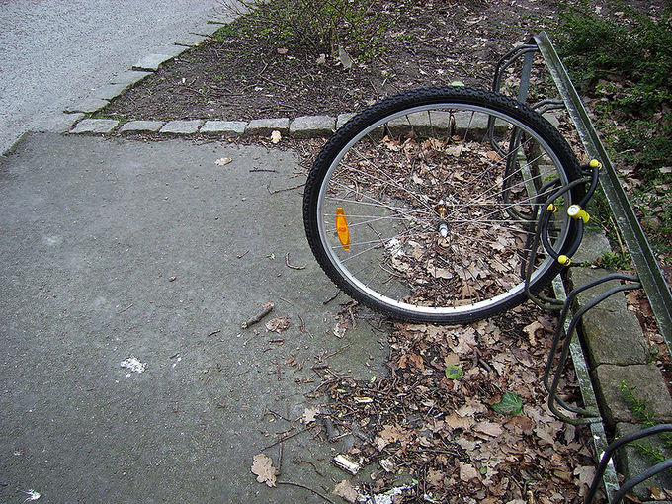
Theft: An example of theft: someone took everything except for the front wheel.
Statistics for violent crimes are accessible and available to the public. In 2004, 12% of households in the United States experienced some type of property crime, with theft being the most common. The percentage of U.S. households that experienced property crime dropped from 21% in 1994 to 12% in 2004. Moreover, from 1996 to 2005, the number of arrests in the United States for property crime has declined by 22.1%. The decline is far larger for offenders under age 18, with a decrease of 43.8% in property crime arrests, compared to a 9.5% decrease for those 18 and over. The peak age for property crime arrests in the United States is 16, compared to 18 for violent crime arrests.

White-Collar Crime
White-collar crime is a financially motivated, nonviolent crime committed for illegal monetary gain.

LEARNING OBJECTIVES
Describe Edwin Sutherland’s work on white collar crime

KEY TAKEAWAYS

Key Points
- White-collar crime, is similar to corporate crime, because white-collar employees are more likely to commit fraud, bribery, ponzi schemes, insider trading, embezzlement, cyber crime, copyright infringement, money laundering, identity theft, and forgery.
- The term “white-collar crime” was coined in 1939 by the sociologist Edwin Sutherland, who defined it as a “crime committed by a person of respectability and high social status in the course of his occupation”.
- White collar crimes stand in contrast to blue-collar street crimes include arson, burglary, theft, assault, rape, and vandalism.
- Corporate crime deals with the company as a whole. Their difference is that white-collar crime benefits the individual involved, and corporate crime benefits the company or the corporation.
- Insider trading, the trading of stock by someone with access to publicly unavailable information, is a type of fraud.

Key Terms
- insider trading: Buying or selling securities of a publicly-held company by a person who has privileged access to information concerning the company’s financial condition or plans.
- copyright infringement: The unauthorized use of copyrighted material in a manner that violates one of the copyright owner’s exclusive rights, such as the right to reproduce or perform the copyrighted work, or to make derivative works that build upon it.
White-collar crime is a financially motivated, nonviolent crime committed for illegal monetary gain. White-collar crime, is similar to corporate crime, because white-collar employees are more likely to commit fraud, bribery, ponzi schemes, insider trading, embezzlement, cyber crime, copyright infringement, money laundering, identity theft, and forgery.
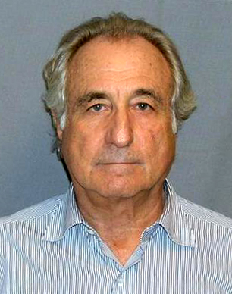
Ponzi scheme: In March 2009, the American financier Bernard Madoff pleaded guilty to 11 federal felonies and admitted to turning his wealth management business into a massive Ponzi scheme that defrauded thousands of investors of billions of dollars.
The term “white-collar crime” was coined in 1939 by Edwin Sutherland, who defined it as a “crime committed by a person of respectability and high social status in the course of his occupation” in a speech entitled “The White Collar Criminal” delivered to the American Sociological Society. Much of Sutherland’s work was to separate and define the differences in blue-collar street crimes such as arson, burglary, theft, assault, rape, and vandalism, which are often blamed on psychological, associational, and structural factors. Instead, white-collar criminals are opportunists, who learn to take advantage of their circumstances to accumulate financial gain. They are educated, intelligent, affluent, and confident individuals whose jobs involve unmonitored access to large sums of money.
Corporate crime deals with the company as a whole. The relationship that white-collar crime has with corporate crime is that they are similar because they both are involved within the business world. Their difference is that white-collar crime benefits the individual involved, and corporate crime benefits the company or the corporation. Insider trading, the trading of stock by someone with access to publicly unavailable information, is a type of fraud. One well-known insider trading case in the United States is the ImClone stock trading case. In December 2001, top-level executives sold their shares in ImClone Systems, a pharmaceutical company that manufactured an anti-cancer drug. The U.S. Securities and Exchange Commission investigated numerous top-level executives, as well as Martha Stewart, a friend of ImClone’s former chief executive who had also sold her shares at the same time. The SEC reached a settlement in 2005.
One common misconception about corporate crime is that its effects are mainly financial. For example, pharmaceutical companies may make false claims regarding their drugs and factories may illegally dump toxic waste. Indeed, the Hooker Chemical Company dumped toxic waste into the abandoned Love Canal in Niagara Falls and sold the land without disclosing the dumping. It was sold in the 1950’s to a private housing developer, whose residents began experiencing major health problems such as miscarriages and birth defects in the 1970’s.

Organized Crime
Organized crime refers to transnational, national, or local groupings of highly centralized enterprises run by criminals.

LEARNING OBJECTIVES
Compare and contrast patron-client networks and bureaucratic organized crime groups

KEY TAKEAWAYS

Key Points
- An organized gang or criminal set can also be referred to as a mob.
- Patron-client networks are defined by the fluid interactions they produce.
- The best known patron-client networks are the Sicilian and Italian American Cosa Nostra, most commonly known as the Sicilian Mafia.
- Bureaucratic and corporate organized crime groups are defined by the general rigidity of their internal structures.
- The term “street gang” is commonly used interchangeably with “youth gang”, referring to neighborhood or street-based youth groups that meet “gang” criteria.

Key Terms
- Corporate Organized Crime: Crimes committed either by a corporation (i.e., a business entity having a separate legal personality from the natural persons that manage its activities), or by individuals acting on behalf of a corporation or other business entity (see vicarious liability and corporate liability).
- Patron-Client Networks: Patron-client networks are defined by the fluid interactions they produce. Organized crime groups operate as smaller units within the overall network, and as such tend towards valuing significant others, familiarity of social and economic environments, or tradition.
- corporate crime: illegal acts committed by a business or corporation (a business entity having a separate legal personality from the natural persons that manage its activities) or by individuals acting on behalf of a business
- Street Gang: A group of recurrently associating individuals with identifiable leadership and internal organization, identifying with or claiming control over territory in the community, and engaging either individually or collectively in violent or other forms of illegal behavior.
Organized crime refers to transnational, national, or local groupings of highly centralized enterprises run by criminals for the purpose of engaging in illegal activity, most commonly for monetary profit. Sometimes criminal organizations force people to do business with them, as when a gang extorts money from shopkeepers for “protection.” Gangs may become “disciplined” enough to be considered “organized.” An organized gang or criminal set can also be referred to as a mob.
Patron-client networks are defined by the fluid interactions they produce. Organized crime groups operate as smaller units within the overall network, and as such tend towards valuing significant others, familiarity of social and economic environments, or tradition.
Some notable patron-client networks involve the Russian and Albanian mafias, the Japanese Yakuza, the Irish mob, and the Sicilian and Italian American Cosa Nostra (i.e. the Sicilian mafia).
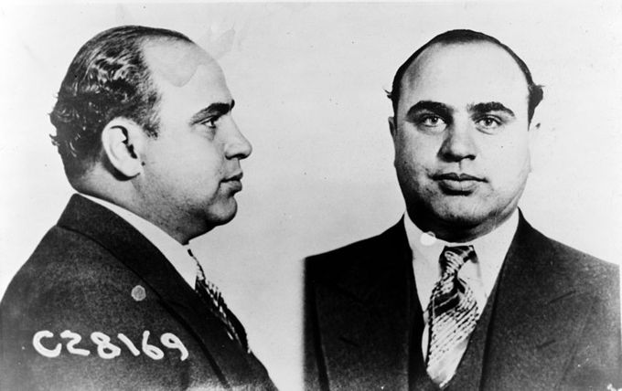
Organized Crime: Al Capone is a name often associated with organized crime.
Bureaucratic and corporate organized crime groups are defined by the general rigidity of their internal structures. Focusing more on how the operations works, succeeds, sustains itself or avoids retribution, they are generally typified by: a complex authority structure; an extensive division of labor between classes and the organization; responsibilities carried out in an impersonal manner; and top-down communication and rule enforcement mechanisms.
A distinctive gang culture underpins many, but not all, organized groups; this may develop through recruiting strategies, social learning processes in the corrective system experienced by youth, family, or peer involvement in crime, and the coercive actions of criminal authority figures. The term “street gang” is commonly used interchangeably with “youth gang”, referring to neighborhood or street-based youth groups that meet “gang” criteria.
Organized crime groups often victimize businesses through the use of extortion or theft and fraud activities like hijacking cargo trucks, robbing goods, committing bankruptcy fraud, insurance fraud, or stock fraud. Organized crime groups seek out corrupt public officials in executive, law enforcement, and judicial roles so that their activities can avoid, or at least receive early warnings about, investigation and prosecution.

Reactions to Deviance

Police
The police are a constituted body of persons empowered by the state to enforce the law, protect property, and limit civil disorder.

LEARNING OBJECTIVES
Explain the relationship between the police and the state, differentiating between preventive police and police detectives

KEY TAKEAWAYS

Key Points
- Preventive police wear uniforms and perform functions that require an immediate recognition of an officer’s legal authority, such as traffic control, stopping and detaining motorists, and active crime response and prevention.
- Police detectives are responsible for investigations and detective work. “Plainclothes” officers dress in attire consistent with that worn by the general public for purposes of blending in.
- Specialized units exist within many law enforcement organizations for dealing with particular types of crime, such as traffic law enforcement and crash investigation, homicide, or fraud.
- In United States constitutional law, police power is the capacity of the states to regulate behavior and enforce order within their territory for the betterment of the general welfare, morals, health, and safety of their inhabitants.
- Transnational policing pertains to all those forms for policing that, in some sense, cross national borders.
- INTERPOL is an organization facilitating international police cooperation.

Key Terms
- INTERPOL: Commonly used name for the International Criminal Police Organization, an international organization facilitating police cooperation.
- Specialized Units: Subdivisions within many law enforcement organizations for dealing with particular types of crime, such as traffic law enforcement and crash investigation, homicide, or fraud.
The police are a constituted body of persons empowered by the state to enforce the law, protect property, and limit civil disorder. Their powers include the legitimized use of force. The term police is most commonly associated with police services of a state that are authorized to exercise the police power of that state within a defined legal or territorial area of responsibility. Police forces are often defined as being separate from military or other organizations involved in the defense of the state against foreign aggressors; however, gendarmerie and military police are military units charged with civil policing.

Preventive Police and Police Detectives
In most Western police forces, perhaps the most significant division is between preventive police and detectives. Terminology varies from country to country. Preventive police designates the police that patrol and respond to emergencies and other incidents, as opposed to detective services. As the name “uniformed” suggests, preventive police wear uniforms and perform functions that require an immediate recognition of an officer’s legal authority, such as traffic control, stopping and detaining motorists, and more active crime response and prevention. On the other hand, police detectives are responsible for investigations and detective work. Detectives, in contrast to uniform police, typically wear ‘business attire’ in bureaucratic and investigative functions where a uniformed presence would be either a distraction or intimidating. “Plainclothes” officers dress in attire consistent with that worn by the general public for purposes of blending in, but a need to establish police authority still exists.
Specialized units exist within many law enforcement organizations for dealing with particular types of crime, such as traffic law enforcement and crash investigation, homicide, or fraud. In counter insurgency type campaigns, select and specially trained units of police armed and equipped as light infantry have been designated as police field forces. They perform paramilitary type patrols and ambushes whilst retaining their police powers in areas that were highly dangerous.

Police in the United States
In United States constitutional law, police power is defined as the capacity of the states to regulate behavior and enforce order within their territory for the betterment of the general welfare, morals, health, and safety of their inhabitants. Police power can be exercised in the form of making laws and compelling obedience to those laws through legal sanctions, physical means, or other forms of coercion and inducements. In the United States, concern over such issues has increasingly weighed upon law enforcement agencies, courts, and legislatures at every level of government since the 1960s. Incidents such as the 1965 Watts Riots and the videotaped 1991 beating of Rodney King by Los Angeles Police officers and the riot following their acquittal have been suggested by some as evidence that U.S. police are dangerously lacking in appropriate controls.
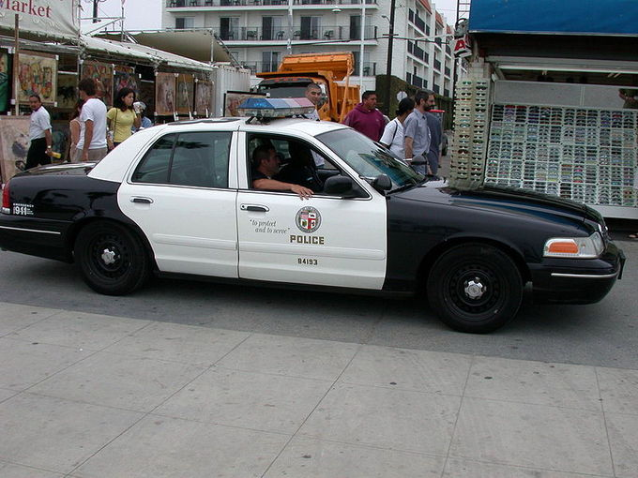
Police: The Los Angeles Police Department (LAPD) has been heavily fictionalized in numerous movies and television shows throughout its history. The department has also been involved in a number of controversies, mostly involving racial animosity and police corruption.

Transnational Police
The term transnational policing entered into use in the mid-1990s as a description for forms of policing that transcended the boundaries of the sovereign nation state. Transnational policing pertains to all those forms for policing that, in some sense, transgress national borders. This includes a variety of practices, but cross-border police cooperation, criminal intelligence exchange between police agencies working in different nation-states, and police development-aid to weak, failed, or failing states are the three types that have received the most scholarly attention. The International Criminal Police Organization (ICPO), widely known as INTERPOL, is an organization facilitating international police cooperation. It was established as the International Criminal Police Commission (ICPC) in 1923 and adopted its telegraphic address as its common name in 1956.

Courts
A court is a form of tribunal with the authority to adjudicate legal disputes between parties, and carry out the administration of justice.

LEARNING OBJECTIVES
Describe the three levels of the court system

KEY TAKEAWAYS

Key Points
- In both common law and civil law legal systems, courts are the central means for dispute resolution. Generally, all persons have an ability to bring their claims before a court.
- Jurisdiction refers to the court’s practical authority to decide cases. There are two types of jurisdiction. The first is personal jurisdiction: the court’s jurisdiction over the parties to a lawsuit.
- Secondly, subject -matter jurisdiction is the authority of a court to hear cases of a particular type or cases relating to a specific subject matter.
- There are three levels of courts. Trial courts initially hear cases and review evidence and testimony to determine the facts of the case. Appellate courts hear an appeal of a trial court or other lower tribunal. The Supreme Court primarily reviews the decisions of the intermediate courts.
- A tribunal in the general sense is any person or institution with the authority to judge, adjudicate, or determine claims or disputes.
- The Supreme Court primarily reviews the decisions of the intermediate courts.
- A tribunal in the general sense is any person or institution with the authority to judge, adjudicate, or determine claims or disputes.

Key Terms
- civil law: The body of law dealing with the private relations between members of a community; it contrasts with criminal law, military law, and ecclesiastical law.
- common law: Law developed by judges through decisions of courts and similar tribunals (also called case law), as distinguished from legislative statutes or regulations promulgated by the executive branch.
- tribunal: Any person or institution with the authority to judge, adjudicate, or determine claims or disputes.

What is a Court?
A court is a form of tribunal, often a governmental institution, with the authority to adjudicate legal disputes between parties, and carry out the administration of justice in civil, criminal, and administrative matters in accordance with the rule of law. In both common law and civil law legal systems, courts are the central means for dispute resolution, and it is generally understood that all persons have an ability to bring their claims before a court. Similarly, the rights of those accused of a crime include the right to present a defense before a court.
The system of courts that interpret and apply the law are collectively known as the judiciary. The place where a court sits is known as a venue. The room where court proceedings occur is known as a courtroom, and the building is known as a courthouse; court facilities range from simple and very small facilities in rural communities, to large buildings in cities. A judge is a person who presides over court proceedings, either alone or as part of a panel of judges.

Jurisdiction
The practical authority given to the court is known as its jurisdiction, or the court’s power to decide certain kinds of questions or petitions. A plaintiff is the term used in some jurisdictions for the party who initiates a civil lawsuit before a court. A defendant is any party required to answer a plaintiff’s complaint in a civil lawsuit, or any party that has been formally charged or accused of violating a criminal statute. A legal remedy is the means with which a court of law (usually in the exercise of civil law jurisdiction) enforces a right, imposes a penalty, or makes some other court order to impose its will.
In the United States, the legal authority of a court to take action is based on personal jurisdiction, subject-matter jurisdiction, and venue over the parties to the litigation. Personal jurisdiction refers to a court’s jurisdiction over the parties to a lawsuit. Personal jurisdiction means the power of the court to decide a dispute, as against a particular person. Subject-matter jurisdiction is the authority of a court to hear cases of a particular type, or cases relating to a specific subject matter. For instance, bankruptcy court only has the authority to hear bankruptcy cases.

Types of Courts
In most jurisdictions, the court system is divided into at least three levels: the trial court, which initially hears cases and reviews evidence and testimony to determine the facts of the case; at least one intermediate appellate court that hears an appeal of a trial court or other lower tribunal; and a supreme court, which primarily reviews the decisions of the intermediate courts. A tribunal, in the general sense, is any person or institution with the authority to judge, adjudicate on, or determine claims or disputes, whether or not it is called a tribunal in its title. For example, the Nuremberg Trials were a series of military tribunals, held by the victorious allied forces of World War II, most notable for the prosecution of prominent members of the political, military, and economic leadership of the defeated Nazi Germany.
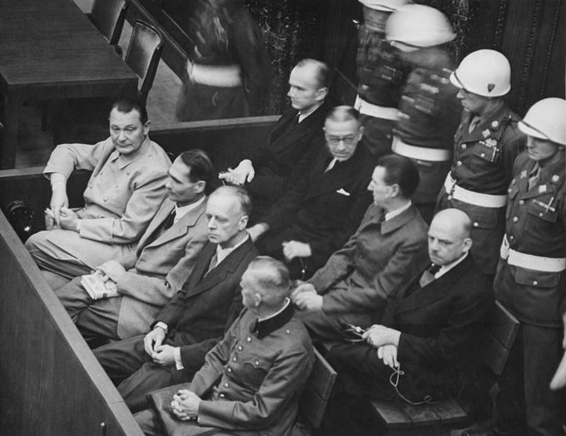
Nuremberg Tribunal: At the Nuremberg Tribunals, the main target of the prosecution was Hermann Göring (at the left edge on the first row of benches), considered to be the most important surviving official in the Third Reich after Hitler’s death.
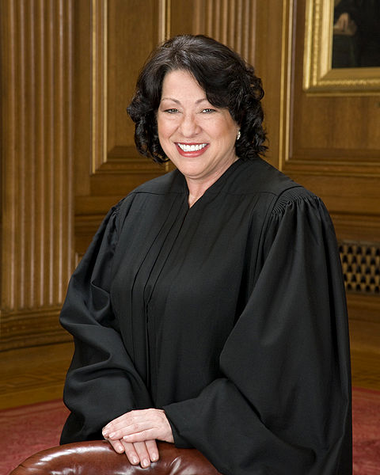
U.S. Supreme Court Justice Sonia Sotomayor: United States Supreme Court Associate Justice Sonia Sotomayor
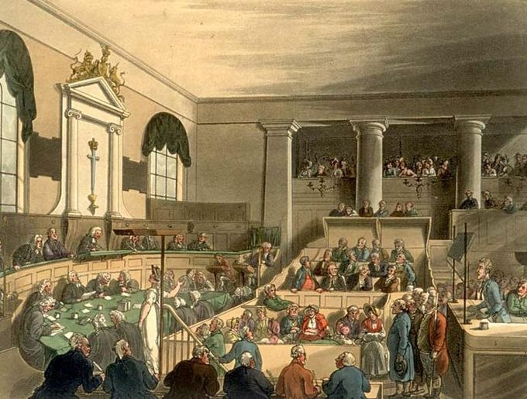
The Old Bailey: A trial at the Old Bailey in London, as drawn by Thomas Rowlandson and Augustus Pugin, for Ackermann’s Microcosm of London (1808-11).

Prisons
A prison is a place in which people are physically confined and, usually, deprived of a range of personal freedoms.

LEARNING OBJECTIVES
Analyze recent developments in the rate of incarceration in the U.S.

KEY TAKEAWAYS

Key Points
- Imprisonment is a legal penalty that may be imposed by the state for the commission of a crime.
- The modern prison system was born in London, influenced by the utilitarianism of Jeremy Bentham.
- In the U.S., jails are county or city administrated institutions, which house both inmates awaiting trial on the local level, and convicted misdemeanants serving a term of one year or less.
- Supermax prisons provide long term, segregated housing for inmates classified as the highest security risks in the prison system.
- The United States has the highest documented incarceration rate in the world (743 per 100,000 population ).

Key Terms
- Supermax Prisons: Prisons that provide long term, segregated housing for inmates classified as the highest security risks in the prison system.
- Jeremy Bentham: An English founder of utilitarianism who was influential in designing the first modern prisons.
A prison is a place in which people are physically confined and, usually, deprived of a range of personal freedoms. Imprisonment is a legal penalty that may be imposed by the state for the commission of a crime. For most of history, imprisoning has not been a punishment in itself, but rather a way to confine criminals until corporal or capital punishment was administered. Only in the 19th century, beginning in Britain, did prisons as they are known today become commonplace. The modern prison system was born in London, influenced by the utilitarianism of Jeremy Bentham.

Prison Design
Prisons are normally surrounded by fencing, walls, earthworks, geographical features, or other barriers to prevent escape. Multiple barriers, concertina wire, electrified fencing, secured and defensible main gates, armed guard towers, lighting, motion sensors, dogs and roving patrols may all also be present, depending on the level of security.
Prison: Barbed wire is a feature of prisons.
Modern prison designs have sought to increasingly restrict and control the movement of prisoners throughout the facility, while permitting a maximal degree of direct monitoring by a smaller prison staff. As compared to traditional large landing-cellblock designs, which were inherited from the 19th century and which permitted only intermittent observation of prisoners, many newer prisons are designed in a decentralized “popular” layout.

Incarceration in the United States
In the United States, “jail” and “prison” refer to separate levels of incarceration; generally speaking, jails are county or city administrated institutions which house both inmates awaiting trial on the local level, and convicted misdemeanants serving a term of one year or less, while prisons are state or federal facilities housing convicted felons serving a term of more than one year. Supermax prisons provide long term, segregated housing for inmates classified as the highest security risks in the prison system—the “worst of the worst” criminals, and those who pose a threat to national and international security.
The United States has the highest documented incarceration rate in the world (743 per 100,000 population). Incarceration rate in the U.S. for federal and state prisons in 2007 was the highest in history of the country. It was 5.5 times greater than the sharp peak that occurred during the Great Depression at 137 per 100,000 in 1939. According to the U.S. Bureau of Justice Statistics (BJS), 2,266,800 adults were incarcerated in U.S. count jails and federal and state prisons at yearend 2010; this represents about 0.7% of adults in the U.S. resident population. Additionally, 4,933,667 adults at yearend 2009 were on probation or on parole. In total, 7,225,800 adults were under correctional supervision (probation, parole, jail, or prison) in 2009, representing about 3.1% of adults in the U.S. resident population.
According to the U.S. Bureau of Justice Statistics (BJS), non-Hispanic blacks accounted for 39.4% of the total prison and jail population in 2009. According to the 2010 census of the U.S. Census Bureau, blacks (including Hispanic blacks) comprised 13.6% of the US population. Hispanics (of all races) were 20.6% of the total jail and prison population in 2009. Hispanics comprised 16.3% of the U.S. population according to the 2010 U.S. census.

The Death Penalty
Capital punishment is a legal process whereby a person is put to death by the state as a punishment for a crime.

LEARNING OBJECTIVES
Evaluate arguments for and against the death penalty

KEY TAKEAWAYS

Key Points
- Crimes that can result in a death penalty are known as capital crimes or capital offences.
- Supporters of the death penalty argue that the death penalty is morally justified when applied to murder cases, especially cases with aggravating elements, such as multiple homicide, child murder, torture murder and mass killing including terrorism or genocide.
- Capital punishment is often opposed on the grounds that innocent people will inevitably be executed.
- Abolitionists believe capital punishment is the worst violation of human rights.

Key Terms
- insubordination: The quality of being insubordinate; disobedience to lawful authority.
- capital punishment: Punishment by death.
- capital crime: A crime that is punishable by death.

What Is Capital Punishment?
Capital punishment is a legal process whereby a person is put to death by the state as a punishment for a crime. Crimes that can result in a death penalty are known as “capital crimes” or “capital offenses. ” Capital punishment has in the past been practiced by most societies. Currently, only 58 nations actively practice it, and 97 countries have abolished it. Although many nations have abolished capital punishment, over 60% of the world’s population live in countries where executions take place–the People’s Republic of China, India, the United States, and Indonesia–the four most-populous countries in the world, that continue to apply the death penalty.
Execution of criminals and political opponents has been used by nearly all societies–both to punish crime and to suppress political dissent. In most places that practice capital punishment, it is reserved for murder, espionage, treason, or as part of military justice. In some countries sexual crimes, such as rape, adultery, incest, and sodomy, carry the death penalty, as do religious crimes, such as apostasy in Islamic nations. In many countries that use the death penalty, drug trafficking is also a capital offense. In China, human trafficking and serious cases of corruption are punished by the death penalty. In militaries around the world courts, martial have imposed death sentences for offenses, such as cowardice, desertion, insubordination, and mutiny.

Arguments For and Against
Supporters of the death penalty argue that the death penalty is morally justified when applied in murder, especially with aggravating elements, such as multiple homicide, child murder, torture murder, and mass killing including terrorism or genocide. Some even argue that not applying the death penalty in latter cases are patently unjust. Supporters of the death penalty, especially those who do not believe in the deterrent effect of the death penalty, say the threat of the death penalty could be used to urge capital defendants to plead guilty, testify against accomplices, or disclose the location of the victim’s body.
Capital punishment is often opposed on the grounds that innocent people will inevitably be executed. Between 1973 and 2005, 123 people in 25 states were released from death row when new evidence of their innocence emerged. Abolitionists believe capital punishment is the worst violation of human rights, because the right to life is the most important, and judicial execution violates it without necessity and inflicts to the condemned to a psychological torture. In addition, opponents of the death penalty use the argument that executing a criminal costs more than life imprisonment does. Many states have found it cheaper to sentence criminals to life in prison than to go through the time-consuming and bureaucratic process of executing a convicted criminal.
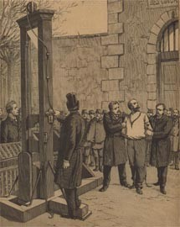
Capital Punishment: Anarchist Auguste Vaillant guillotined in France in 1894.

Systems of Stratification

Stratification
Global stratification refers to the hierarchical arrangement of individuals and groups in societies around the world.

LEARNING OBJECTIVES
Analyze the three dominant theories that attempt to explain global stratification

KEY TAKEAWAYS

Key Points
- Society is stratified into social classes based on individuals’ socioeconomic status, gender, and race.
- Stratification results in inequality when resources, opportunities, and privileges are distributed based on individuals’ positions in the social hierarchy.
- Stratification and inequality can be analyzed as micro-, meso-, and macro-level phenomena, as they are produced in small group interactions, through organizations and institutions, and through global economic structures.
- There are three dominant theories that consider why inequality exists on a global scale. First, some sociologists use a theory of development and modernization to argue that poor nations remain poor because they hold onto traditional attitudes and beliefs, technologies and institutions.
- Second, dependency theory blames colonialism and neocolonialism (continuing economic dependence on former colonial countries) for global stratification.
- Lastly, world systems theory suggests that all countries are divided into a three-tier hierarchy based on their relationship to the global economy, and that a country’s position in this hierarchy determines its own economic development.

Key Terms
- Global Stratification: The hierarchical arrangement of individuals and groups in societies around the world.
- socioeconomic status: One’s social position as determined by income, wealth, occupational prestige, and educational attainment.
- inequality: An unfair, not equal, state.
Global stratification refers to the hierarchical arrangement of individuals and groups in societies around the world. Sociologists speak of stratification in terms of socioeconomic status (SES). Socioeconomic status is a measure of a person’s position in a class structure. For example, a person may be designated as “lower class” or “upper class” based on their SES. A person’s SES is usually determined by their income, occupational prestige, wealth, and educational attainment, though other variables are sometimes considered.
Inequality occurs when a person’s position in the social hierarchy is tied to different access to resources. Inequality largely depends on differences in wealth. For example, a homeowner will have access to consistent shelter, while a person who cannot afford to own a home may have substandard shelter or be homeless. Because of their different levels of wealth, they have different access to shelter. Likewise, a wealthy person may receive higher quality medical care than a poor person, have greater access to nutritional foods, and be able to attend higher caliber schools. Material resources are not distributed equally to people of all economic statuses.
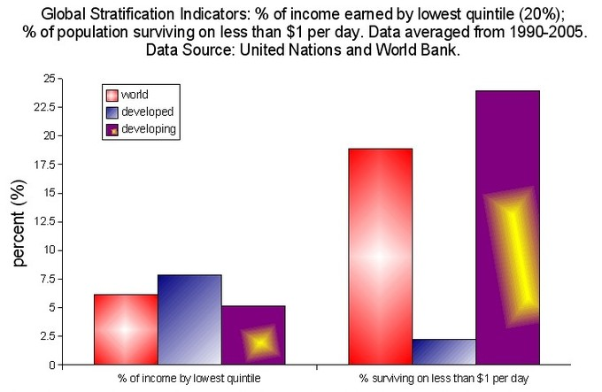
Global Stratification Indicators – Inequality and Income: Globally, the poorest 20% of the population, or lowest tier of the stratified economic order, makes a disproportionately small percentage of global income and lives off of a meager amount.
While stratification is most commonly associated with socioeconomic status, society is also stratified by statuses such as race and gender. Together with SES, race and gender shape the unequal distribution of resources, opportunities, and privileges among individuals. For example, within a given social class, women are less likely to receive job promotions than men. Similarly, within American cities with heavily racially segregated neighborhoods, racial minorities are less likely to have access to high quality schools than white people.

Perspectives on Stratification
Stratification is generally analyzed from three different perspectives: micro-level, meso-level, and macro-level.
Micro-level analysis focuses on how prestige and personal influence create inequality through face-to-face and small group interactions. For example, the more physically attractive a person is, the more likely they are to achieve status in small groups. This effect happens on a small-scale and is difficult to analyze as a uniform, widespread occurrence. Thus, stratification based on levels of physical attractiveness is analyzed as a micro-level process.
Meso-level analysis of stratification focuses on how connections to organizations and institutions produce inequality. For example, parents, teachers, and friends convey expectations about one’s class position that teach different skills and values based on status. These educational disparities occur in the small setting of a classroom, but are consistent across a wide range of schools. Thus, they are analyzed as meso-level phenomena that reinforce systems of inequality.
Macro-level analysis of stratification considers the role of international economic systems in shaping individuals’ resources and opportunities. For example, the small African nation of Cape Verde is significantly indebted to European nations and the U.S., and the majority of the nation’s industry is controlled by foreign investors. As the nation’s economy has ceded control of once public services, such as electricity, its citizen have lost jobs and the price of electricity has increased. Thus, the nation’s position in the world economy has resulted in poverty for many of its citizens. A global structure, or a macro-level phenomenon, produces unequal distribution of resources for people living in various nations.

Theories of Macro-Level Inequality
There are three dominant theories that sociologists use to consider why inequality exists on a global scale. First, some sociologists use a theory of development and modernization to argue that poor nations remain poor because they hold onto traditional attitudes and beliefs, technologies and institutions. According to this theory, in the modern world, the rise of capitalism brought modern attitudes, modern technologies, and modern institutions which helped countries progress and have a higher standard of living. Modernists believe economic growth is the key to reducing poverty in poor countries.
Second, dependency theory blames colonialism and neocolonialism (continuing economic dependence on former colonial countries) for global stratification. Countries have developed at an uneven rate because wealthy countries have exploited poor countries in the past and today through foreign debt and transnational corporations (TNCs). According to dependency theory, the key to reversing inequality is to relieve former colonies of their debts so that they can benefit from their own industry and resources.
Lastly, world systems theory suggests that all countries are divided into a three-tier hierarchy based on their relationship to the global economy, and that a country’s position in this hierarchy determines its own economic development. In this model nations are divided into core, semiperipheral, and peripheral countries. Core nations (e.g. the United States, France, Germany, and Japan) are dominant capitalist countries characterized by high levels of industrialization and urbanization. Semiperipheral countries (e.g. South Korea, Taiwan, Mexico, Brazil, India, Nigeria, and South Africa) are less developed than core nations but are more developed than peripheral nations. Peripheral countries (e.g. Cape Verde, Haiti, and Honduras) are dependent on core countries for capital, and have very little industrialization and urbanization.

Slavery
Slavery is a system in which people are bought and sold as property, forced to work, or held in captivity against their will.

LEARNING OBJECTIVES
Describe different types of slavery

KEY TAKEAWAYS

Key Points
- Slavery is a system of social stratification that has been institutionally supported in many societies around the world throughout history.
- The Atlantic slave trade brought African slaves to the Americas from the 1600’s to the 1900’s, spurring the growth of slave use on plantations in the U.S., where the slave population reached 4 million before slavery was made illegal in 1863.
- Human trafficking, or the illegal trade of humans, is primarily used for forcing women and children into sex industries.

Key Terms
- Atlantic Slave Trade: The enterprise through which African slaves were brought to work on plantations in the Caribbean Islands, Latin America, and the southern United States primarily.
- bonded labor: A form of indenture in which a loan is repaid by work, the worker being unable to leave until the debt is repaid
- slavery: an institution or social practice of owning human beings as property, especially for use as forced laborers
- debt bondage: A condition similar to slavery where human beings are unable to control their lives or their work due to unpaid debts.
Slavery is a system under which people are treated as property to be bought and sold, and are forced to work. Slaves can be held against their will from the time of their capture, purchase, or birth; and can also be deprived of the right to leave, to refuse to work, or to demand compensation. Historically, slavery was institutionally recognized by many societies. In more recent times slavery has been outlawed in most societies, but continues through the practices of debt bondage, indentured servitude, serfdom, domestic servants kept in captivity, certain adoptions in which children are forced to work as slaves, child soldiers, and forced marriage.
Slavery predates written records and has existed in many cultures. The number of slaves today is higher than at any point in history, remaining as high as 12 million to 27 million. Most are debt slaves, largely in South Asia, who are under debt bondage incurred by lenders, sometimes even for generations. Human trafficking, or the illegal trade of humans, is primarily used for forcing women and children into sex industries.

Types of Slavery
Chattel slavery, so named because people are treated as the personal property, chattels, of an owner and are bought and sold as commodities, is the original form of slavery. When taking these chattels across national borders, it is referred to as human trafficking, especially when these slaves provide sexual services.
Debt bondage or bonded labor occurs when a person pledges himself or herself against a loan. The services required to repay the debt and their duration may be undefined. Debt bondage can be passed on from generation to generation, with children required to pay off their parents’ debt. It is the most widespread form of slavery today.
Forced labor is when an individual is forced to work against his or her will, under threat of violence or other punishment, with restrictions on their freedom. It is also used as a general term to describe all types of slavery and may also include institutions not commonly classified as slavery, such as serfdom, conscription and penal labor.

History of Slavery
Evidence of slavery predates written records, and has existed in many cultures. Prehistoric graves from about 8000 BCE in Lower Egypt suggest that a Libyan people enslaved a San-like tribe. Slavery is rare among hunter-gatherer populations, as slavery is a system of social stratification. Mass slavery also requires economic surpluses and a high population density to be viable. Due to these factors, the practice of slavery would have only proliferated after the invention of agriculture during the Neolithic Revolution about 11,000 years ago.
In the United States, the most notorious instance of slavery is the Atlantic slave trade, through which African slaves were brought to work on plantations in the Caribbean Islands, Latin America, and the southern United States primarily. An estimated 12 million Africans arrived in the Americas from the 1600’s to the 1900’s. Of these, an estimated 645,000 were brought to what is now the United States. The usual estimate is that about 15 percent of slaves died during the voyage, with mortality rates considerably higher in Africa itself as the process of capturing and transporting indigenous peoples to the ships often proved fatal. Although the trans-Atlantic slave trade ended shortly after the American Revolution, slavery remained a central economic institution in the southern states of the United States, from where slavery expanded with the westward movement of population. By 1860, 500,000 American slaves had grown to 4 million. Slavery was officially abolished in 1863; but, even after the Civil War, many former slaves were essentially enslaved as tenant farmers.
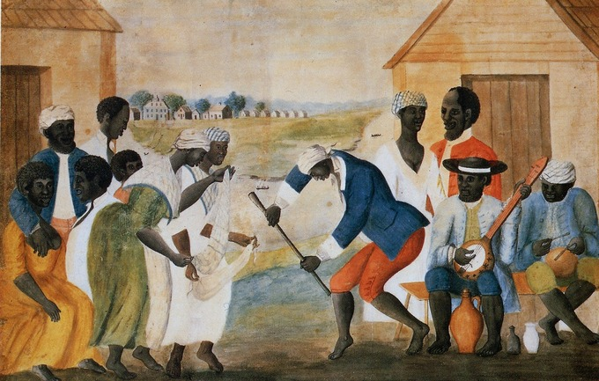
African American Slaves: Depiction of Slaves on a Virginian Plantation

Caste Systems
Caste systems are closed social stratification systems in which people inherit their position and experience little mobility.

LEARNING OBJECTIVES
Compare the caste system in ancient India with the estate system in feudal Europe

KEY TAKEAWAYS

Key Points
- Castes are most often stratified by race or ethnicity, economic status, or religious status.
- Castes have been noted in societies all over the world throughout history, though they are mistakenly often assumed to be a tradition specific to India.
- Historically, the caste system in India consisted of four well known categories: Brahmins (priests), Kshatriyas (warriors), Vaishyas (commerce), Shudras (workmen). Some people left out of these four caste classifications were called “outcasts” or “untouchables” and were shunned and ostracized.

Key Terms
- endogamy: The practice of marrying or being required to marry within one’s own ethnic, religious, or social group.
- estate: A major social class or order of persons regarded collectively as part of the body politic of the country and formerly possessing distinct political rights (w:Estates of the realm)
- social stratification: The hierarchical arrangement of social classes, or castes, within a society.
Caste is an elaborate and complex social system that combines some or all elements of endogamy, hereditary transmission of occupation, social class, social identity, hierarchy, exclusion, and power. Caste as a closed social stratification system in which membership is determined by birth and remains fixed for life; castes are also endogamous, meaning marriage is proscribed outside one’s caste, and offspring are automatically members of their parents’ caste.
Although Indian society is often associated with the word “caste,” the system is common in many non-Indian societies. Caste systems have been found across the globe, in widely different cultural settings, including predominantly Muslim, Christian, Hindu, Buddhist, and other societies. UNICEF estimates that identification and sometimes discrimination based on caste affects 250 million people worldwide.
In colonial Spain, throughout South America and Central America, castas referred to a method of stratifying people based on race, ethnicity, and social status and was in common usage since the 16th century. The term caste was applied to Indian society in the 17th century, via the Portuguese. The Dutch also used the word caste in their 19th century ethnographic studies of Bali and other parts of southeast Asia. In Latin American sociological studies, the word caste often includes multiple factors such as race, ethnicity, and economic status. Multiple factors were used to determine caste in part because of numerous mixed births during the colonial times between natives, Europeans, and people brought in as slaves or indentured laborers.
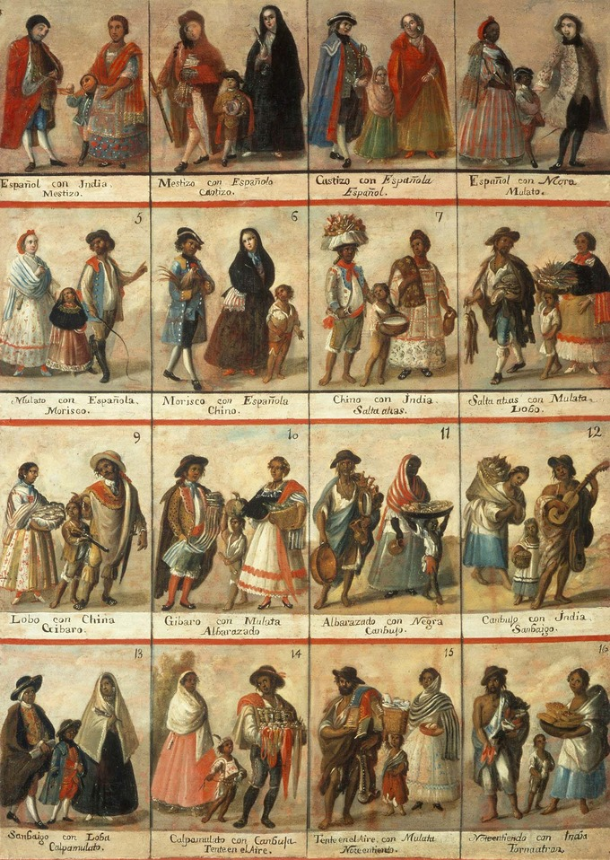
Colonial Mexican Caste System: After the Spanish colonized Mexico, one’s position in a caste system depended on how European or indigenous one seemed. Both biological and sociocultural indicators were used to measure ethnicity.
Some literature suggests that the term caste should not be confused with race or social class. Members of different castes in one society may belong to the same race or class, as in India, Japan, Korea, Nigeria, Yemen, or Europe. Usually, but not always, members of the same caste are of the same social rank, have a similar group of occupations, and typically have social mores which distinguish them from other groups. Some sociologists suggest that caste systems come in two forms: racial caste systems and non-racial caste systems.

India
Caste is often associated with India. Historically, the caste system in India consisted of four well known categories (Varnas): Brahmins (priests), Kshatriyas (warriors), Vaishyas (commerce), Shudras (workmen). Some people left out of these four caste classifications were called “outcasts” or “untouchables” and were shunned and ostracized. Ancient Indian legal texts, such as Manusmṛti (ca. 200 BCE-200 CE), suggest that caste systems have been part of Indian society for millennia.
Other Indian scriptures suggest ancient Indian law was not rigid about endogamy within castes. For example, Nāradasmṛti, another text on ancient Indian law, written after Manusmṛti and dated to be over 1400 years old, approves of many, but not all marriages across caste lines. The Nāradasmṛti set out categories of approved marriages between castes. Several statutes recognized offsprings of mixed castes, much like caste system of colonial Spain. Ancient Indian texts also suggest that India’s social stratification system was controversial, a topic of profound historical debates within the Indian community, and inspired efforts for reform.

Europe
Social systems identical to caste systems found elsewhere in the world have historically existed in Europe as well. European societies were historically stratified according to closed, endogamous social systems with groups such as the nobility, clergy, bourgeoisie, and peasants. These caste groups had distinctive privileges and unequal rights, which were not a product of informal advantages such as wealth and were not rights enjoyed as citizens of the state. These unequal and distinct privileges were sanctioned by law or social mores, were exclusive to each distinct social subset of society, and were inherited automatically by offspring. In some European countries, these closed social classes or castes were given titles, followed mores and codes of behavior specific to their caste, and even wore distinctive dress. Nobility rarely married commoners, and if they did, they lost certain privileges. Caste endogamy wasn’t limited to royalty; in Finland, for example, it was a crime—until modern times—to seduce and defraud into marriage by declaring a false social class. In parts of Europe, these closed social caste groups were called estates.
Along with the three or four estates recognized in various European countries, an additional group existed below the bottom layer of the hierarchical society. This bottom social strata with limited rights was understood to serve those with recognized social status. Prominent for centuries throughout Europe, and enduring through the mid-19th century in some areas, members of this numerically large caste were called serfs. In some countries such as Russia, the 1857 census found that over 35 percent of the population could be categorized as a serf. Serf mobility was heavily restricted, and in matters of marriage and living arrangements, they were subject to rules dictated by the State, the Church, by landowners, and by often rigid local custom and tradition.

Class
Social class refers to the grouping of individuals in a stratified social hierarchy, usually based on wealth, education, and occupation.

LEARNING OBJECTIVES
Compare and contrast Marx’s understanding of ‘class’ with Weber’s class model

KEY TAKEAWAYS

Key Points
- Sociologists may analyze social class using a simple three-stratum model of stratification, Marxist theory, or a structural-functionalist approach.
- Max Weber formulated a three-component theory of stratification that saw political power as an interplay between “class”, ” status ” and ” group power. ” Weber theorized that class position was determined by a person’s skills and education, rather than by their relationship to the means of production.
- The three-stratum model of stratification recognizes three categories: a wealthy and powerful upper class that owns and controls the means of production; a middle class of professional or salaried workers; and a lower class who rely on hourly wages for their livelihood.
- In Marxist theory, the class structure of the capitalist mode of production is characterized by two main classes: the bourgeoisie, or the capitalists who own the means of production, and the much larger proletariat (or working class ) who must sell their own labor power for wages.
- Social class often has far reaching effects, influencing one’s educational and professional opportunities and access to resources such as healthcare and housing.

Key Terms
- class mobility: Movement from one class status to another–either upward or downward.
- socioeconomic status: One’s social position as determined by income, wealth, occupational prestige, and educational attainment.
- class consciousness: A term used in social sciences and political theory to refer to the beliefs that a person holds regarding one’s social class or economic rank in society, the structure of their class, and their class interests.
Social class refers to the grouping of individuals into positions on a stratified social hierarchy. Class is an object of analysis for sociologists, political scientists, anthropologists and social historians. However, there is not a consensus on the best definition of the term “class,” and the term has different contextual meanings. In common parlance, the term “social class” is usually synonymous with socioeconomic status, which is one’s social position as determined by income, wealth, occupational prestige, and educational attainment.
Common models used to think about social class come from Marxist theory: common stratum theory, which divides society into the upper, middle, and working class; and structural-functionalism.

Class in Marxist Theory
According to the class social theorist Karl Marx, class is a combination of objective and subjective factors. Objectively, a class shares a common relationship to the means of production. Subjectively, the members will necessarily have some perception of their similarity and common interests, called class consciousness. Class consciousness is not simply an awareness of one’s own class interest but is also a set of shared views regarding how society should be organized legally, culturally, socially and politically.
In Marxist theory, the class structure of the capitalist mode of production is characterized by two main classes: the bourgeoisie, or the capitalists who own the means of production, and the much larger proletariat (or working class) who must sell their own labor power for wages. For Marxists, class antagonism is rooted in the situation that control over social production necessarily entails control over the class which produces goods—in capitalism this is the domination and exploitation of workers by owners of capital.

Weberian Class
The class sociologist Max Weber formulated a three-component theory of stratification that saw political power as an interplay between “class”, “status” and “group power. ” Weber theorized that class position was determined by a person’s skills and education, rather than by their relationship to the means of production.
Weber derived many of his key concepts on social stratification by examining the social structure of Germany. He noted that contrary to Marx’s theories, stratification was based on more than simply ownership of capital. Weber examined how many members of the aristocracy lacked economic wealth yet had strong political power. Many wealthy families lacked prestige and power, for example, because they were Jewish. Weber introduced three independent factors that form his theory of stratification hierarchy: class, status, and power: class is person’s economic position in a society; status is a person’s prestige, social honor, or popularity in a society; power is a person’s ability to get his way despite the resistance of others. While these three factors are often connected, someone can have high status without immense wealth, or wealth without power.

The Common Three-Stratum Model
Contemporary sociological concepts of social class often assume three general categories: a very wealthy and powerful upper class that owns and controls the means of production; a middle class of professional or salaried workers, small business owners, and low-level managers; and a lower class, who rely on hourly wages for their livelihood.
The upper class is the social class composed of those who are wealthy, well-born, or both. They usually wield the greatest political power.
The middle class is the most contested of the three categories, consisting of the broad group of people in contemporary society who fall socioeconomically between the lower class and upper class. One example of the contestation of this term is that In the United States middle class is applied very broadly and includes people who would elsewhere be considered lower class. Middle class workers are sometimes called white-collar workers.
The lower or working class is sometimes separated into those who are employed as wage or hourly workers, and an underclass—those who are long-term unemployed and/or homeless, especially those receiving welfare from the state. Members of the working class are sometimes called blue-collar workers.

Consequences of Social Class
A person’s socioeconomic class has wide-ranging effects. It may determine the schools he is able to attend, the jobs open to him, who he may marry, and his treatment by police and the courts. A person’s social class has a significant impact on his physical health, his ability to receive adequate medical care and nutrition, and his life expectancy.
Class mobility refers to movement from one class status to another–either upward or downward. Sociologists who measure class in terms of socioeconomic status use statistical data measuring income, education, wealth and other indexes to locate people on a continuum, typically divided into “quintiles” or segments of 20% each. This approach facilitates tracking people over time to measure relative class mobility. For example, the income and education level of parents can be compared to that of their children to show inter-generational class mobility.
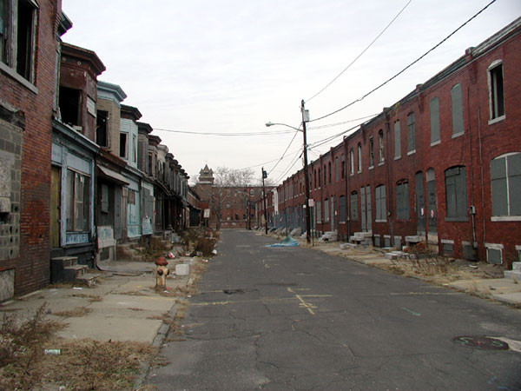
Social Class and Living Conditions: In the United States, neighborhoods are stratified by class such that the lower class is often made to live in crime-ridden, decaying areas.
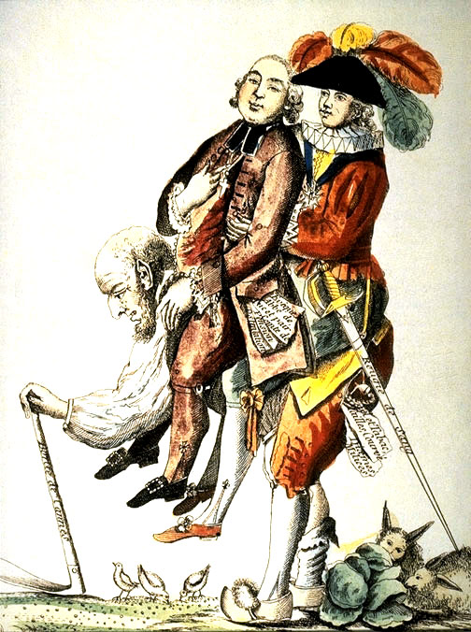
French Estates: In France before the French Revolution, society was divided into three estates: the clergy, nobility, and commoners. In this political cartoon, the Third Estate (commoners) is carrying the other two on its back.

Gender
Along with economic class and race, society is stratified by gender, with women often holding a lower social position than men.

LEARNING OBJECTIVES
Describe the effects of gender discrimination on women’s employment and wealth

KEY TAKEAWAYS

Key Points
- In the labor force, women are often relegated to lower status jobs, lower wages, and fewer promotions and raises than their male counterparts.
- Sexism is discrimination against a person on the basis of their sex, and tends to result in disadvantages for women who do not embrace their traditional gender role as mother and household overseer.
- Women’s participation in the labor force also varies depending on marital status and social class.

Key Terms
- sexism: The belief that people of one sex or gender are inherently superior to people of the other sex or gender.
- Motherhood Penalty: The loss of pay and promotions among women due to the perceived association between women and the demands of childrearing.
- Informal Economies: Employment domains that are not regulated by governments and law enforcement.
Economic class, race, and gender shape the opportunities, the privileges, and the inequalities experienced by individuals and groups. The United States continues to be greatly stratified along these three lines.
Capitalism also takes advantage of gender inequality. Women workers are often used as a source of cheap labor in informal economies, or employment domains that are not regulated by governments and law enforcement. For example, women work for low wages without health benefits as nannies and maids in New York, in clothing sweatshops in Los Angeles, and on rose farms in Ethiopia. In formal economies, women often receive less pay and have less chances for promotion than men. This phenomenon is referred to as the gender gap in employment.
Current U.S. labor force statistics illustrate women’s changing role in the labor force. For instance, since 1971, women’s participation in the labor force has grown from 32 million (43.4% of the female population 16 and over) to 68 million (59.2% of the female population 16 and over). Women also make, on average, $17,000 less than men do. Women tend to be concentrated in less prestigious and lower paying occupations than men, particularly those that are traditionally considered women’s jobs or pink-collar jobs. Women’s participation in the labor force also varies depending on marital status and social class.
Sociological research shows that women are not paid the same wages as men for similar work. Women tend to make between 75% and 91% of what men make for comparable work, with the highest inequality between men and women found among those with college and graduate degrees. The fact that women earn less than men with equal qualifications helps explain why women are enrolling in college at higher rates than men — they require a college education to make the same amount as men with a high school diploma. The income gap between genders used to be similar between middle-class and affluent workers, but it is now widest among the most highly paid. A woman earning in the 95th percentile in 2006 would earn about $95,000 per year; a man in the 95th earning percentile would make about $115,000, a 28% difference.
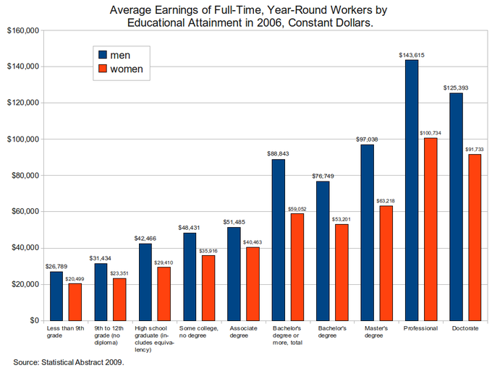
Average Earnings of Full-Time, Year-Round Workers by Educational Attainment in 2006, Constant Dollars: Wages based upon gender and education point to a distinctive glass ceiling as it pertains to women in the workplace.
The most common explanation for the wage gap between men and women is the finding that women pay a motherhood penalty, regardless of whether or not they are actually mothers. This can be explained from the perspective of a potential employer: assuming you have two equally qualified candidates for a position, both are in their mid-twenties, married, and straight out of college, but one is a male and the other is female, which would you choose? Many employers choose men over women because women are “at risk” of having a child, even though they may not want to have children. The employer considers women who have children to be cumbersome, based on the expectation that women will take maternity leave and will be primarily responsible for childrearing. If women do actually take time off to bear and raise children, this further reduces the likelihood that they will be considered for raises or promotions.

Sexism
Sexism is discrimination against people based on their sex or gender, and can result in lower social status for women. Sexism can refer to three subtly different beliefs or attitudes: the belief that one sex is superior to the other; the belief that men and women are very different and that this should be strongly reflected in society, language, and the law; the simple hatred of men (misandry) or women (misogyny). Many peoples’ beliefs about sex equality range along a continuum. Some people believe that women should have equal access with men to all jobs, while others believe that while women are superior to men in a few aspects, in most aspects men are superior to women.
Sexist beliefs are an example of essentialist thought, which holds that individuals can be understood (and often discriminated against) based on the characteristics of the group to which they belong–in this case, their gender.
Sexism has been linked to widespread gender discrimination. One example is the disparity in wealth between men and women in the U.S. Sociological research has shown that there are fewer wealthy women than there are wealthy men and that they are less likely to control the management of their own wealth. Up until the 19th Century most women could not own property and women’s participation in the paid labor force outside the home was limited. It is possible that wealth among the elite may be redistributed toward a more equal balance between the sexes with increasing numbers of women entering the workforce and moving toward more financially lucrative positions in major corporations.

