Exercise # 11
RUSTS
Rusts are important group of plant diseases, belonging to order Uredinales and class Basidiomycetes.They are nutritionally obligate parasites. Three types of rust diseases are real threat for wheat crop in Pakistan. Rusts of lentil, pea, linseed, gram and shaftal are also causing severe yield losses in Pakistan.
Materials
- Samples of uredia, telia, pycnidia and aecia of following rusts from their primary and alternate hosts:
- Yellow rust of wheat (Puccinia striiformis f.sp. tritici)
- Brown rust of wheat (P. recondita f.sp. tritici)
- Black rust of wheat (P. graminis f.sp. tritici)
- Sugarcane rust (P. koehnii)
- Pea and lentil rust (Uromyces fabae)
- Linseed rust (Melampsora lini)
- Gram rust (U. ciceris-arietini)
- Shaftal rust (U. trifolii)
- Samples of rust infected leaves.
Procedure
- Study the pustules colour, shape, arrangement and position on wheat leaves and characterize rusts symptoms on the basis of these characteristics.
- Prepare permanent slides of pycniospore, urediospores, teliospore and aeciospore, and observe them under high power microscope.
- Draw the sketches of pycniospore, urediospores, teliospore and aeciospore and label them.
- Observe the symptoms of above mentioned rust diseases and draw them on your practical manual.
- Study the fruiting bodies (pycnidia, uredia, aecia and telia) present on infected leaves under stereomicroscope and draw their labeled diagrams.
- Make the cross sections of rust infected leaves taken from primary and alternate hosts and observe them under microscope for the presence of mycelium and fruiting bodies in infected tissues.

Questions
- What are the obligate parasites?
These are parasites which take their food only from living source (plants).
- What is alternate host?
A host other than primary host but its family is different from the family of the primary host.
- What is the best way to control rust diseases?
The best method is the use of resistant cultivars.
- What is the time of appearance of three wheat rust diseases in Punjab, Pakistan?
Yellow rust (also known as strip rust): appears in February
Brown rust (also known as leaf rust): appears in March
Black rust (also known as stem rust): appears in late March and early April
- What is Ug99?
Ug99 is the race of black (stem) rust. “Ug” means Uganda as this race was first appeared in Uganda in 1999, therefore, this is called Ug99.
- What do you mean by heteroecious and autoecious rusts?
Rusts which complete their life cycle on single host known as autoecious rusts. Rusts which complete their life cycle on different hosts known as heteroecious rusts.
- Separate the heteroecious and autoecious rusts mentioned above?
Yellow, brown and black rusts of wheat are heteroecious rusts while remaing rusts are autoecious.
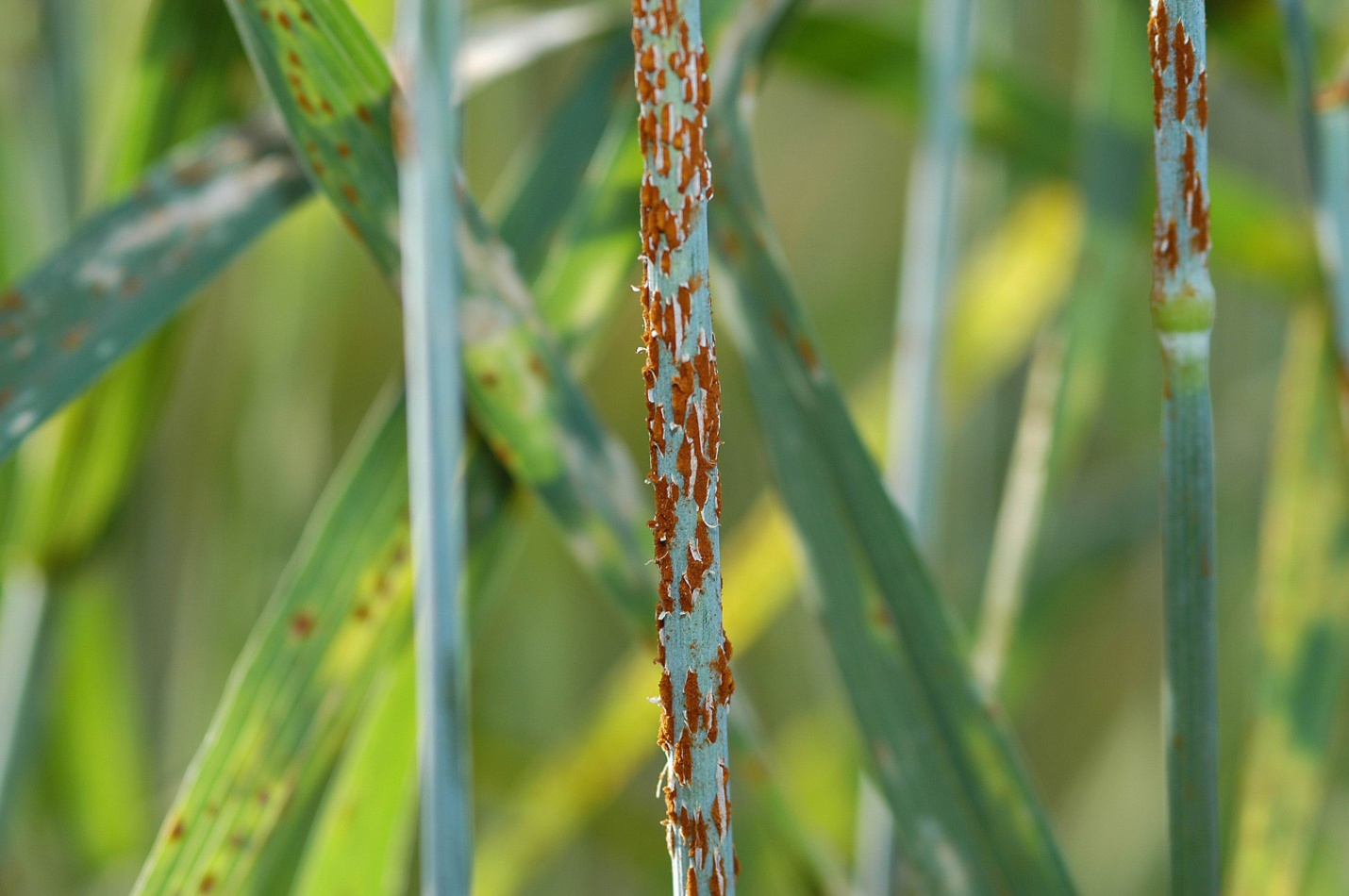
Stem Rust of Wheat
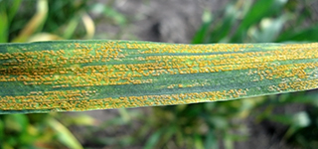
Stripe Rust of Wheat
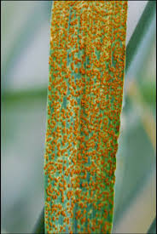
Leaf Rust of Wheat

